Силин В МО-11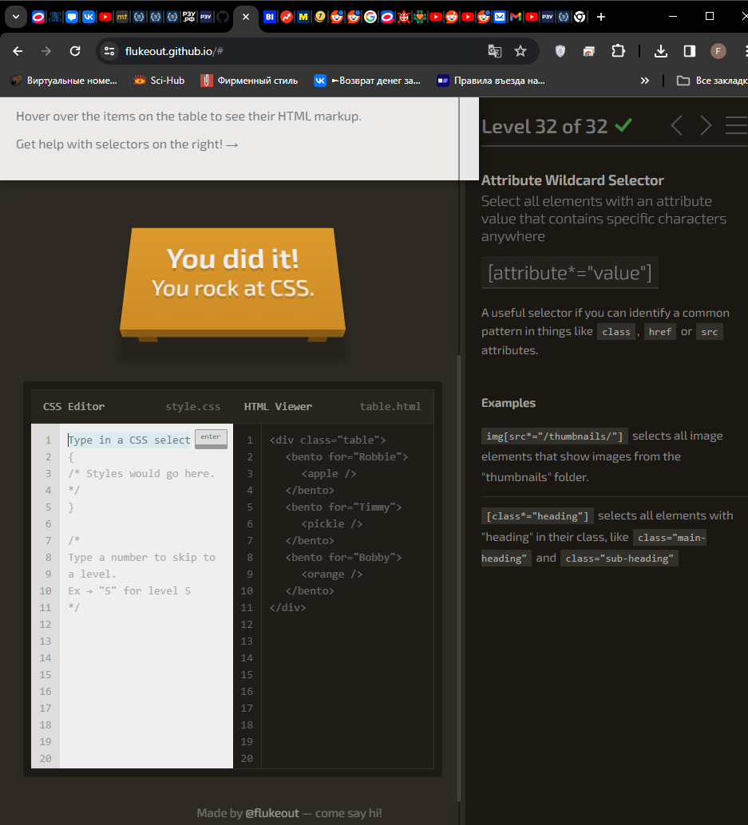

Gismeteo:

document.querySelectorAll('[data-row="temperature-air"] .values .maxt .unit_temperature_c')[0].innerText

document.querySelectorAll('[data-row="temperature-air"] .values .maxt .unit_temperature_c')[1].innerText

document.querySelectorAll('[data-row="temperature-air"] .values .maxt .unit_temperature_c')[2].innerText

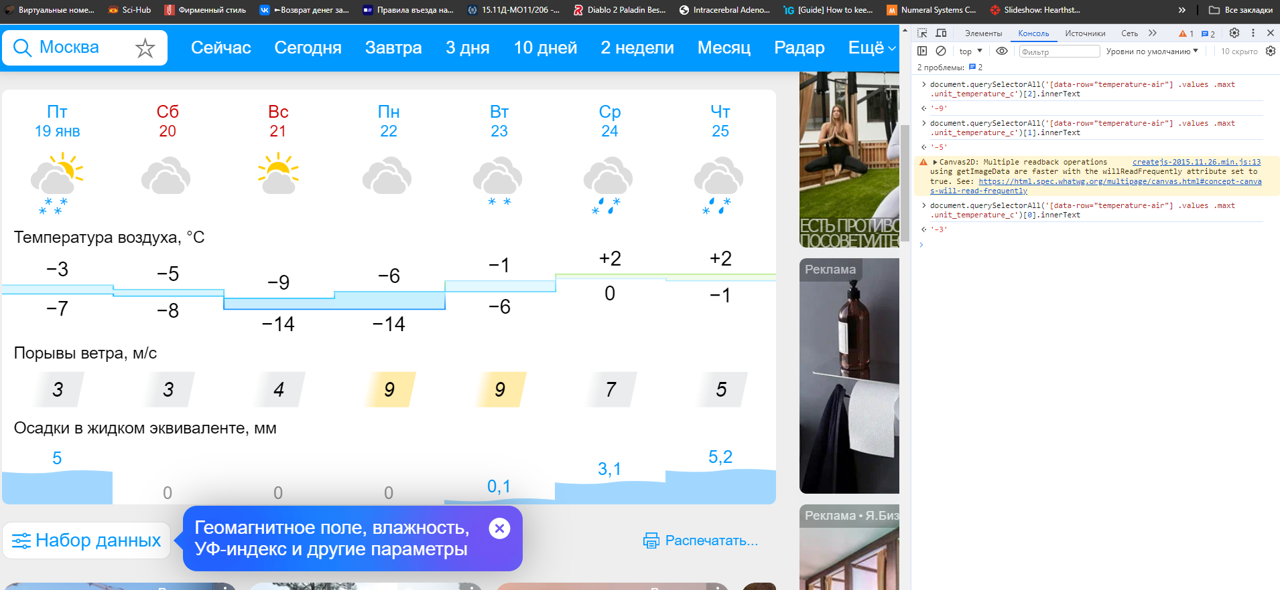

Yandex:

document.querySelectorAll('.forecast-briefly__day .temp__value_with-unit')[2].innerText

document.querySelectorAll('.forecast-briefly__day .temp__value_with-unit')[4].innerText

document.querySelectorAll('.forecast-briefly__day .temp__value_with-unit')[6].innerText

