# Sarcomere Measurments v1.0

## Go to app website

<https://vinarsky.shinyapps.io/sarcomere/>

## Prepare your files for analysis (copy them in one folder)

Example file:  
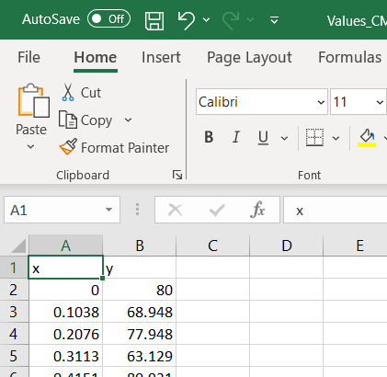

## Upload files

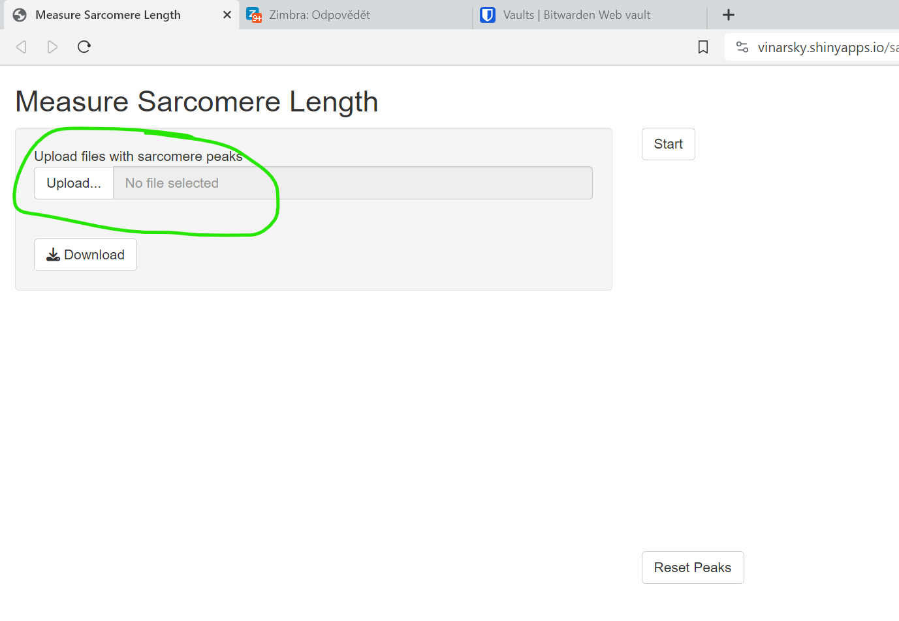

## Start app

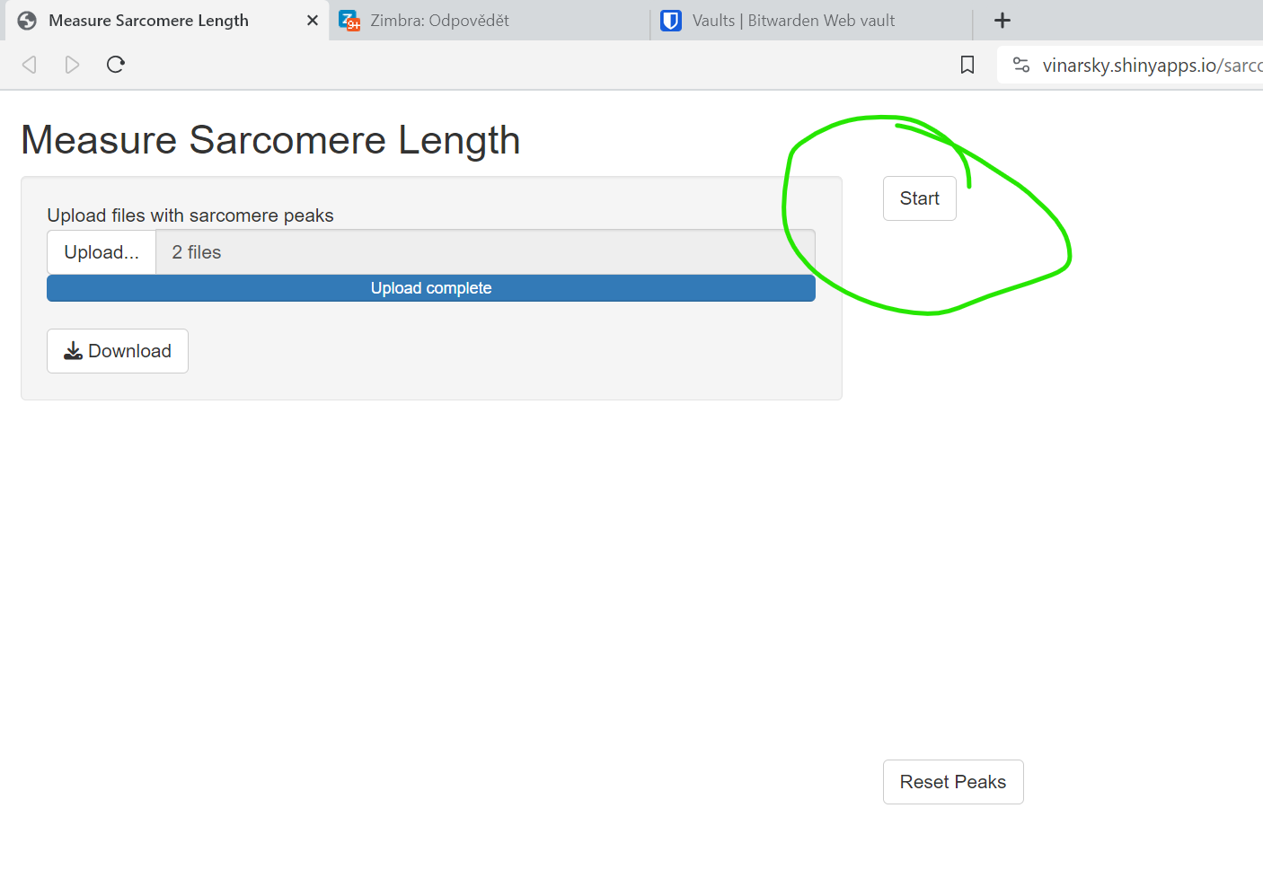

## Select peaks

File is loaded:  
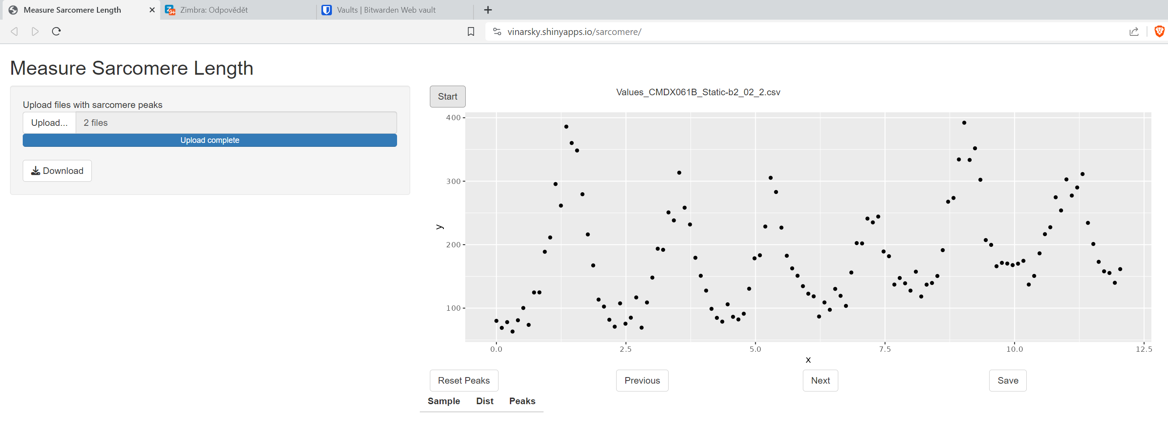

Select peaks by clicking:  
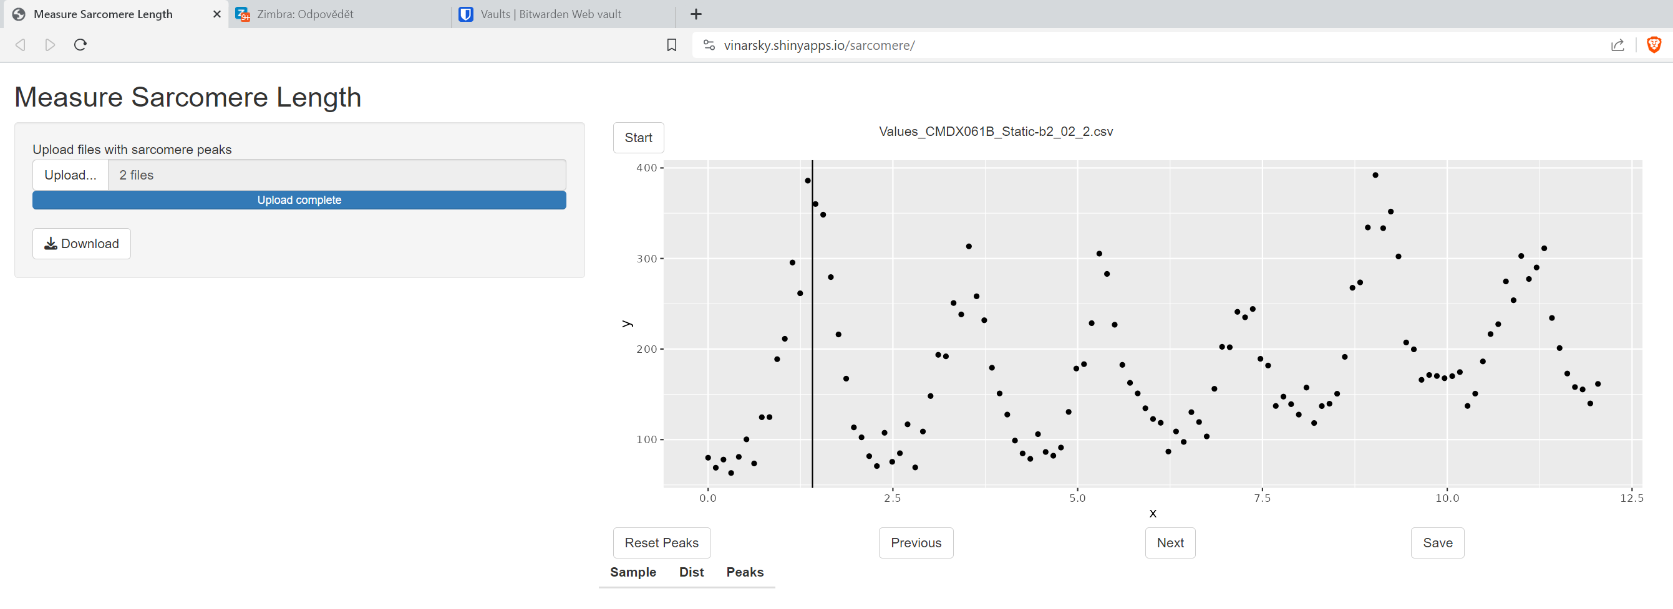

Reset peaks selection:  
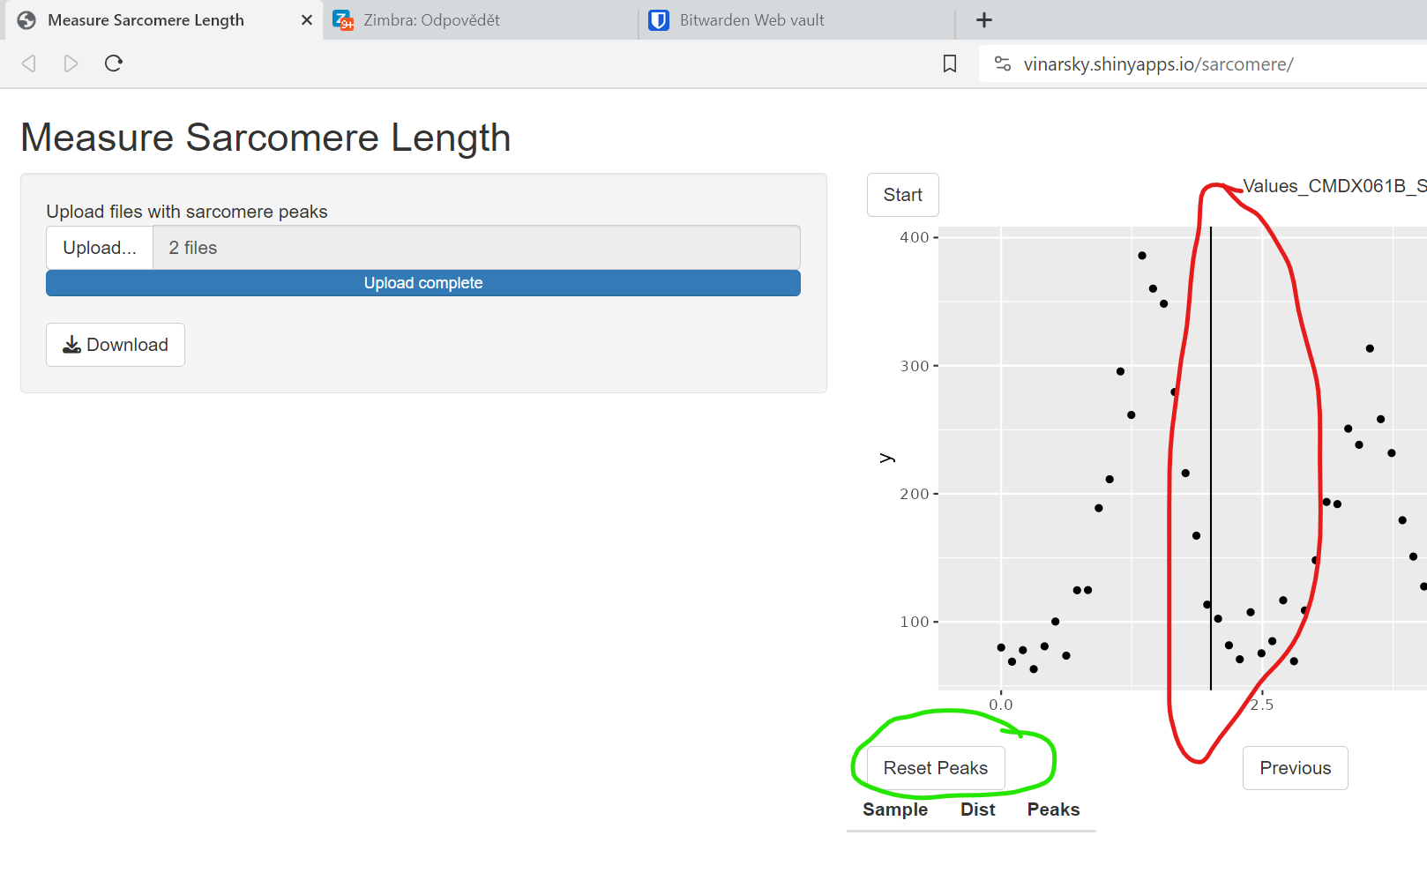

## Save first file and move one

Save peaks from the first file:  
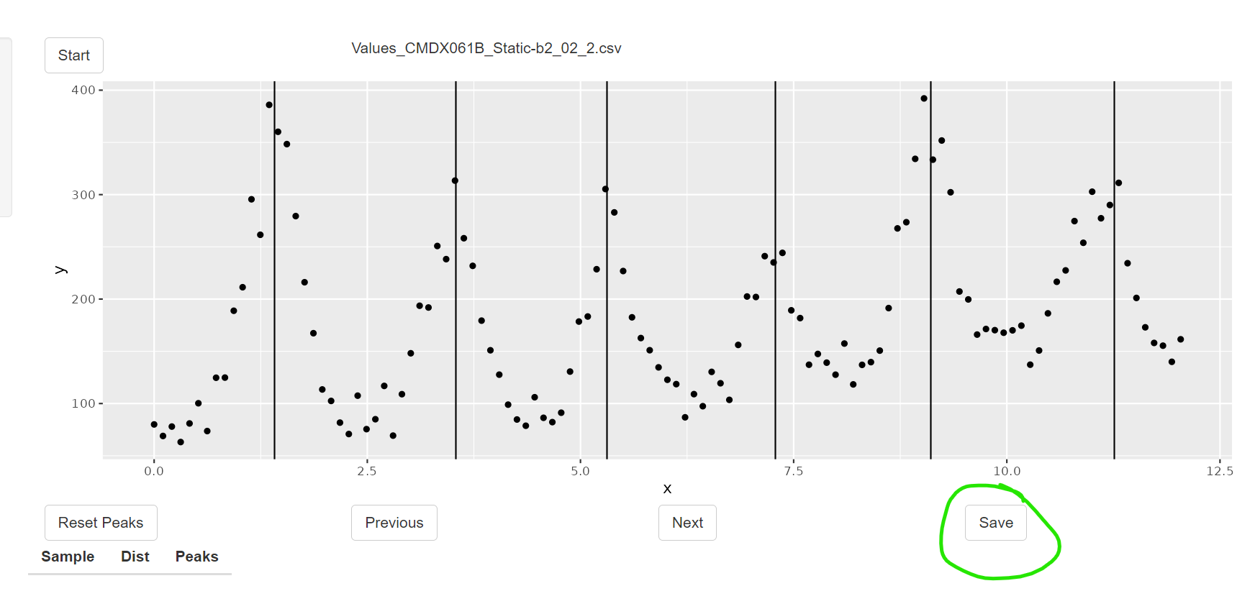

The first measurments added to table:  
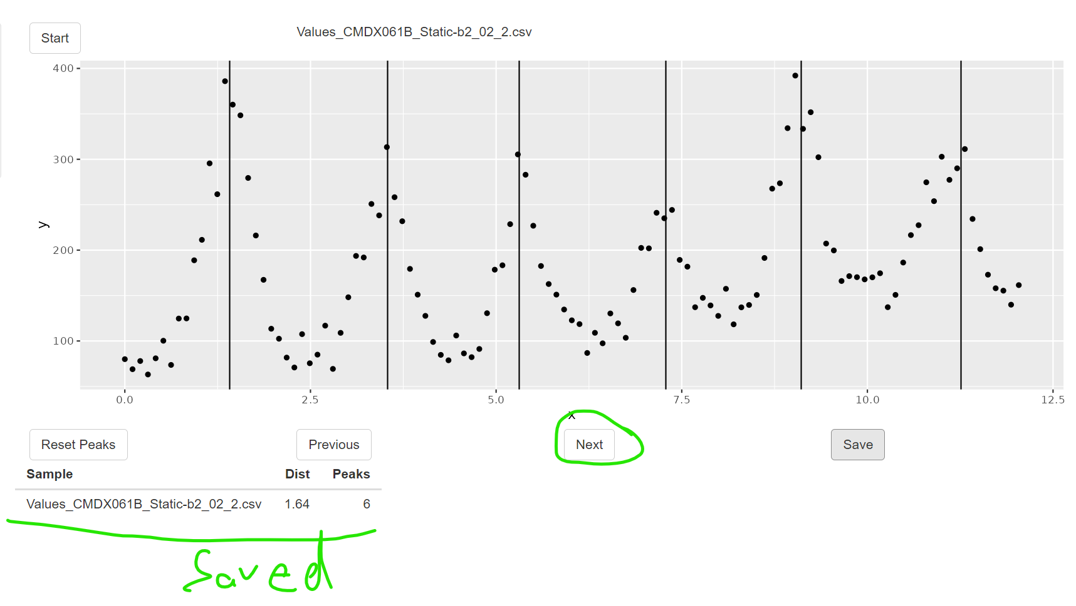

## Export results

Download the table:  
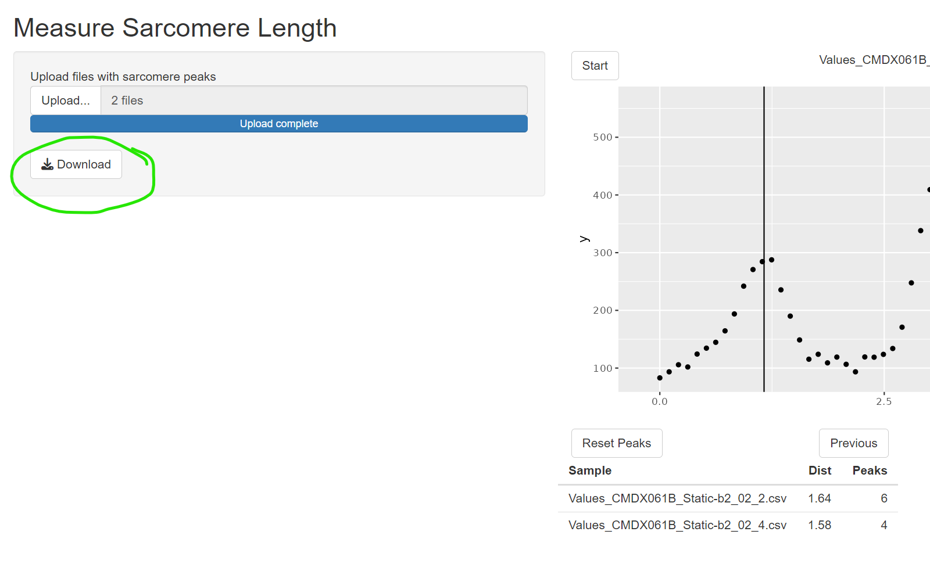

Results example:  
