HOG+SVM Tool Manual
This source include all functions to train SVM classifier (linear type), predict classifying results. If you know OpenCV and SVM, you can develop such codes easily. Here I will show you how to use this tool to do research.
After you successfully compiling the source code, you are ready to do some tests. In the release or debug folder, you can find the file HogSvmDetection.exe, which is a command line program, a very important command is :
HogSvmDetection -t 32 32 40 16 16 8 8 8 8 9 $POSTIVE_SAMPLE_FOLDER\\*.* $NEGATIVE_SAMPLE_FOLDER\\*.* $TARGET_FOLDER\\svm_xml _model_1.0.0.xml
This command tells the program to start a training task using specified parameter to train a SVM model using the training dataset, and save the result as a xml file which can be used for prediction and detection task later.
The meaning of the command line is:

HogSvmDetection is the program name
-t means training, is the command type which tells the program to do training task
The first 32 means the width of the training samples to be scaled
The second 32 means the height of the training samples to be scaled
The 40 means the maximum ratio between number of the negative samples over that of positive (if you get over 100,000 positive samples, the value typically takes 7 or 8, not that big as 40).
The first 16 means the width of the cell size.
The second 16 means the height of the cell size.
The first 8 means the width of the sub-cell.
The second 8 means the height of the sub-cell.
The last number 9 specifies of number of bins.
The parameter $POSTIVE_SAMPLE_FOLDER is the folder where you save your positive samples, and the $NEGATIVE_SAMPLE_FOLDER is the folder for negative images, the last parameter $TARGET_FOLDER is the folder where you save the SVM model, an xml file that define the support vector.
To know why we need to set those parameters, you need to understand the algorithm of HOG, and the principle on how to training the SVM classifier. Both source code and papers are good resource for such purpose.

If your dataset can finally produce a good SVM model, then you probably want to check how well the model works on some other dataset, to do this, you can execute the following command:

HogSvmDetection –p $LABEL $DATA_SET_PATH\\*.* $SVM_MODEL_FILE_PATH

The meaning of the command lines is to tell the program to start a prediction task which is specified by –p or –predict
$LABEL can only take two values, 1 or 0. 1 to tell the program that the dataset is expected to be all positive while 0 means negative.
$DATA_SET_PATH is the folder where the images you would like to predict using the SVM model.
$SVM_MODEL_FILE_PATH is the SVM model file you got in proceeding task.

After executing such command, the program will output a correction rate. Try it!

So far, the previous two task all using cropped small training images to feed the program, in practical usage, we want to detect a given image which may contain objects we interested in, such as bird for this project. Then we want to feed the program with a full size image, and hope the program to output an image with labels (as showed in the next image). To do this, you can execute the command line:
HogSvmDetection –d $IMAGE_FILE_PATH $SVM_MODEL_FILE_PATH
As before, the –d specifies the task type
$IMAGE_FILE_PATH is the path for the image you want to test
$SVM_MODEL_FILE_PATH means the same as other tasks we mentioned.

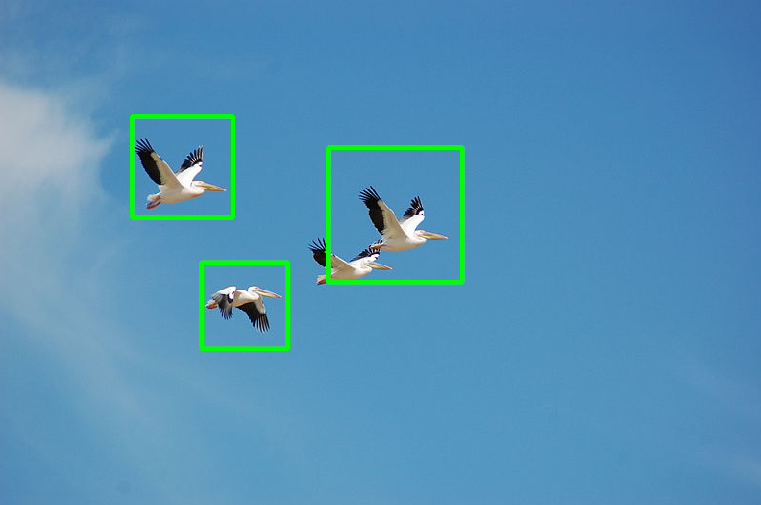

To this point, I show you the three functions the program can do for this research. There are lots of details you may need to learn to get better output, such as how to tweak those parameters in prediction and detection in the code which requires you to understand those code first. One of the most important things is that you need to improve you training dataset using some tricks, which I can share my experience when you are ready to discuss.

8/20/2014 11:44:31 AM

Chunde Huang

