**Create functionality**

**Resource can be added by using this request:**

INSERT INTO Resources (title, body, userId)

VALUES (‘et iusto sed quo iure\nvoluptatem occaecati omnis eligendi aut ad\nvoluptatem doloribus vel accusantium quis pariatur\nmolestiae porro eius odio et labore et velit aut’, ‘ea molestias quasi exercitationem repellat qui ipsa sit aut’, 3);

**Verification of the result:**

Tester runs a query on the MYSQL database server to check if a particular row is present

**Query:**

SELECT * FROM Resources WHERE title =’ et iusto sed quo iure\nvoluptatem occaecati omnis eligendi aut ad\nvoluptatem doloribus vel accusantium quis pariatur\nmolestiae porro eius odio et labore et velit aut’ and body = ‘ea molestias quasi exercitationem repellat qui ipsa sit aut’ and userId=3;

**Query result:**

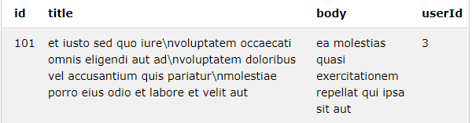

**Update functionality:**

**Resource can be updated by following these steps:**

1. Find records that needs to be updated
2. Create update query

**Query:**

UPDATE Resources

SET title =’New title’

WHERE id=101;

**Verification of the result:**

Tester runs a query on the MYSQL database server to check if a particular row is present

**Query:**

SELECT * FROM Resources

WHERE id=101;

**Query result:**

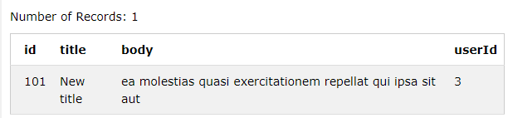

**Delete functionality**

**Resource can be deleted by following these steps:**

1. Find records that needs to be deleted
2. Create update query

**Query:**

DELETE FROM Resources

WHERE id=101;

**Verification of the result:**

Tester runs a query on the MYSQL database server to check if a particular row has been deleted

**Query**

SELECT * FROM Resources

WHERE id=101;

**Query result:**

