The folder contains a docker-compose file which can be used to get infrastructure in order to test the solution.

See <https://docs.docker.com/compose/install/> if you have any problem with the docker-compose installation/configuration.

Just run *docker-compose up* in the folder and you will get a working environment with ssh access to all hosts. HostA will be accessible through the port 2222. You can ssh to it with user “root” and password “password”. All other host accessible only from inside the “docker” network.

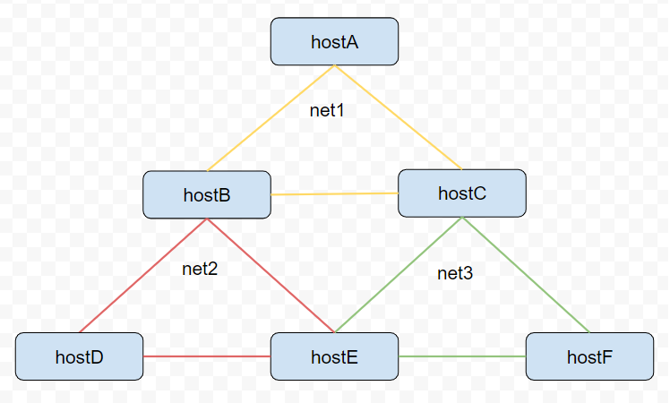

All details about the network structure described in the docker-compose.yml, but the solution itself should not base on any assumption about the network structure.

The solution should work without any changes in the docker-compose.yml.

.

├── build

│ └── Dockerfile # All containers will be deployed from single docker file

├── code # Add your solution here. Here you can create any file structure you want.

│ └── worm.py # Example application. It is here just to show that an example works

└── docker-compose.yml

* You can edit the Dockerfile if you need to add any dependency. You may change base image to something more comfortable for you if you want. But in an ideal solutions, you should not copy your code into the image.
* Put your code into the “code” directory and submit the whole folder as your solution.
* Folder ‘code’ will be mounted to “entry point ” host(hostA in current config). So you can easily execute your code inside the container without a rebuild or need to copy files.
* You can execute code using env variable, sshd will not be started in this case  
   *COMMAND='python worm.py "hostname" 10.0.0.1,10.0.0.2,192.168.0.5' docker-compose up*