App Designs
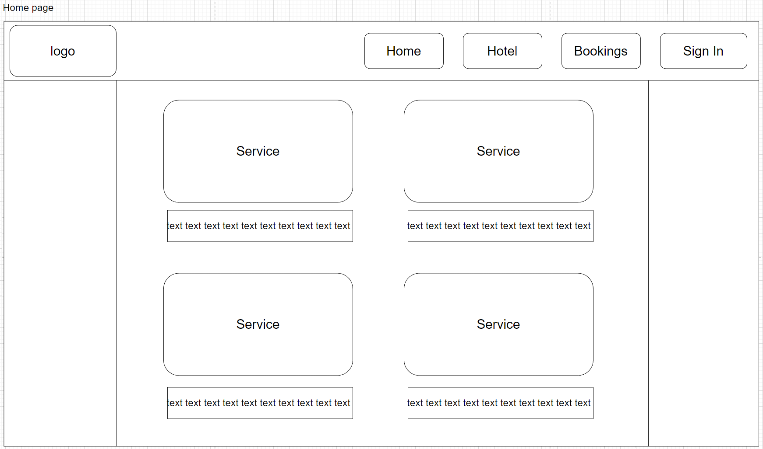
When opening the app, the user will usually be greeted with the home page (logged out if no account was created before on that device), the home page will contain a navigation bar at the top of the page to allow for easy navigation across the app (the navigation bar will be present across the whole app), as well as the different services of the that the zoo provides. The services will be laid out in a grid with 2 columns going down the page where the user can scroll down using a scroll bar, each service would be expandable to show more information on click so the user can read more about the service, also if the user expanded 1 service and they try to open a new one the last one will automatically update, this is to avoid clutter within the app.

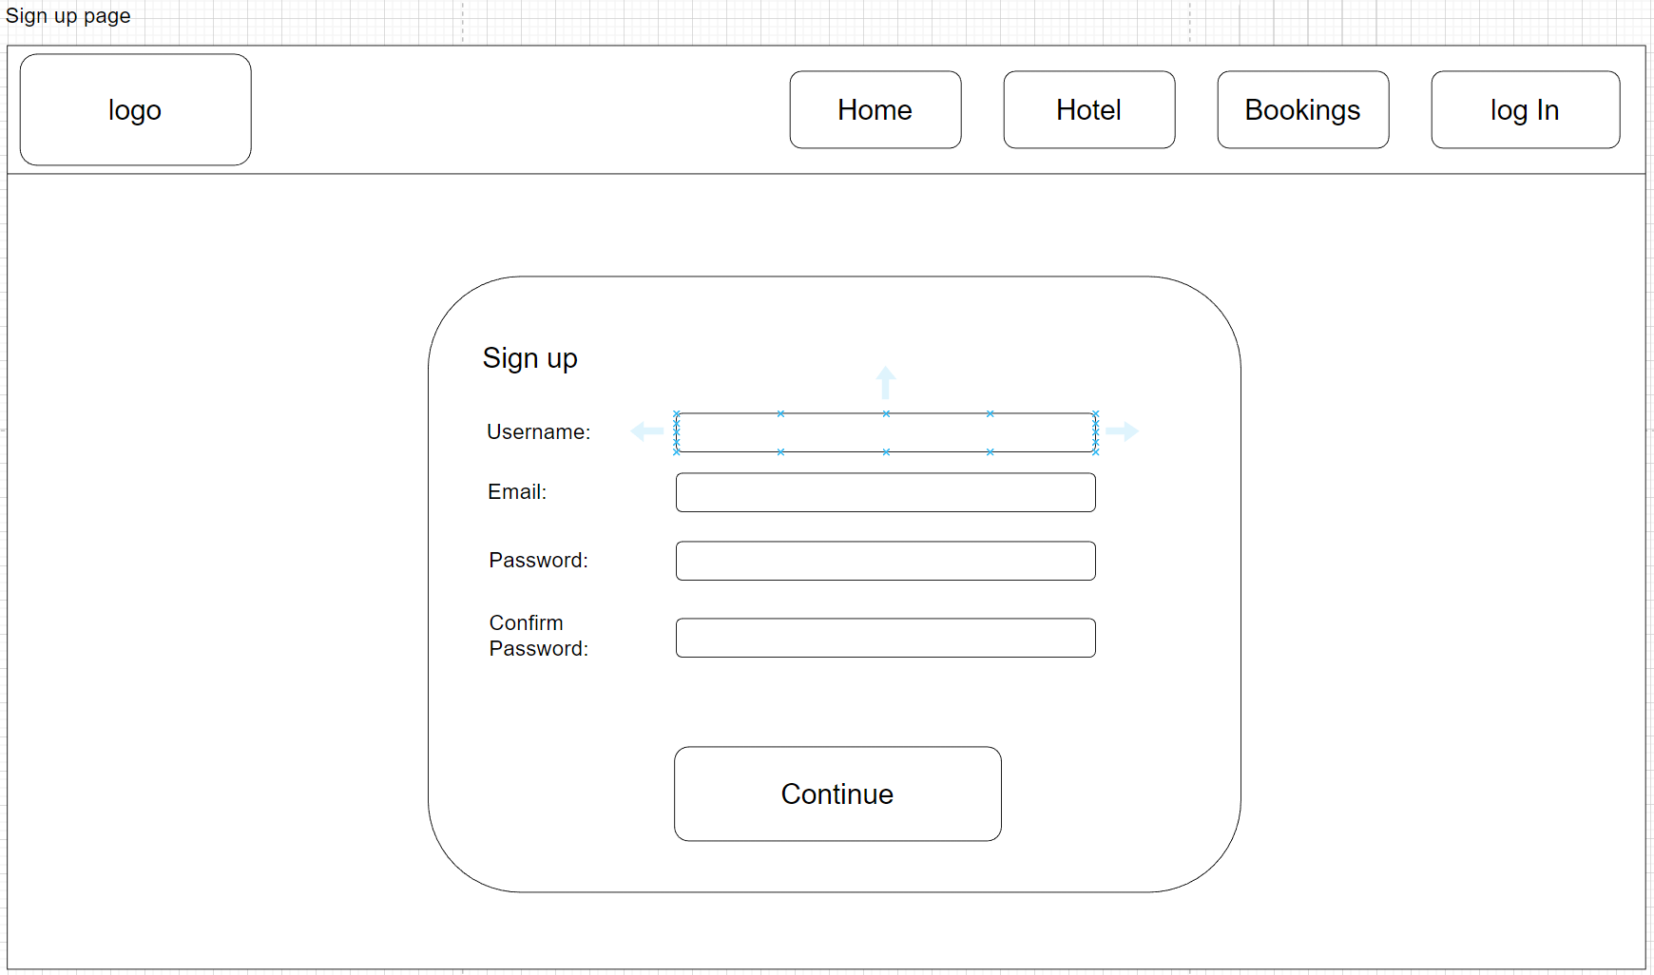
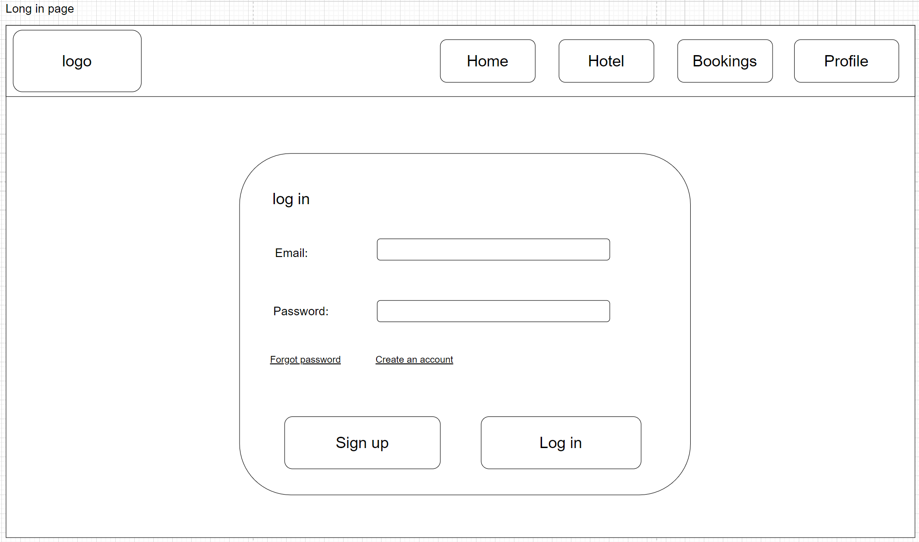
In order to access the booking information and the profile page the user must log in or create an account if the user isn’t registered yet, clicking on any button from the nav bar except for Home button while not logged in will take the user to the log in page where they will need to enter their account details to log in or create an account if they don’t have one already,
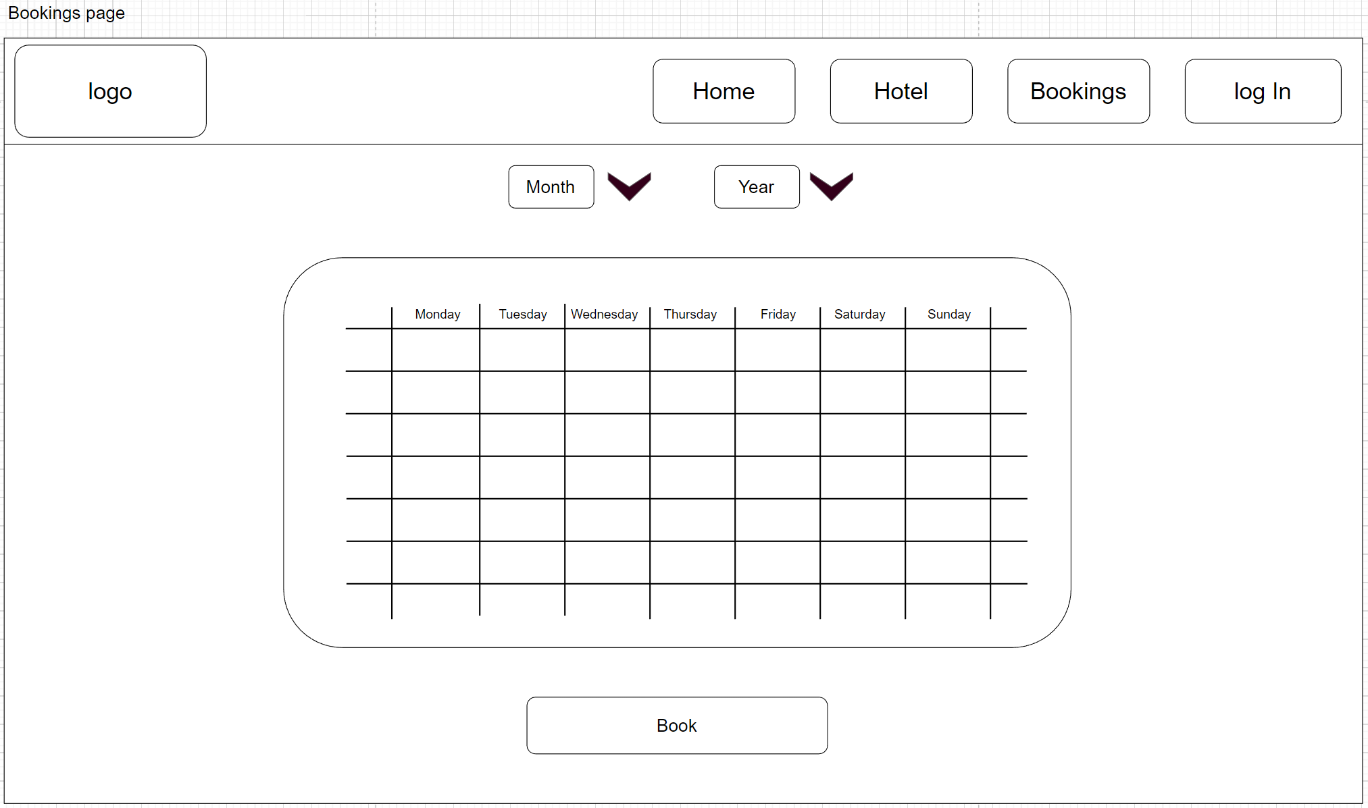
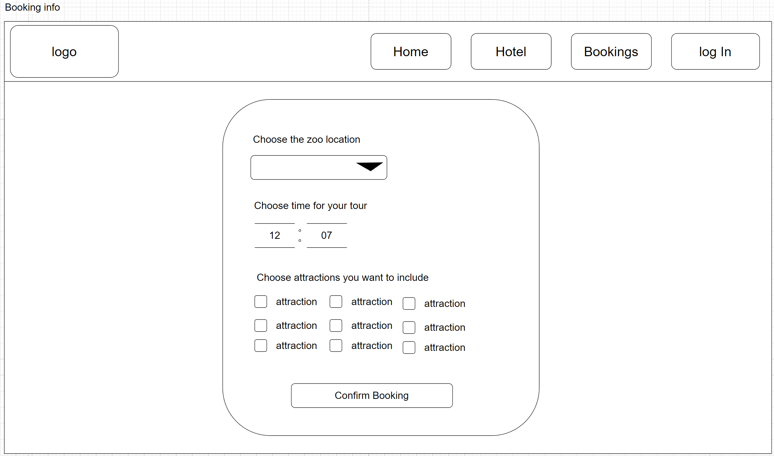
Clicking on the bookings button on the nav bar will redirect me the user to the page with a calendar where they will be shown what days are available for them to book. Once selected the date the user will be redirected to a form that would take the information on about the booking like what location time and attraction they want to choose. This design avoids confusion for the user and makes it easy to make a booking. After confirming the booking the user will get a confirmation message and will be redirected back to the home page
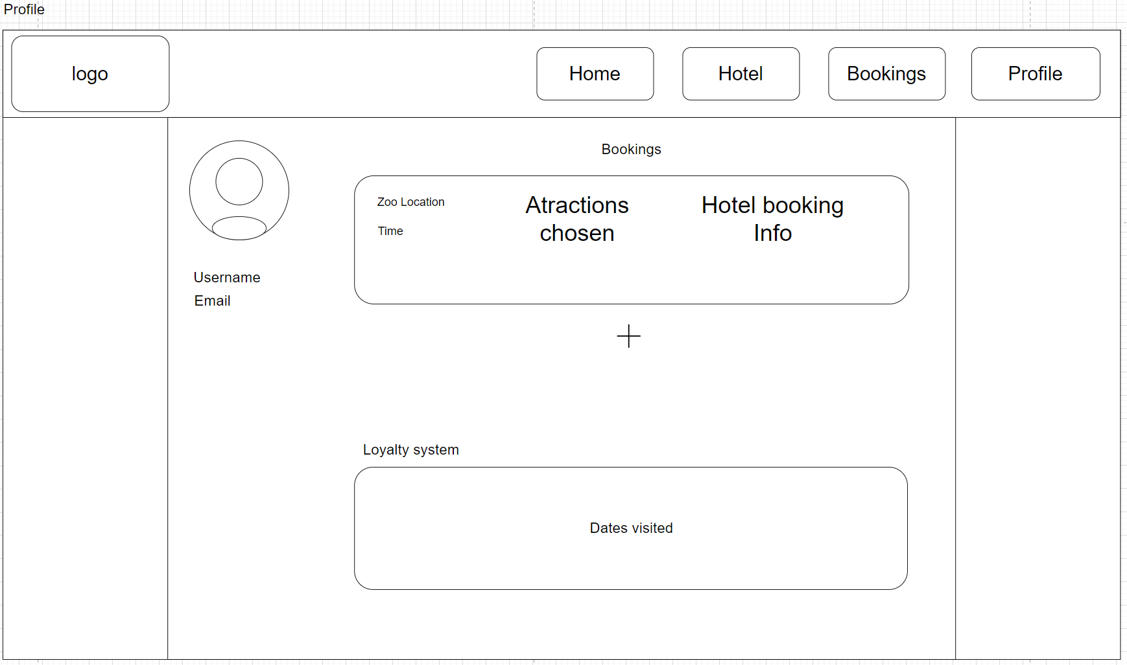

The profile page will show the information about the user profile such as username and email and profile picture if the user chooses to upload it, additionally the user can see the bookings that they got and info about them such as tour info and hotel options, also the user can add another booking straight from the profile page by clicking the plus button below the booking info. At the bottom of the page the user will see their loyalty scheme where they can see their past visits and the perks that they get from each visit.

Data Requirements
User account
Attribute name | Data type | Max Length | Required | justification
userId | Integer | 10000 | Required (primary key) | Unique identifier
username | string | 50 | Required | User name for the account
email | varchar | 50 | Required | Email that will be attached to the account for verification and security
password | hash | 20 | Required | Password to log in or create an account

Bookings
Attribute name | Data Type | Max Length | Required | Where used
bookingId | Integer | N/A | Required (primary key) | Unique identifier
userId | Integer | N/A | Required  (Foreign key) | Id that will tie the booking to the user
tourDate | datetime | N/A | Required | Date when the tour is booked for
tourTime | datetime | N/A | Required | Time when the tour will take place
numChildren | Integer | 10 | Required | How many children will be visiting and booking for hotel
numAdults | Integer | 10 | Required | How many adults will be visiting and booking for hotel
numRooms | Integer | 10 | Required | How many rooms does the user want to pick
numDays | integer | 10 | Required | How many days does the user want to stay at the hotel

Data Flow Diagram

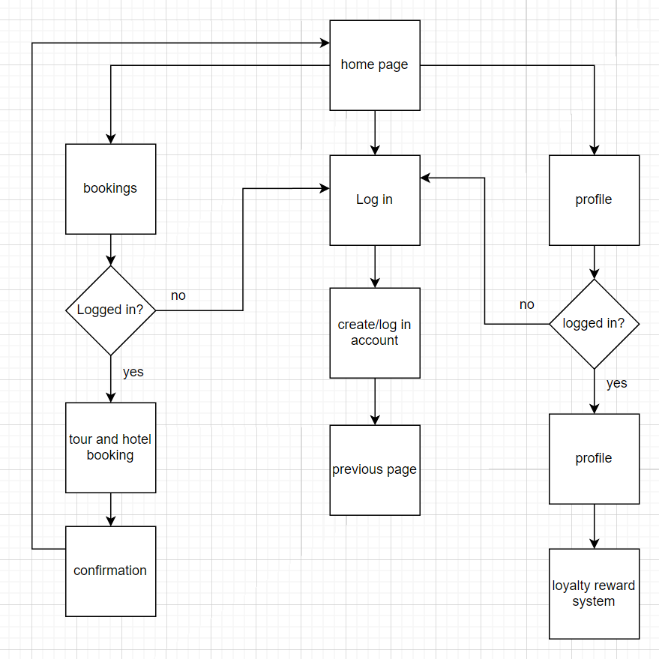

Algorithms

User account system log in/register
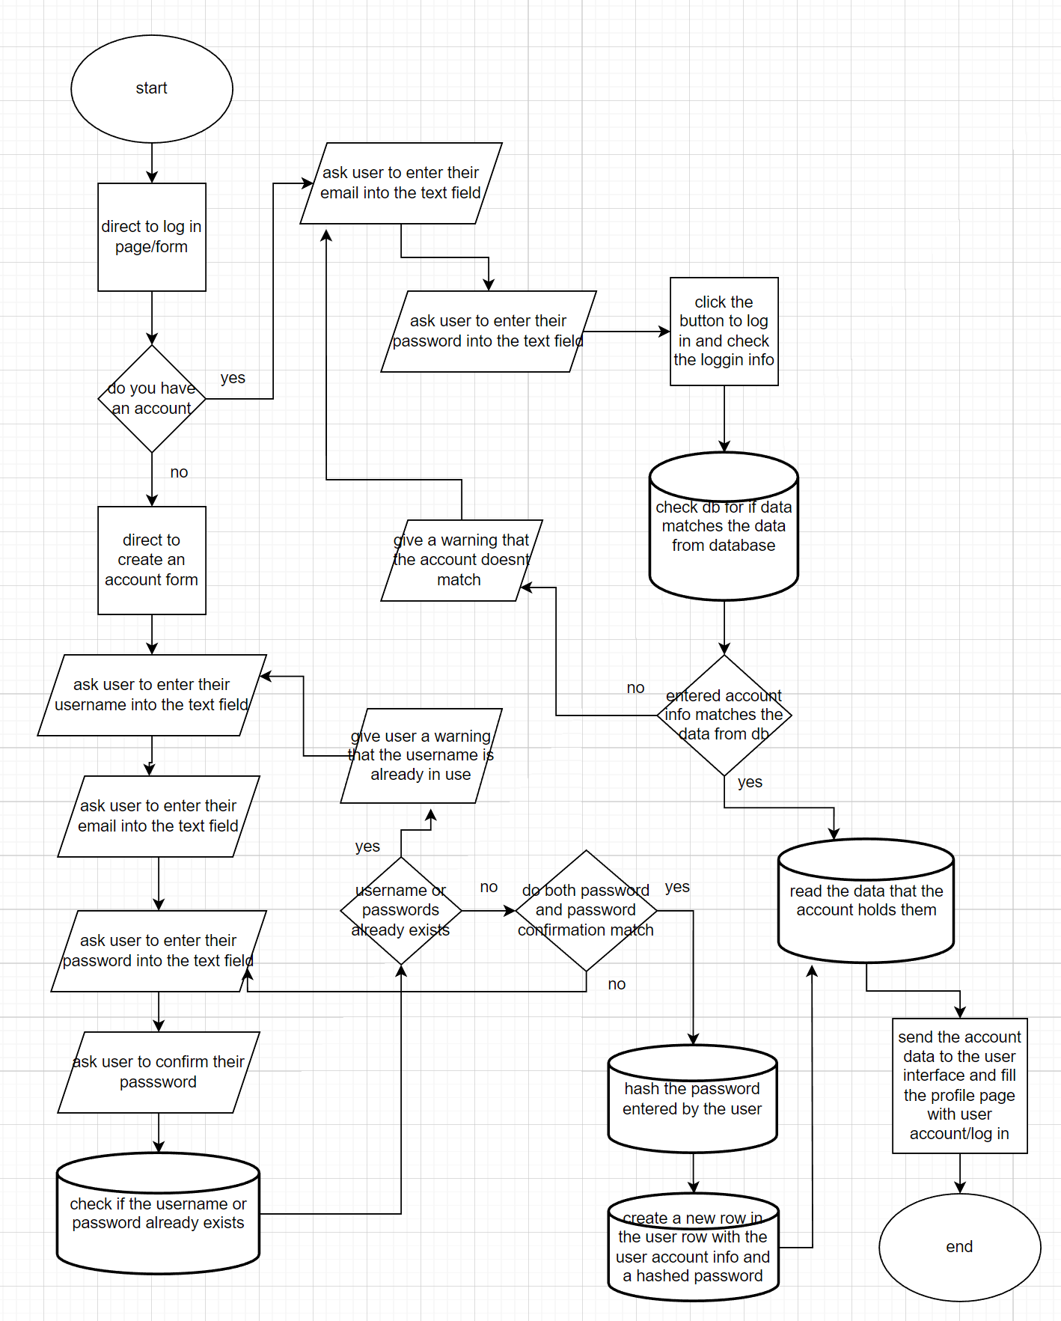
This diagram represents how the user will log in or register to an account using their info, in both cases the system uses the same database to access or create an account.

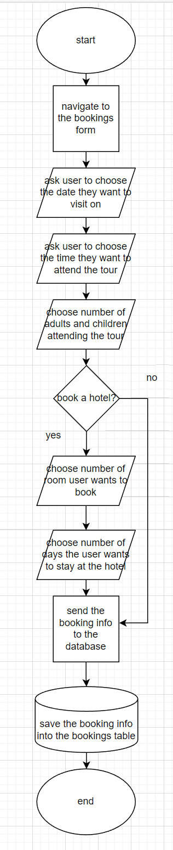
This flow chart shows how the app will collect the booking info from the user and store it in the database

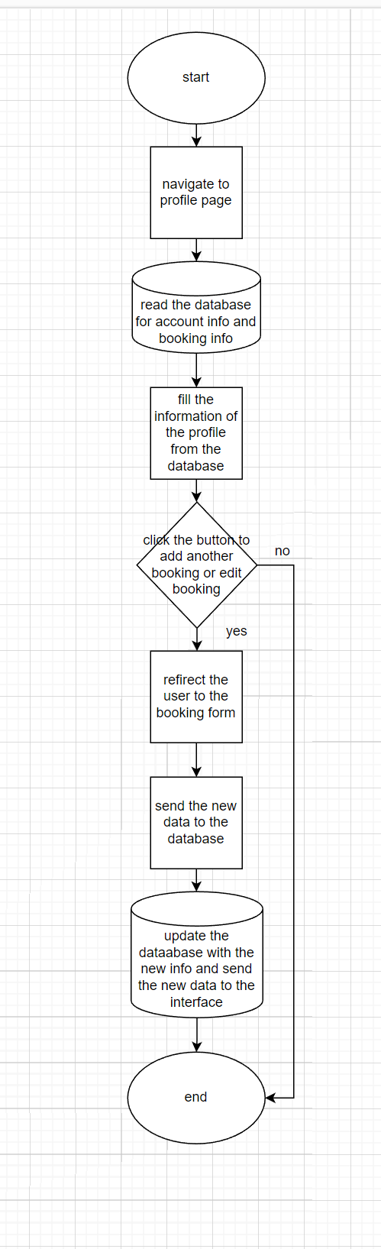
This flow chart shows how the user can manage their booking from the profile page

Test Plan

Test to be carried out | requirements
When signing up with incorrect username or password should result into an error | Access to the app  Compute  Incorrect username or password
When signing up with a correct username or password the app should log in the user | Access to the app  Compute  Correct username or password
When signing up entering if the confirmed password field does not match the password it  will result in an error | Access to the app  Computer  Incorrect confirm password input
When logging in if the username and password are correct the user will be redirected to the previous page before log in/sign up | Access to the app  Computer  Correct username: ‘Test123’  Correct password ‘admin’
When a button linking to a different page in the
dashboard is clicked the user will be redirected to that page

