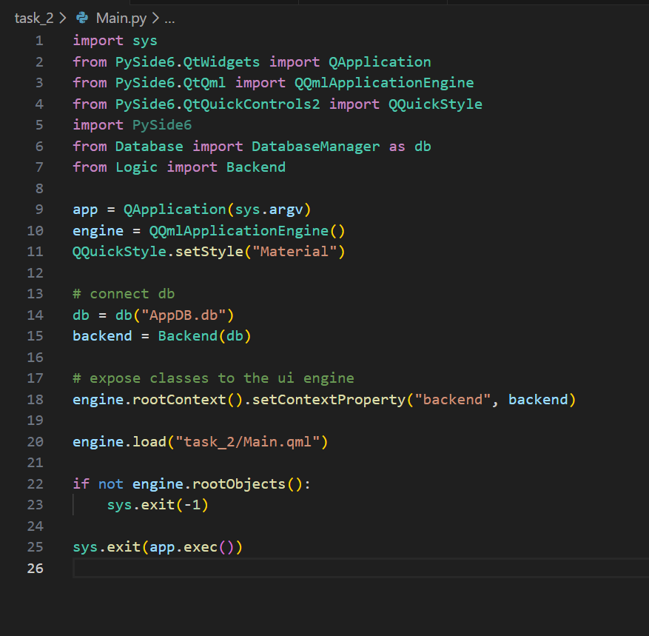
Have used inbuild material style to make the development easier

Create a single database and pass it to the back end side

Pass the back end class to the ui so the ui can use database functionalities

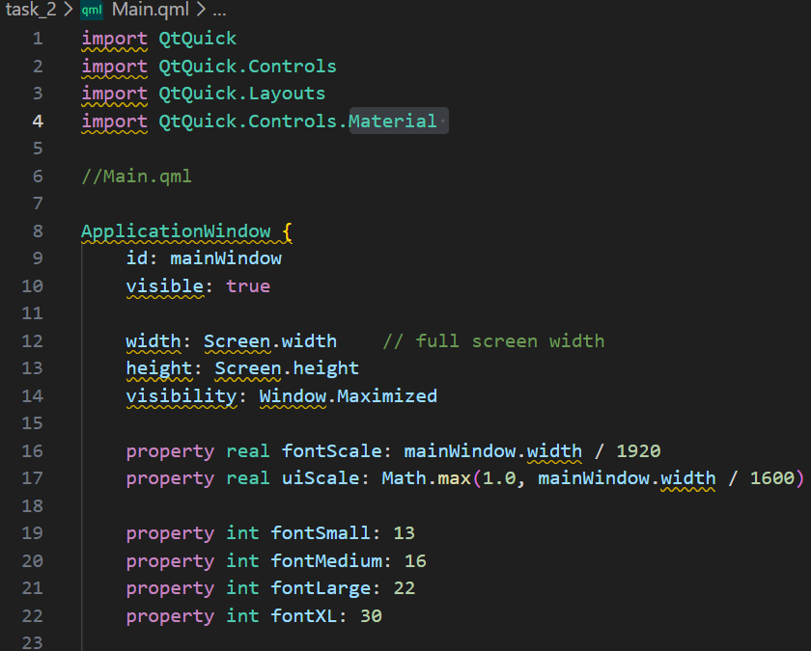
initialise the main window

create a scale for the font size so the font can look consistent compared to the screen size

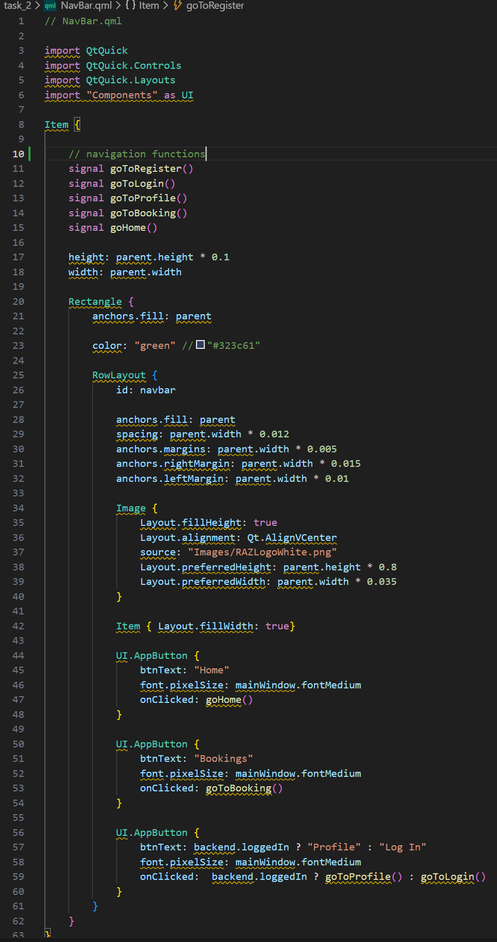
the navigation bar file

create the navigation signals for the buttons

set the main colour of the nav bar

set the logo

create the pre created buttons and connect them to the signals

change the button text and signal depending if the user is logged in or not

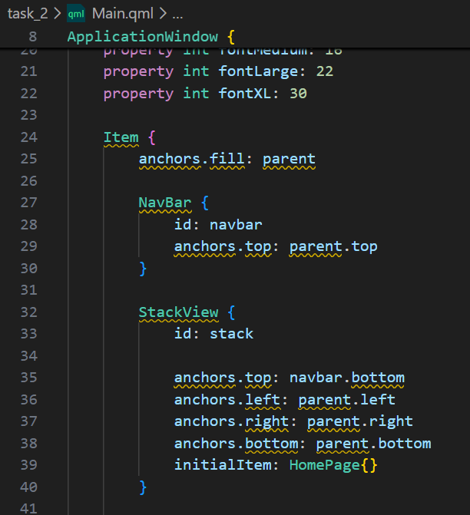
.

Initialise the nav bar in the main window at the top of the screen

Initialise the function to manage the navigation system

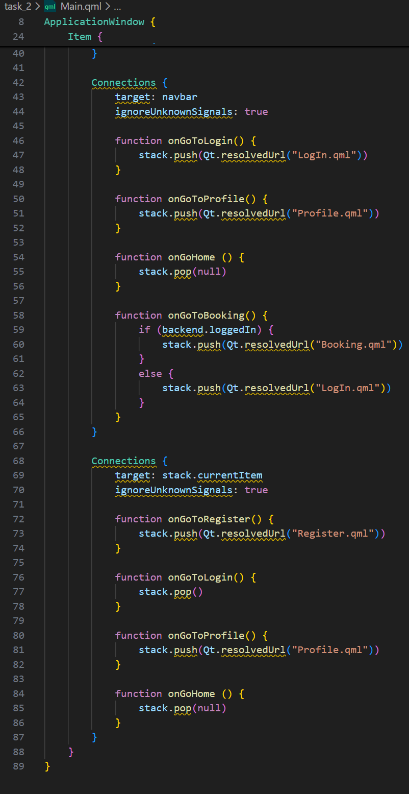 create the signals for the navigation across the app including outside the nav bar like cancel from the login form

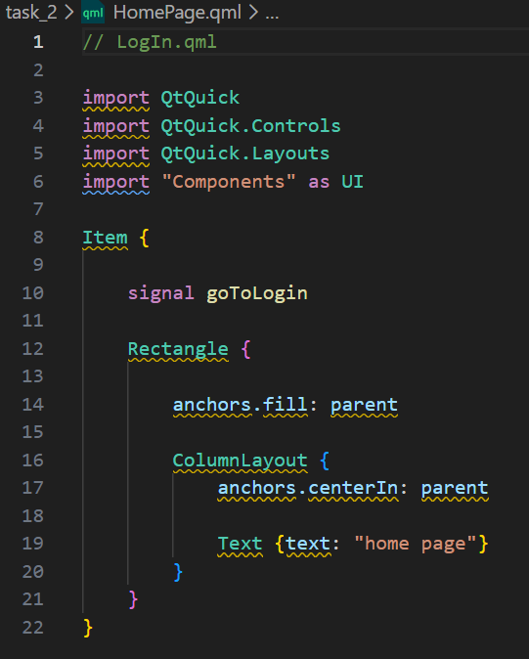
Home page is currently a place holder for the zoo info and only has text saying “home page”

Have created reusable components to avoid repetitions and make the code simpler
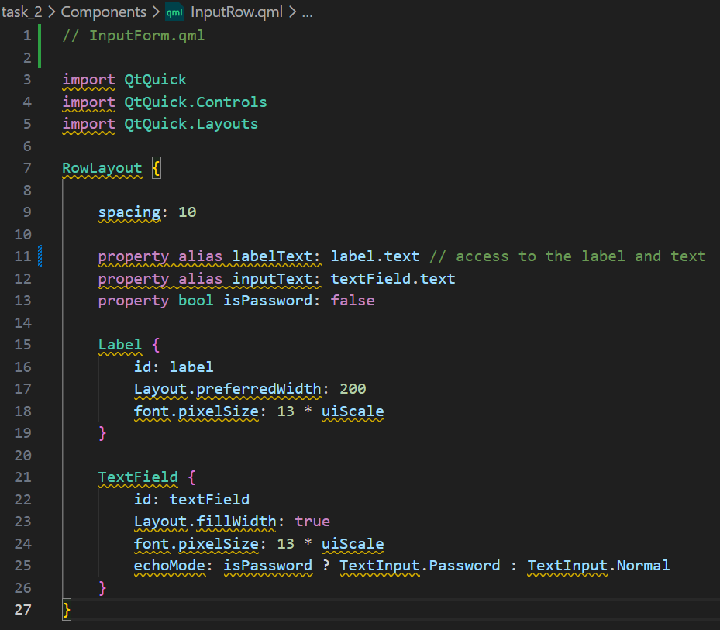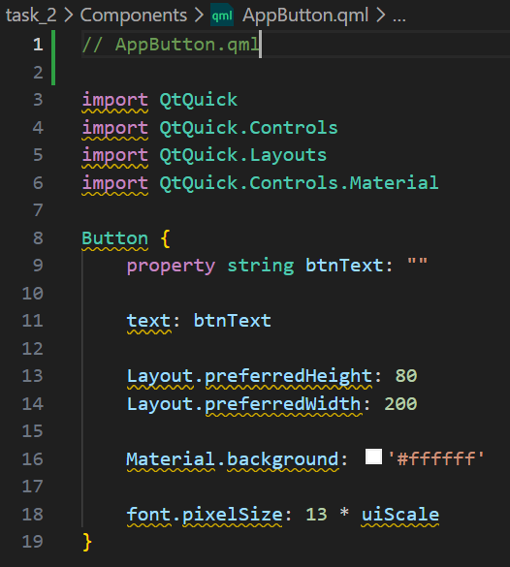

As well as a form frame to use it as a reusable frame for forms such as login and booking
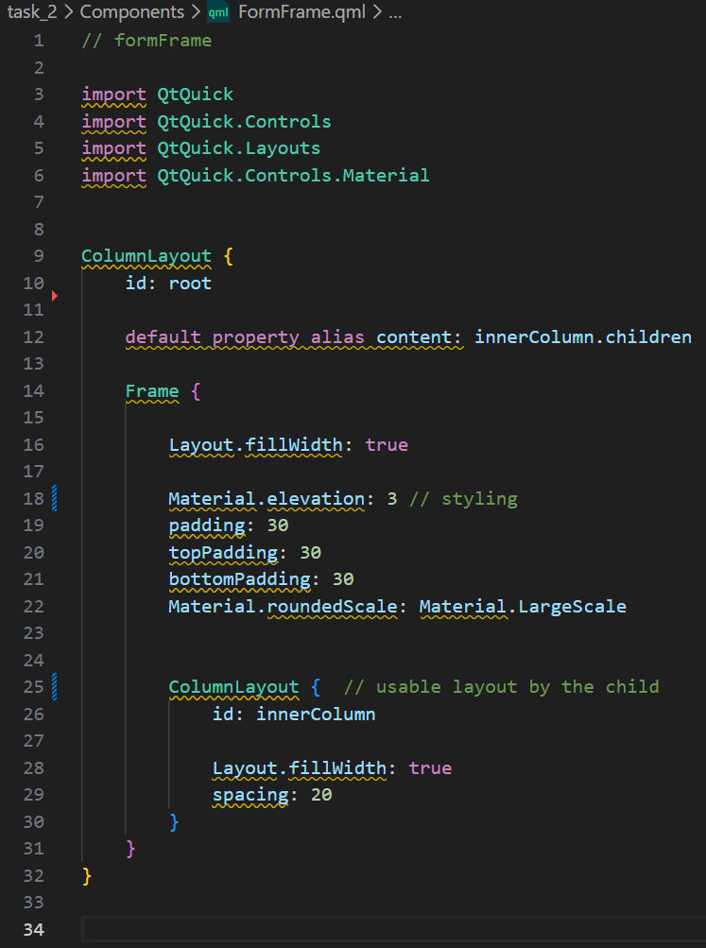

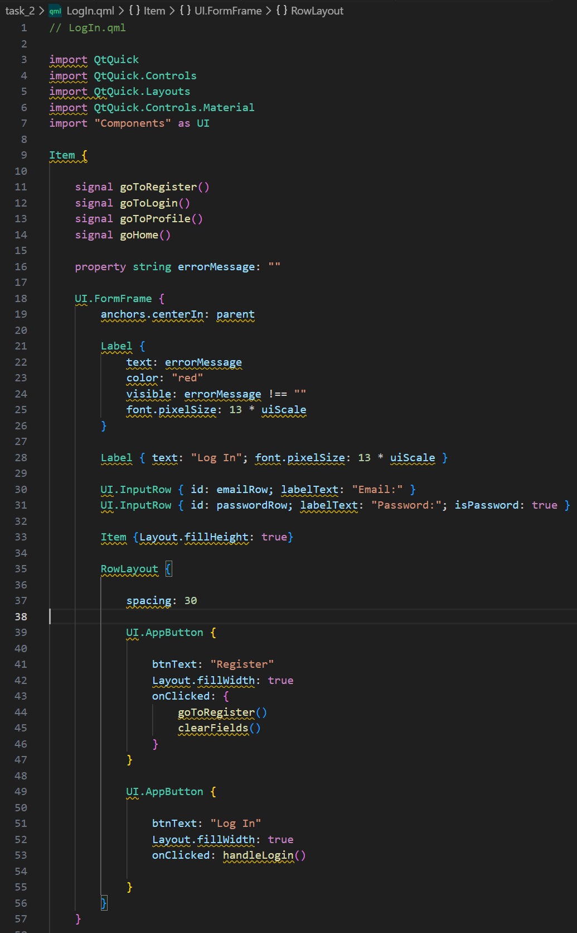
Define the signals for the navigation

Error message

