Occupational Specialism Task 1 – Proposal
Activity A (ii)
Business context:
Riget Zoo Adventures want to create a website for their zoo to attract more customers and present their services to a bigger audience. RAZ want to allow their customers to register and book their attractions and potentially their onsite hotel. RAZ want the website to provide help and information about attractions and facilities, provide materials to support educational visits. The website will be primarily used so the customers can book the tickets for the zoo and book the onsite hotel. Also, the website should have a loyalty reward scheme to reward the frequent customers.
RAZ want to make sure the website attracts as much new customers as possible by making the website simple and accessible to allow even non-technical people to use it, this can be accomplished by designing the website with the minimal design and bright colour contrast to separate the interactable user interface with non-interactable user interface for example buttons.

Description of the proposed solution:
I will be developing a solution for Riget Zoo Adventures (RZA), the solution will be an easy to navigate desktop that will inform the user of the zoo attractions and show what they can experience while visiting the zoo. The user will be able to book tickets and hotel once they are logged in signed up, this allows user to see what they can experience before creating an account and viewing the booking availability. The Desktop will be developed using python for the main back end, QML library for the main user interface and SQLite database for storing data such as accounts info, bookings and bookings history.
Upon opening the app, the user will be greeted with a home page where they can browse through the page to see all of the different attractions and experiences available. The user can navigate through the website to access options like bookings and profile using a navigation bar at the top of the app that consists of buttons that will redirect to the said page. Logging in or creating an account will open access to ticket bookings and hotel availability as well as the user’s profile. The user profile will contain the information about the account such as existing bookings and the bookings history for the loyalty system. The profile page will also have settings option that will let them access the accessibility options as the RZA has required.
I was inspired by Whipsnade Zoo to place all of the zoo and tour information at the home page of the app without the user needing to register or log in. This will allow the user to get fully informed on the tour, the page will be used as a greeting main page where the users will be able to see it even if they aren’t logged in or haven’t created their account. The attractions on the main page will interactable and they will be working as a button so when the user clicks on them, they can expand the text to show more information about the attraction. The attractions will include the offers that RZA have provide such as safari-style wildlife, on-site hotel, educational visits options and additional information on the facilities.
Next RZA has requested a way to manage their bookings and account registration, to achieve this I will develop an account system where the user will be able to log in/create an account which will give access to bookings availability for tours and hotel, as well as the profile page of the user which will have all of the information about the account such as personal info and upcoming tours that the user has booked. The profile page will allow the user to view their bookings and possibly make changes. This will allow the user to always see their bookings as well as be informed through notifications which will remind the user of their booking. The profile page will also contain the loyalty reward system which will store the history of the users visits and will give various of discounts and perks depending on the past visits.

Functional and non-functional requirements:
Functional Requirements
No. | Features | Justification | Priority
1 | Display the attractions and services the zoo provides on the main page of the app | Allows the user to see the experience they can have before creating the account | High
2 | All the users need to create an account or log in to make a booking | Lets only registered users make a booking with all the relevant information | High
3 | Allow registered/logged in users to see availability and book tours | Lets only logged in user see tours availability and book the tour | High
4 | Allow registered/logged in users to see availability and book the on-site hotel | Lets only logged in user see hotel availability and book a time period | High
5 | Show the booking history to the user | User will be able to see the history and track their loyalty system | High

Non-Functional Requirements
No. | Features | Justification | Priority
1 | The app should be available all the time | Users will be able to access the app all the time allowing easier booking for people who are busy | High
2 | All of the navigation to be centred at the top of the app across the app | This would allow easy navigation across the app and give more accessibility | High
3 | Scale the sizing of the app based of the resolution and size of the screen | Allows people with any screens to easily use the app including mobile | High
4 | Write code in a consistent variable style | Makes the code base more maintainable and scalable for other developers to work on | Medium
5 | Have security on users accounts including their passwords | Increased security will hold the users info more securely from hackers and breaches | High

Decomposition of the problems that need to be solved:
I have decided to implement the app using python as my main back-end language and the QML python library to create the front end for it, also I will be using SQLite to create and manage the database for the app. I have decided to use these languages as they allow me to create the app as a desktop or mobile app which the user can easily download, by creating a desktop app I can focus purely on developing the app and meeting the client’s requirements, this will make the developing easier and faster as I will have the full control over the developing process and if something won’t work, I will be able to easily identify the problem. The QML library allows an easy front end developing process as it has a lot of prebuilt UI components which has can drastically reduce the developing time. For the database I will be using an SQLite database which lets me create a light weight file-based database, this kind of database requires minimal set up and is light on the system so the data can be uploaded and extracted very fast so the app will respond instantly.

KPIs (Key Performance Indicators):
Key-Performance Indicators | Justification
Number of people to create an account compared to number of people to visit the website | This will show the amount of people that visit the app without registering an account showing the interest people have over the services the website provides
Amount of time people spend on the website on average | This will show how interested the person is in the app and services and this will allow to understand what part of the website is the most poplar
Which pages of the app get the highest number of visits | This will show what part of the app people are the most interested in
How many new users create an account in the app | This will show how many new people are creating accounts to see if the app is still attracting new users and customers

Risks and Risk Mitigation:
Threat | Solution | Justification
Forgotten login information | Add a forgot password button to allow the user to reset their password | This will allow the user to reset their password and be able to access their account again
Multiple users having the same login or username | When signing up the system will check against the database and will not allow to create duplicates | This will prevent the users from creating duplicate accounts in the first place
SQL Injection | Check all of the inputs before sending it to the database | This prevents users to manipulate the back end without having the authorised access
Phishing attacks | Hash all the passwords before they reach the database so the database only holds hashed password and it is not possible to decrypt it | This allows only the people that know the password to log in

Activity A (i)
Research

London Zoo
In order to start designing the solution for the Riget Zoo Adventures (RAZ) I will carry out research for similar apps to understand the quality that they require, and it will be useful to compare against other apps that have already been developed so I can recognise the patterns between them and make sure the features of the app are up to date with the market and modern practises. London Zoo is the first web app I looked at, who are focused on providing accessible tours around their zoo.
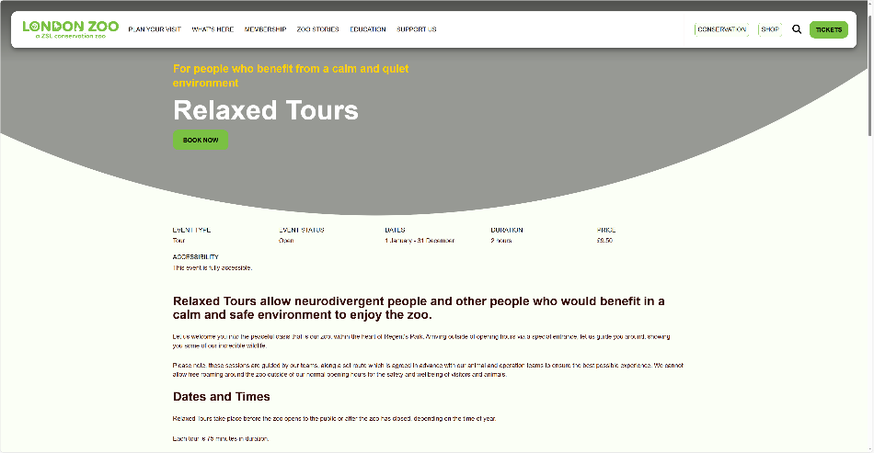
London Zoo are making booking easy by providing a easy to see button to book on the home page of the website, which then provides a easy to use calendar to pick from the available dates.

The home page also provides lots of information about the tour itself which informs the person about the tour like dates prices and accessibility.

Whipsnade Zoo
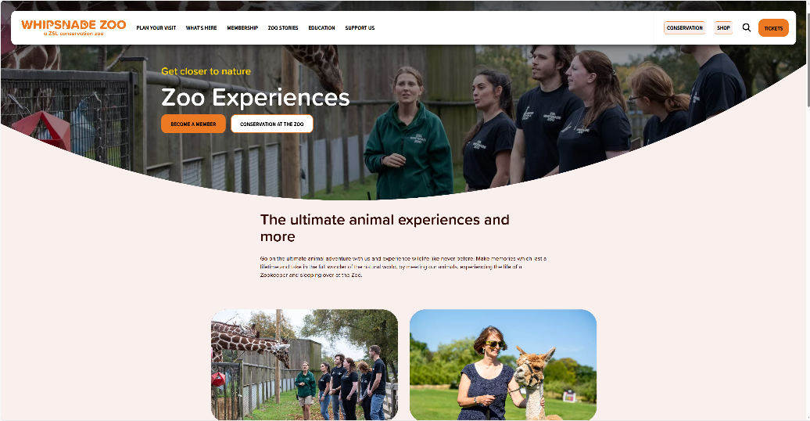
Whipsnade Zoo is a website made to inform users more about their zoo and let people book a tour at their zoo. This app is a great example of presenting the services and activities that the centre provides and gives a good idea on what to expect from visiting.
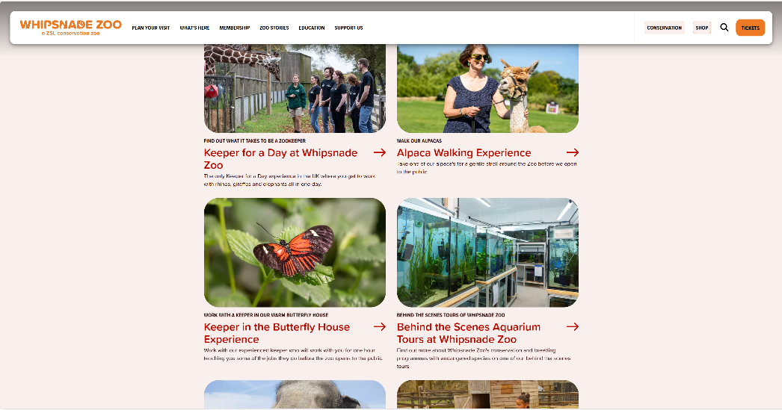

This website has neatly laid out the experienced that a tourist can have while visiting the zoo with a brief summary of that experience which shows even more information including availability if clicked on the service, this allows the user to see the full list of experiences they could have without doing a lot of research which reduces possible frustration in attempt to find more info about a zoo or a tour.

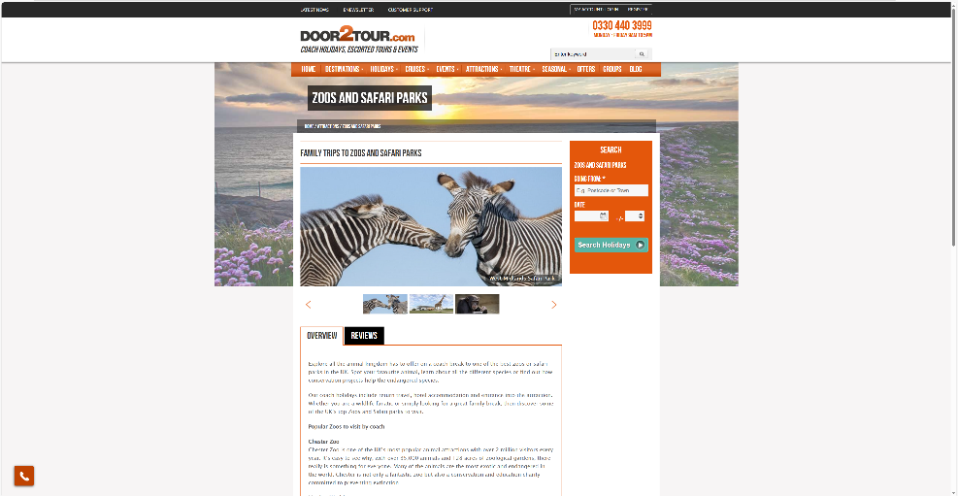
Door2Tour
Door2Tour is another example of a zoo website to show people of their different services that they provide. A great thing about this website is that it has most of the information and options on the home page which can be useful, but in this specific example, the old design is making it look cluttered and busy. This can cause overwhelming for a new user that can get lost looking for a thing they need. A simpler and more minimalistic design could help reduce the clutter of the home page while still keeping the amount of information this way the user won’t get lost as easily and would be able to find the information they need

