TEST PROJECT   
IT SOFTWARE SOLUTIONS   
FOR BUSINESS

module 3

WSC2017_TP09_M3_actual

Submitted by:

WorldSkills International   
Independent Test Project Design Team

## Contents

This Test Project proposal consists of the following documentation/files:

1. WSC2017_TP09_S3_EN.pdf (Session 3 instructions)
2. Session3-MySQL.sql (SQL Script to create tables with data for MySQL)
3. Session3-MsSQL.sql (SQL Script to create tables with data for Microsoft SQL)

## Introduction

As part of their automation system, AMONIC Airlines is asking to implement a ticketing system to operate out of their offices. To reserve a ticket with AMONIC Airlines, the would-be passengers can either call one of the airlines’ offices or walk into one of their locations and provide the required details.

The following are the main functionalities of the session:

* Search for flights and find the flight to fit the needs of the passengers.
* Issue tickets based on the details provided by the client.

## Description of project and tasks

In submitting your solution, please make sure the deliverables conform to the basic guidelines drawn out by different departments at AMONIC Airlines:

* There should be consistency in using the provided style guide throughout development.
* All required software modules must have applicable and useful validation and error messages as expected by the industry.
* Where applicable, use comments in code to have the code more programmer-readable.
* The use of valid and proper naming conventions is expected in all material submitted.
* Any form or report once created should be displayed in the centre of the screen.
* When a form or a dialogue is in focus, operations on other forms need to be suspended.
* The caption of Delete and Cancel buttons need to be in red to help with accidental mishaps.
* When using colours to differentiate between rows or records, there needs to be visible clarification on the screen as to what they stand for.
* The wireframe diagrams provided as part of this document are only suggestions and the solution produced does not have to be, in any way, mirror what has been pictured.
* Time management is critical to the success of any project and so it is expected of all deliverables to be complete and operational upon delivery.

## Instructions to the Competitor

### 3.1 CreatING the database

Create a database by the name of “Session3” in your desired RDBMS Platform (MySQL or Microsoft SQL Server). This will be the main and only database you will use in this session.

### 3.2 ImportING database structure

Depending on your preferred RDBMS platform, a SQL scripts is made available. The said scripts consists of the database structure and data required to complete the required tasks. The data needs to be imported to the database created for this session named “Session3”.

As instructed by the designers, the database structure provided for the purpose of this section cannot be altered. This applies to removal of tables, adding or deleting any fields on the tables or of change in their data types.

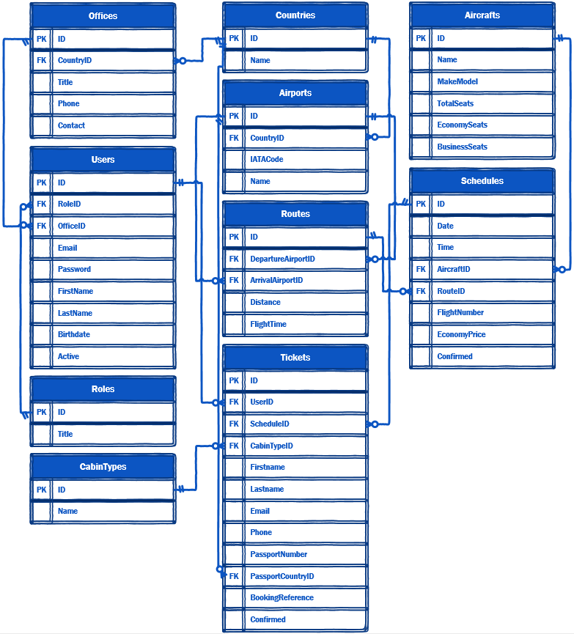

To help further perceive the thinking behind the structure of the database, the database designers provide an Entity-Relationship Diagram (ERD). The aforementioned diagram explains the conceptual and representational model of data used in the database.

### 

### 3.3 Searching for flights

In order to book a flight, the system operator needs to find out if there are flights on schedule for that the passenger needs.

In order to find the correct flight, the operator can fill in some or all of the following parameters:

* The departure and arrival airports combo boxes must be put on the form that list the airports we have services to.
* The outbound date is required. Should the passenger choose to get return tickets, they can then choose a return date as well.
* There is an option for when the passenger gets to choose either tickets for a one-way booking or return tickets as part of the booking as well. The return tickets need to have the same departure and arrival airports but in reverse. The return flight can only be booked for dates after that of the outbound tickets.
* Cabin type, which affects the price of the ticket, needs to be included as a parameter in the form of a combo box. The default cabin type is set to “Economy”.

Once the flight criterion is set, a list (two lists if the user asks for return flights) will be shown which are characterized as follows:

* The list with the outbound flights needs to be on the screen at all times even if there are no results. The list corresponding to return flights will only be shown to the user when the user chooses to book a return flight.
* By using a checkmark above each of the lists, the user can choose to have the booking system look for flight three days before and after the specified date. This is to eliminate to need to have to search multiple times to find similar results.
* The items on the list include the departure airport (From), arrival airport (To), date and time of departure, flight number or flight numbers if there are stops on the way.
* The price of business class seats has 35% premium over economy and first class flights are 30% more expensive than those of business class seats. In case you do not come up with rounded numbers you can round the numbers down to their nearest whole number.

Upon selecting the flight or flights, the user will confirm the number of passengers that want to book the same path and confirm their booking. The system will then look to see if there are enough seats on the picked flights for the passengers. If so, they will be able to proceed to the booking confirmation form.

Please consider the following in order to better understand how the booking system behaves:

* AMONIC Airlines has limited flights to destinations in its region of operation. At times, passengers might want to book flights that the airline does not have direct flights to.

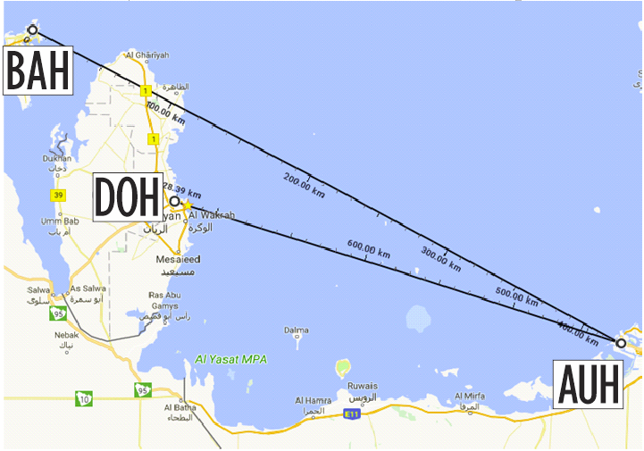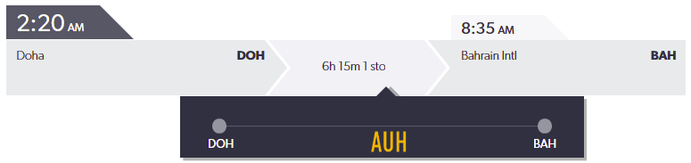

* Consider the flight on the picture above. Since we do not have a direct flight from Doha to Bahrain, we offer our passengers the DOH-AUH-BAH route indirectly through Abu Dhabi (our main hub). Your system should be able to find and offer booking based on all routes available.

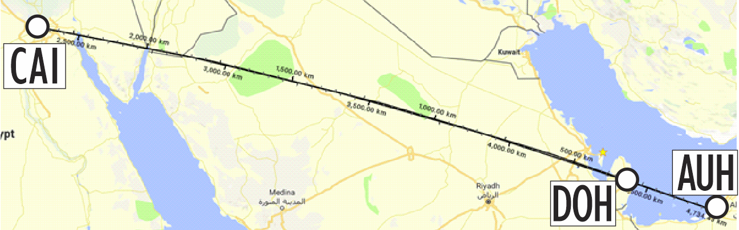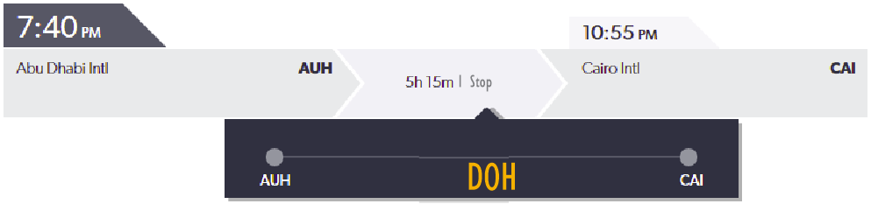

* Airlines around the world depending on their routes and how well they are received, can choose to have stopovers. This will help with the costs and make the routes and flights financially viable. They are called indirect flights.   
  As shown above, the AUH-CAI route on its own has not attracted as much interest to warrant for as many flights but when we do have a stop in Doha, we can offer our services to AUH-DOH flyers as well as people who want to fly DOH-CAI. To summarize, our booking system in these situations will offer the route AUH-CAI but in order to do so, it will issue two tickets for the routes AUH-DOH and DOH-CAI. Of course we do still have direct flights on that same route on some days of the week as well.

### 

### 3.4 Booking confirmation

Once the flights for the booking have been selected, the booking confirmation form appears where the operator can enter details of the passengers flying on the booking.

This form should include the following:

* Details of the flight or flights for both the outbound flight and the return flights.
  + If there’s no return flight selected then there’s no need to show return flight information.
  + If there are multiple flights for outbound or return flights, those information need to be displayed as well.
* Passenger information to add booking for:
  + The fields required to add someone are first name, last name, birthdate, passport number, passport country, and phone number.
  + The passport country should be a combo box listing all the countries in the database.
  + Entering all passenger information requested are mandatory to register a booking.
* By clicking a button to add booking for the passenger, their details needs to be added to a list. The user then cannot edit any of the records but they can remove them by using a remove button.
* When the details are finalized, the “Confirm booking” button will take the user to the billing confirmation dialogue.

### 

### 3.5 Billing Confirmation

At the end of the process, the user needs to confirm that they have received the total amount. The details of what this form needs to have are the following:

* Calculate the total amount payable, which is the sum of the total price of all the tickets that are going to be issued as part of this booking.
* The ability to choose between credit card, cash or voucher as payment method. This information will not be stored anywhere at this phase of the solution.
* The confirmation button which is labelled as issue tickets in the picture above will in turn issue all the tickets and store them in the database:
  + For every passenger on each flight, a correspondent record needs to be stored in the database.
  + To differentiate between each booking, which consists of one or a number of flights for every person, booking reference is actively used in the industry. Booking reference is a string made of six alphanumerical characters. This string of characters needs to be unique and cannot be shared between bookings.
  + When issuing multiple tickets for a single booking, a booking reference number is generated and set on all the tickets.
* The cancel button will close this form and return the user to booking confirmation.