?????
?? ????????????? ??????? ?1
??????? ???????? ?????? ? ??????? ?????????? ????????

???????: ???????? ????????? ????????
??????: J3300
??????????? ???????: https://github.com/Vladislavim/Engine_AID

2026 ?.

1. ???? ? ?????????? ??????
???? ?????? ? ??????? ??????????? ??????? ?????? ???????? ?????? ? ?????????? ???????? ????? ? ???????????? ???????????? ?????? ????? ??????? ??????????.
? ?????? ????????????? ??????? ??????????? ??????????? ????? Application, ??????? ????????? ????, ?????? deltaTime, ??????? ???????????, ????????? RenderAdapter ? ????????? ????????? ?????????. ????????????? ????????? ????????? ????? ? ?????????? ? ???? ??? ?????????? ???????? ? ?????? deltaTime.
????????????? ????????????????:
- ?????????????, ?????? ? ?????????? ?????????? (????? Application);
- ??????? ??????? ???? ? ???????? deltaTime ????? std::chrono;
- ??????? ?????????: Loading, Menu, Gameplay;
- ??????????? ??????? ? ???????? deltaTime ? ??????? ? ???? logs/app.log;
- ??????? ??????? (IRenderAdapter) ? ?????????? ?? ???? raylib;
- ????????? ????????? ????????? (???????) ? ????;
- ?????????? ????????: ???????, ??? (???????), ??? (???????), Esc/Enter/1/2/3 ??? ?????????.
2. ???????? ????? ??????????? ???????
?????? ???????? ?? ????????? ???????. ????? Application ????????? ????????? ?????? ????????? ? ??????? ??????. ??????? ????????? ???????? ????????? ????????? ??????? (????????, ????, ??????? ?????). ????????? ????? ?? ??????????? IRenderAdapter, ??? ????????? ???????? ??????????? ?????????? ??? ????????? ???????? ??????. ????????? ?????? Logger ???????? ?? ??????????????, ? InputController ? ?? ????????? ????? ? ????????? ?????????? ?????????.
???????? ?????? ???????:
- src/core/Application.* ? ?????????????, ??????? ????, ????? ?????????, ?????????? ??????;
- src/core/GameState.h ? src/core/States.* ? ??????? ????????? ????????? ? ?????????? ?????????;
- src/core/Logger.* ? ??????????? ? ??????? ? ????;
- src/render/IRenderAdapter.h ? ????????? ?????????;
- src/render/RaylibRenderAdapter.* ? ?????????? ???????? ?? raylib;
- src/game/InputController.* ? ????????? ??????????/???? ? ??????? ????????? ?????????? ???????.
3. ???????? ???????? ???????? ?????? ????
??????? 1. ????????? ???????? ??????????
????: src/render/IRenderAdapter.h
class IRenderAdapter {
public:
virtual ~IRenderAdapter() = default;
virtual bool initialize(int width, int height, const std::string& title) = 0;
virtual bool windowShouldClose() const = 0;
virtual InputFrame pollInput() = 0;
virtual WindowSize getWindowSize() const = 0;
virtual void beginFrame(const ColorRGBA& clearColor) = 0;
virtual void drawPrimitive(const PrimitiveTransform& transform, const ColorRGBA& color) = 0;
virtual void drawTextLine(const std::string& text, int x, int y, int fontSize, const ColorRGBA& color) = 0;
virtual void endFrame() = 0;
virtual void shutdown() = 0;
};
??????? 2. ??????? ??????? ???? ? ?????? deltaTime
????: src/core/Application.cpp
while (running_ && !renderer_->windowShouldClose()) {
const auto now = std::chrono::steady_clock::now();
const std::chrono::duration<double> dtDuration = now - lastFrameTime_;
lastFrameTime_ = now;
double dt = dtDuration.count();
if (dt > 0.25) dt = 0.25;
dtLogTimer_ += dt;
if (dtLogTimer_ >= 0.5) {
std::ostringstream ss;
ss << std::fixed << std::setprecision(4) << "deltaTime=" << dt;
Logger::instance().info(ss.str());
dtLogTimer_ = 0.0;
}
const InputFrame input = renderer_->pollInput();
scene_.windowSize = renderer_->getWindowSize();
handleGlobalStateSwitch(input);
if (state_) {
if (auto next = state_->update(dt, input, scene_); next.has_value()) {
changeState(*next);
}
}
renderer_->beginFrame(clearColorForState());
if (state_) state_->render(*renderer_, scene_);
renderer_->endFrame();
}
??????? 3. ????????? ????? ? ?????? deltaTime
????: src/game/InputController.cpp
void InputController::updateFromInput(const InputFrame& input, double dt,
PrimitiveTransform& transform, WindowSize windowSize) {
if (input.mouseLeftPressed) {
scaleAroundCenter(transform, windowSize, 1.08f);
}
handleMouseActions(input);
const float moveSpeed = 240.0f;
const float moveStep = static_cast<float>(dt) * moveSpeed;
if (input.up) transform.position.y -= moveStep;
if (input.down) transform.position.y += moveStep;
if (input.left) transform.position.x -= moveStep;
if (input.right) transform.position.x += moveStep;
const float sLerp = std::min(1.0f, static_cast<float>(dt) * 8.0f);
const float rLerp = std::min(1.0f, static_cast<float>(dt) * 10.0f);
transform.scale += (targetScale_ - transform.scale) * sLerp;
transform.rotationDeg += (targetRotation_ - transform.rotationDeg) * rLerp;
}

4. ????????? ???????? ??????????
???? ????????? ????????? ??????????? ?????????? ? ???? ? ??????? ???????.
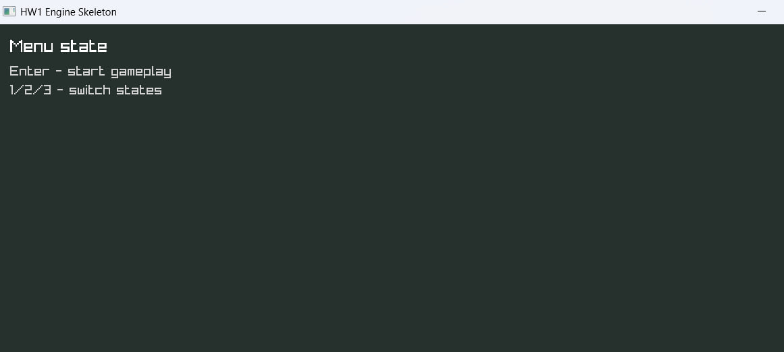
??????? 1 ? ????????? ???? ??????????.
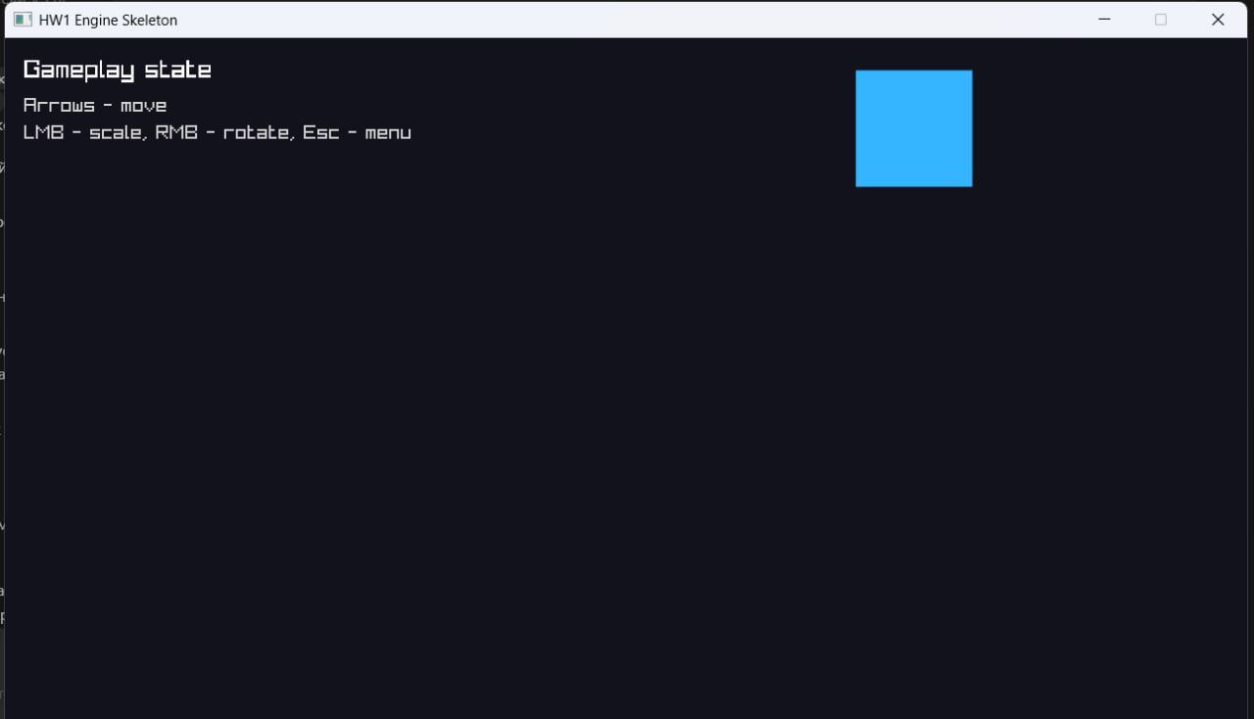
??????? 2 ? ????????? Gameplay ? ???????? ?????????? (?????????).
5. ???????? ?????????????????
? ???? ???????? ?????????????? ?????? ????, ???????? ????? ???????????, ????????? ????????? ? ????????? ?????. ?????????? ????????? ? ???????? ???? ???????? ?????????, ??????????? ? ????????? ?????????? ??????? ??????????? ?????? ????????? ????????????? deltaTime.
????????????? ???????? ????? ????????? ?????????? ? ??????? ? ?????? ??????? ? ???? logs/app.log.
6. ??????
? ?????????? ?????????? ????????????? ??????? ?????????? ??????????? ?????? ???????? ??????, ????????? ??? ??????????? ??????????. ??????? ??????? ??????????? ?????????? ? ??????????? ?? ?????? (Application, ?????????, ??????-???????, ???????????, ????), ?????????? ??????? ???? ? ???????? deltaTime ? ?????????? ????????? ??????? ? ??????????? ????.
?????????????? ??????? ?? ????? ? ?????????? ? ???? ????? ?????????.
7. ?????????? ? ??????
- ??????????? ? ???????? ?????: https://github.com/Vladislavim/Engine_AID
- ???????????????? ???? ??????: CMakeLists.txt
- ????????? ??????????: docs/screenshots/menu.jpg, docs/screenshots/gameplay.jpg
- ???? ?????? ? ??????? DOCX ? PDF ? ????? docs/

