# Digital Signal Processing

## Lab 1: Basics of Signals

Vladislav Paškevitš

### Exercise 1

Plot the sequence for Ui [n], do the same for Us[n] and Ur[n] when the appropriate exercises have been completed.

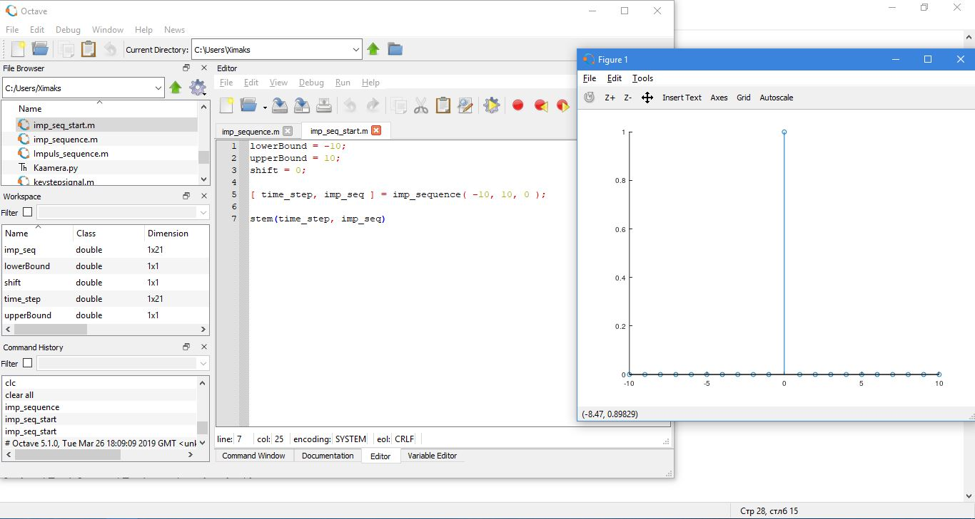

Figure 1 Ui[n]

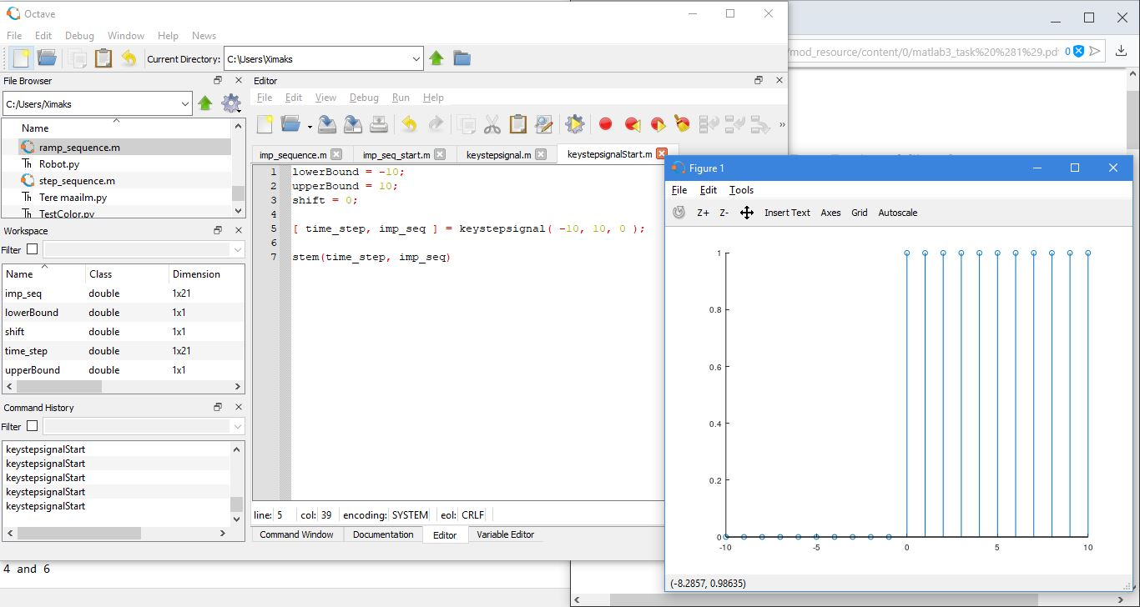

Figure 2 Us[n]

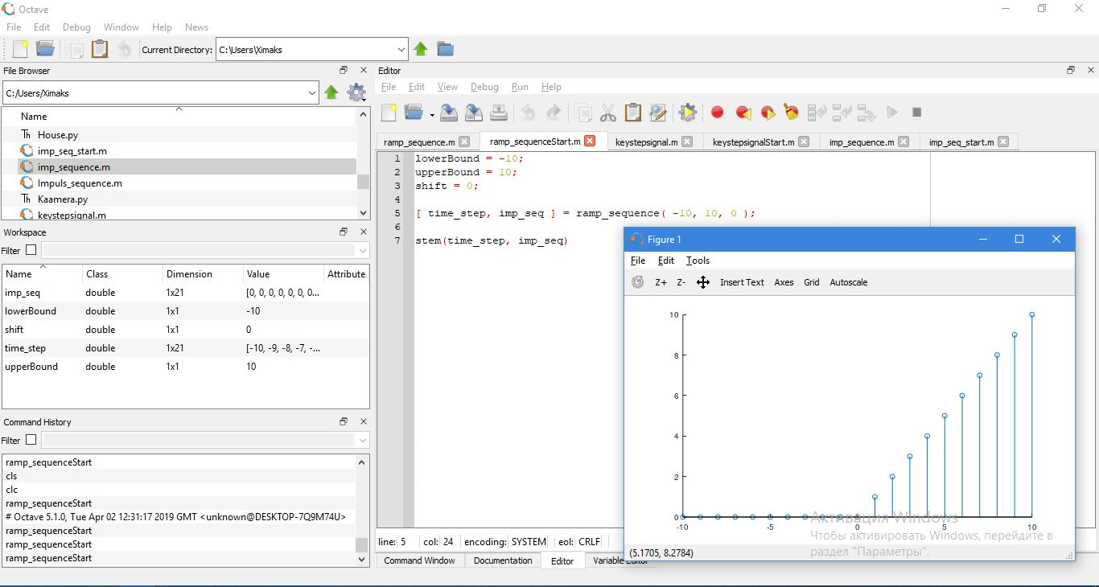

Figure 3 Ur[n]

### Exercise 2

Plot the following sequences, where −20 ≤ n ≤ 20, n ⊂ Z

1. w[n] = 2Ui [n] − Ui [n + 1] − Ui [n − 1]
2. q[n] = 2sin[ π 20n]

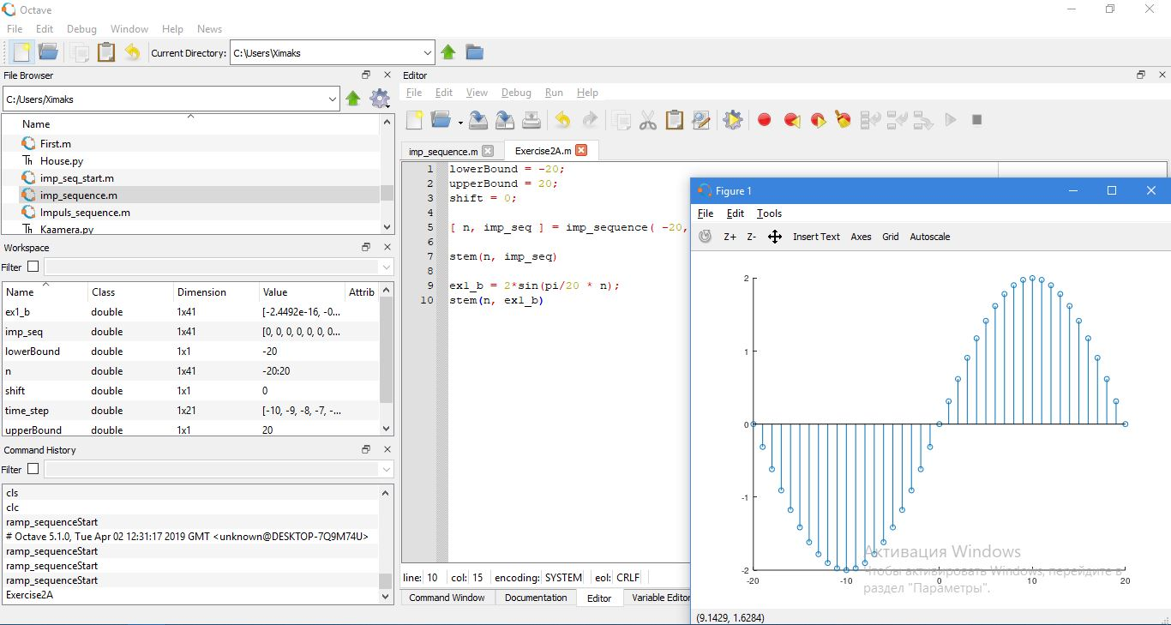

Figure 4 Exercise 2 ( B )

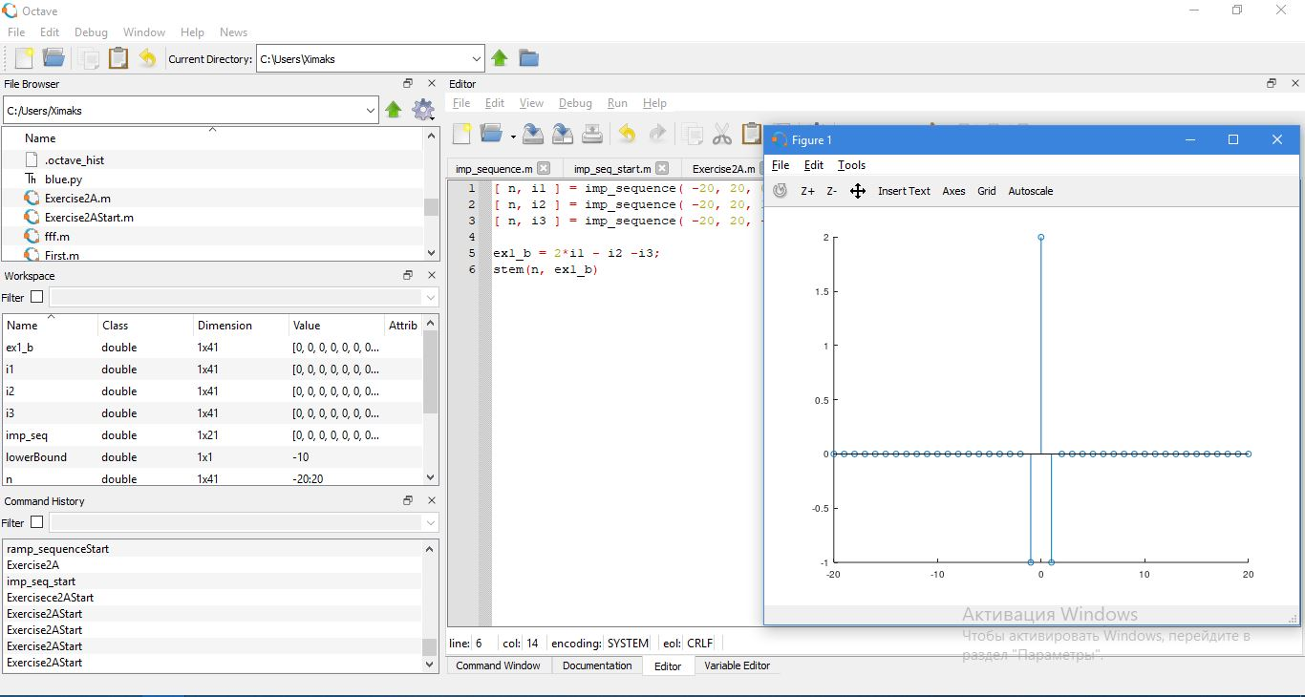

Figure 5 Exercise 2 ( A )

### Exercise 3

Write function to represent unit step sequence Us[n]. You may use the example for unit impulse sequence Ui [n] as a reference



Figure 6 Us[n]

### Exercise 4

Plot the following sequences, where −20 ≤ n ≤ 20, n ⊂ Z

1. x[n] = Us[n] − 2Us[n − 1] + Us[n − 4]
2. y[n] = Ui [n + 1] − Ui [n] + Us[n + 1] − Us[n − 2]
3. q[n] = − 1/ 2 n Us[n]

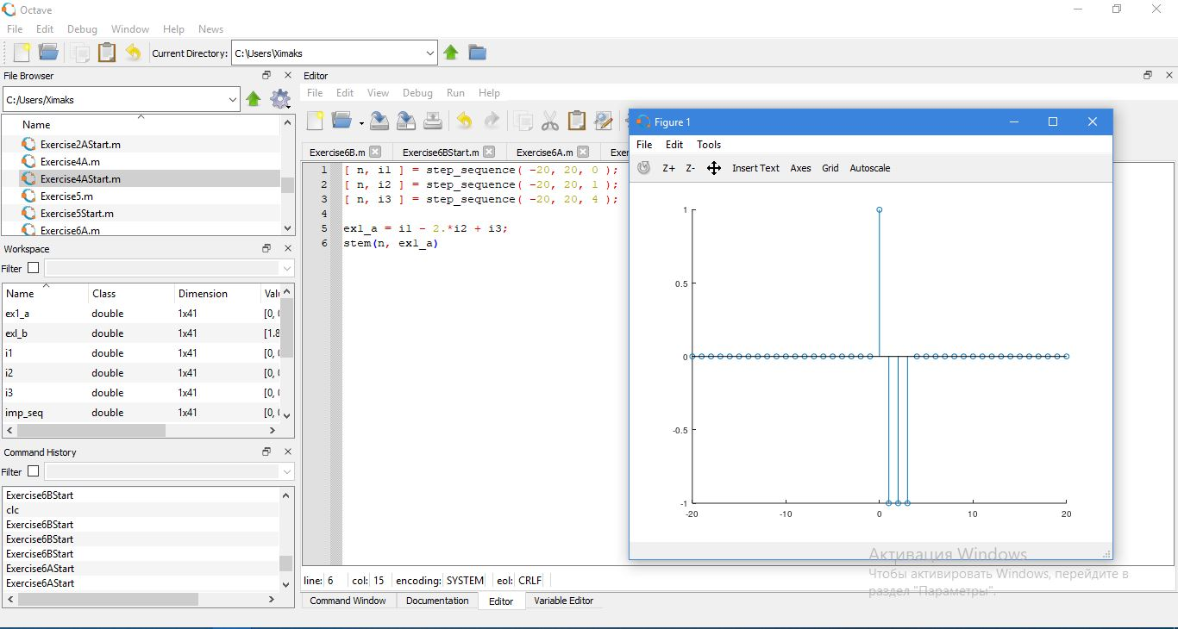

Figure 7 x[n] = Us[n] − 2Us[n − 1] + Us[n − 4]

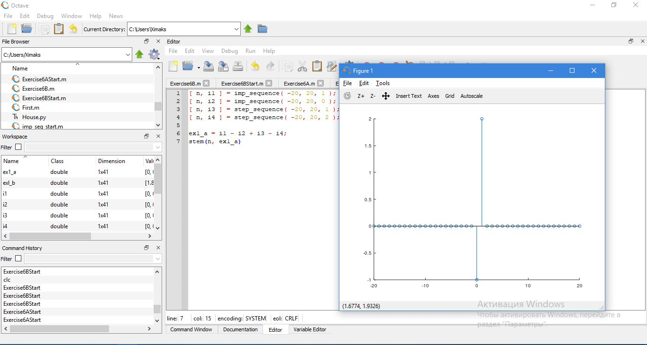

Figure 8 y[n] = Ui [n + 1] − Ui [n] + Us[n + 1] − Us[n − 2]

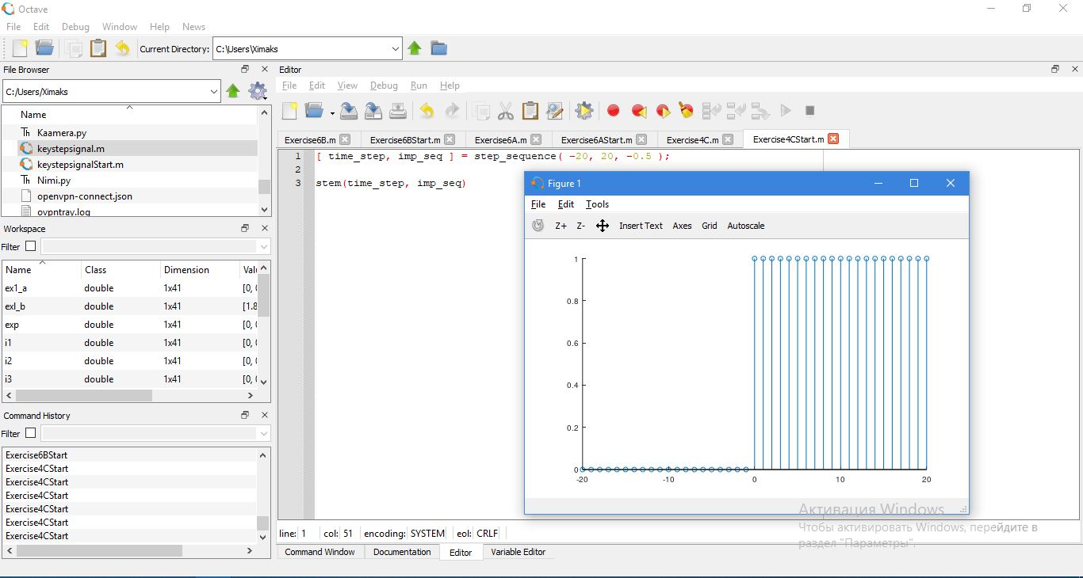

Figure 9 q[n] = − 1/ 2 n Us[n]

### Exercise 5

Write function to represent unit ramp sequence Ur[n].

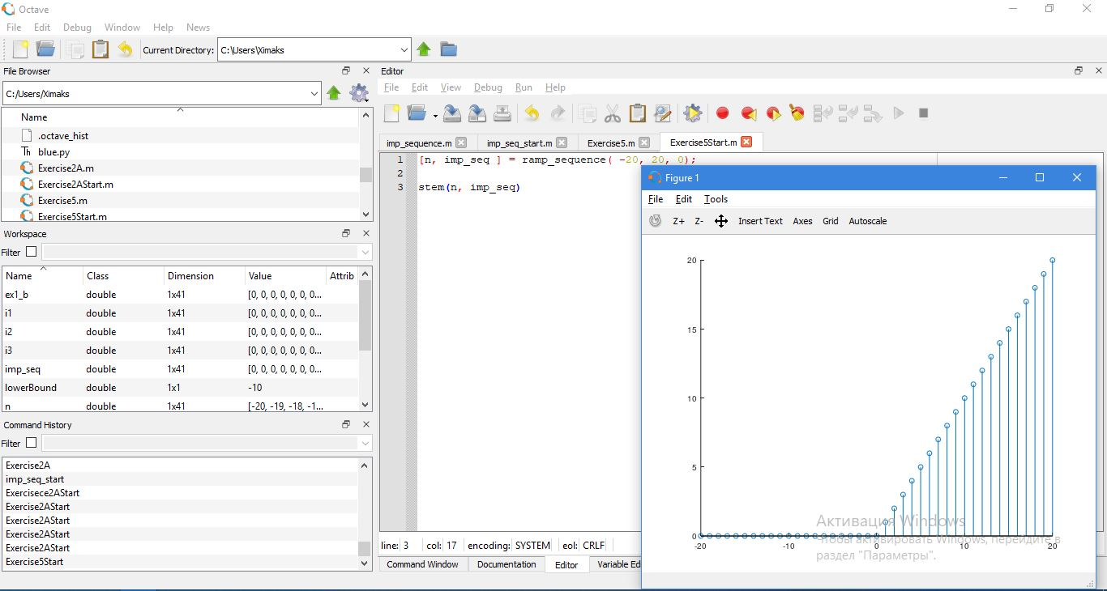

Figure 10 Unit Ramp Signal

### Exercise 6

Plot the following sequences, where −20 ≤ n ≤ 20, n ⊂ Z

1. z[n] = Ur[n + 2] − 2Us[n] − n · Us[n − 4]
2. w[n] = e^ n−7 − n · Ui [n − 5] − 3Ur[n]

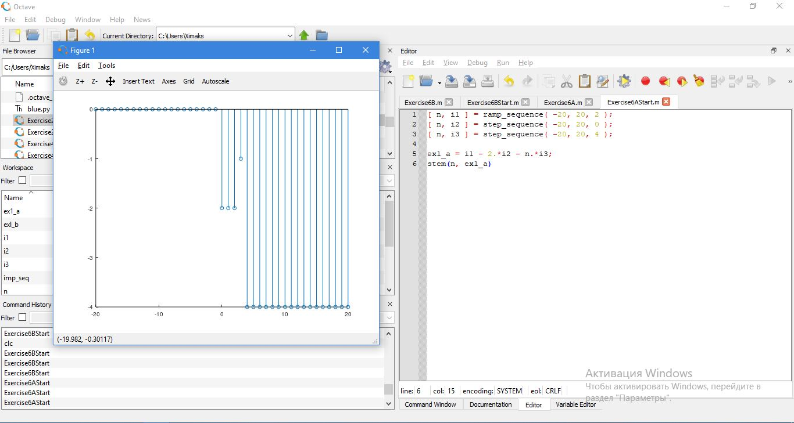

Figure 11 z[n] = Ur[n+2] - 2Us[n] - n * Us[n-4]

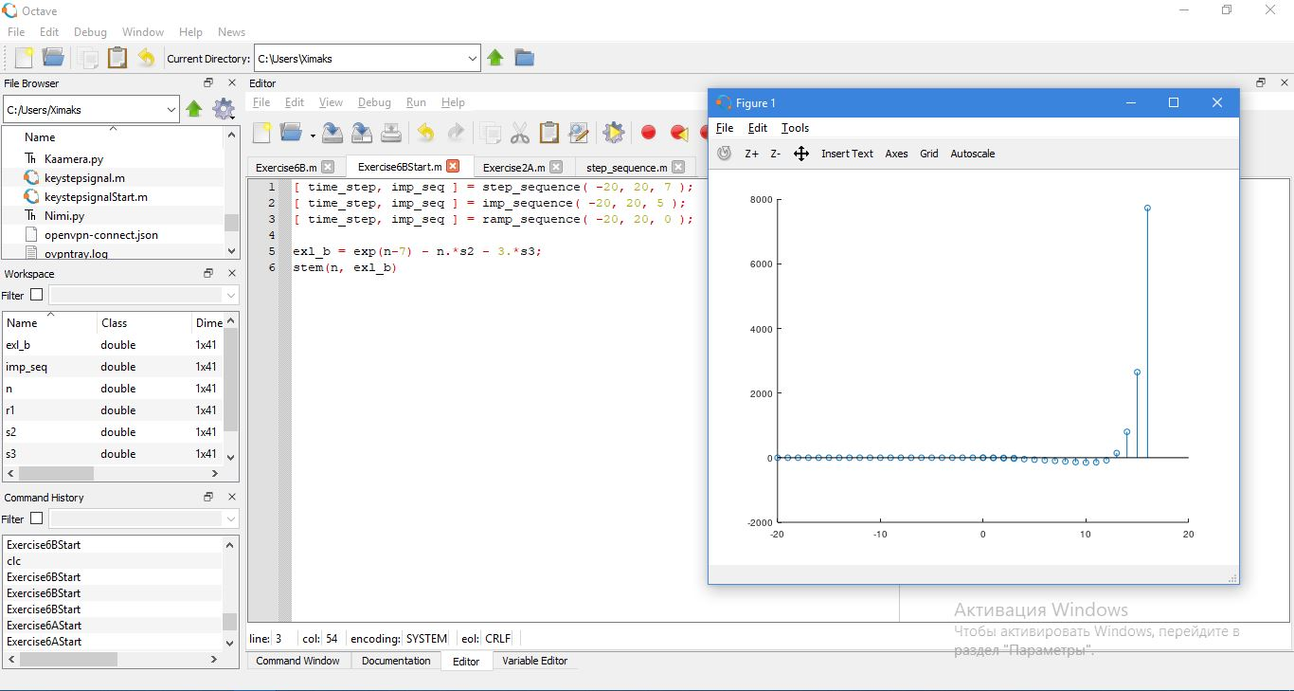

Figure 12 w[n] = e^ n−7 − n · Ui [n − 5] − 3Ur[n]

### Exercise 7

Very briefly explain the effects of multiplying each of the 3 unit sequences with any function f(n) using your own words. i.e what would happen to sin(n) if you multiplied it with an impulse sequence Ui [n].

* Effects of multiplying each of the unit sequences: if we conduct multiplication on signal then for example signal will be flipped up-down and the magnitude will be increased/decreased.

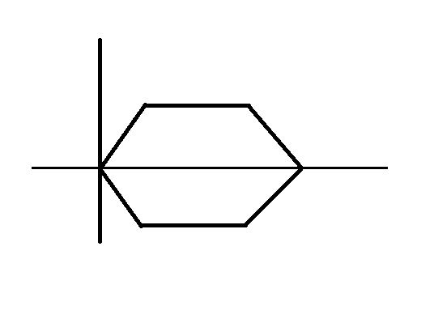

* The signal can be also expanded.

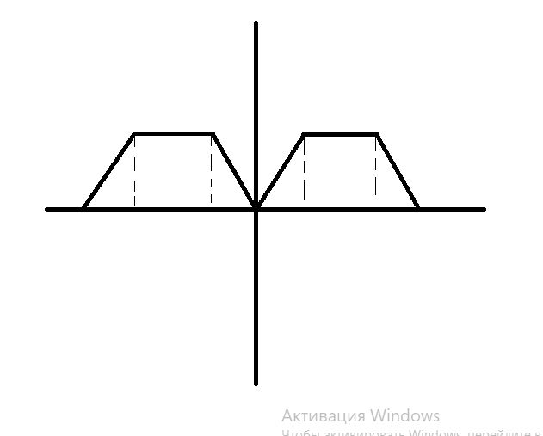

### Exercise 8

Apply Fast Fourier Transform to the sequences defined in Exercise 2 and plot the results(You may plot only the real component). Very briefly try to explain what happened to the sequences in frequency domain using your own words. You may experiment with different values and ranges to get a better understanding

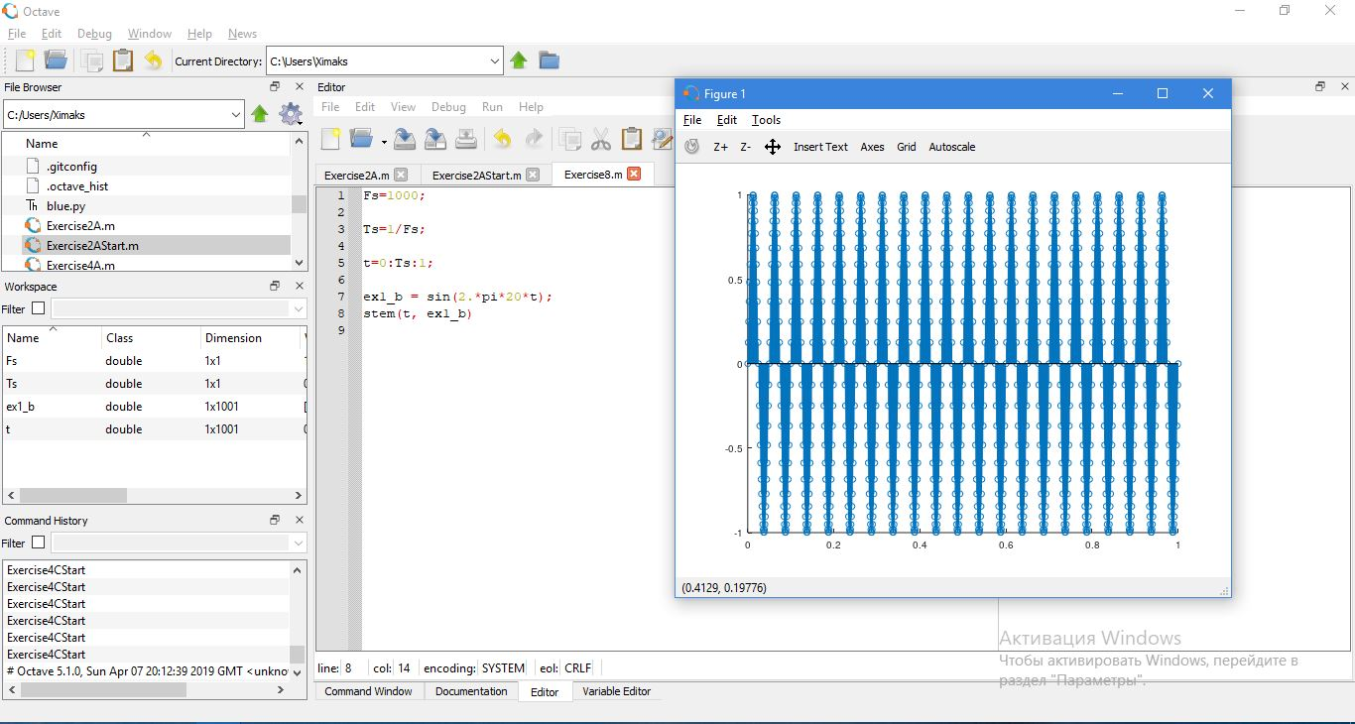

Figure 13 Fast Fourier Transform

One reason that we convert time domain representations into frequency domain representations is that the individual components are often much more closely related to the properties we care about.