# Digital Signal Processing

## Lab 2: Convolution

Vladislav Paškevitš

### Exercise 1

Implement a convolution function in MATLAB or Python and perform it on the following signals and plot the results:

* x[n] = [1, 1, 1, 1] h[m] = [1, 0, −1]
* x[n] = [4, 1, 2, −5] h[m] = [−1, 2, −1]
* x[n] = sin(n/5) h[m] = [−1, −2, 8, −2, −1] 20 ≤ n < 20

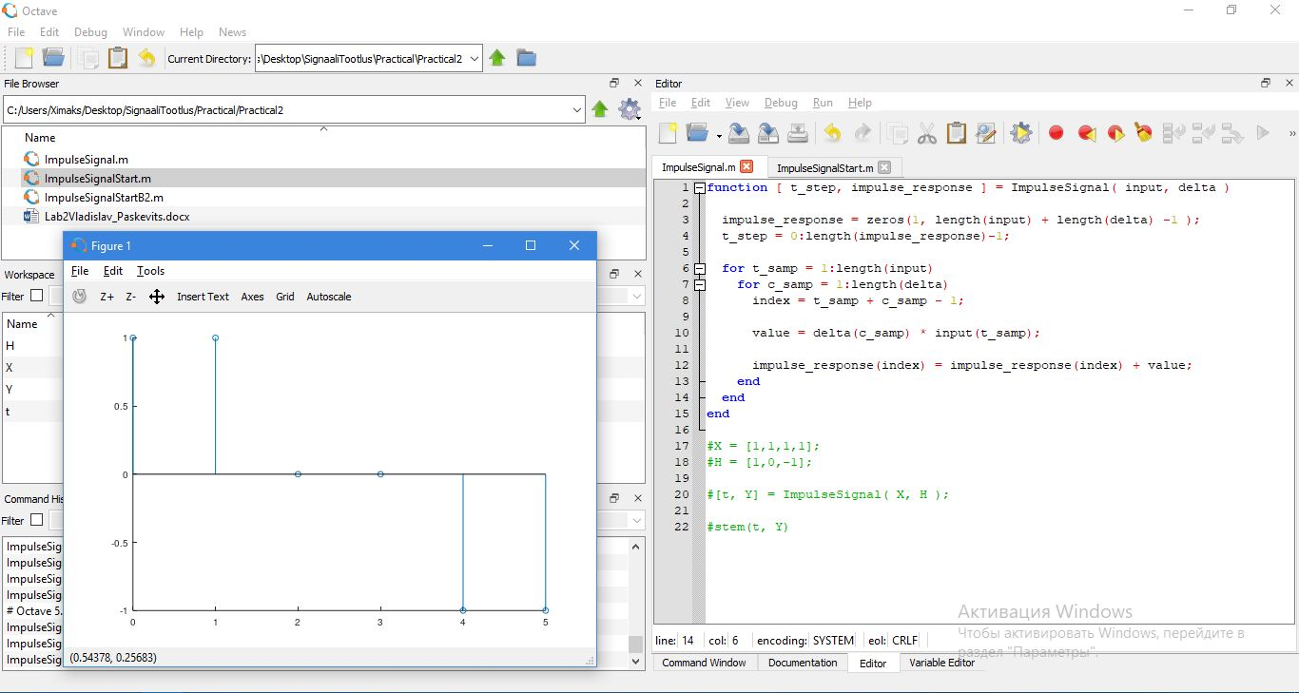

Figure 1 x[n] = [1, 1, 1, 1] h[m] = [1, 0, −1]

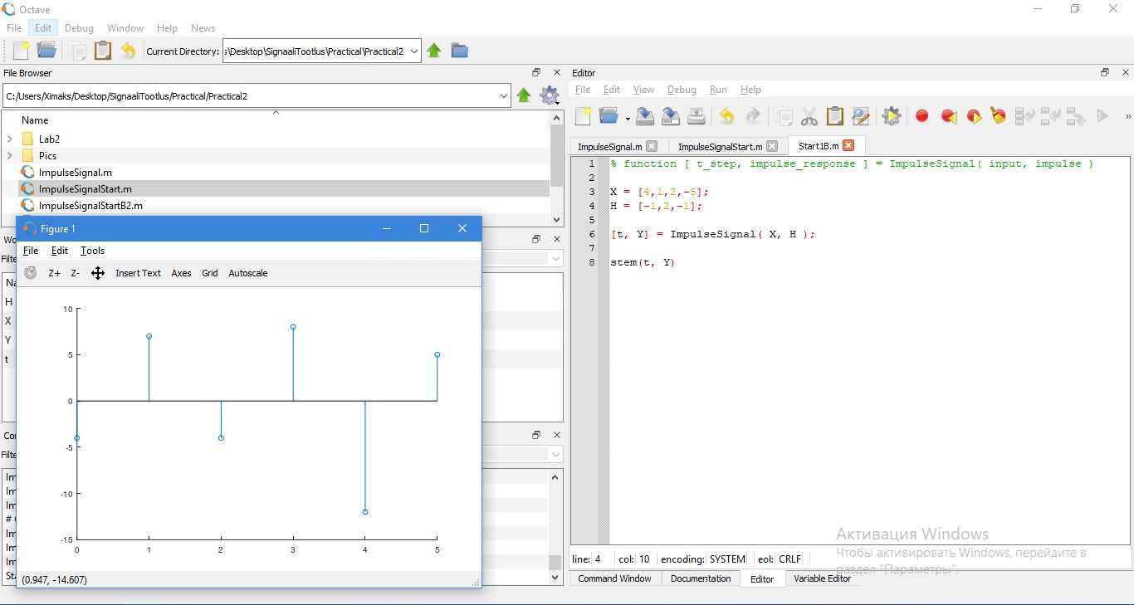

Figure 2 x[n] = [4, 1, 2, −5] h[m] = [−1, 2, −1]

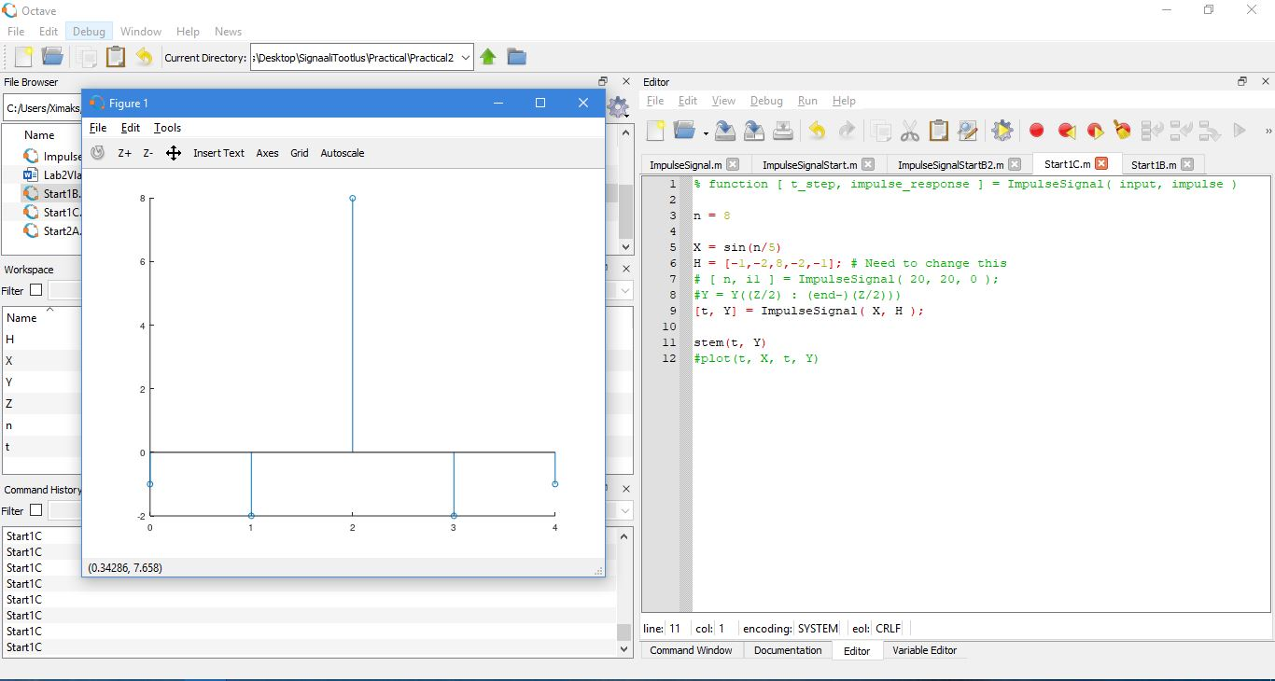

Figure 3 x[n] = sin(n/5) h[m] = [−1, −2, 8, −2, −1]

### Exercise 2

Given the input signal x[n] = 0.3∗sin(n/5) + sin(n/50)

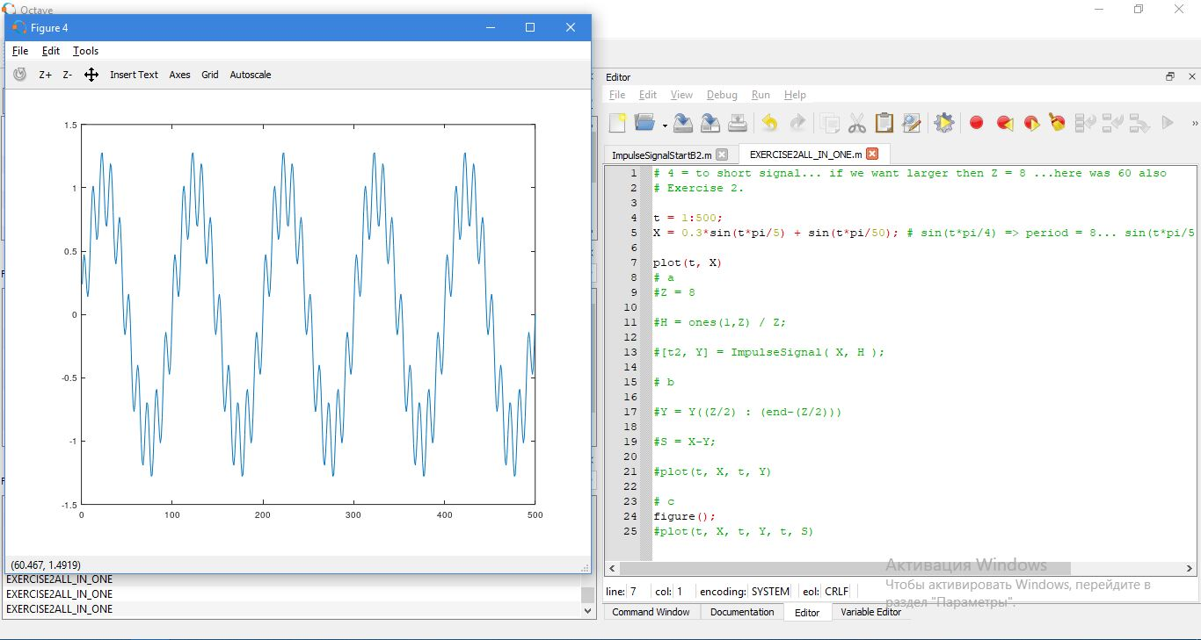

Figure 4 x[n] = 0.3∗sin(n/5) + sin(n/50)

1. Create your own delta signal h[m] that removes the higher frequency sinusoidal component to get yl [n].
2. Subtract the yl [n] from the original signal(x[n]) and get the higher frequency component yh[n](pay attention to array sizes and phase shift)
3. Plot x[n], yl [n] and yh[n] on the same graph

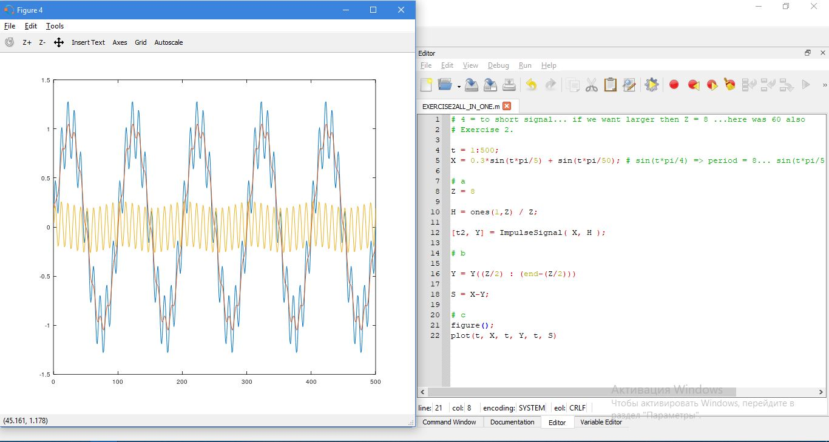

Figure 5 Plot x[n], yl [n] and yh[n] on the same graph