# Digital Signal Processing

## Lab 4: Short-Time Fourier Transform

Vladislav Paskevits

1. Find or record a .wav file of your choice ( preferably mono sound and 16bit ) and perform the following:
   1. Perform STFT on the audio file

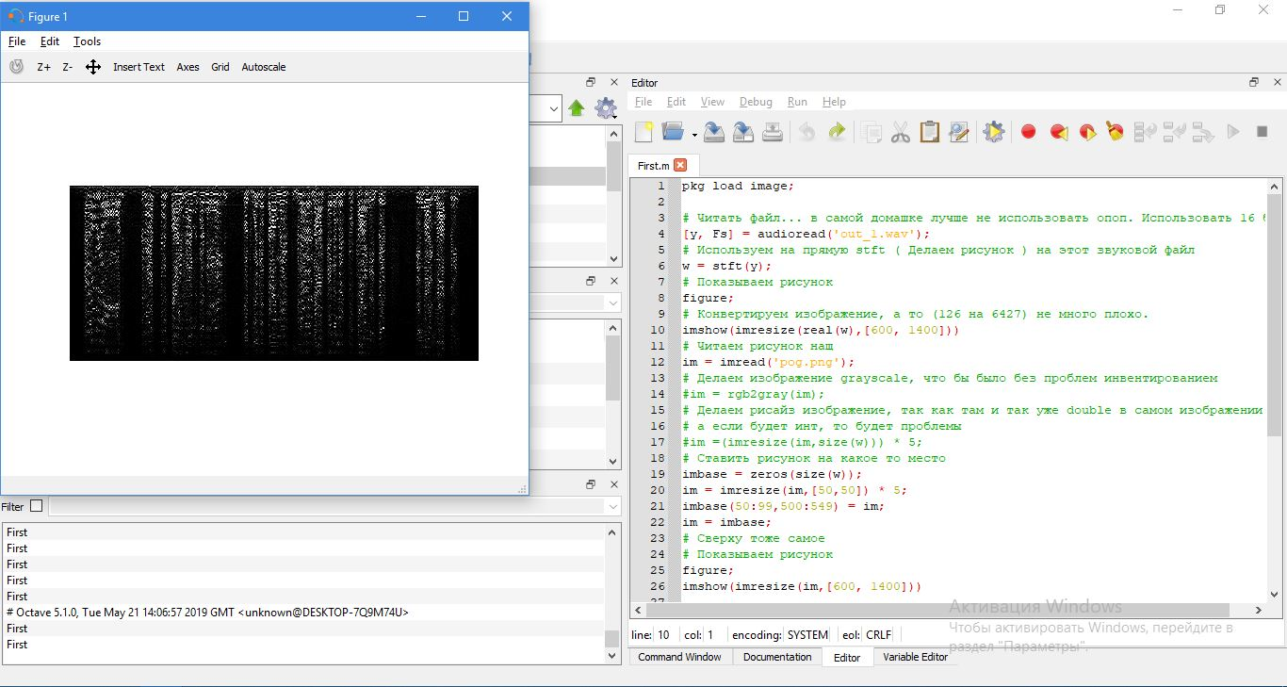

* 1. Plot the spectrogram, include both the real and imaginary components (Plot it as a heatmap or image).

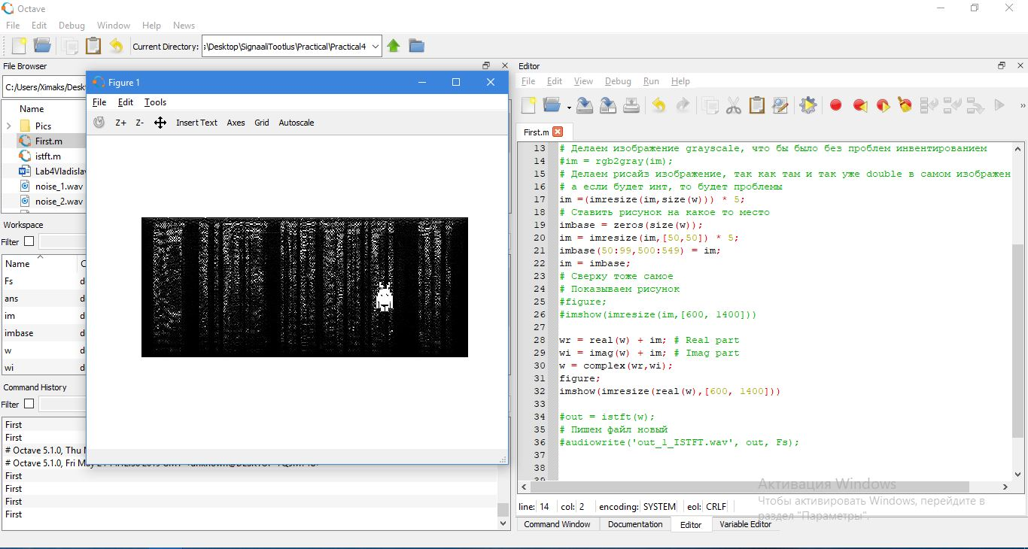

Figure 1 Real-Imaginary parts ( Complex )

* 1. Try to add an image of your choosing into the spectrum data (Add the real and imaginary components separately).

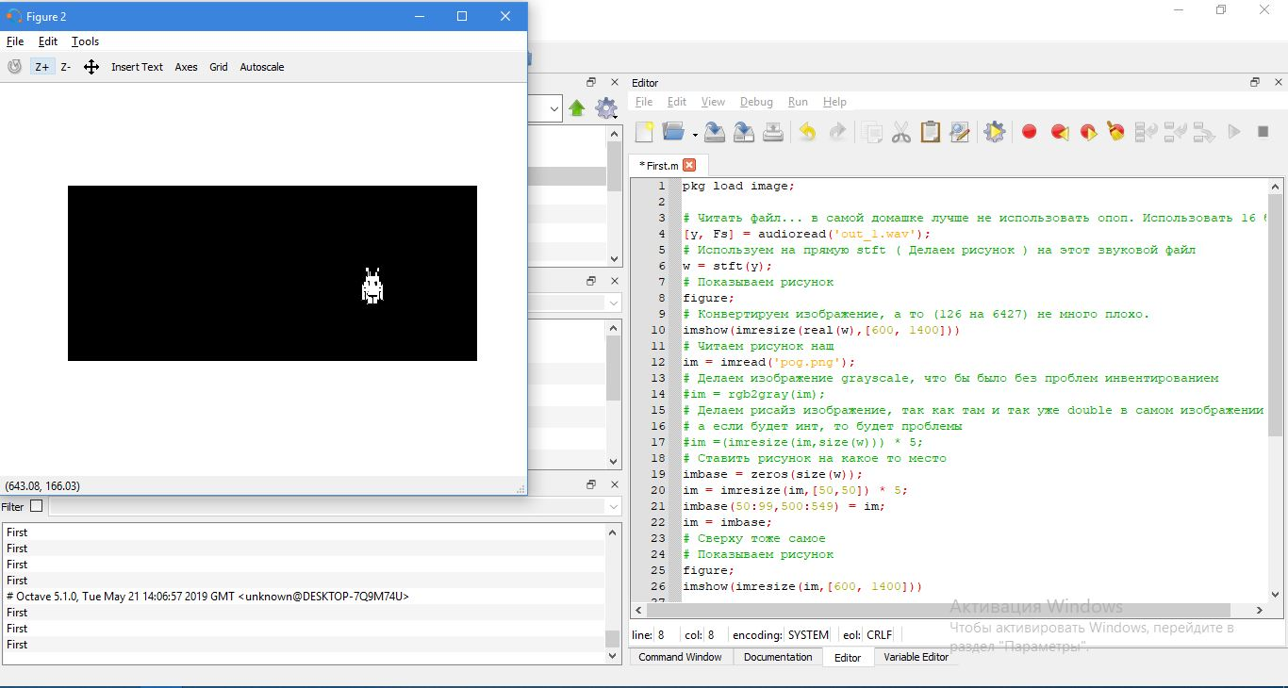

Figure 2 Picture to be added

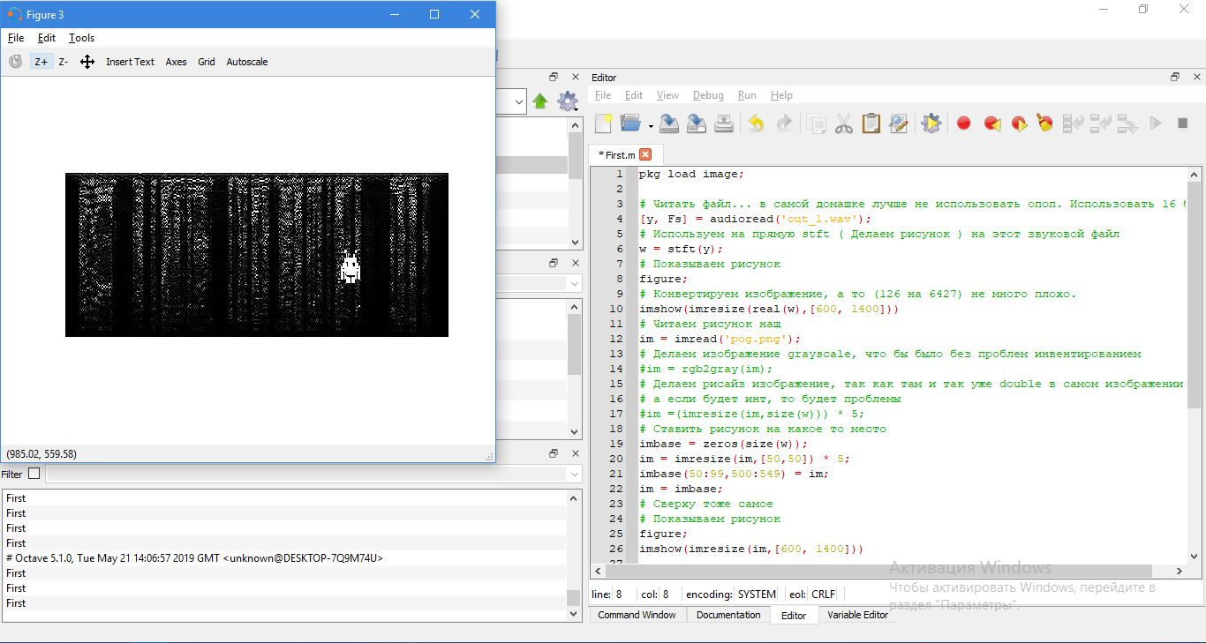

Figure 3 Picture that are added

* 1. Perform Inverse STFT to get the new altered signal

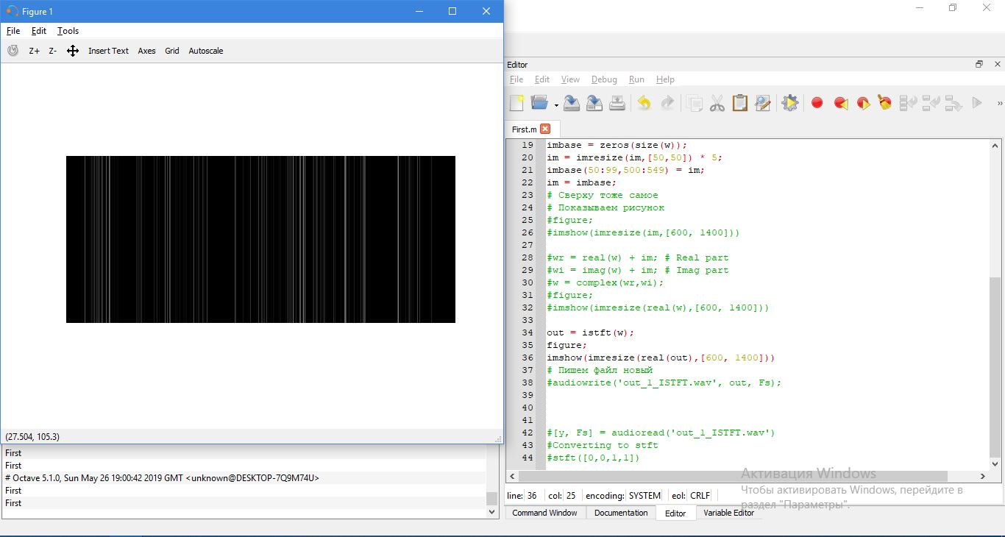.

* 1. Save the audio file and make sure you can still hear most of the original audio.

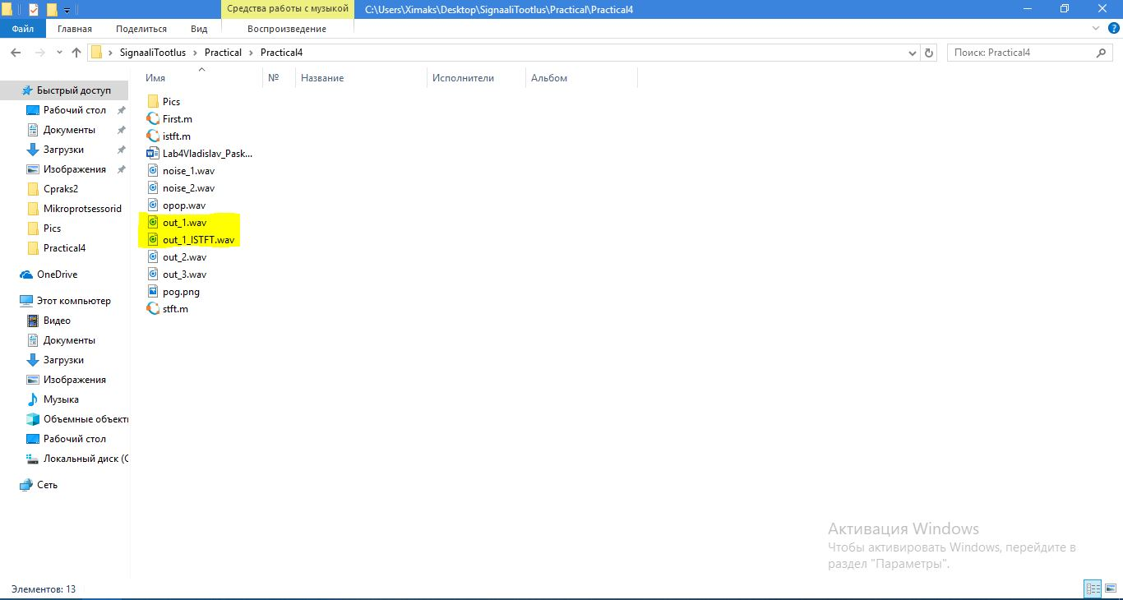

* 1. Read in the new file, perform STFT and plot it. Is the image still there?



1. Find an audio file online that has a hidden image:
   1. Perform STFT on the audio file.
   2. 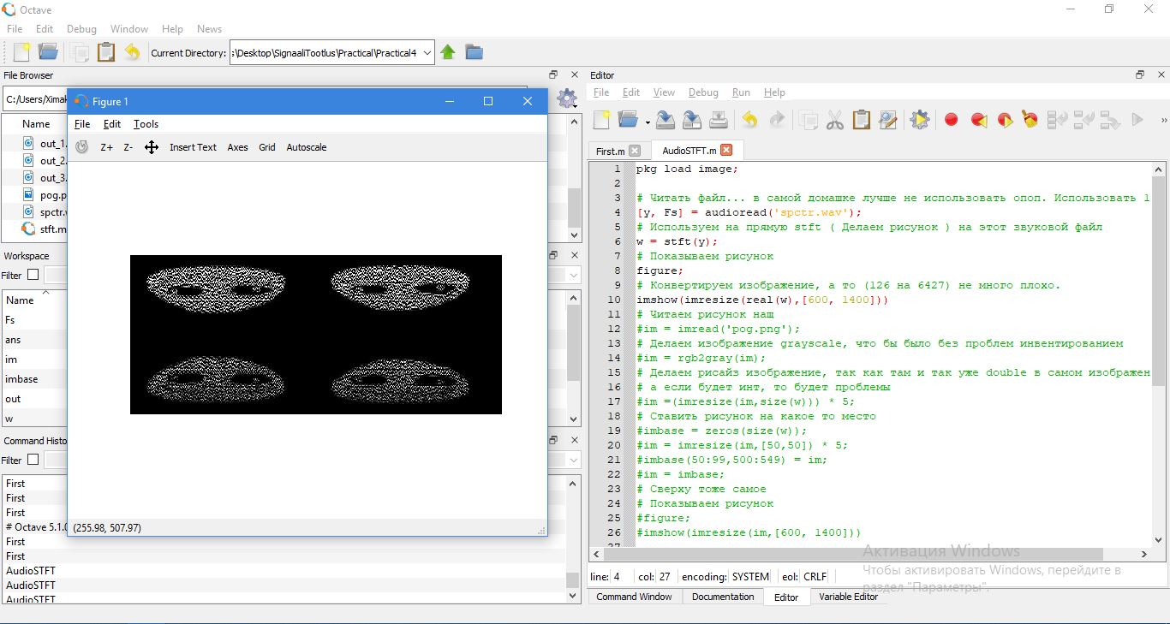Plot the spectrogram, exposing the hidden image

Figure 4 STFT

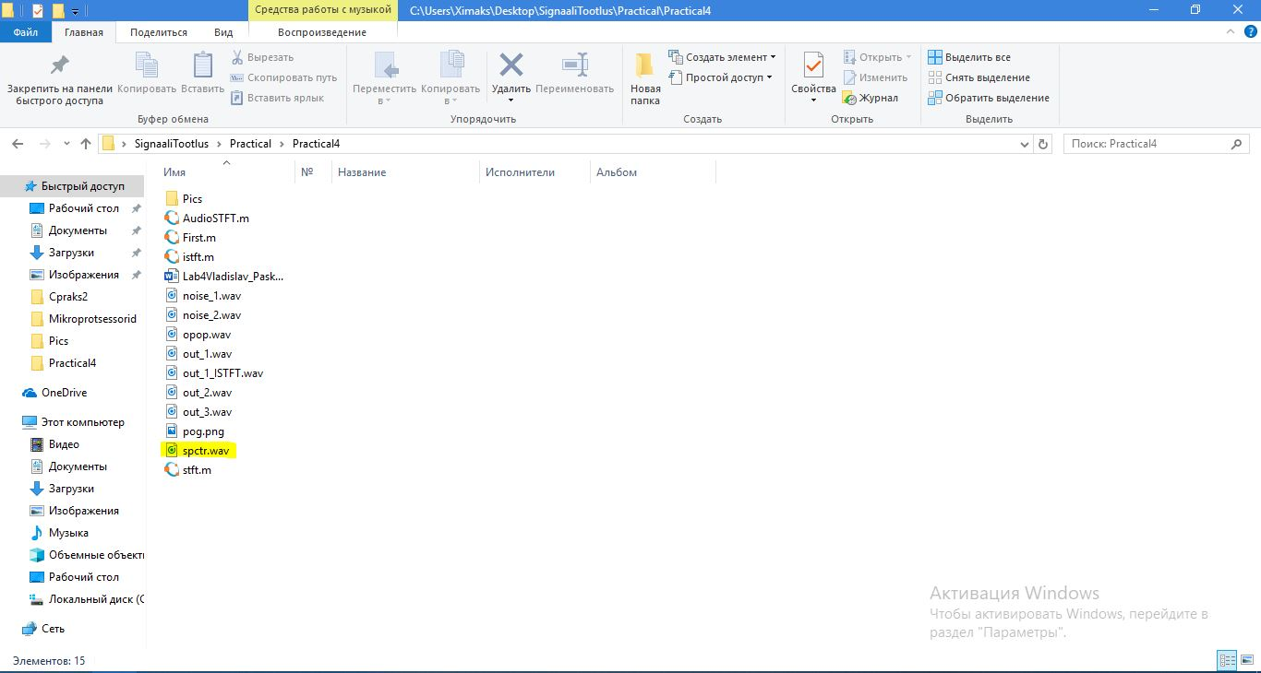

Figure 5 File