Міністерство освіти і науки України
Карпатський національний університет
імені В.Стефаника

Факультет математики та інформатики
Кафедра інформаційних технологій

Інформатика і програмування

Лабораторна робота No 2

Тема: Manage Subscriptions and RBAC

Виконав: Прокутко В.В
Група ІПЗ-43
Дата: 12 грудня 2025
Викладач: Поварчук Д.Д

Івано-Франківськ – 2025

Task 1: Implement Management Groups
In this task, you will create and configure management groups. Management groups are used to logically organize and segment subscriptions. They allow for RBAC and Azure Policy to be assigned and inherited to other management groups and subscriptions. For example, if your organization has a dedicated support team for Europe, you can organize European subscriptions into a management group to provide the support staff access to those subscriptions (without providing individual access to all subscriptions). In our scenario everyone at the Help Desk will need to create a support request across all subscriptions.

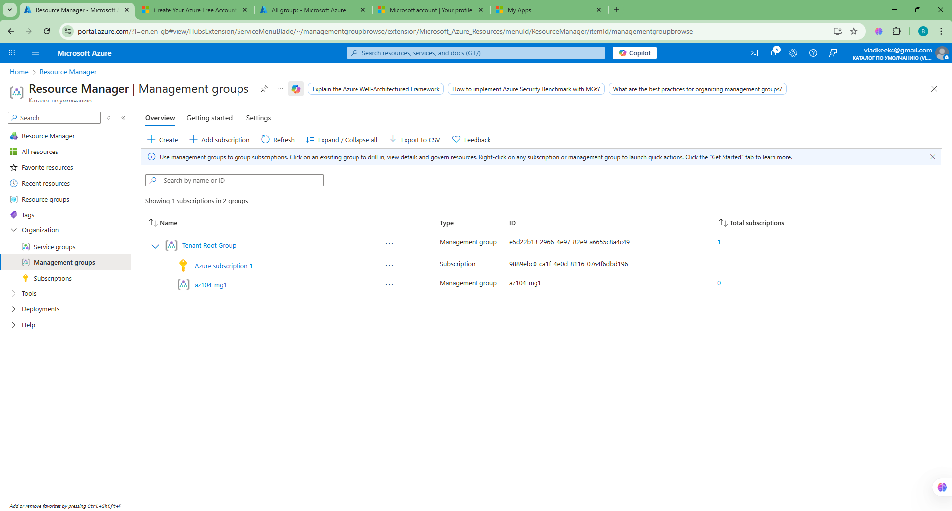

Task 2: Review and assign a built-in Azure role
In this task, you will review the built-in roles and assign the VM Contributor role to a member of the Help Desk. Azure provides a large number of built-in roles.
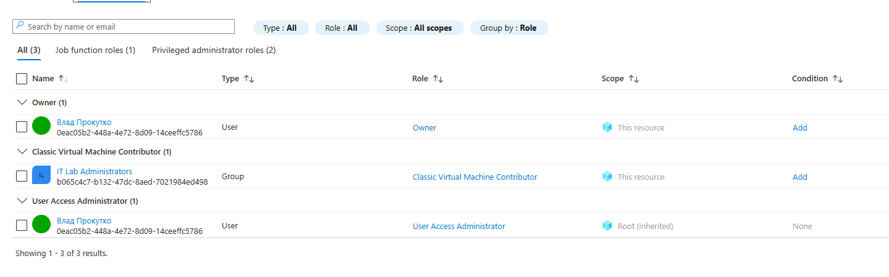

Task 3: Create a custom RBAC role
In this task, you will create a custom RBAC role. Custom roles are a core part of implementing the principle of least privilege for an environment. Built-in roles might have too many permissions for your scenario. We will also create a new role and remove permissions that are not necessary. Do you have a plan for managing overlapping permissions?
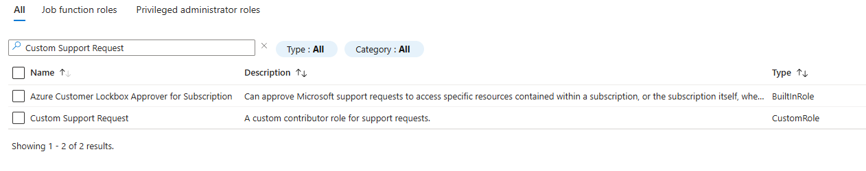

Task 4: Monitor role assignments with the Activity Log
In this task, you view the activity log to determine if anyone has created a new role.
- In the portal locate the az104-mg1 resource and select Activity log. The activity log provides insight into subscription-level events.
- Review the activites for role assignments. The activity log can be filtered for specific operations.

