Міністерство освіти і науки України
Карпатський національний університет
імені В.Стефаника

Факультет математики та інформатики
Кафедра інформаційних технологій

Інформатика і програмування

Лабораторна робота No 2b

Тема: Manage Governance via Azure Policy

Виконав: Прокутко В.В
Група ІПЗ-43
Дата: 12 грудня 2025
Викладач: Поварчук Д.Д

Івано-Франківськ – 2025

Task 1: Assign tags via the Azure portal
In this task, you will create and assign a tag to an Azure resource group via the Azure portal. Tags are a critical component of a governance strategy as outlined by the Microsoft Well-Architected Framework and Cloud Adoption Framework. Tags can allow you to quickly identify resource owners, sunset dates, group contacts, and other name/value pairs that your organization deems important. For this task, you assign a tag identifying the resource Cost Center.

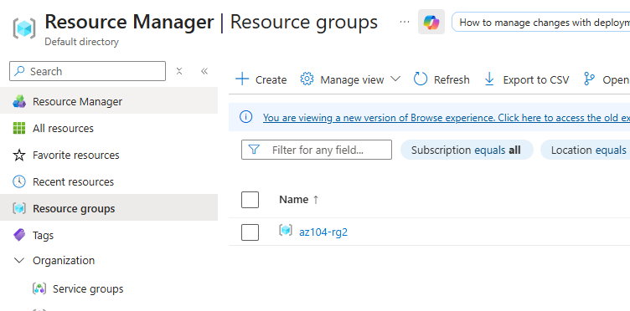

Task 2: Enforce tagging via an Azure Policy
In this task, you will assign the built-in Require a tag and its value on resources policy to the resource group and evaluate the outcome. Azure Policy can be used to enforce configuration, and in this case, governance, to your Azure resources.

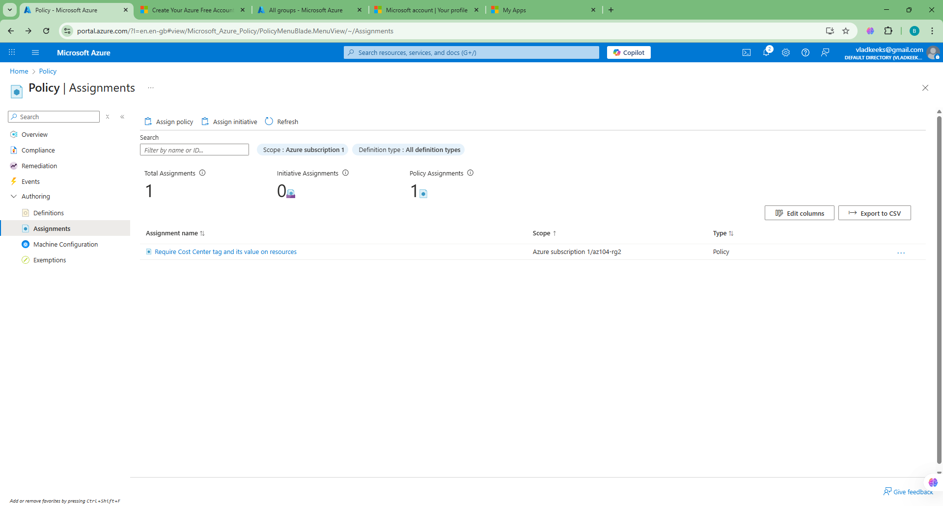
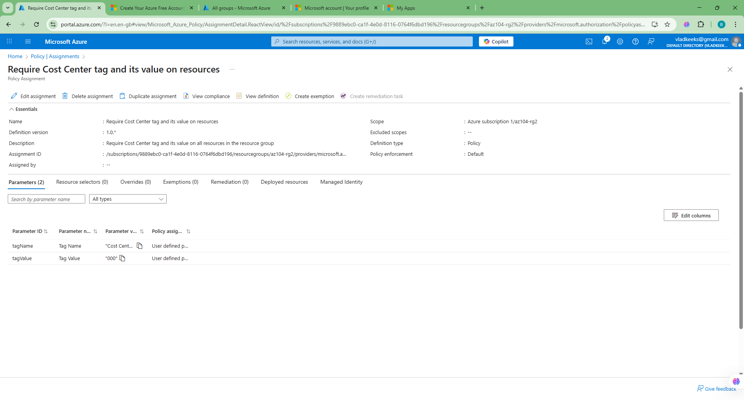
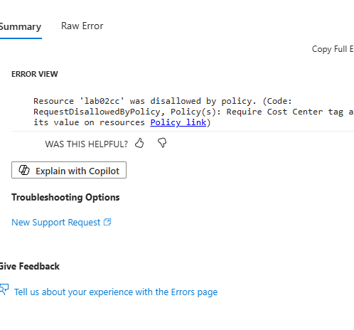

Task 3: Apply tagging via an Azure policy
In this task, we will use the new policy definition to remediate any non-compliant resources. In this scenario, we will make any child resources of a resource group inherit the Cost Center tag that was defined on the resource group.

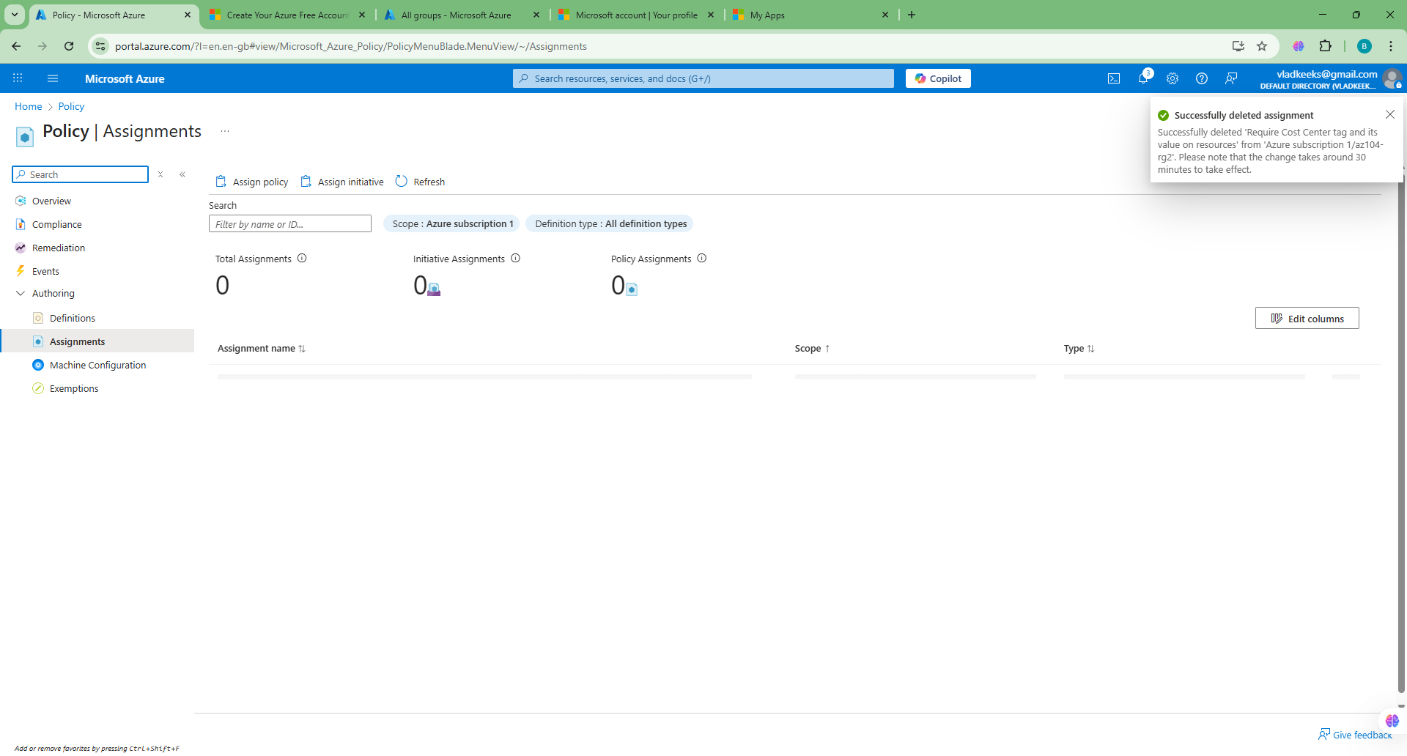
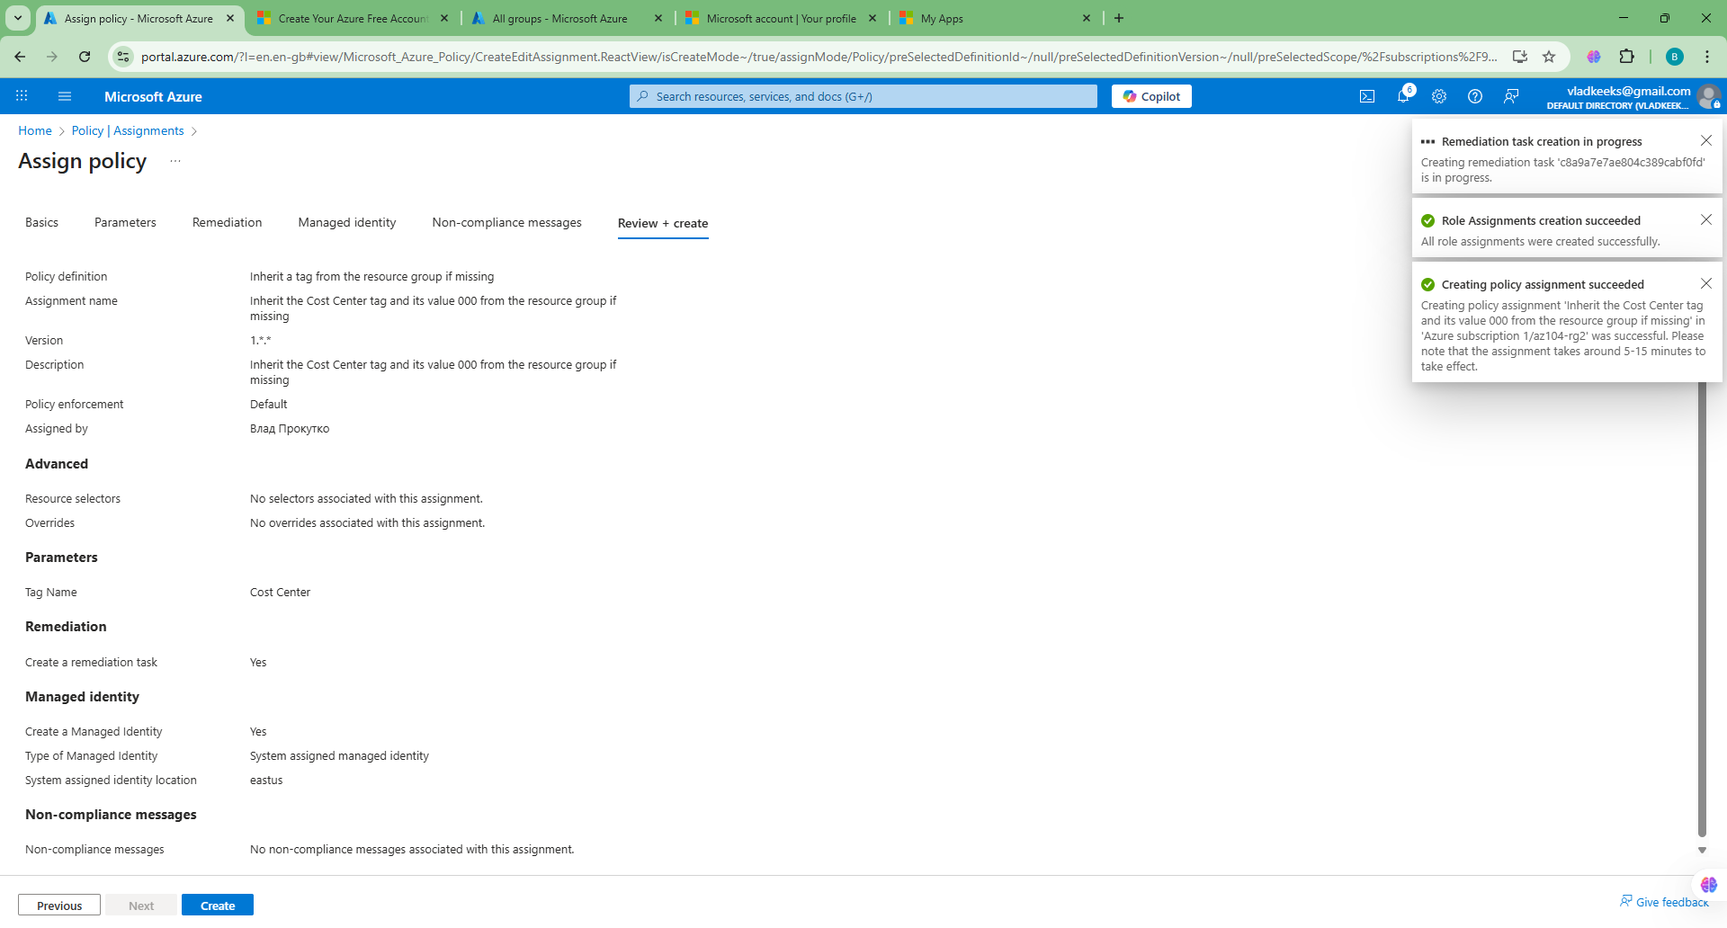

Task 4: Configure and test resource locks
In this task, you configure and test a resource lock. Locks prevent either deletions or modifications of a resource.

