Міністерство освіти і науки України
Карпатський національний університет
імені В.Стефаника

Факультет математики та інформатики
Кафедра інформаційних технологій

Інформатика і програмування

Лабораторна робота No 9a

Тема: Implement Web Apps

Виконав: Прокутко В.В
Група ІПЗ-43
Дата: 12 грудня 2025
Викладач: Поварчук Д.Д

Івано-Франківськ – 2025

Task 1: Create and configure an Azure web app
In this task, you create an Azure web app. Azure App Services is a Platform As a Service (PAAS) solution for web, mobile, and other web-based applications. Azure web apps is part Azure App Services hosting most runtime environments, such as PHP, Java, and .NET. The app service plan that you select determines the web app compute, storage, and features.

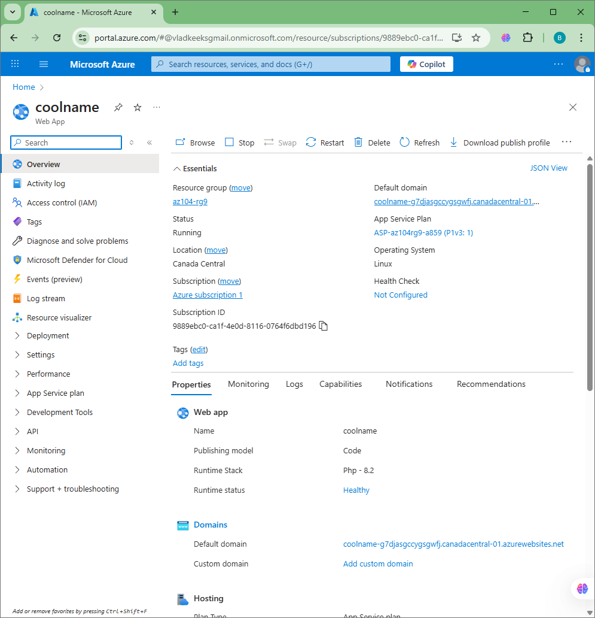

Task 2: Create and configure a deployment slot
In this task, you will create a staging deployment slot. Deployment slots enable you to perform testing prior to making your app available to the public (or your end users). After you have performed testing, you can swap the slot from development or staging to production. Many organizations use slots to perform pre-production testing. Additionally, many organizations run multiple slots for every application (for example, development, QA, test, and production).
- On the blade of the newly deployed Web App, click the Default domain link to display the default web page in a new browser tab.
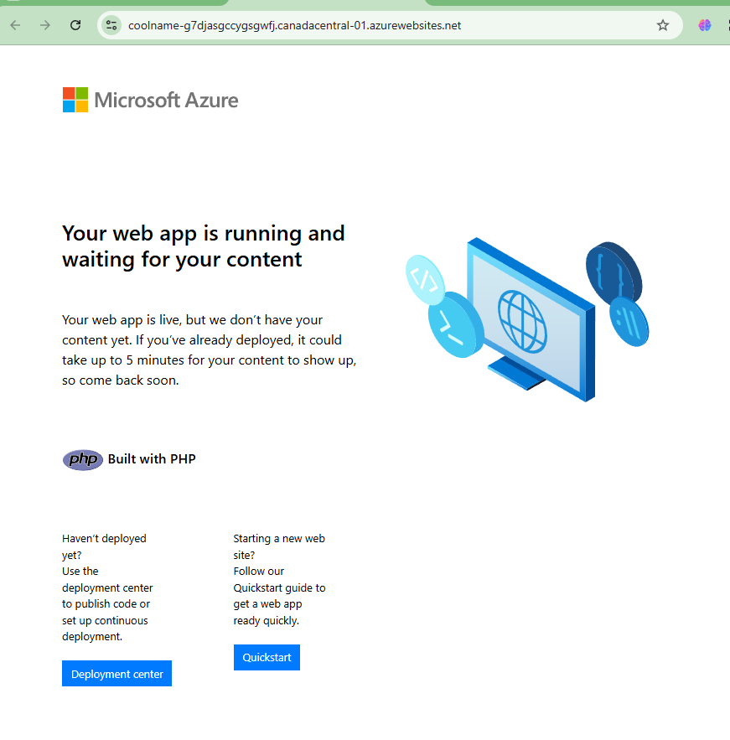
Click Add slot, and add a new slot with the following settings:
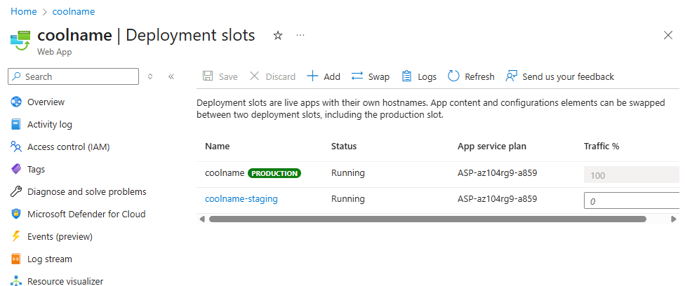
- Review the staging slot blade and note that its URL differs from the one assigned to the production slot.
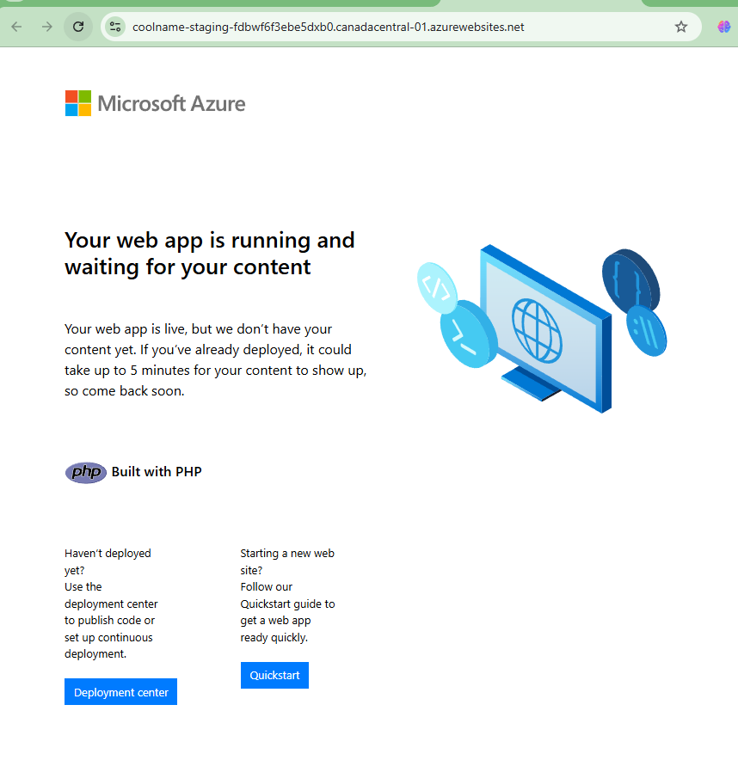

Task 3: Configure Web App deployment settings
In this task, you will configure Web App deployment settings. Deployment settings allow for continuous deployment. This ensures that the app service has the latest version of the application.
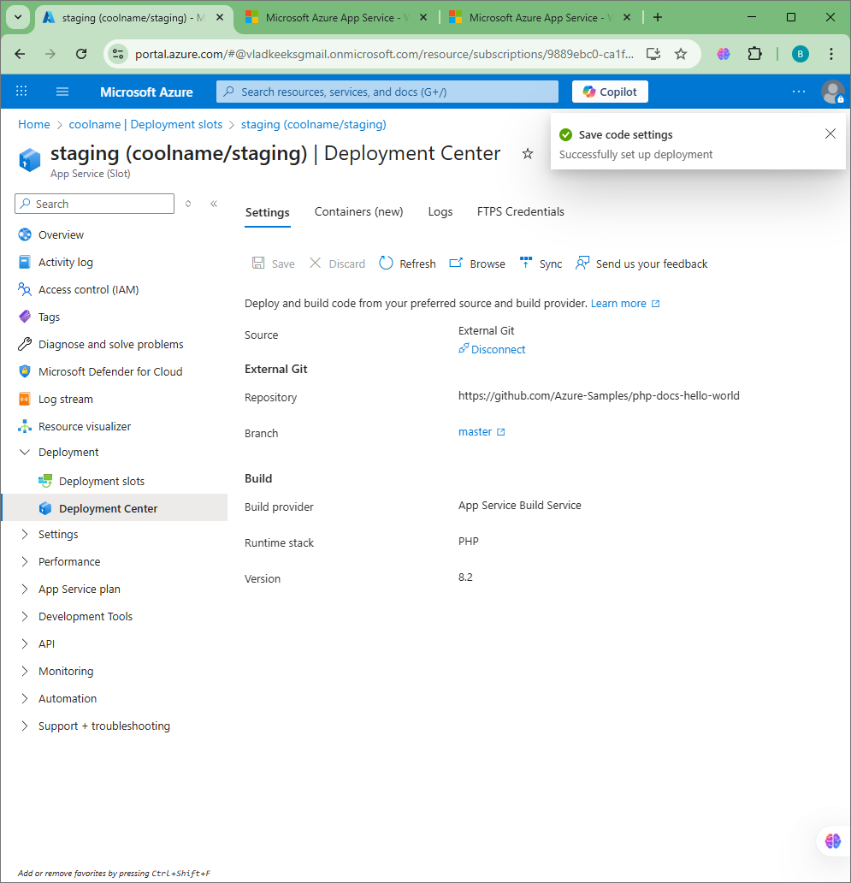

- Verify that the staging slot displays Hello World.



Task 4: Swap deployment slots
In this task, you will swap the staging slot with the production slot. Swapping a slot allows you to use the code that you have tested in your staging slot, and move it to production. The Azure portal will also prompt you if you need to move other application settings that you have customized for the slot. Swapping slots is a common task for application teams and application support teams, especially those deploying routine app updates and bug fixes.
- Review the default settings and click Start Swap. Wait for the notification that the swap has finished.
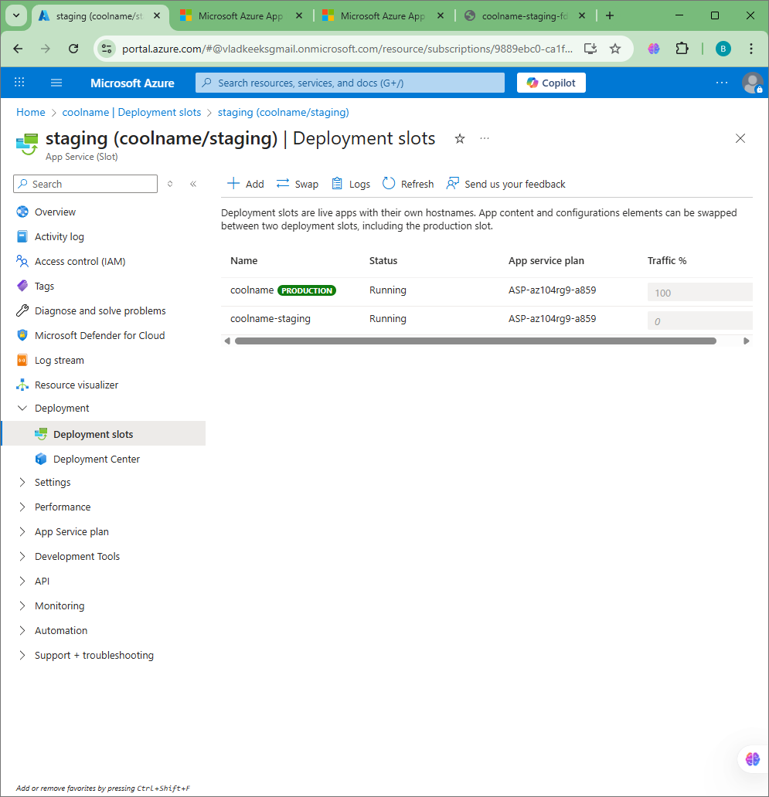

- Select the App Service web app and on the Overview blade of the Web App select the Default domain link to display the website home page.
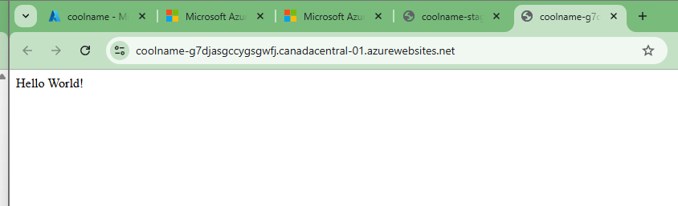

Task 5: Configure and test autoscaling of the Azure Web App
In this task, you will configure autoscaling of Azure Web App. Autoscaling enables you to maintain optimal performance for your web app when traffic to the web app increases. To determine when the app should scale you can monitor metrics like CPU usage, memory, or bandwidth.

In the left pane, in the App Service plan section, select Scale out.
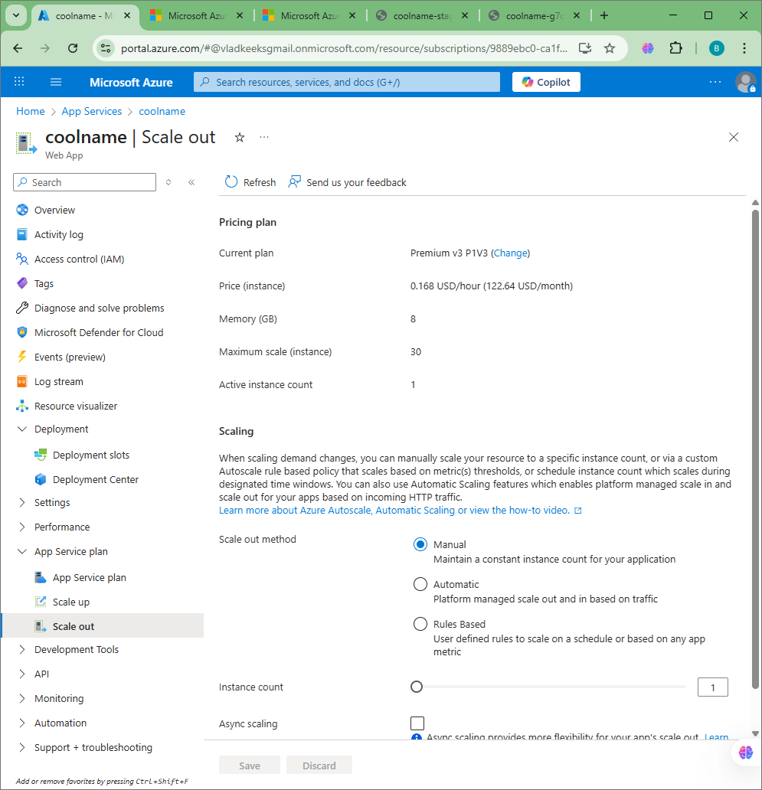

- Wait for the load test to create, and then select Go to resource.
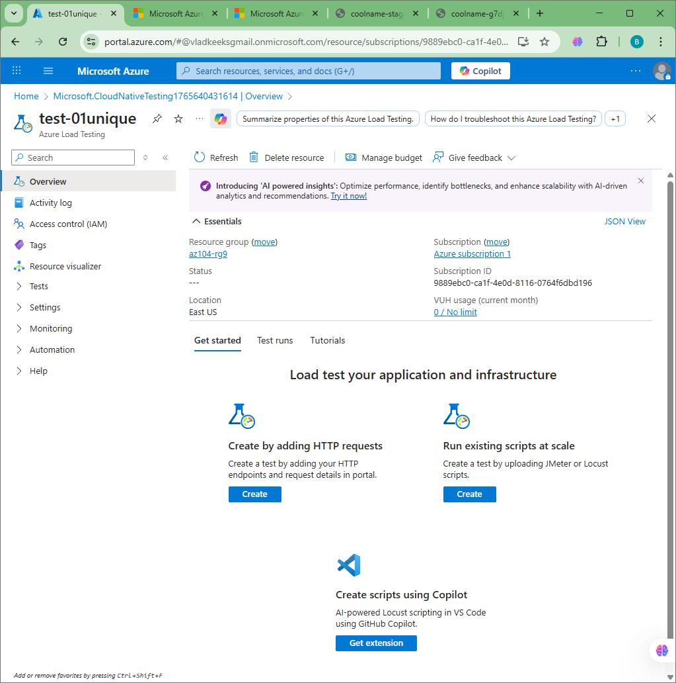
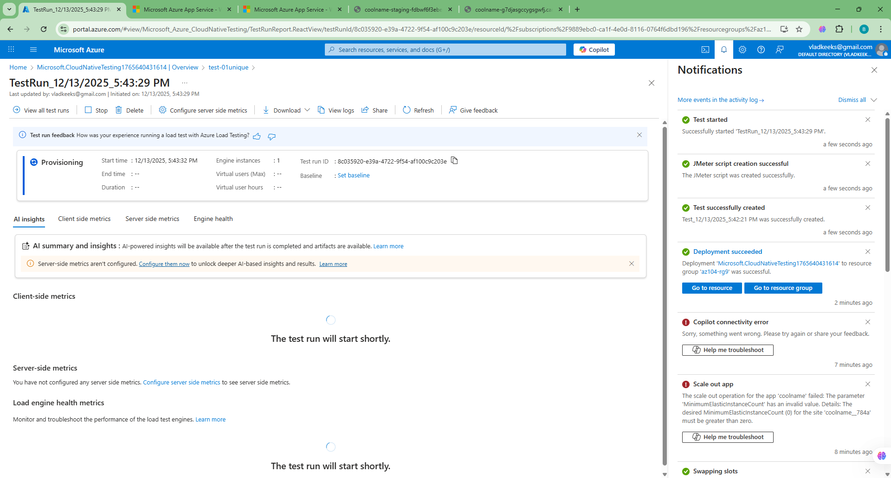

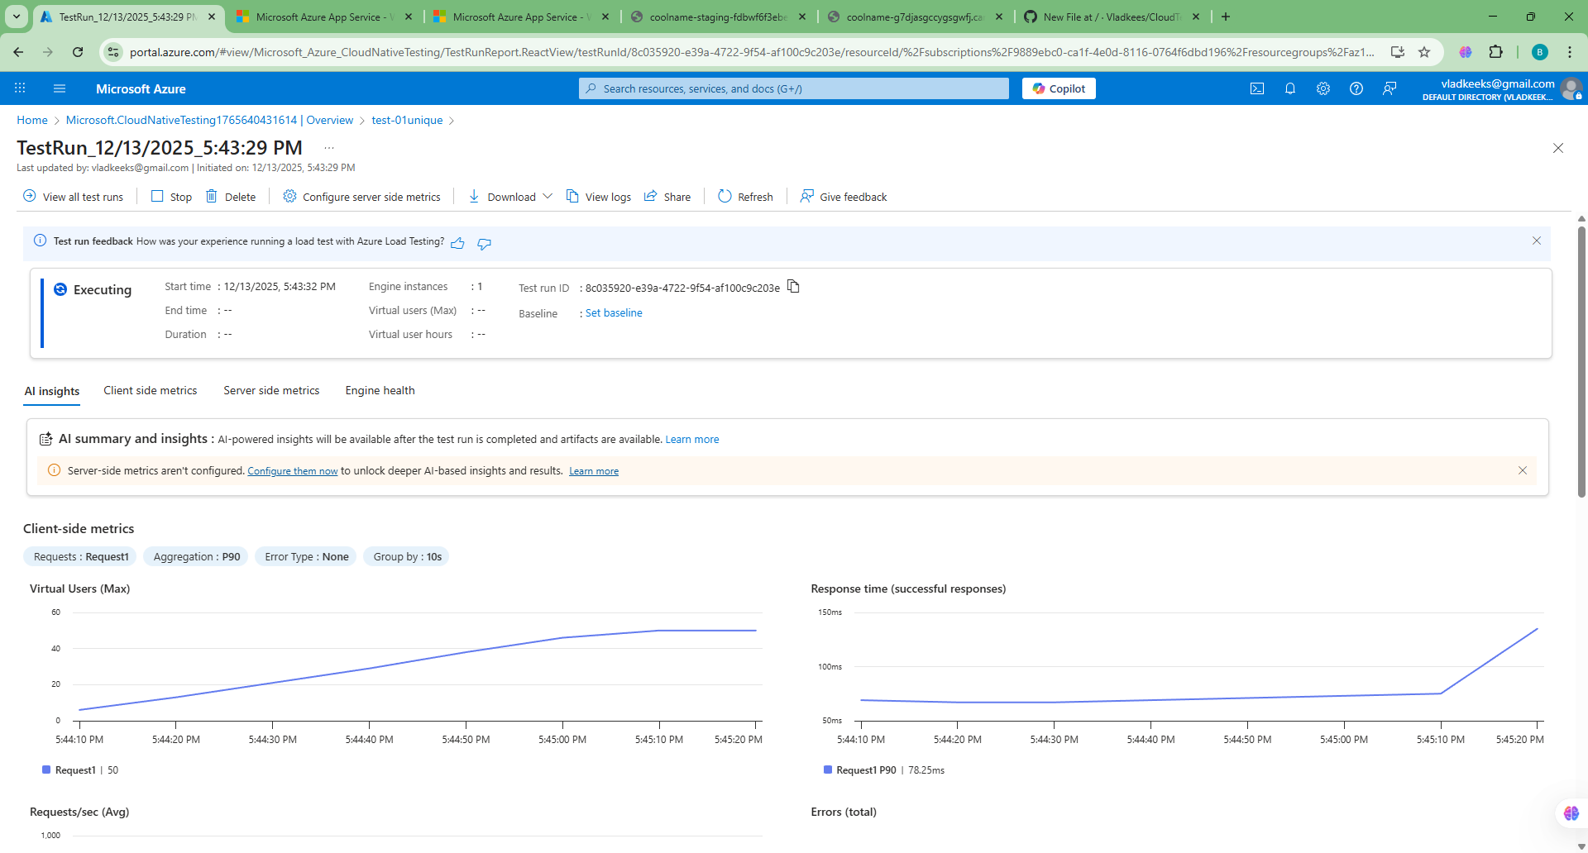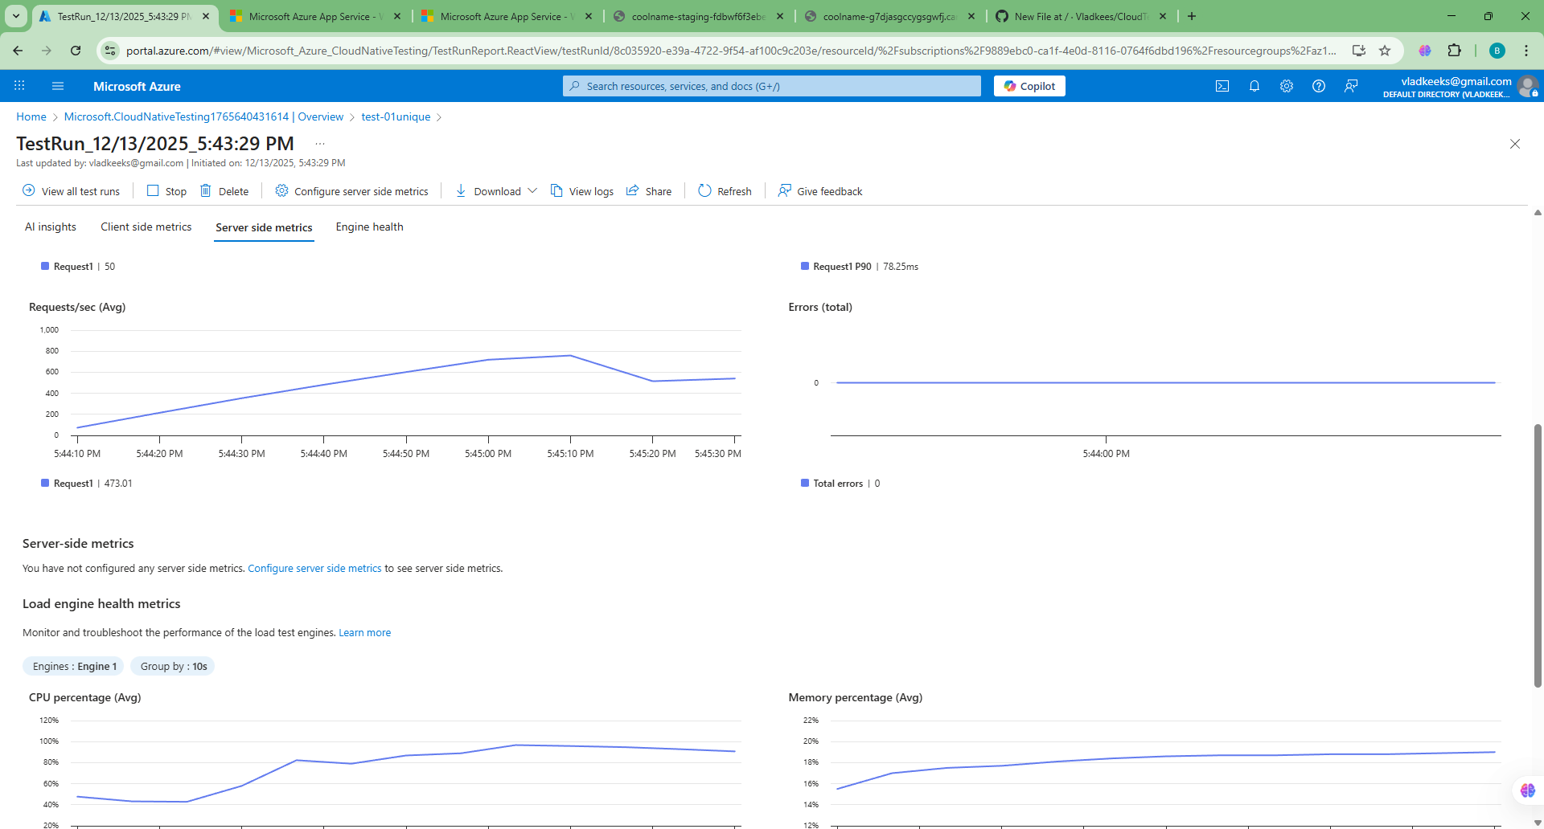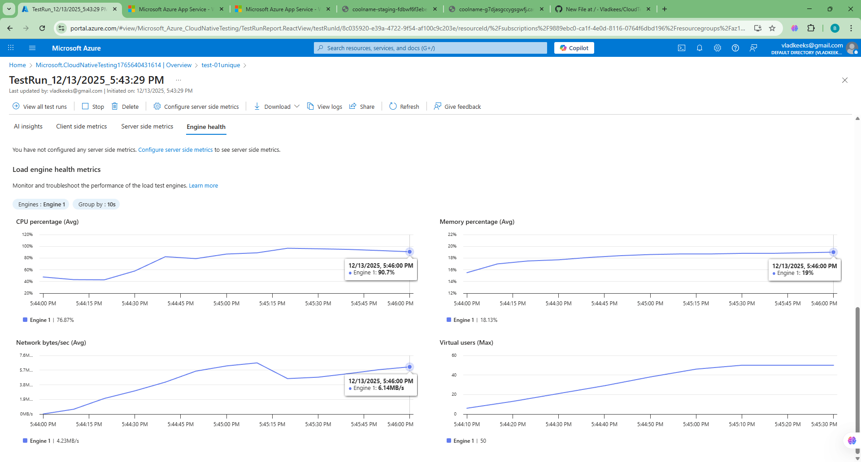
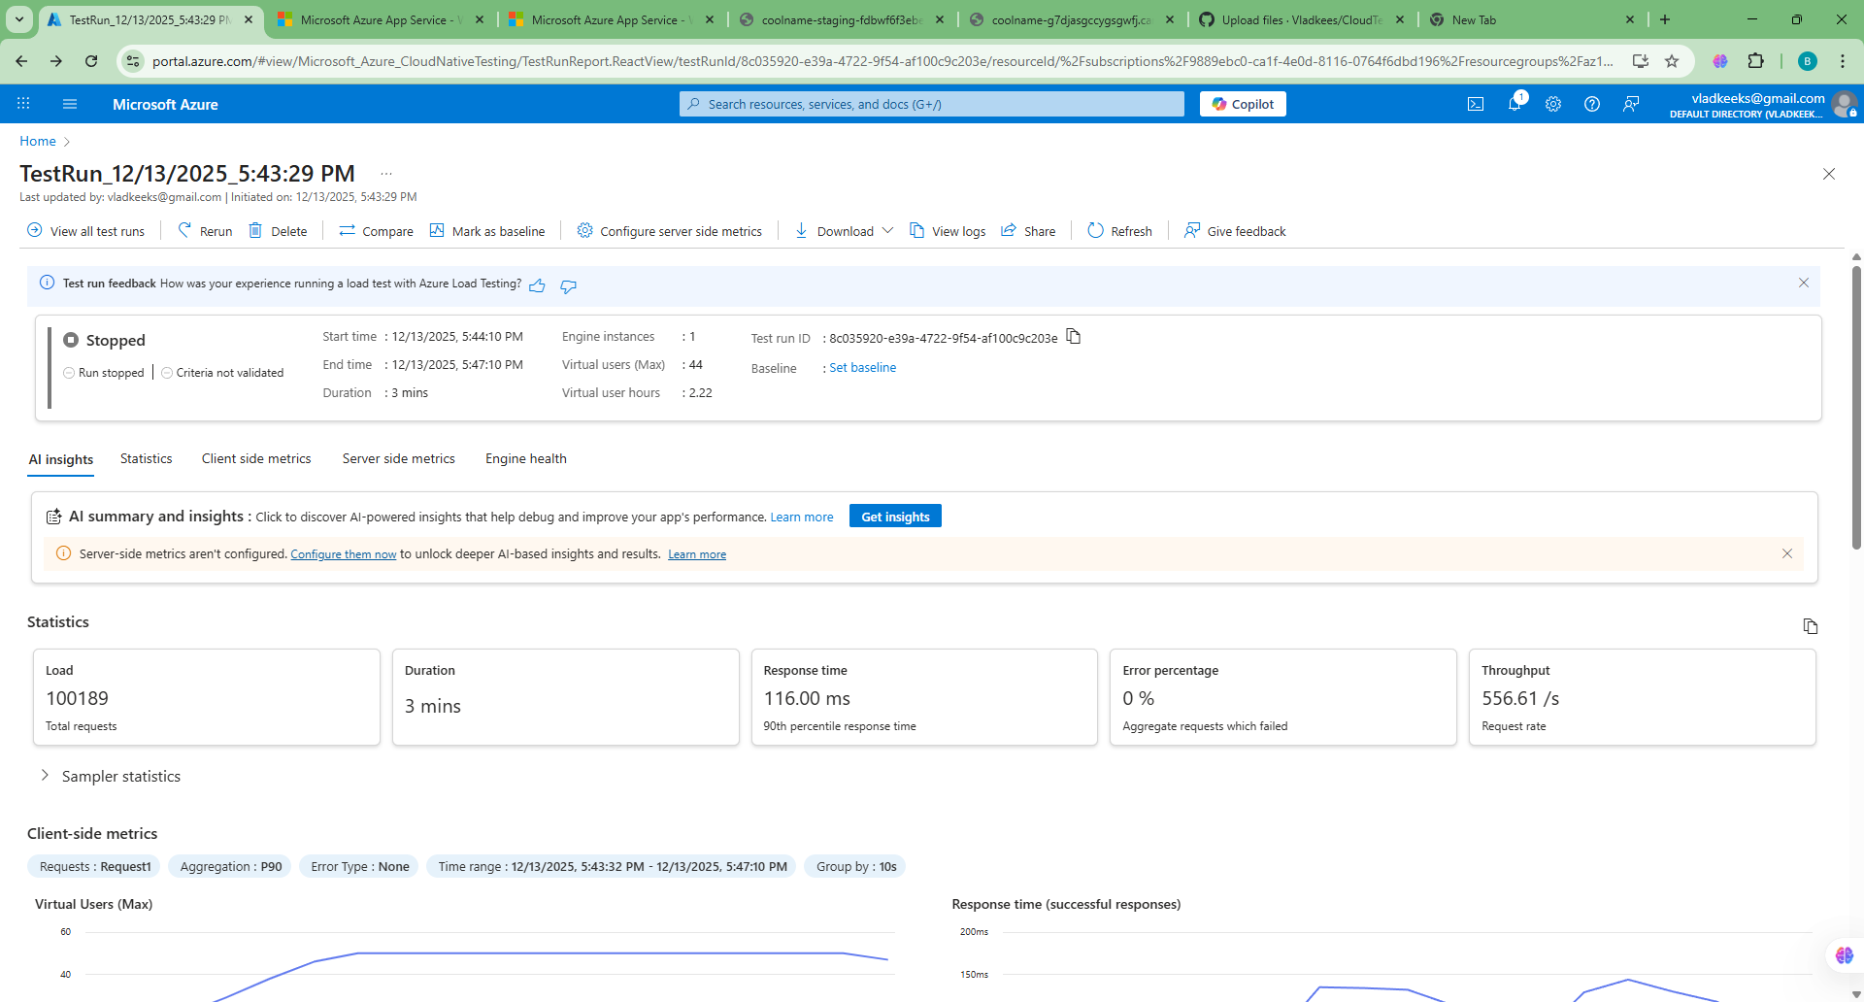

overall

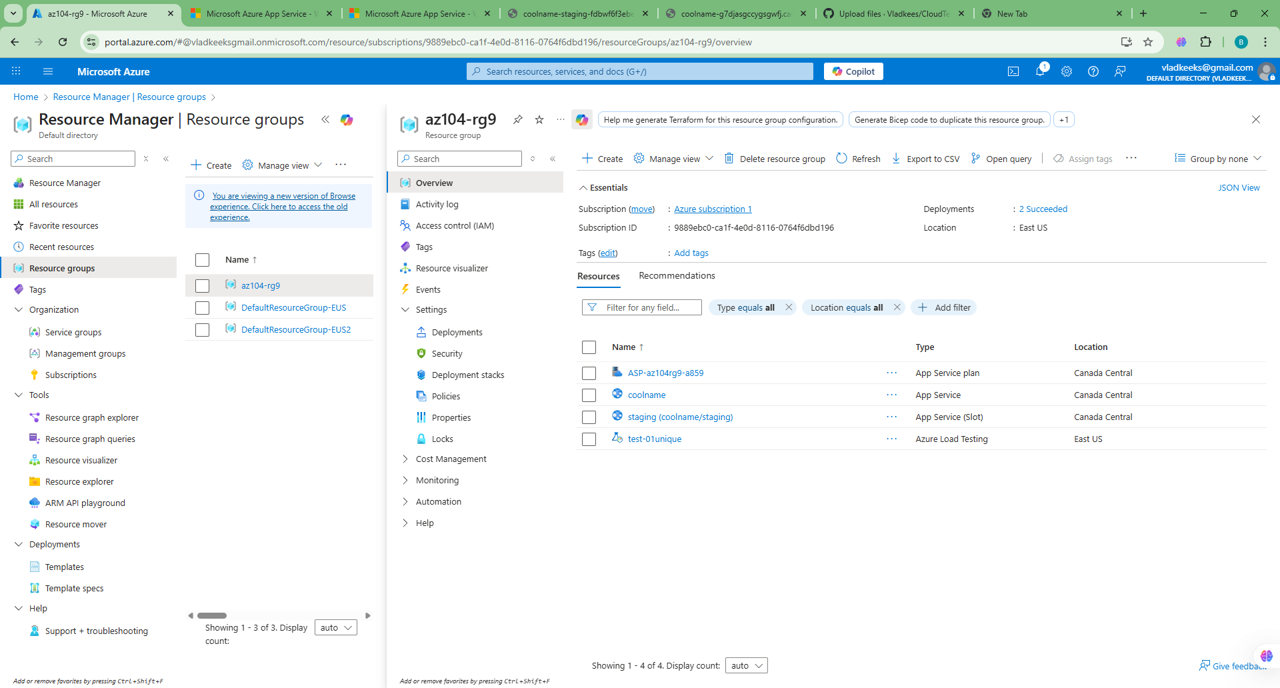

costs:

