Міністерство освіти і науки України
Карпатський національний університет
імені В.Стефаника

Факультет математики та інформатики
Кафедра інформаційних технологій

Інформатика і програмування

Лабораторна робота No 9b

Тема: Implement Azure Container Instances

Виконав: Прокутко В.В
Група ІПЗ-43
Дата: 13 грудня 2025
Викладач: Поварчук Д.Д

Івано-Франківськ – 2025

Task 1: Deploy an Azure Container Instance using a Docker image
In this task, you will create a simple web application using a Docker image. Docker is a platform that provides the ability to package and run applications in isolated environments called containers. Azure Container Instances provides the compute environment for the container image.

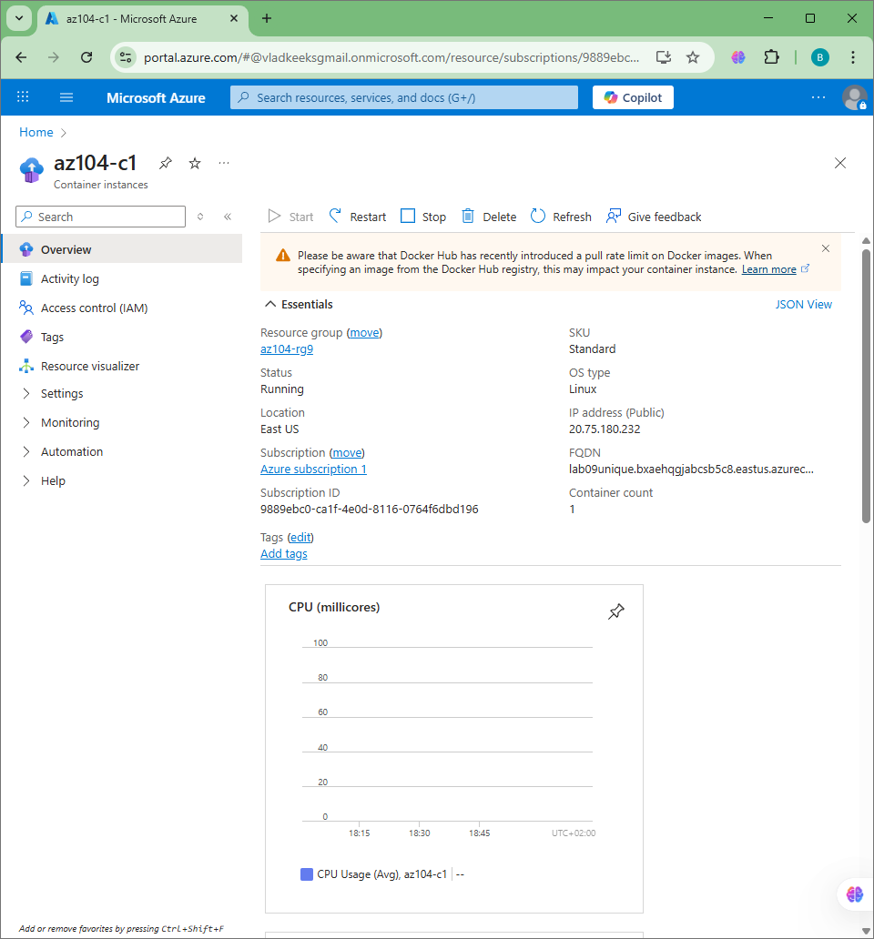

Task 2: Test and verify deployment of an Azure Container Instance
In this task, you review the deployment of the container instance. By default, the Azure Container Instance is accessible over port 80. After the instance has been deployed, you can navigate to the container using the DNS name that you provided in the previous task.
- On the Overview blade of the container instance, verify that Status is reported as Running.

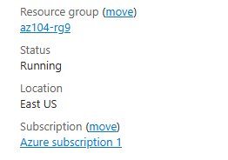
- Verify that the Welcome to Azure Container Instance page is displayed. Refresh the page several times to create some log entries then close the browser tab.

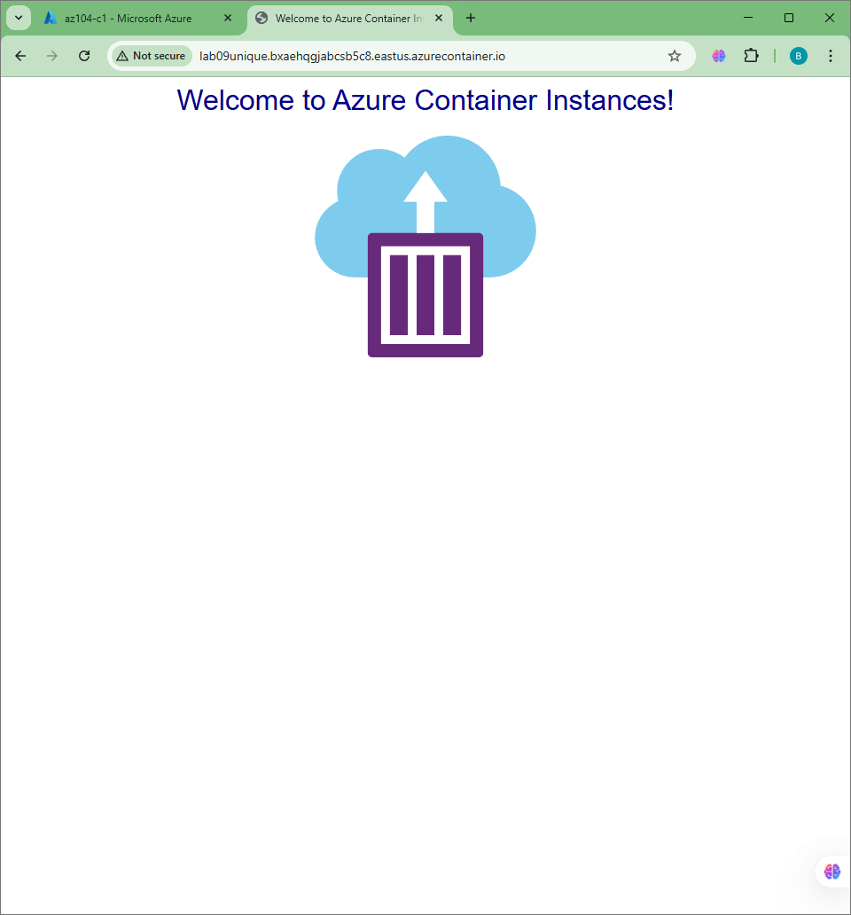

logs:

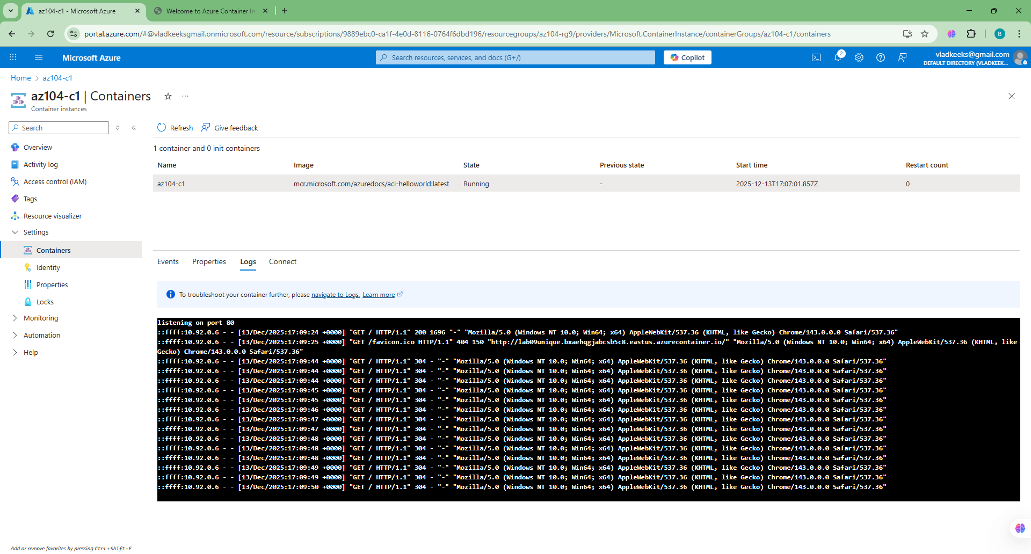

overall:

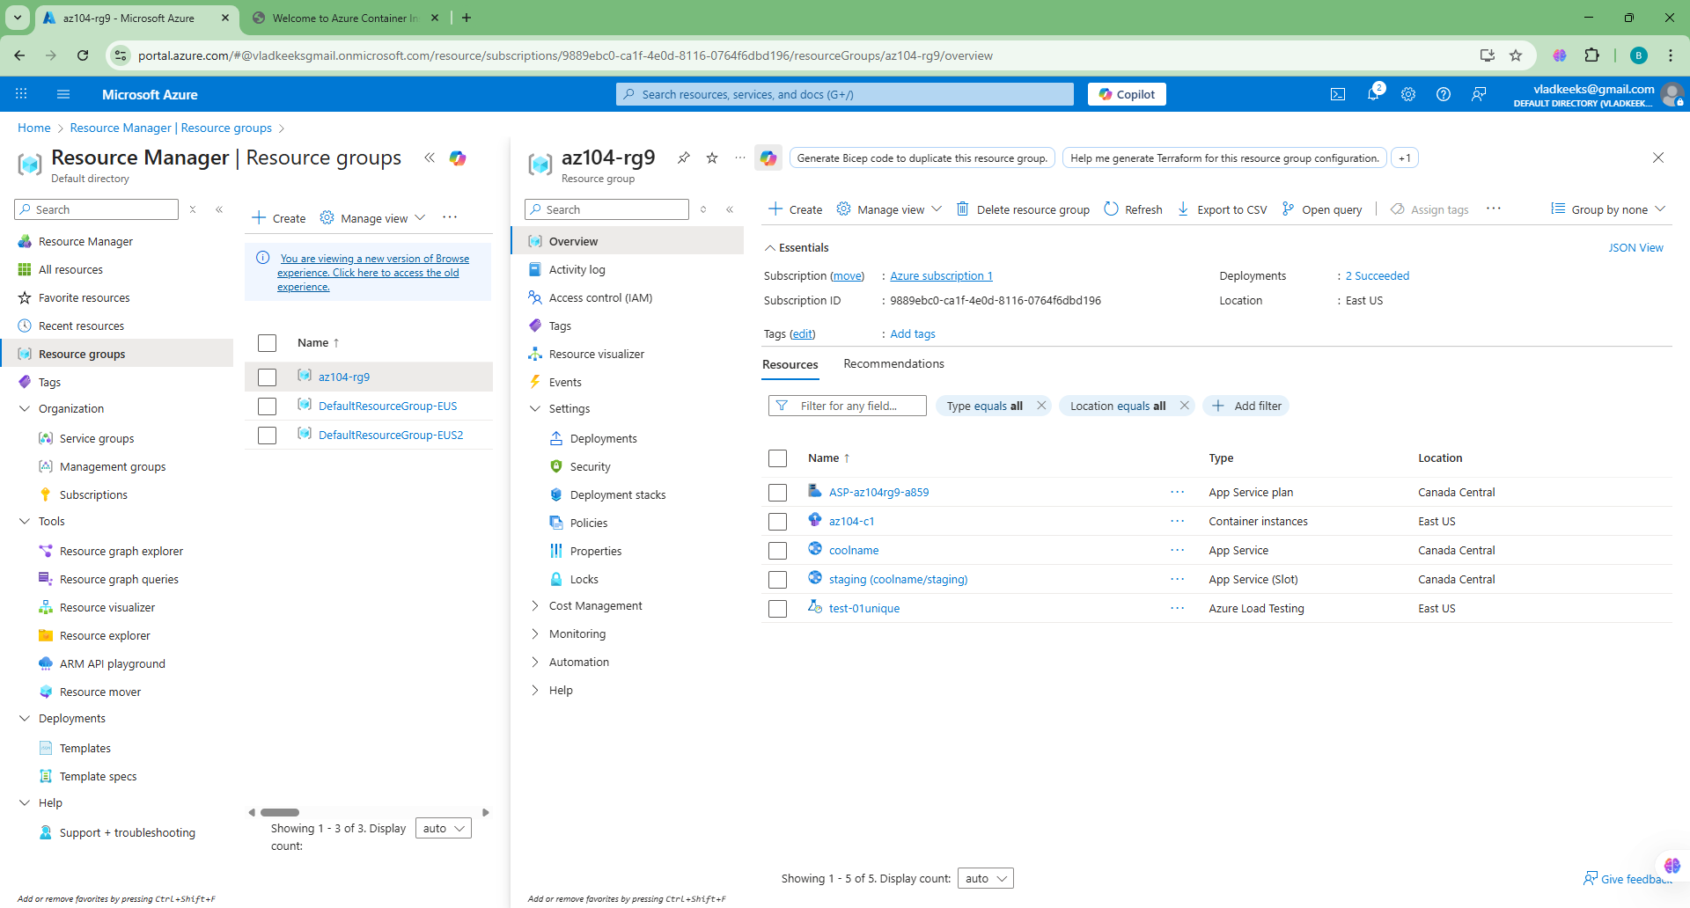

costs:
