Міністерство освіти і науки України
Карпатський національний університет
імені В.Стефаника

Факультет математики та інформатики
Кафедра інформаційних технологій

Інформатика і програмування

Лабораторна робота No 7

Тема: Implement Intersite Connectivity

Виконав: Прокутко В.В
Група ІПЗ-43
Дата: 12 грудня 2025
Викладач: Поварчук Д.Д

Івано-Франківськ – 2025

Task 1: Create a core services virtual machine and virtual network
In this task, you create a core services virtual network with a virtual machine.
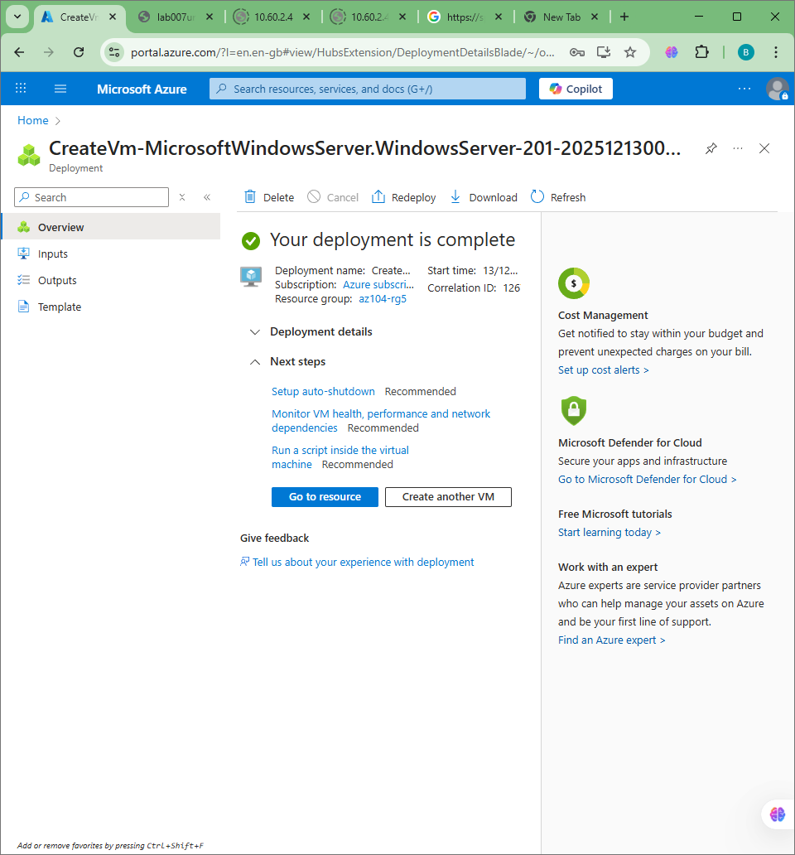

Task 2: Create a virtual machine in a different virtual network
In this task, you create a manufacturing services virtual network with a virtual machine.

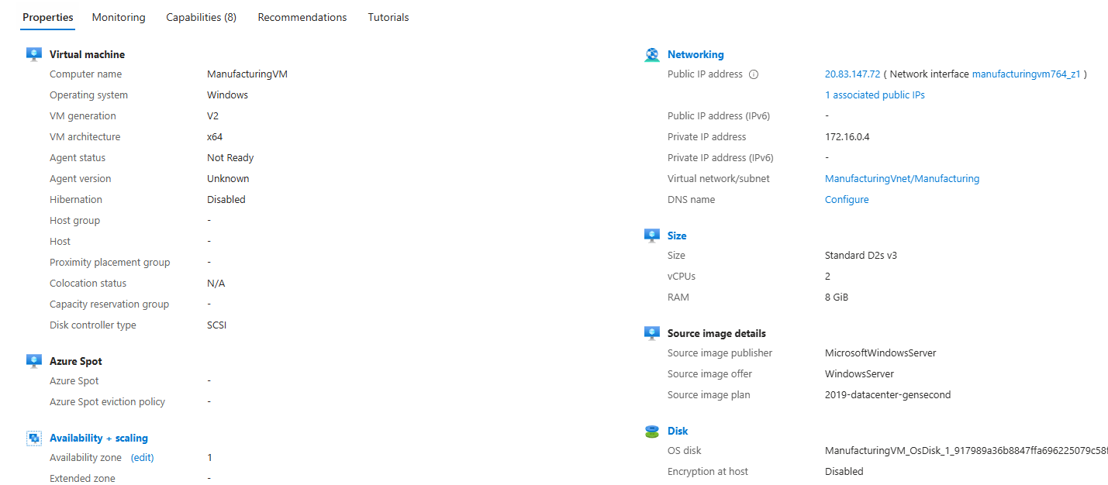

Task 3: Use Network Watcher to test the connection between virtual machines
In this task, you verify that resources in peered virtual networks can communicate with each other. Network Watcher will be used to test the connection. Before continuing, ensure both virtual machines have been deployed and are running.

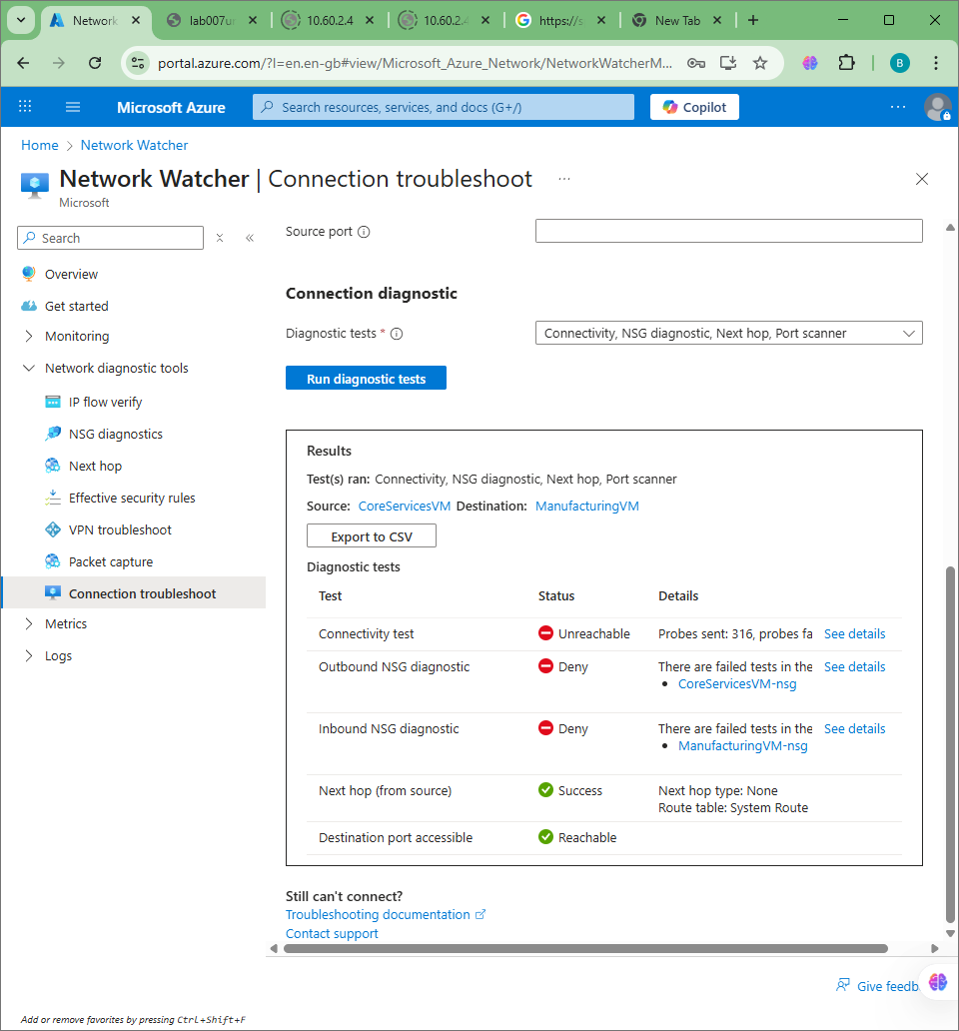

Task 4: Configure virtual network peerings between virtual networks
In this task, you create a virtual network peering to enable communications between resources in the virtual networks.

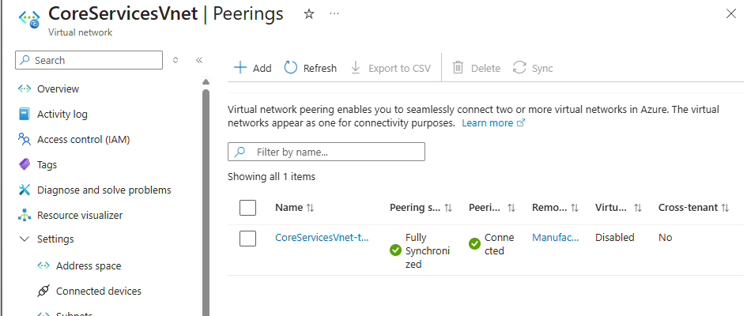

Task 5: Use Azure PowerShell to test the connection between virtual machines
In this task, you retest the connection between the virtual machines in different virtual networks.

there is error, idk why

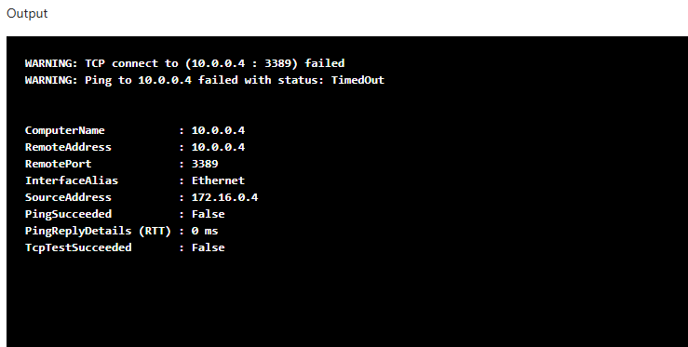

Task 6: Create a custom route
In this task, you want to control network traffic between the perimeter subnet and the internal core services subnet. A virtual network appliance will be installed in the perimeter subnet and all traffic should be routed there.
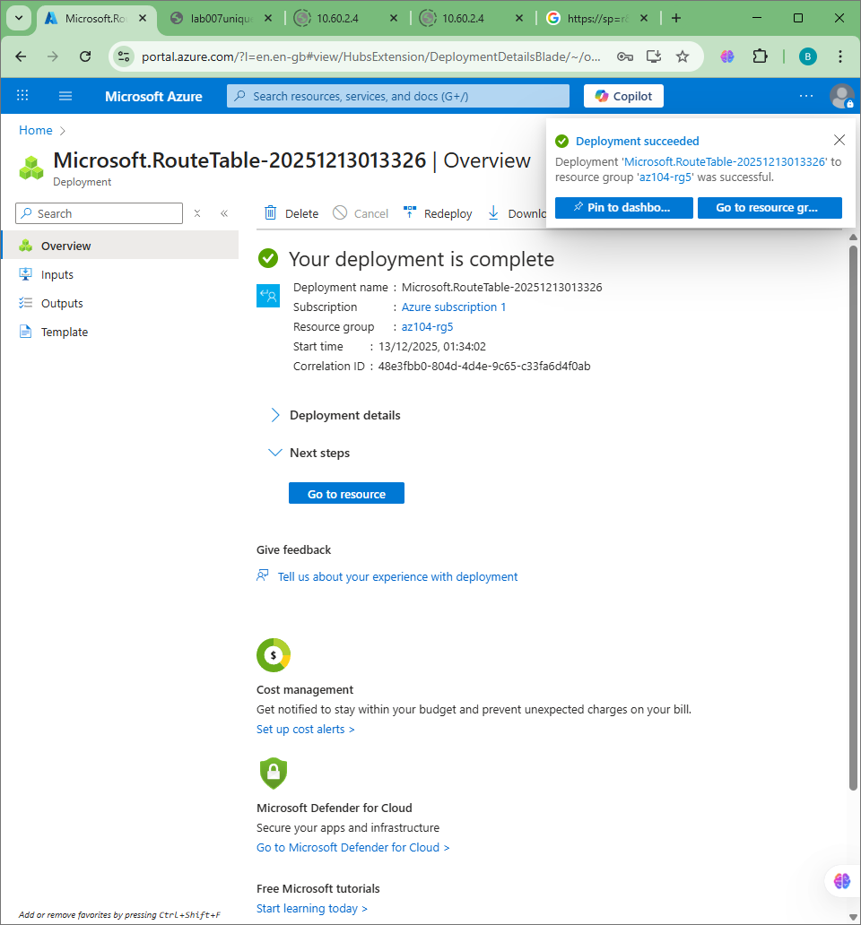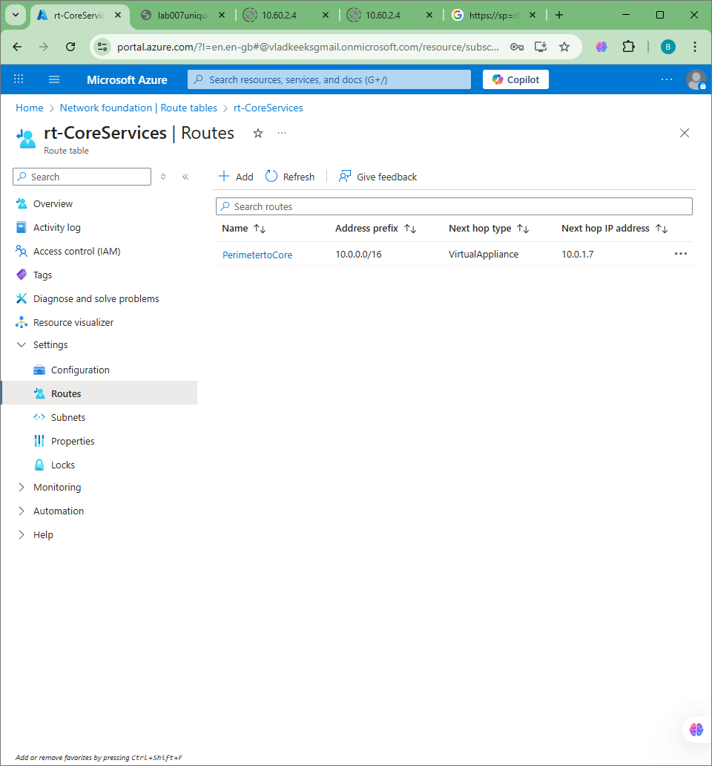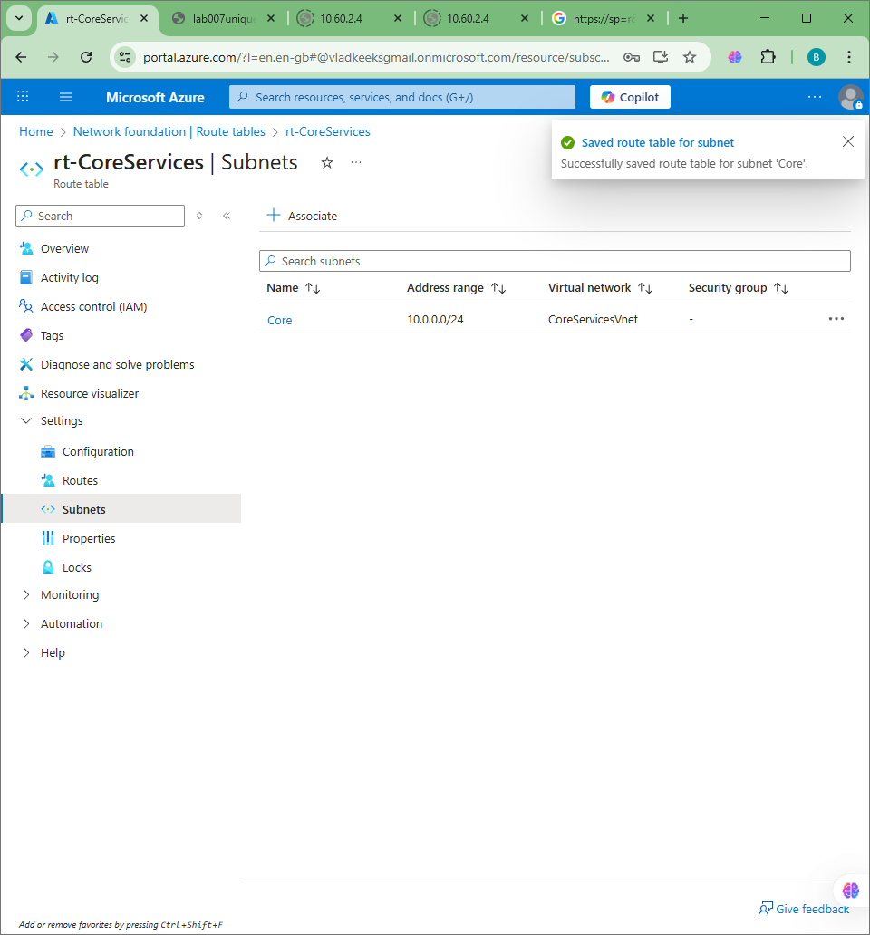
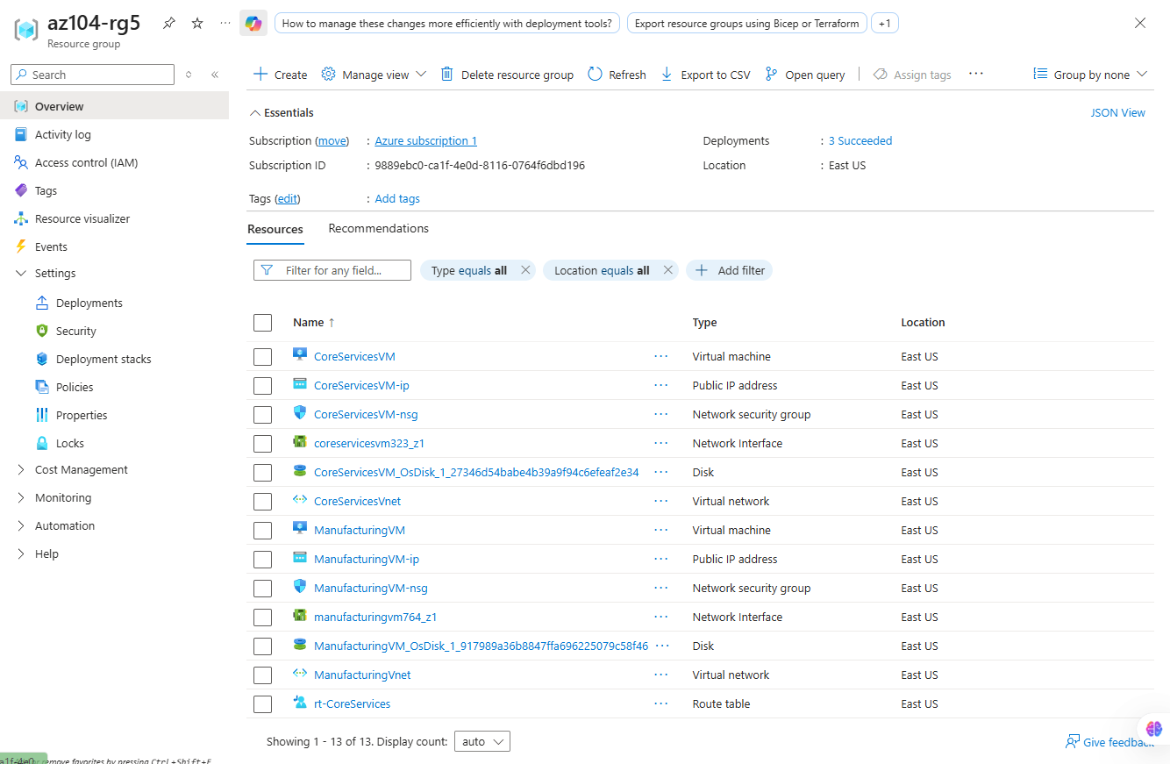

Costs:
