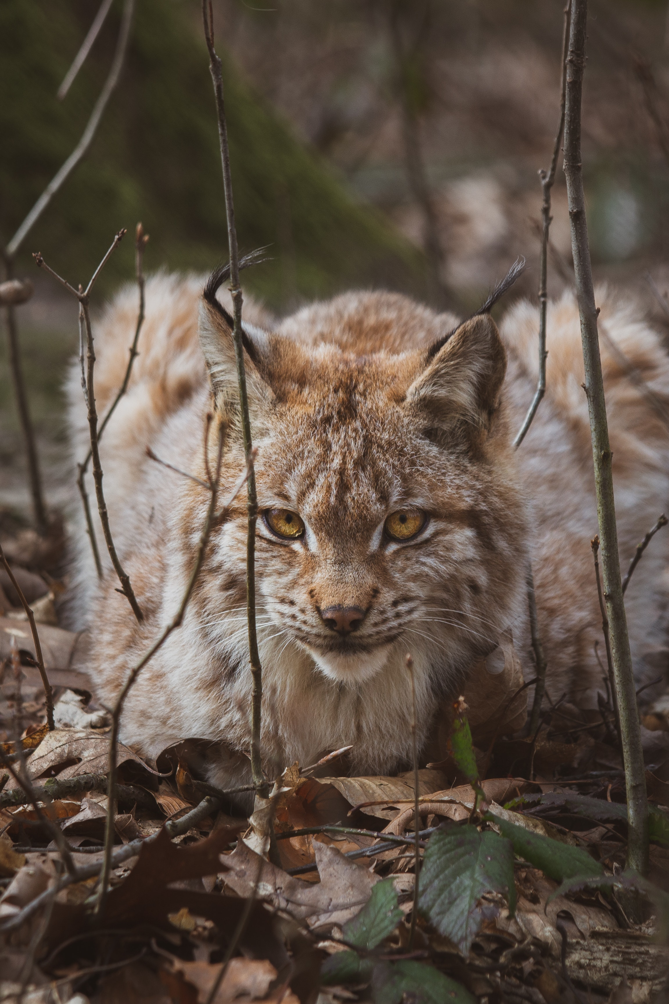

Vlada | 06603996266 | vlada@gmail.com

# About me

I love coding

# Work Experience

**Swarovski** *2015-2021*bad

# Skills

* Gaming
* drawing