The first step is to add a Thread Group, which represents the users:
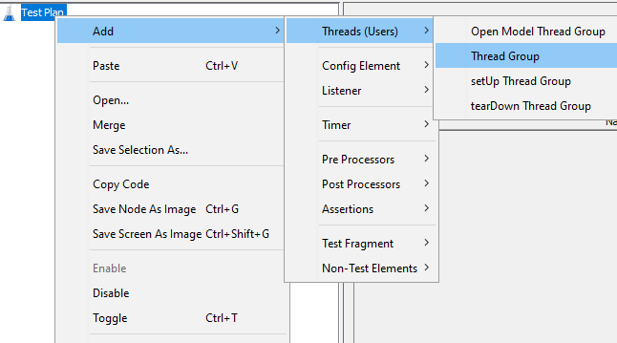
Amount of users is 10, number of loop count is 10:
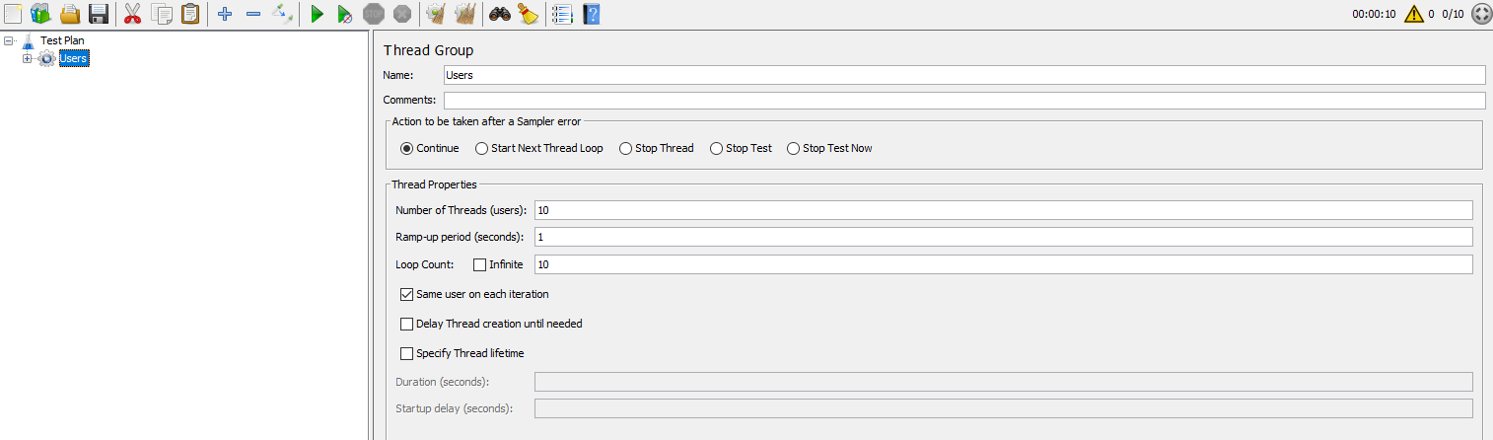
Let’s add a simple HTTP call:
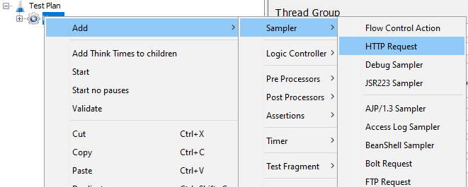
Let’s search “hunt” in steam store. The HTTP call is next: https://store.steampowered.com/search/?term=hunt. Now let’s put that into Jmeter:
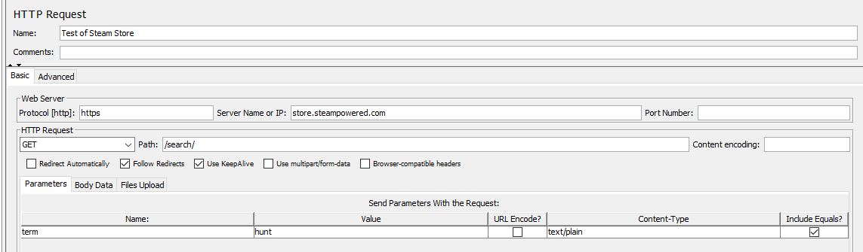

Let’s add two listeners – View Results in Table to see all requests and Summary Report to see aggregated result as long as there are 100 requests in total:
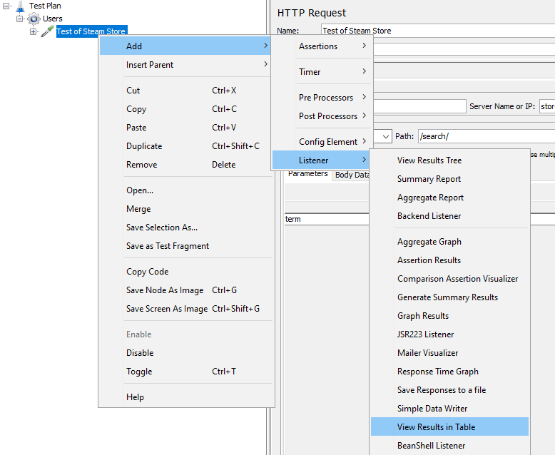
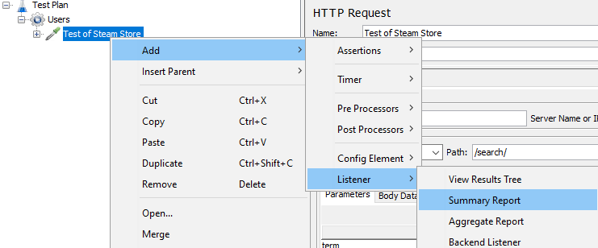
Ok, so the result of testing looks like follows:
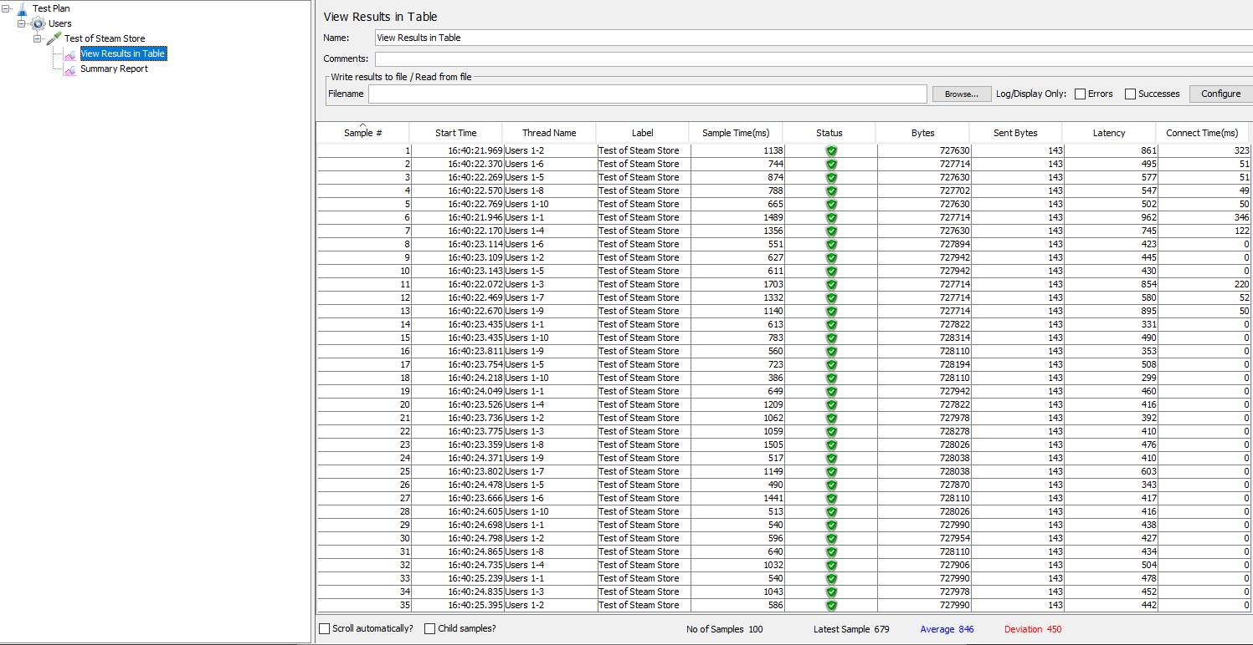
The result in a nice compact way:
