1 | Is there any inconsistency in the UI?    (buttons disabled)  The cursor should not have the pointer style.
2 | Is there any inconsistency in the UI?  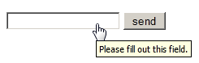  The cursor should be in “input text” style.
3 | Is there any inconsistency in the UI?    Input and cursor are not active, and button is active.
4 | How checkbox can be checked off?  By clicking on it or pressing Space while tabbing through inputs.
5 | The gender selection is implemented on screen below. Please describe the weak points of this implementation and propose better way of implementation.  It is better to use radio button as long as it is unclear which variant is selected.
6 | Please, propose improvements for the part of the screen below.  Requirement: if ‘no thanks’ checkbox is checked off other fields should be disabled  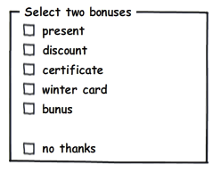  “Bonus” is misspelled. There should be 2 sets of radio buttons for bonuses, and ‘no thanks’ .
7 | Please provide your recommendations regarding improvements of the part of screen below.  It is better to use checkbox to express boolean statement.
8 | Would a radio button be a better choice? (select between Portrait and Landscape mode, Portrait uses by default )    Use radio button or toggle between variants, since with checkbox it is not clear what are the two options.
9 | Is radio button the best choice?  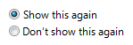  It is better to use checkbox here. The text should be “Don’t show this again” and the checkbox  should be checked by default.
10 | Is it the best implementation of the part of screen?  It would be much better to use vertical arrangement.
11 | What is mixed-state for checkbox?  It means that part of the options are selected.
12 | Can we use checkboxes as a progress indicator?  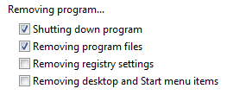  For such case it would be better to use progress bar.
13 | Can we use the selection of a checkbox to perform commands?  No, as long as checkboxes are used for selection, not execution.
14 | Can we use the selection of a checkbox to dynamically display other controls related to the selected control (screen readers cannot detect such events)?  No
15 | Can we use the selection of a checkbox to display other windows, such as a dialog box to gather more input?  No
16 | Are there any inconsistency in the relationship between radio buttons and checkboxes?  Requirement: when ‘Custom’ radio-button is selected all checkboxes are enabled.  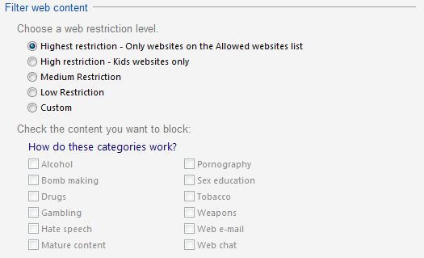  Text color should be black. Checkboxes should be active and checked automatically depending on radio button selection, and radio button should change to custom when checkboxes are clicked manually.
17 | Is it the best implementation of screen?  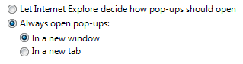  Yes, it is not bad.
18 | How implementation of screen can be improved?  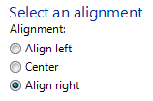  Remove subheader “Alignment:” and “Align” words, place these buttons horizontally.
19 | Is it the best way of the controls’ location on the screen?    Yes
20 | Is it right to leave editable text boxes and drop-down lists enabled if they share the radio button's label? (See example). What requirement should be for the editable field?  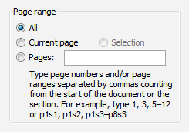  1. Yes, it’s fine.  2. Text field must be disabled until “Pages” radio is active.
21 | What is list-box, drop-down list, combobox? What are the two types of combobox?  List box allows one or multiple items selection.  Drop-down list allows selection between items, which become visible on click.  Combobox combines a text input field with dropdown.  Types of combobox:  1. Dropdown Combo: Opens a list when clicked for selection.  2).Autocomplete Combo: Provides real-time suggestions as users type.
22 | There are numbers from 1 to 31 (day of month) in dropdown list. How we can select 5?  By clicking on the dropdown trigger and selecting 5 from the list or entering 5 in the text box.
23 | There are numbers from 1 to 31 (day of month) in dropdown list. How we can change selection between 3, 30, 31 items?  Enter 3 in the text box.

