НАЦІОНАЛЬНИЙ ТЕХНІЧНИЙ УНІВЕРСИТЕТ УКРАЇНИ
«Київський політехнічний інститут імені Ігоря Сікорського»
Факультет інформатики та обчислювальної техніки
Кафедра інформатики та програмної інженерії

Звіти до комп’ютерних практикумів дисципліни

«Системне програмне забезпечення»

Прийняв  доцент кафедри ІПІ  Лісовиченко О.І.  “26” травня 2023 р. | Виконав  Студент групи ІП-11  Прищепа В.С.

Київ-2023
Комп’ютерний практикум №5
Тема: макрозасоби мови асемблер.
Завдання:
Скласти програму на нижче наведені завдання:
1) переписати програму комп‘ютерного практикуму №2 з використанням одного макроса;
2) переписати програму комп‘ютерного практикуму №3 з використанням макросів та передачею параметрів в них;
3) переписати одну програму (на вибір студента) комп‘ютерного практикуму №4 з використанням макросів та залученням міток в тілі макросу.

Текст програми 1:
input_digit macro

;input a string
lea dx, inarr
mov ah, 10
int 21h

;print a new line after the input
mov al,10
int 29h
mov al,13
int 29h
endm

STSEG SEGMENT PARA STACK "STACK"
DB 64 DUP("STACK")
STSEG ENDS

DSEG SEGMENT PARA PUBLIC "DATA"
inarr db 7,?,7 dup (" $")
input_tip db 13, 10, "Enter x in [-10922; 10922] =>> $"
is_negative db 0
num dw 0
digit dw 0
is_error db 0
error_message_1 db "Invalid symbol(s)!$"
error_message_2 db "Number out of diapason!$"
DSEG ENDS

CSEG SEGMENT PARA PUBLIC "CODE"
ASSUME CS:CSEG, DS:DSEG, SS:STSEG

main proc

;ds initialisation
mov ax, dseg
mov ds, ax

;showing a tip
lea dx, input_tip
mov ah, 9
int 21h

;input of number
input_digit
call str_to_int
cmp is_error, 1
je raise_error_1
cmp is_error, 2
je raise_error_2

;3*num
mov ax, num
mov bx, 3
imul bx
jo raise_error_2
mov num, ax

;printing of the result
call result_print
jmp end_program

;invalid symbol(s) error
raise_error_1:
LEA dx, error_message_1
MOV ah,9
INT 21h
jmp end_program

;wrong number error
raise_error_2:
LEA dx, error_message_2
MOV ah,9
INT 21h

;program finishing
end_program:
mov AH, 4CH
int 21H
ret
main endp

str_to_int proc

;load the address of first element of the array
mov si, offset inarr + 2
mov cx, 0

;check if inarr is empty
mov ax, 0
mov al, inarr + 1
cmp al, 0
je error_1

;converting of the array into number
convert_loop:

;check if it is the end of inarr
mov ax, 0
mov al, inarr + 1
cmp al, cl
je last

;set element of inarr to al
mov al, [si]

;check if the character is between "0" and "9"
cmp al, '0'
jl check_minus
cmp al, '9'
jg error_1
inc cx
inc si

;jump for converting character to digit
jmp convert_to_digit

;check character for "-"
check_minus:
cmp al, '-'
jne error_1

;check if it is the first element in inarr
cmp cx, 0
jne error_1
mov is_negative, 1
inc cx
inc si
jmp convert_loop

;converting character to digit
convert_to_digit:
sub al, '0'
mov digit, ax
mov bx, 10
mov ax, num
mul bx
jc error_2
js error_2
mov num, ax
mov ax, digit
add num, ax
jc error_2
js error_2
jmp convert_loop

;Used wrong symbol(s)
error_1:
mov is_error, 1
jmp finish

;Inputed number out of range
error_2:
mov is_error, 2
jmp finish

;check if the number is negative
last:
cmp is_negative, 1
jne finish
neg num

finish:
ret
str_to_int endp

result_print proc

;check if result is negative
mov bx, num
or bx, bx
jns m1

;if is negative, print '-' and make it positive
mov al, '-'
int 29h
neg bx

;prepare to split number into digits
m1:
mov ax, bx
xor cx, cx
mov bx, 10

;split it into digits and write it down
m2:
xor dx, dx
div bx
add dl, '0'
push dx
inc cx
test ax, ax
jnz m2

;print these digits in correct order
m3:
pop ax
int 29h
loop m3
ret
result_print endp

CSEG ENDS
END MAIN

Текст програми 2:
input_digit macro

;input a string
lea dx, inar
mov ah, 10
int 21h

;print a new line after the input
mov al,10
int 29h
mov al,13
int 29h
endm

str_to_int macro inarr
local convert_loop, check_minus, convert_to_digit, error_1, error_2, last, finish

;load the address of first element of the array
mov si, offset inarr + 2
mov cx, 0

;check if inarr is empty
mov ax, 0
mov al, inarr + 1
cmp al, 0
je error_1

;converting of the array into number
convert_loop:

;check if it is the end of inarr
mov ax, 0
mov al, inarr + 1
cmp al, cl
je last

;set element of inarr to al
mov al, [si]

;check if the character is between "0" and "9"
cmp al, '0'
jl check_minus
cmp al, '9'
jg error_1
inc cx
inc si

;jump for converting character to digit
jmp convert_to_digit

;check character for "-"
check_minus:
cmp al, '-'
jne error_1

;check if it is the first element in inarr
cmp cx, 0
jne error_1
mov is_negative, 1
inc cx
inc si
jmp convert_loop

;converting character to digit
convert_to_digit:
sub al, '0'
mov digit, ax
mov bx, 10
mov ax, num
mul bx
jc error_2
js error_2
mov num, ax
mov ax, digit
add num, ax
jc error_2
js error_2
jmp convert_loop

;Used wrong symbol(s)
error_1:
mov is_error, 1
jmp finish

;Inputed number out of range
error_2:
mov is_error, 2
jmp finish

;check if the number is negative
last:
cmp is_negative, 1
jne finish
neg num

finish:
endm

calc_res macro xpar
local x_zero, x_less, error, finishs

;compare xpar with 0
cmp xpar, 0
je x_zero
jl x_less

;xpar>0 z=5*(4*xpar+7)/((xpar+1)*(xpar+2))
mov ax, xpar
add ax, 1
jc error
mov bx, ax
add ax, 1
jc error
mul bx
jc error
mov denom, ax
mov ax, xpar
mov bx, 4
mul bx
jc error
add ax, 7
jc error
mov bx, 5
mul bx
jc error
mov bx, denom
div bx
mov num, ax
mov ax, dx
mov nom, ax
jmp finishs

;xpar=0 z=5
x_zero:
mov ax, 5
mov num, ax
jmp finishs

;xpar<0 z=5*xpar^2/(1-xpar)
x_less:
mov ax, xpar
neg ax
jo error
add ax, 1
jc error
mov denom, ax
sub ax, 1
mov bx, ax
mul bx
jc error
mov bx, 5
mul bx
jc error
mov bx, denom
div bx
mov num, ax
mov ax, dx
mov nom, ax
jmp finishs

;xpar out of diapason
error:
mov is_error, 2

finishs:
endm

result_print macro number
local m1, m2

;prepare to split number into digits
mov ax, number
xor cx, cx
mov bx, 10

;split it into digits and write it down
m1:
xor dx, dx
div bx
add dl, '0'
push dx
inc cx
test ax, ax
jnz m1

;print these digits in correct order
m2:
pop ax
int 29h
loop m2
endm

exit macro

mov AH, 4CH
int 21H
endm

error_check macro
local raise_error_1, raise_error_2, continue

cmp is_error, 1
je raise_error_1
cmp is_error, 2
je raise_error_2
jmp continue

;invalid symbol(s) error
raise_error_1:
LEA dx, error_message_1
MOV ah,9
INT 21h
exit

;wrong number error
raise_error_2:
LEA dx, error_message_2
MOV ah,9
INT 21h
exit

continue:
endm

res_fraction macro
local frac, end_p

;printing of the result
cmp num, 0
je frac
result_print num
mov al, ' '
int 29h

cmp nom, 0
jne frac
jmp end_p

;printing of the fraction
frac:
result_print nom
mov al, '/'
int 29h
result_print denom

end_p:
endm

STSEG SEGMENT PARA STACK "STACK"
DB 64 DUP("STACK")
STSEG ENDS

DSEG SEGMENT PARA PUBLIC "DATA"
x dw 0
nom dw 0
denom dw 0
inar db 7,?,7 dup (" $")
input_tip db 13, 10, "Enter x in [-114;-1], {0} or [1;254] ==> $"
is_negative db 0
num dw 0
digit dw 0
is_error db 0
error_message_1 db "Invalid symbol(s)!$"
error_message_2 db "Number out of diapason!$"
DSEG ENDS

CSEG SEGMENT PARA PUBLIC "CODE"
ASSUME CS:CSEG, DS:DSEG, SS:STSEG

main proc

;ds initialisation
mov ax, dseg
mov ds, ax

;showing a tip
lea dx, input_tip
mov ah, 9
int 21h

;input of number
input_digit
str_to_int inar
error_check

;calculation
mov ax, num
mov x, ax
calc_res x
error_check
res_fraction
exit
ret
main endp

CSEG ENDS
END MAIN

Особливості роботи:
В даній програмі ми передаємо параметри в деякі макроси. Покажемо, як це працює, на фрагментах lst-файла:

......
15 str_to_int macro inarr
16 local convert_loop, check_minus, convert_to_digit, error_1, error_2, last, finish
17
18 ;load the address of first element of the array
19 mov si, offset inarr + 2
20 mov cx, 0
21
22 ;check if inarr is empty
23 mov ax, 0
24 mov al, inarr + 1
25 cmp al, 0
26 je error_1
27
28 ;converting of the array into number
29 convert_loop:
30
31 ;check if it is the end of inarr
32 mov ax, 0
33 mov al, inarr + 1
34 cmp al, cl
35 je last
36
37 ;set element of inarr to al
38 mov al, [si]
39
40 ;check if the character is between "0" and "9"
41 cmp al, '0'
42 jl check_minus
43 cmp al, '9'
44 jg error_1
45 inc cx
46 inc si
47
48 ;jump for converting character to digit
49 jmp convert_to_digit
50
51 ;check character for "-"
52 check_minus:
53 cmp al, '-'
54 jne error_1
55
56 ;check if it is the first element in inarr
57 cmp cx, 0

Turbo Assembler Version 4.0 05/08/23 14:57:39 Page 2
Lab5_2.asm

58 jne error_1
59 mov is_negative, 1
60 inc cx
61 inc si
62 jmp convert_loop
63
64 ;converting character to digit
65 convert_to_digit:
66 sub al, '0'
67 mov digit, ax
68 mov bx, 10
69 mov ax, num
70 mul bx
71 jc error_2
72 js error_2
73 mov num, ax
74 mov ax, digit
75 add num, ax
76 jc error_2
77 js error_2
78 jmp convert_loop
79
80 ;Used wrong symbol(s)
81 error_1:
82 mov is_error, 1
83 jmp finish
84
85 ;Inputed number out of range
86 error_2:
87 mov is_error, 2
88 jmp finish
89
90 ;check if the number is negative
91 last:
92 cmp is_negative, 1
93 jne finish
94 neg num
95
96 finish:
97 endm
......
301 str_to_int inar
1 302 001B BE 0008r mov si, offset inar + 2
1 303 001E B9 0000 mov cx, 0
1 304 0021 B8 0000 mov ax, 0
1 305 0024 A0 0007r mov al, inar + 1
1 306 0027 3C 00 cmp al, 0
1 307 0029 74 4C je ??0003
1 308 002B ??0000:
1 309 002B B8 0000 mov ax, 0
1 310 002E A0 0007r mov al, inar + 1
1 311 0031 3A C1 cmp al, cl
1 312 0033 74 52 je ??0005
1 313 0035 8A 04 mov al, [si]
1 314 0037 3C 30 cmp al, '0'
1 315 0039 7C 09 jl ??0001
1 316 003B 3C 39 cmp al, '9'
1 317 003D 7F 38 jg ??0003
1 318 003F 41 inc cx
1 319 0040 46 inc si
1 320 0041 EB 13 90 jmp ??0002
1 321 0044 ??0001:
1 322 0044 3C 2D cmp al, '-'
1 323 0046 75 2F jne ??0003
1 324 0048 83 F9 00 cmp cx, 0
1 325 004B 75 2A jne ??0003
1 326 004D C6 06 0042r 01 mov is_negative, 1
1 327 0052 41 inc cx
1 328 0053 46 inc si
1 329 0054 EB D5 jmp ??0000
1 330 0056 ??0002:
1 331 0056 2C 30 sub al, '0'
1 332 0058 A3 0045r mov digit, ax
1 333 005B BB 000A mov bx, 10
1 334 005E A1 0043r mov ax, num
1 335 0061 F7 E3 mul bx
1 336 0063 72 1A jc ??0004
1 337 0065 78 18 js ??0004
1 338 0067 A3 0043r mov num, ax
1 339 006A A1 0045r mov ax, digit
1 340 006D 01 06 0043r add num, ax
1 341 0071 72 0C jc ??0004
1 342 0073 78 0A js ??0004

Turbo Assembler Version 4.0 05/08/23 14:57:39 Page 7
Lab5_2.asm

1 343 0075 EB B4 jmp ??0000
1 344 0077 ??0003:
1 345 0077 C6 06 0047r 01 mov is_error, 1
1 346 007C EB 14 90 jmp ??0006
1 347 007F ??0004:
1 348 007F C6 06 0047r 02 mov is_error, 2
1 349 0084 EB 0C 90 jmp ??0006
1 350 0087 ??0005:
1 351 0087 80 3E 0042r 01 cmp is_negative, 1
1 352 008C 75 04 jne ??0006
1 353 008E F7 1E 0043r neg num
1 354 0092 ??0006:
.........

Тут, наприклад, ми можемо бачити, як транслюється макрос str_to_int в залежності від переданого параметра-рядка. У першому випадку було оголошено макрос, який приймав параметр inarr, у другому – програма викликала макрос із параметром inar, який був підставлений замість inarr, і через це в нас змінився фактичний код програми в lst файлі.

Текст програми 3:
input_digit macro
mov ah, 9 ;showing a tip
int 21h
lea dx, inme ;input a number
mov ah, 10
int 21h
mov al,10 ;print a new line after the input
int 29h
mov al,13
int 29h
endm

str_to_int macro inmes
local convert_loop, minus_check, convert_to_digit, add_digit, minimal_possible, error_1, error_2, finn, done
mov num, 0
mov is_negative, 0
mov si, offset inmes + 2 ;load the address of the first element
mov ch, 0
convert_loop:
mov ax, 0 ;check if it is the end of inmes
mov al, inmes + 1
cmp al, ch
je finn
mov al, [si] ;set element of inmes to al
cmp al, '0'
jl minus_check ;check if the character is between "0" and "9"
cmp al, '9'
jg error_1
inc ch
inc si
jmp convert_to_digit ;go to next element in inmes
minus_check: ;check character for "-"
cmp al, '-'
jne error_1
cmp ch, 0 ;check if it is the first element in inmes
jne error_1
mov is_negative, 1
inc ch
inc si
jmp convert_loop
convert_to_digit:
sub al, '0'
mov digit, ax
mov bx, 10
mov ax, num
mul bx
jc error_2
js error_2
mov num, ax
mov ax, digit
cmp num, 32760
je minimal_possible
add_digit:
add num, ax
jc error_2
js error_2
jmp convert_loop
minimal_possible:
cmp is_negative, 0
je add_digit
neg num
sub num, ax
jo error_2
jmp done
error_1:
mov is_error, 1
jmp done
error_2:
mov is_error, 2
jmp done
finn:
cmp is_negative, 1 ;check if the number is negative
jne done
neg num
done:
xor ch, ch
endm

result_print macro number
local m1, m2, m3
mov bx, number
or bx, bx
jns m1
mov al, '-'
int 29h
neg bx
m1:
mov ax, bx
xor cx, cx
mov bx, 10
m2:
xor dx, dx
div bx
add dl, '0'
push dx
inc cx
test ax, ax
jnz m2
m3:
pop ax
int 29h
loop m3
endm

result_print_dword macro summ
local m_1, m_2, m_3
.386
mov ebx, summ
or ebx, ebx
jns m_1
mov al, '-'
int 29h
neg ebx
m_1:
mov eax, ebx
xor cx, cx
mov ebx, 10
m_2:
xor edx, edx
div ebx
add dl, '0'
push dx
inc cx
test eax, eax
jnz m_2
m_3:
pop ax
int 29h
loop m_3
endm

array_input macro
local elem_inp
.386
lea dx, elements_tip ;print a tip
mov ah, 9
int 21h
mov al,10 ;print a new line
int 29h
mov al,13
int 29h
mov counter, 0
mov di, 0
elem_inp: ;input loop
lea dx, el_tip ;formatted input array element
mov ah, 9
int 21h
result_print counter
lea dx, el_input_tip
input_digit
str_to_int inme
error_check
mov ax, num
mov [arr+di], ax
inc counter
add di, 2
mov cx, counter
cmp cx, arr_size
jne elem_inp
endm

array_sum macro summ
local sum_loop
.386
lea dx, sum_print
mov ah, 9
int 21h
xor dx, dx
xor ax, ax
mov cx, arr_size
mov di, 0
sum_loop:
mov ax, [arr+di]
cwde
add edx, eax
add di, 2
loop sum_loop
mov summ, edx
endm

array_min_and_max macro
local read_num, set_new_min, set_new_max, exit
mov ax, [arr]
mov min, ax
mov max, ax
mov cx, arr_size
sub cx, 1
jcxz exit
mov si, 2
read_num:
mov ax, [arr+si]
cmp ax, min
jl set_new_min
cmp ax, max
jg set_new_max
add si, 2
loop read_num
jmp exit
set_new_min:
mov min, ax
add si, 2
dec cx
jcxz exit
jmp read_num
set_new_max:
mov max, ax
add si, 2
dec cx
jcxz exit
jmp read_num
exit:
endm

array_sort macro
local outer_loop, inner_loop, continue, sort_done
cmp arr_size, 1
je sort_done
mov si, 0
outer_loop:
mov cx, arr_size
dec cx
mov di, 0
inner_loop:
mov ax, [arr+di] ;compare this element and next one
cmp ax, [arr+di+2]
jng continue
mov dx, [arr+di] ;swap elements if next one less
mov ax, [arr+di+2]
mov [arr+di], ax
mov [arr+di+2], dx
continue:
add di, 2
loop inner_loop
inc si
cmp si, arr_size
jl outer_loop
sort_done:
endm

array_print macro
local show
lea dx, sorted_arr_print
mov ah, 09h
int 21h
mov di, 0
mov si, 0
show:
result_print [arr+si]
mov al, ' '
int 29h
add si, 2
inc di
cmp di, arr_size
jne show
endm

exit macro
mov AH, 4CH
int 21H
endm

error_check macro
local raise_error_1, raise_error_2, contin
cmp is_error, 1
je raise_error_1
cmp is_error, 2
je raise_error_2
jmp contin
raise_error_1: ;invalid symbol(s) error
LEA dx, error_message_1
MOV ah,9
INT 21h
exit
raise_error_2: ;wrong number error
LEA dx, error_message_2
MOV ah,9
INT 21h
exit
contin:
endm

check_interval macro st, en, number
local final, con
cmp number, st
jle final
cmp number, en
jg final
jmp con
final:
LEA dx, error_message_2
MOV ah,9
INT 21h
exit
con:
endm

STSEG SEGMENT PARA STACK "STACK"
DB 64 DUP("STACK")
STSEG ENDS

DSEG SEGMENT PARA PUBLIC "DATA"
arr_size dw 0
inme db 7,?,7 dup (" $")
el_tip db "The $"
el_input_tip db " element => $"
is_negative db 0
num dw 0
digit dw 0
is_error db 0
error_message_1 db "Invalid symbol(s)!$"
error_message_2 db "Number is out of diapason!$"
size_tip db "Enter the size of array (1-32) => $"
elements_tip db "Enter values in [-32768; 32767]:$"
arr dw 32 dup (?)
sum_print db "Total sum: $"
sum dd 0
min_print db 13,10, "Minimal element: $"
min dw 0
max_print db 13,10, "Maximal element: $"
max dw 0
sorted_arr_print db 13, 10, "Sorted array: $"
counter dw 0
DSEG ENDS

CSEG SEGMENT PARA PUBLIC "CODE"
ASSUME CS:CSEG, DS:DSEG, SS:STSEG

main proc
mov ax, dseg
mov ds, ax
lea dx, size_tip ;input and convert size of array
input_digit
str_to_int inme
error_check
check_interval 0, 32, num
mov ax, num
mov arr_size, ax
array_input ;entering array elements
error_check
array_sum sum ;calculate and print the sum
result_print_dword sum
array_min_and_max ;find and print min and max element
lea dx, min_print
mov ah, 9
int 21h
result_print min
lea dx, max_print
mov ah, 9
int 21h
result_print max
array_sort ;sort array and print it
array_print
exit
ret
main endp

CSEG ENDS
end main

Особливості роботи:
В даній програмі ми використовуємо мітки в деяких макроси. Ті макроси з мітками, які використовуються неодноразово, мають команду local. Покажемо, як вона працює, на фрагментах lst-файла:

........
364 str_to_int inme
1 365 001B C7 06 0025r 0000 mov num, 0
1 366 0021 C6 06 0024r 00 mov is_negative, 0
1 367 0026 BE 0004r mov si, offset inme + 2 ;load the address of the first element
1 368 0029 B5 00 mov ch, 0
1 369 002B ??0000:
1 370 002B B8 0000 mov ax, 0 ;check if it is the end of inme
1 371 002E A0 0003r mov al, inme + 1
1 372 0031 3A C5 cmp al, ch
1 373 0033 74 70 je ??0007
1 374 0035 8A 04 mov al, [si] ;set element of inme to al
1 375 0037 3C 30 cmp al, '0'
1 376 0039 7C 0A jl ??0001 ;check if the character is between "0" and "9"
1 377 003B 3C 39 cmp al, '9'
1 378 003D 7F 56 jg ??0005
1 379 003F FE C5 inc ch
1 380 0041 46 inc si
1 381 0042 EB 14 90 jmp ??0002 ;go to next element in inme
1 382 0045 ??0001: ;check character for "-"
1 383 0045 3C 2D cmp al, '-'
1 384 0047 75 4C jne ??0005
1 385 0049 80 FD 00 cmp ch, 0 ;check if it is the first element in inme
1 386 004C 75 47 jne ??0005
1 387 004E C6 06 0024r 01 mov is_negative, 1
1 388 0053 FE C5 inc ch
1 389 0055 46 inc si
1 390 0056 EB D3 jmp ??0000
1 391 0058 ??0002:
1 392 0058 2C 30 sub al, '0'
1 393 005A A3 0027r mov digit, ax
1 394 005D BB 000A mov bx, 10
1 395 0060 A1 0025r mov ax, num
1 396 0063 F7 E3 mul bx
1 397 0065 72 36 jc ??0006
1 398 0067 78 34 js ??0006
1 399 0069 A3 0025r mov num, ax

Turbo Assembler Version 4.0 05/08/23 11:14:08 Page 8
Lab5_3.asm

1 400 006C A1 0027r mov ax, digit
1 401 006F 81 3E 0025r 7FF8 cmp num, 32760
1 402 0075 74 0A je ??0004
1 403 0077 ??0003:
1 404 0077 01 06 0025r add num, ax
1 405 007B 72 20 jc ??0006
1 406 007D 78 1E js ??0006
1 407 007F EB AA jmp ??0000
1 408 0081 ??0004:
1 409 0081 80 3E 0024r 00 cmp is_negative, 0
1 410 0086 74 EF je ??0003
1 411 0088 F7 1E 0025r neg num
1 412 008C 29 06 0025r sub num, ax
1 413 0090 70 0B jo ??0006
1 414 0092 EB 1C 90 jmp ??0008
1 415 0095 ??0005:
1 416 0095 C6 06 0029r 01 mov is_error, 1
1 417 009A EB 14 90 jmp ??0008
1 418 009D ??0006:
1 419 009D C6 06 0029r 02 mov is_error, 2
1 420 00A2 EB 0C 90 jmp ??0008
1 421 00A5 ??0007:
1 422 00A5 80 3E 0024r 01 cmp is_negative, 1 ;check if the number is negative
1 423 00AA 75 04 jne ??0008
1 424 00AC F7 1E 0025r neg num
1 425 00B0 ??0008:
1 426 00B0 32 ED xor ch, ch
........
1 512 str_to_int inme
2 513 0159 C7 06 0025r 0000 mov num, 0

Turbo Assembler Version 4.0 05/08/23 11:14:08 Page 10
Lab5_3.asm

2 514 015F C6 06 0024r 00 mov is_negative, 0
2 515 0164 BE 0004r mov si, offset inme + 2 ;load the address of the first element
2 516 0167 B5 00 mov ch, 0
2 517 0169 ??0012:
2 518 0169 B8 0000 mov ax, 0 ;check if it is the end of inme
2 519 016C A0 0003r mov al, inme + 1
2 520 016F 3A C5 cmp al, ch
2 521 0171 0F 84 0084 je ??0019
2 522 0175 8A 04 mov al, [si] ;set element of inme to al
2 523 0177 3C 30 cmp al, '0'
2 524 0179 7C 0E 90 90 jl ??0013 ;check if the character is between "0" and "9"
2 525 017D 3C 39 cmp al, '9'
2 526 017F 7F 68 90 90 jg ??0017
2 527 0183 FE C5 inc ch
2 528 0185 46 inc si
2 529 0186 EB 18 90 jmp ??0014 ;go to next element in inme
2 530 0189 ??0013: ;check character for "-"
2 531 0189 3C 2D cmp al, '-'
2 532 018B 75 5C 90 90 jne ??0017
2 533 018F 80 FD 00 cmp ch, 0 ;check if it is the first element in inme
2 534 0192 75 55 90 90 jne ??0017
2 535 0196 C6 06 0024r 01 mov is_negative, 1
2 536 019B FE C5 inc ch
2 537 019D 46 inc si
2 538 019E EB C9 jmp ??0012
2 539 01A0 ??0014:
2 540 01A0 2C 30 sub al, '0'
2 541 01A2 A3 0027r mov digit, ax
2 542 01A5 BB 000A mov bx, 10
2 543 01A8 A1 0025r mov ax, num
2 544 01AB F7 E3 mul bx
2 545 01AD 72 42 90 90 jc ??0018
2 546 01B1 78 3E 90 90 js ??0018
2 547 01B5 A3 0025r mov num, ax
2 548 01B8 A1 0027r mov ax, digit
2 549 01BB 81 3E 0025r 7FF8 cmp num, 32760
2 550 01C1 74 10 90 90 je ??0016
2 551 01C5 ??0015:
2 552 01C5 01 06 0025r add num, ax
2 553 01C9 72 26 90 90 jc ??0018
2 554 01CD 78 22 90 90 js ??0018
2 555 01D1 EB 96 jmp ??0012
2 556 01D3 ??0016:
2 557 01D3 80 3E 0024r 00 cmp is_negative, 0
2 558 01D8 74 EB je ??0015
2 559 01DA F7 1E 0025r neg num
2 560 01DE 29 06 0025r sub num, ax
2 561 01E2 70 0D 90 90 jo ??0018
2 562 01E6 EB 1E 90 jmp ??001A
2 563 01E9 ??0017:
2 564 01E9 C6 06 0029r 01 mov is_error, 1
2 565 01EE EB 16 90 jmp ??001A
2 566 01F1 ??0018:
2 567 01F1 C6 06 0029r 02 mov is_error, 2
2 568 01F6 EB 0E 90 jmp ??001A
2 569 01F9 ??0019:
2 570 01F9 80 3E 0024r 01 cmp is_negative, 1 ;check if the number is negative

Turbo Assembler Version 4.0 05/08/23 11:14:08 Page 11
Lab5_3.asm

2 571 01FE 75 06 90 90 jne ??001A
2 572 0202 F7 1E 0025r neg num
2 573 0206 ??001A:
2 574 0206 32 ED xor ch, ch
.........

Тут, наприклад, ми можемо бачити, як транслюється макрос str_to_int, що має в собі команду local. Фактичні назви його міток на кожному виклику набувають унікальних значень-чисел.

Схема роботи програми 1:
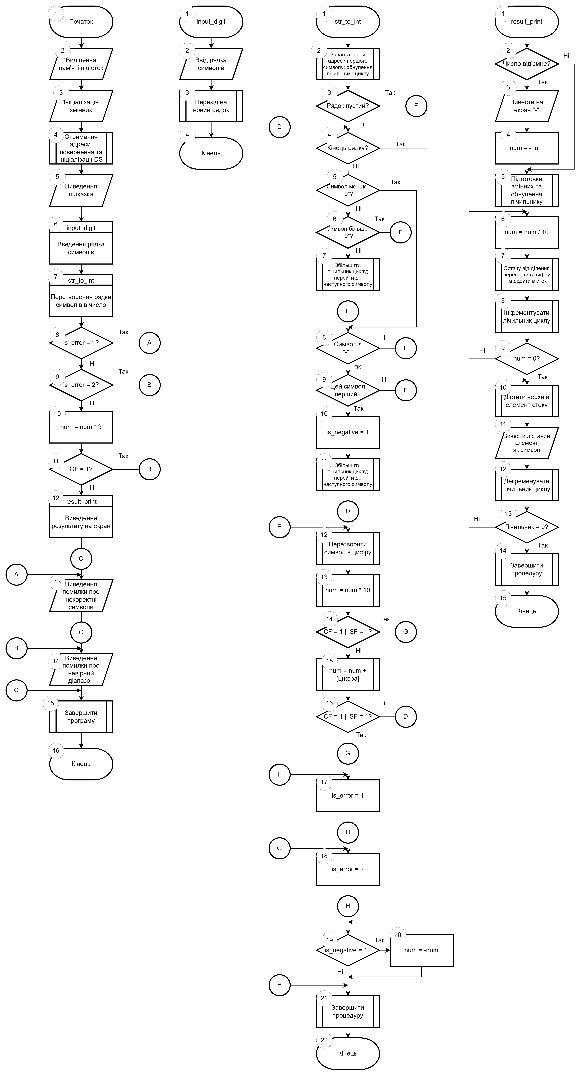

Схема роботи програми 2:

Схема роботи програми 3:
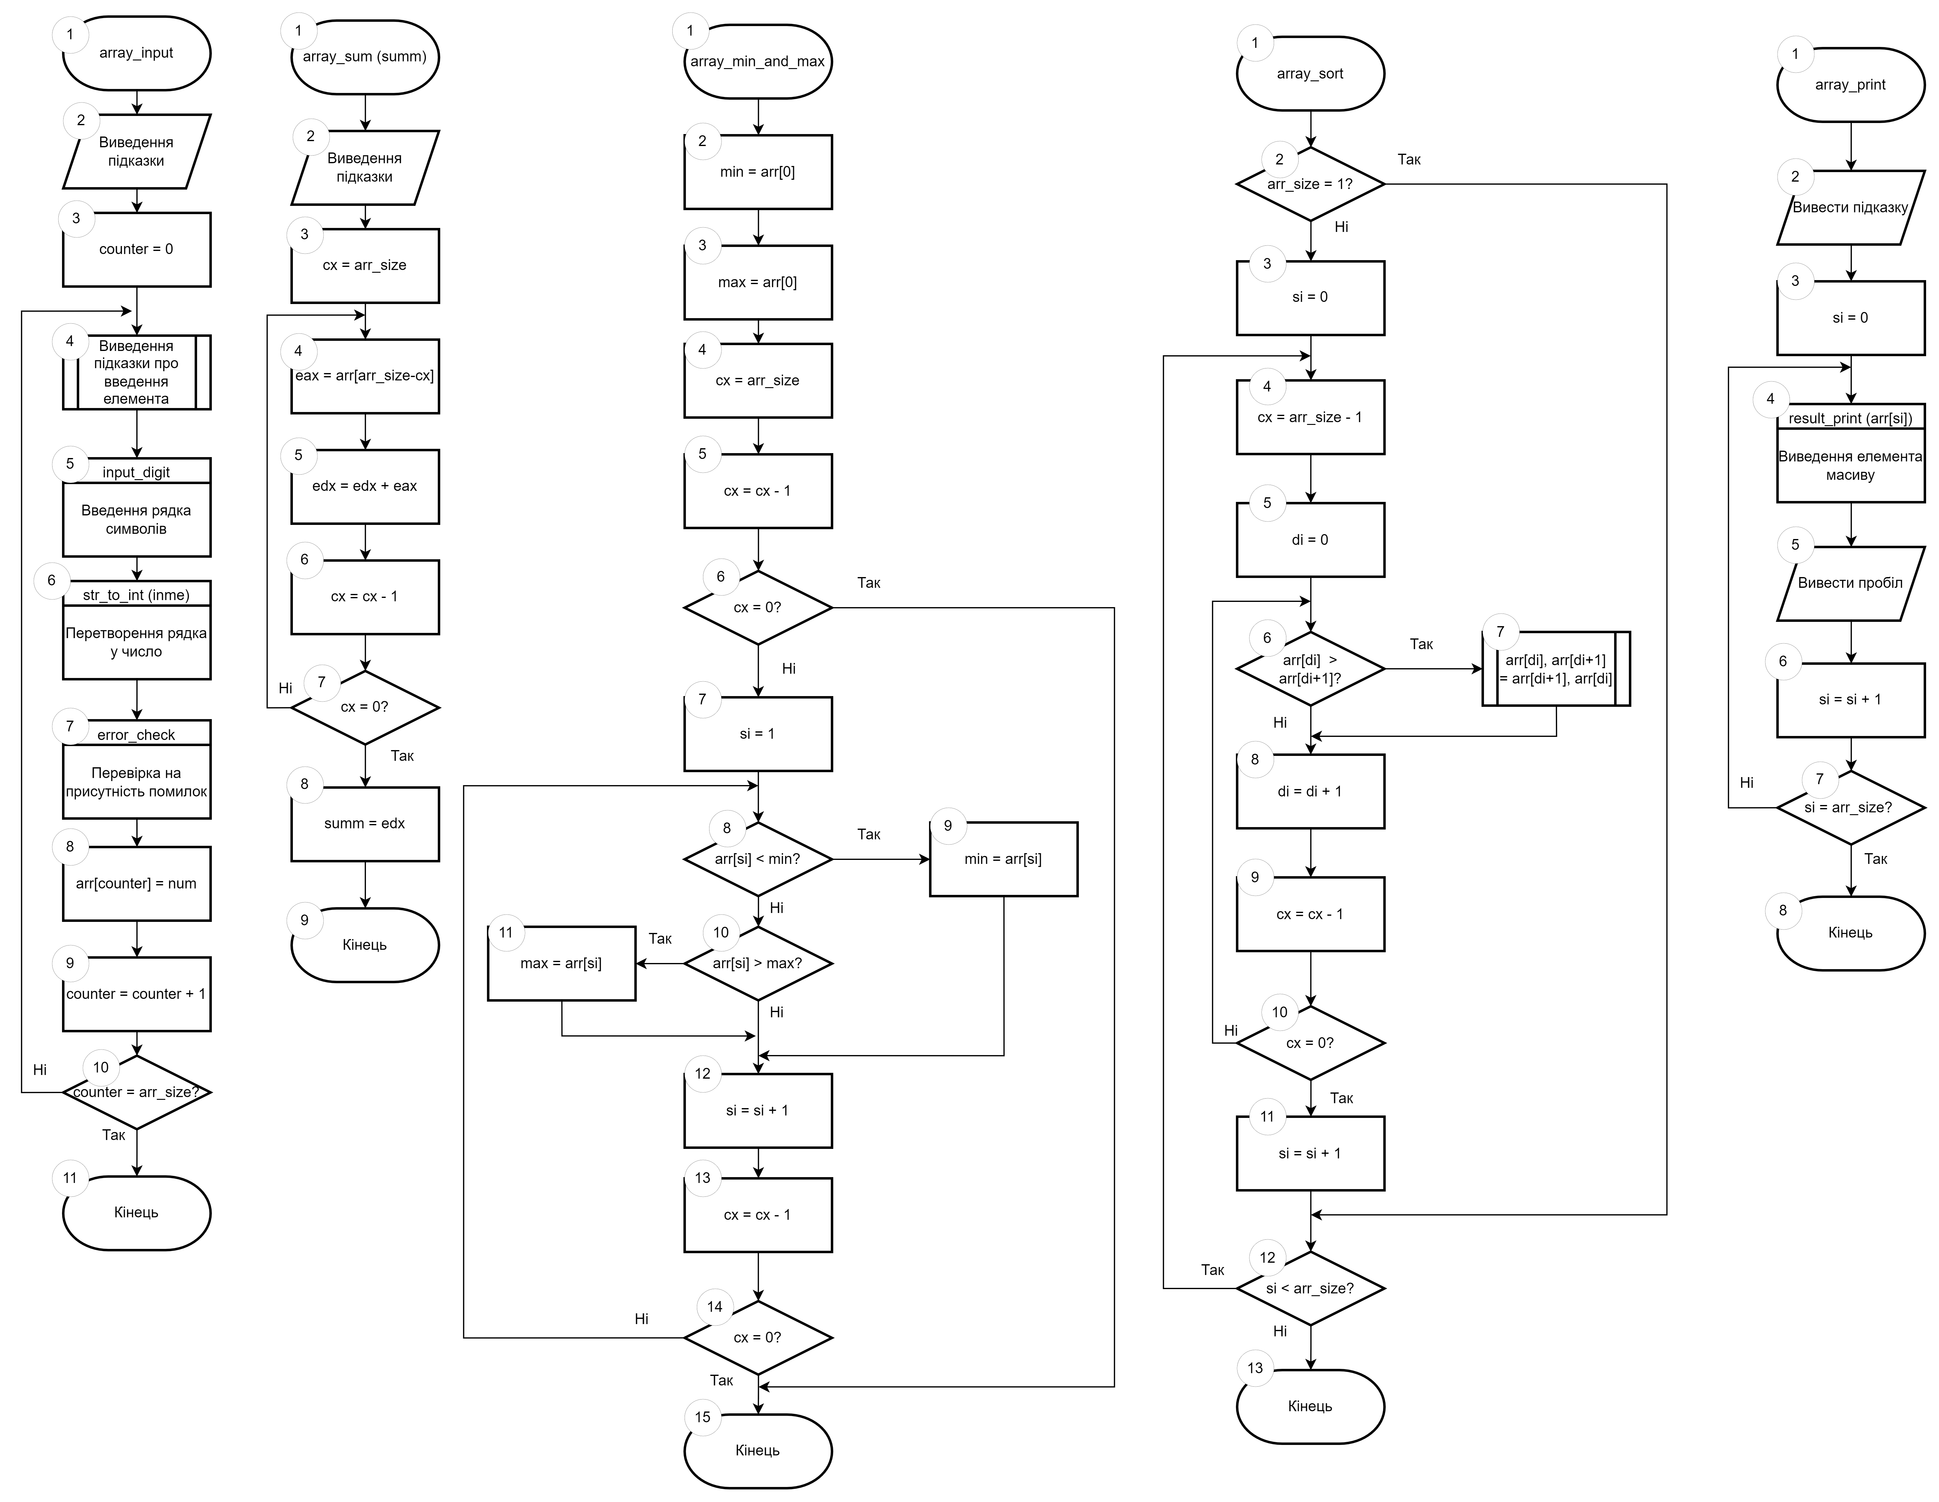
Приклади роботи програм:
Програма 1:
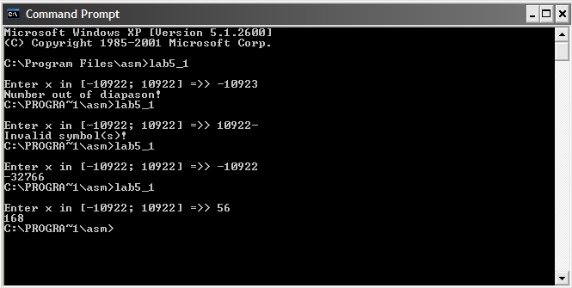
У першому виклику введене значення було поза дозволеного діапазону, в другому — було введене не число, а в третьому та четвертому — були введені правильні числа і програма вивела не повідомлення про помилку, а результат.

Програма 2:
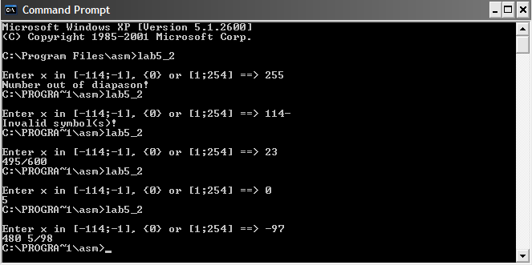
У першому та другому викликах були введені значення поза діапазоном та не число відповідно, що призвело до помилки. В останніх трьох викликах були введені значення для всіх випадків, які передбаченні програмою.

Програма 3:
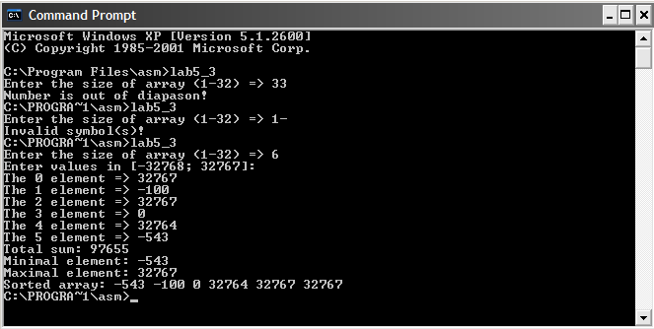
Перші два рази програма вивела помилки «Число поза дозволеного діапазону» чи «Використано невірні символи». Третього разу було продемонстровано, як програма працює при умові введення правильних значень. Спочатку було введено користувачем розмір та значення масиву, а далі програма підрахувала суму, знайшла мінімальний та максимальний елементи масиву і відсортувала масив за зростанням.

Висновок:
Складено програми на нижче наведені завдання (код і приклади виконання наведені нижче):
1) переписано програму комп‘ютерного практикуму №2 з використанням одного макросу (input_digit);
2) переписано програму комп‘ютерного практикуму №3 з використанням макросів та передачею параметрів в них (всі процедури перероблені в макроси, більшість з них приймає параметри). Особливості передачі параметрів у макроси продемонстровано в звіті;
3) переписана програма про масив комп‘ютерного практикуму №4 з використанням макросів та залученням міток в тілі макросу (всі процедури переписані в макроси, більшість з них має мітки). Особливості міток у макросах продемонстровано в звіті.

