**Question 1 Answer**

d. The results are(for net size 1000):

Erdos-Renyi model:

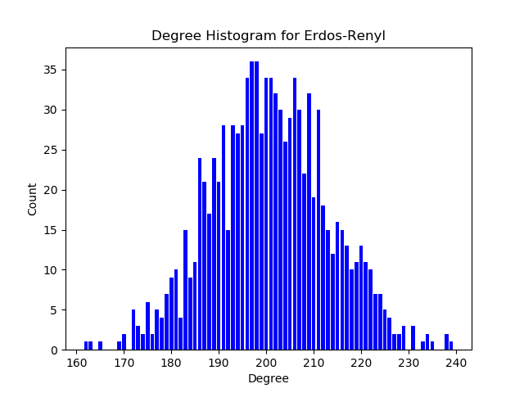**Clustering coefficient**:0.20108218824276208

**diameter**=2

**Degree Histogram:**

Small-World model:

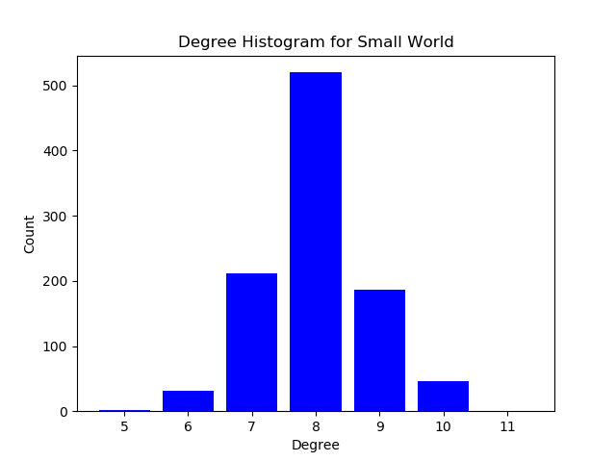**Clustering coefficient**:0.4722241702741702

**diameter**=9

**Degree Histogram:**