Question 3a

We have implemented check balance as shown at lesson 3. We iterate over all the triangles in the graph and check if they are all balanced, so no cycles with odd number of negative edges exit.

Question 3b/c

Solid edges are edges with plus sign.

Dashed edges are edges with minus sign.

Red edges 🡪 The reason why the graph is unbalanced.

G1:

P(+) = 0.9 P(-) = 0.1 🡪 Graph is unbalanced

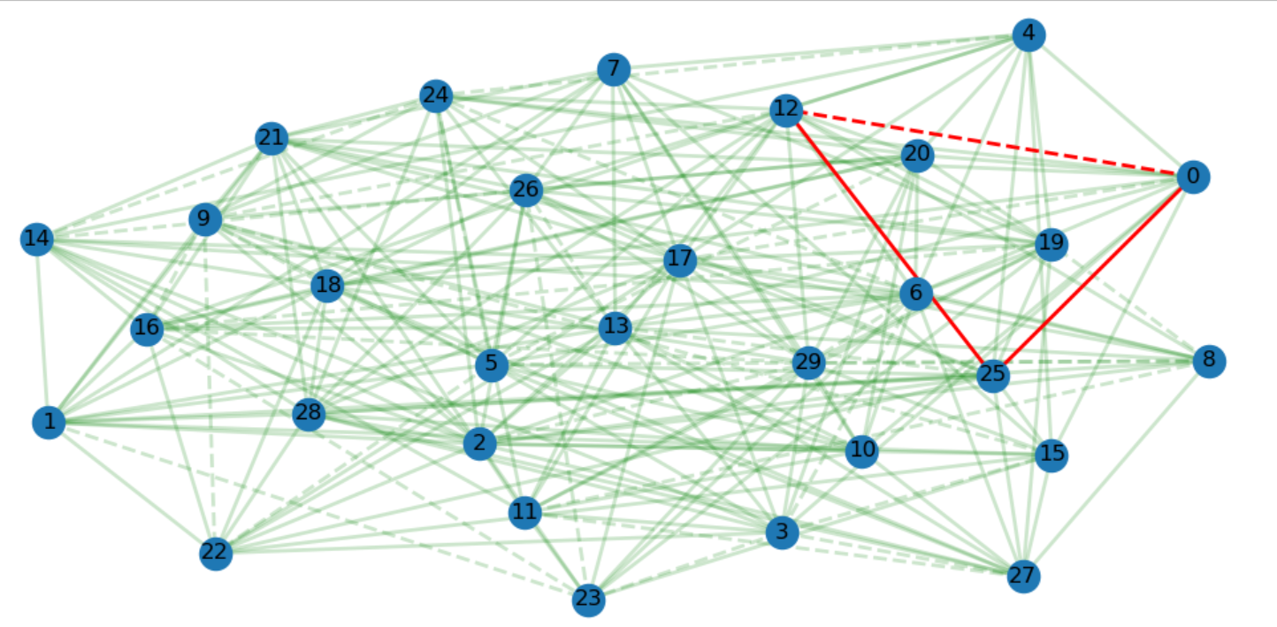

G2:

P(+) = 0.5 = P(-) 🡪 Graph is unbalanced

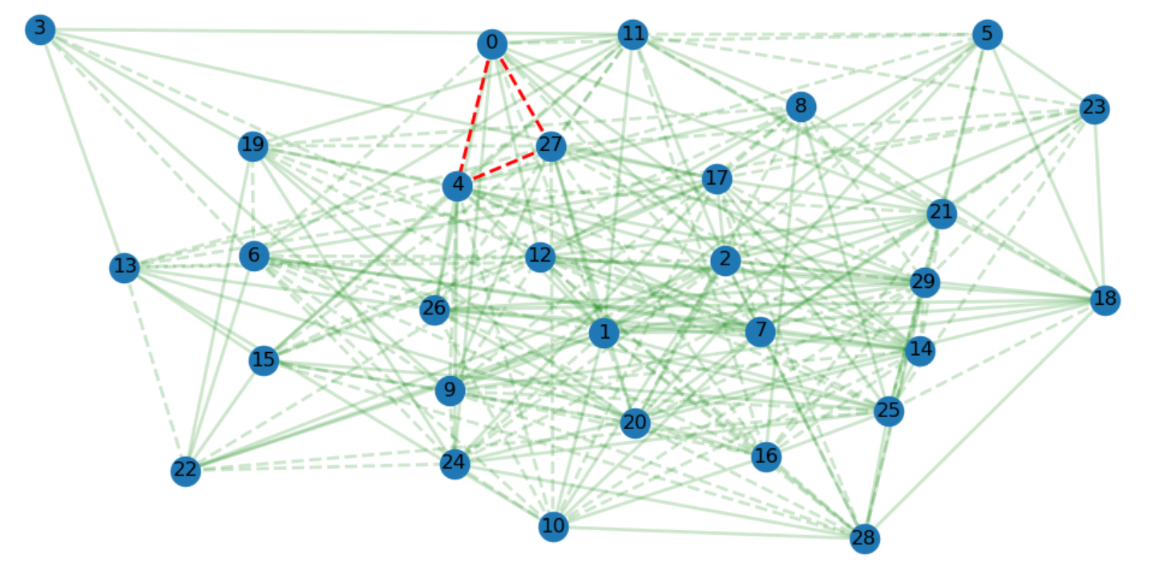

Question 3d

Our real-world example: each node represents a politician. Two politicians which like each other are connected with a solid edge and two politicians which dislike each other are connected with a dashed edge.

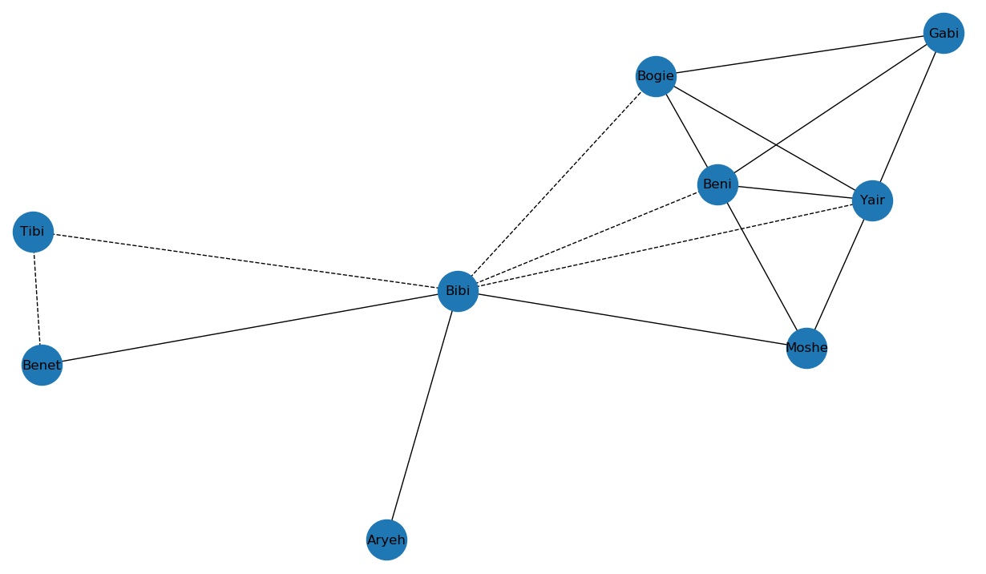

The network doesn’t follow the “Theory of Structural Balance” as we can see there is a cycle with an odd number of negative edges Bibi-Yair-Moshe so the rule of “a friend of a friend is a friend” doesn’t apply.