**Homework 09**

1. Inner folder structure of home task should be exactly as follows:

*<task folder>*

*--- fonts*

*\--all fonts files must be here*

*--- css*

*\--all css files must be here*

*---scss*

*\--all scss files must be here*

*---img*

*\--all images must be here*

*---index.html*

*---blog.html*

*---post.html*

1. Code has to be well-formatted, and validated via validator ([http://validator.w3.org](http://validator.w3.org/))
2. Using BEM and SASS is mandatory.
3. Pixel Perfect with discrepancy no more than 5 pixels

**Tasks**

1. Implement 3 mockups according to designs <https://projects.invisionapp.com/d/main#/projects/prototypes/18264023?scrollOffset=2258> – Module 8.

**REQUIREMENTS:**

* + - 1. You can freely use any html/css approach or technology. Using BEM, semantic class naming, SASS and bootstrap SASS grid is mandatory.
      2. On blog page (<https://projects.invisionapp.com/d/main#/console/18264023/390873709/preview>)

there are different kinds of posts (audio, video, text, etc), they should be handled with modifier classes.

* + - 1. Main menu should highlight current item of menu (hover styles are the same as active).
      2. Main menu links are anchors – after click the link become current and content scrolls to the proper block.
      3. Add scroll to top link. After clicking on it “home” item in menu should became active.
      4. Three square blocks on the left have a little white square in the top corner – make only the inner white square corner rounded.

**\* Additional task –** make all corners rounded.

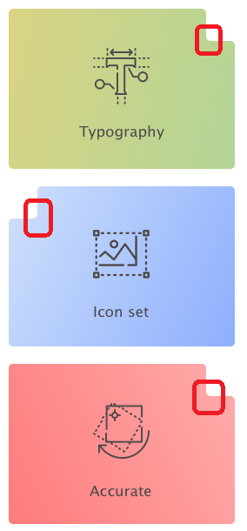

* + - 1. Titles of “Latest posts” should be links.
      2. “Latest portfolio” – add all slider elements (but slider shouldn’t be working). “See all works” is a button.

**\* Additional task** – add controls on slide and shadow on hover.

* + - 1. Map should be an img.
      2. Audio player is native (default).
      3. “Categories” is an accordion with HTML implementation.
      4. Pin Footer to the bottom of the page.
      5. No responsive. Fixed width. On resize nothing should break to 320px.

**Deadlines:**

Home page – should be done before 18.11.2019, 11:59pm

Blog and Post pages – should be done before 25.11.2019, 11:59pm

**ALL 3 pages should be pushed in the one branch - “HW9_final”.**