**Homework 1**

**Task 1.** Create the list with reverse numbering. The example:

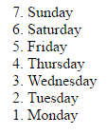

**Task 2.** Create the following table:

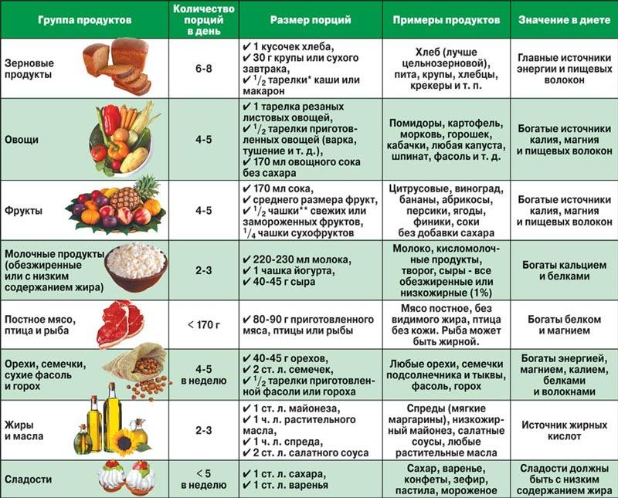

You may use different images for this table. Your list must have special marker. This homework needs to be sent to my e-mail until **8.00 am 29.11.2018**.