**Homework 2**

**Task.** Create following forms:

**Form 1**

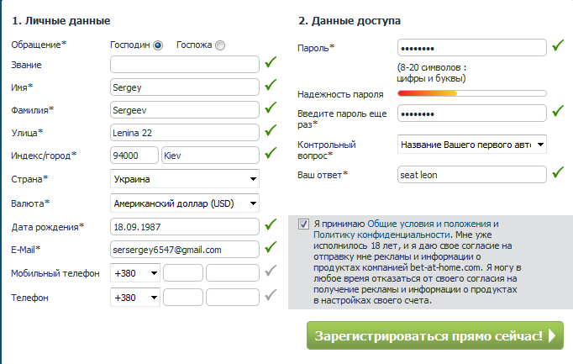

**Form 2**

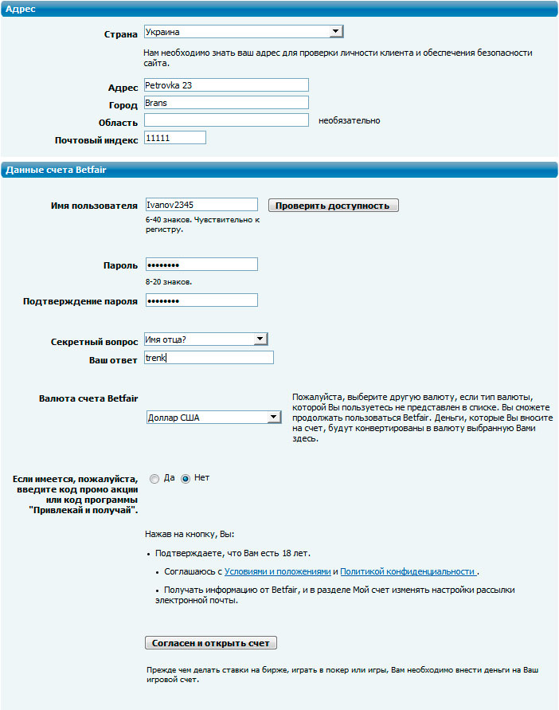

This homework needs to be sent to my e-mail until **8.00 am 04.12.2018**.