The diagram represents the behaviour of the Turing Machine (when adding 1 to a binary number).

* q0 is the initial state ;
* q1,q2 are intermediate states for addition ;
* q3 represents the final state/halt state, where the machine stops.

The instructions X ;Y,Direction :

* X – symbol read from the tape
* Y – symbol written on the tape
* Direction : R (right) or L (left) - the direction of the machine's head movement

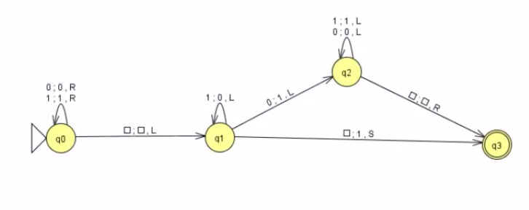



Software used for creating the diagram + additional information found here : http://www.jflap.org/