In order to add two binary numbers we will use two Turing Machines (functions) : one that will substract 1 from a binary number and another one that will add 1 to a binary number.

Let **x** and **y** be the two binary numbers we want to add. We place the numbers on a tape in that order. Considering two random values for x and y, separated by a white space, we have  :

On tape initially : 0010˽0011 // adding 2 + 3

After the addition : 0000˽0101 // equals 5

The algorithm repeatedly subtracts 1 from x, adds 1 to y until x is 0.

The two algorithms, respectively diagrams for the addition and substraction TM :

**Algorithm for subtracting 1**

1. Take 1's complement, change all 1's to 0, all 0's to 1

2. Add one to x

3. Take the 1's complement again

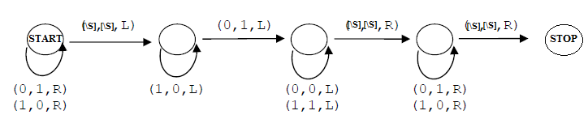

**Algorithm for adding 1**

1. When starting at left end, walk to right end of y

2. Walking right to left, change all 1's to 0's

3. When finding the first 0, change to 1

