**Flexible couplings RA, RG**

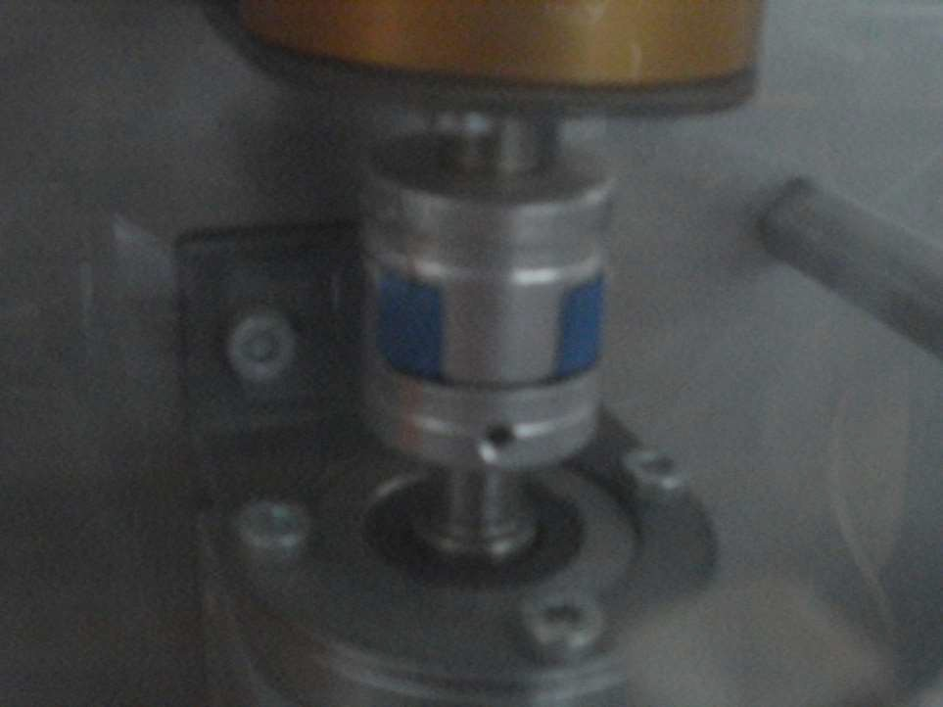

Flexible couplings transmit the torque by positive locking, and compensate for slight nonalignment, stagger and offset of shafts.

Standard toothed ring 92 Shore A.



