#### Moeller 1-EASY400-POW

##### Switched-mode power supply unit

Input voltage range: 85 to 264 V Output voltage: AC 24 V DC +/- 3% Output current, nominal value: 1.25 A Overcurrent limitation from 1.4 A

Potential isolation, primary/secondary: Yes, SELV(to EN 60 0950, VDE 805) Short-circuit proof (secondary): Yes

Overload protection (secondary): Yes

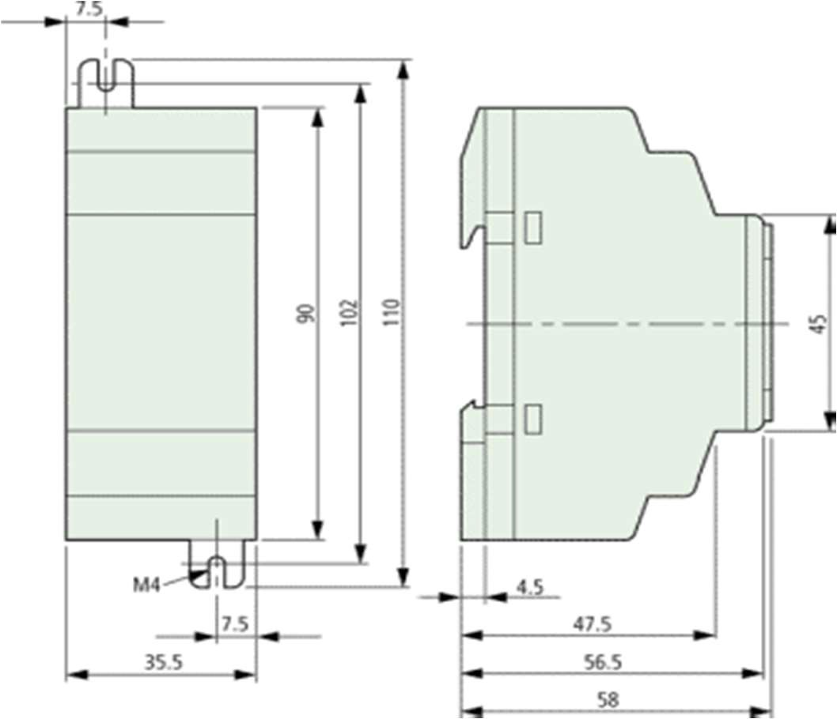Dimensions (W x H x D) inches: 1.39 x 3.54 x 2.28 inch