#### Moeller 2- Easy 825-DC-TCX

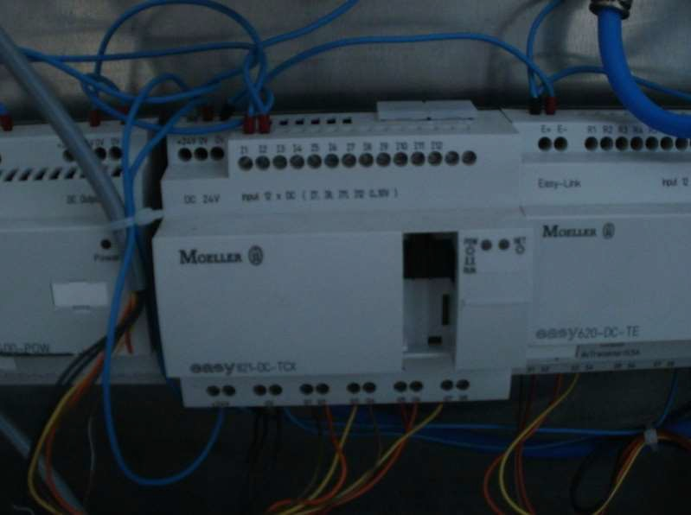

Supply voltage: 24 VDC Power dissipation: 3.4 W Inputs, digital: **12**

Inputs, analog, option (0–10 V): Up to **4** of the provided **12** inputs may be user assigned as analog inputs

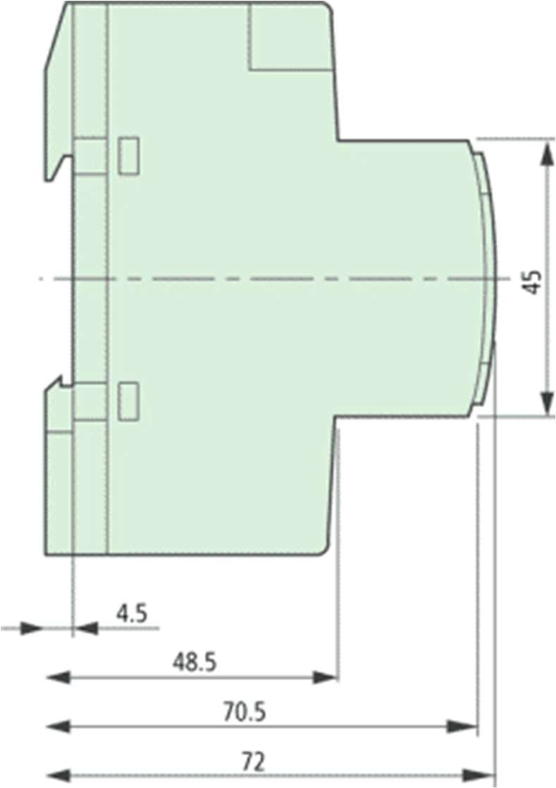Outputs: **8** *Transistors*

Outputs, analog,(0–10 V): -

