**Moeller3- EASY621-DC-TC**

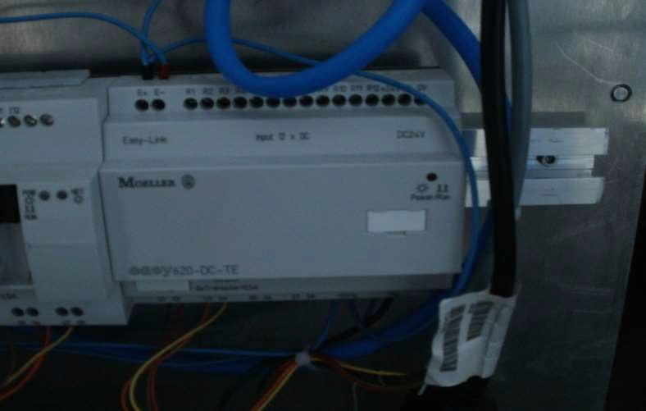

Supply voltage: 24 VDC Power dissipation: 4 W Inputs, digital: **12**

Inputs, analog, option (0–10 V): *Up to* ***2*** *of the provided* ***12*** *inputs may be user assigned as analog inputs*

Outputs: 6 *Relay*

Outputs, analog, (0–10 V): Not Available LC display, keypad/keypad EASY: Yes Week/Year clock: Yes/--

Output continuous current: 0.50 A

Short-circuit proof at cos phi = 1: Line protection B 16, 600 A

Short-circuit proof at cos phi =0.7 0.7: Line protection B 16, 900 A

Dimensions in inches (W x H x D): 4 x 3.5 x 2.3 in.

