# Motor

**BPS-1620-MX Stepping** motor with 3.3 Nm,

shaft end, key groove, spring and with Matrix valve

##### Product characteristics

* Compact motor / valve unit
* Up to 10 Nm torque
* Protection class: IP 55

Technical Information

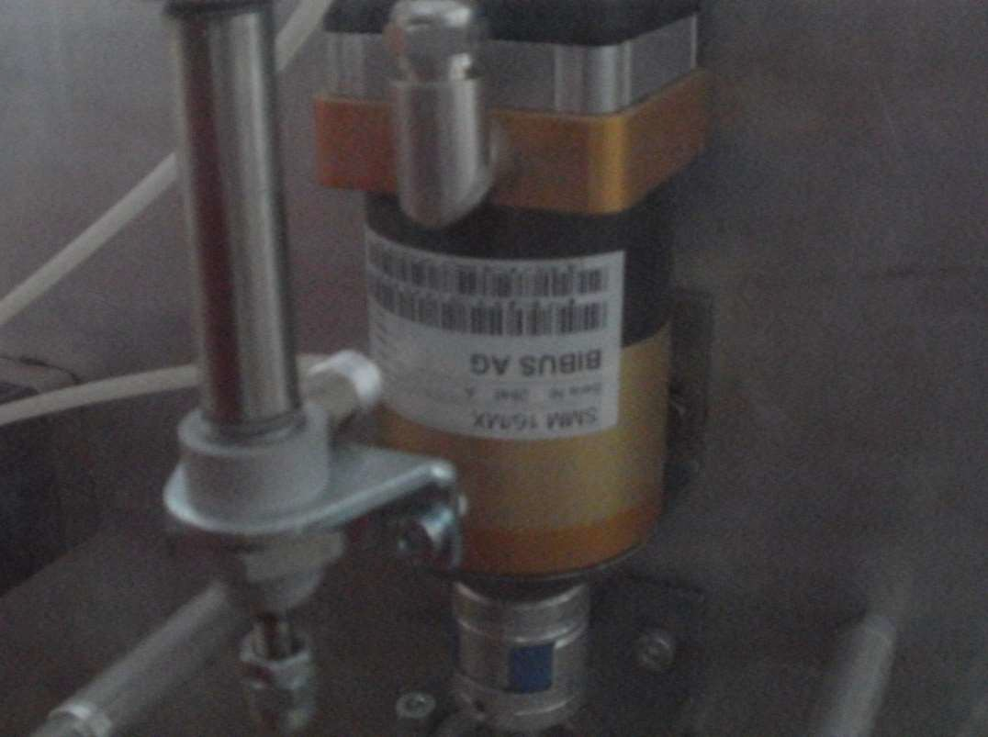The pneumatic stepper motor offers several advantages over electric versions. High torques is achieved even with small dimensions and without a reduction gear thanks to the pneumatic drive. All pneumatic stepper motors are equipped with internal braking – with no step loss – in case of a power failure. This is a decisive advantage particularly for sensitive applications. The flange-mounted valve provides for a very compact unit without additional hose connections. These pneumatic stepper motors are used wherever precision under difficult conditions is demanded. In dusty or dirty environments or in the presence of strong magnetic fields as well the pneumatic stepper motor really shows its strengths. The motor features versatile and simple control and there is a suitable type for every application, e.g. classic with an output shaft or with a spindle for linear motions.