### M008-R00-VS

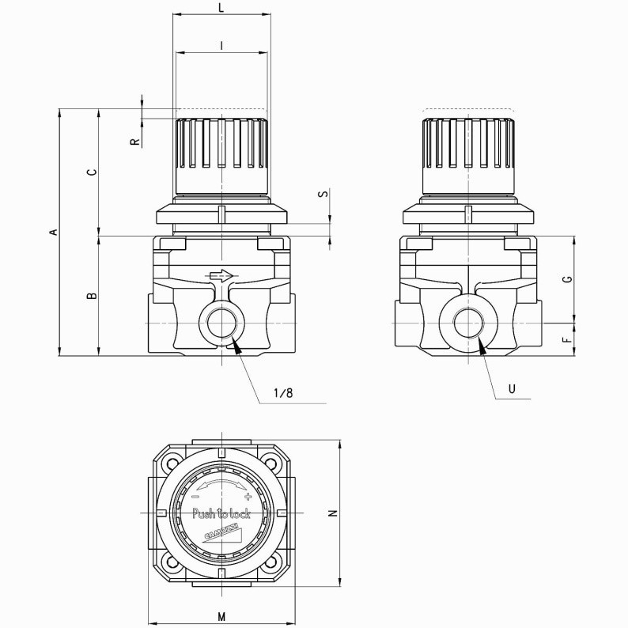

General characteristics

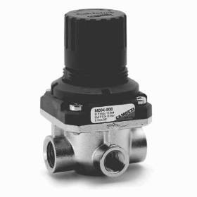Constructive type With membrane Materials body: steel INOX; O-ring:

NBR

Fitting G1/8 - G1/4

Weight Kg 0,235 Working Temperature-5°C ÷ 50°C Entry pressure 0 ÷ 16 bar

Exit pressure 0,5 ÷ 10 bar