**Cylinders**

Service

Inspection interval: The product must be checked monthly for contamination and damage.

Aids

• Only clean the product with damp cloths. This avoids the formation of sparks due to electrostatic charging (explosion protection).

• Only use water for cleaning and a mild detergent, if necessary (material protection)

9.2.2 Procedure

1. Close all openings with suitable safety devices so that no cleaning agent can enter into the system.

2. Remove all dust deposits from the product and the adjacent system parts.

3. If necessary, remove other production-related deposits from the product and the adjacent system parts.

Ambient conditions

• Let the product acclimatize for a few hours before installation. Otherwise water may condense in the housing.

• Keep the installation location free from vibration.

• Protect the product from direct sunlight and UV radiation.

• Avoid increased output pressure tolerances: Make sure that high-frequency radiation from interference-emitting devices is kept away from the product.

Aggressive ambient conditions include, for example:

• High temperatures

• Heavy accumulation of dirt

• Proximity to grease-dissolving liquids or vapors

9.1.2 Procedure

Preparation

1. Do not carry out any work on the system during preparation.

2. Close off dangerous areas.

3. Make sure the system or system part is not under pressure or voltage.

4. Protect the system against being restarted.

5. Allow the product and adjacent system parts to cool down.

6. Wear PPE.

Visual inspection- Visually inspect for integrity.

Detailed inspection

• Identifications and warnings on the product: The system owner has to replace labels or warnings that are difficult to read immediately.

• Check to make sure that all fittings are properly connected.

• Check the safety devices on the system.

• Check the product functions.

Troubleshooting

12.1 Procedure

Step 1: Check the system

In case of malfunctions, first check the system or the system part where the product is installed. Check the following items:

• All connections

• Settings

Step 2: Check the product

1. Make sure the system or system part is not under pressure or voltage.

2. Check the product based on the fault patterns described below.

3. Perform troubleshooting using the information under “Remedy”.

If the malfunction cannot be eliminated as described under “Remedy”: Disassemble the product and return it

4. After the malfunction has been eliminated; Put the system or product back into operation

12.2 Malfunction types

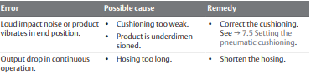

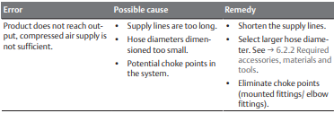

Technical data

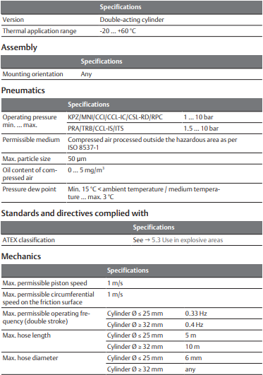

Maintenance Videos:

[Pneumatic Cylinder Seal Changing | How to use a pneumatic cylinder | Creative Uae - YouTube](https://www.youtube.com/watch?v=t_peXaC6DDo&ab_channel=CreativeUAE)

[How to adjust cushion on air cylinder - YouTube](https://www.youtube.com/watch?v=_jjnr0wNtZw&ab_channel=BABABUILDER)