**Cylinders**

2.6 Hazards

2.6.1 Danger of explosion due to formation of sparks

Formation of sparks due to mechanical loads Mechanical loads lead to the formation of sparks and present an explosion hazard.

• Never twist or bend the product and add-on parts, or mount them when they are under tension. Friction sparks due to circumferential speeds greater than 1 m/s

Some piston rod attachments and mounting elements allow oscillating rotary movements and swiveling movements of the product. The use of these elements as radial plain bearings with circumferential speeds greater than 1 m/s leads to impermissible heating. If the heating is too high, friction sparks are generated, which represent an explosion hazard.

• Ensure that circumferential speeds on the friction surfaces do not exceed 1 m/ s

2.6.3 Material damage

Damage due to too high mechanical loads

• Never twist or bend the product and add-on parts, or mount them when they are under tension.

• Avoid mechanical stress when connecting the hoses.

• Do not use the product as a handle or step.

• Do not position any objects on the product.

9.1.1 General requirements

Use in normal ambient conditions

• Inspection interval: The product must be checked monthly for contamination and damage.

Use in aggressive ambient conditions

Aggressive ambient conditions include, for example:

• High temperatures

• Heavy accumulation of dirt

• Proximity to grease-dissolving liquids or vapors

Aggressive ambient conditions lead to further requirements for inspection:

• Adapt the inspection interval for seals to the ambient conditions.

NOTICE! Seals age faster under aggressive ambient conditions. Defective

seals will lead to pneumatic leaks and non-compliance with the d

9.3 Maintenance

In normal ambient conditions, the product is maintenance-free.

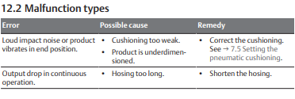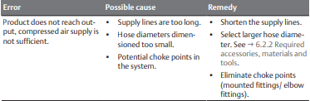

Valves

The valve system contains electronic components that are sensitive to electrostatic discharge (ESD)!

If the electrical components are touched by persons or objects, this may lead to an electrostatic discharge that could damage or destroy the components of

the valve system.

1. Ground the components to prevent electrostatic charging of the valve system.

2. Use wrist and shoe grounding straps, if necessary, when working on the valve system.

Regularly clean the device with a damp cloth. Only use water or a mild cleaning agent.

8.2 Component maintenance

The valve system is maintenance-free.

However, observe any stipulated maintenance intervals and requirements for the entire system.

AF2

Ensure that the specified air quality class for the flow medium is maintained. Contamination in the compressed air leads to damage to the product, measurement errors and malfunctions. Unintended signals at the outputs lead to personal injury or material damage (injury prevention, material protection).

Cleaning intervals

• The system owner specifies the cleaning intervals in line with the ambient conditions at the operating site.

9.3 Maintenance

In normal ambient conditions, the product is maintenance-free.

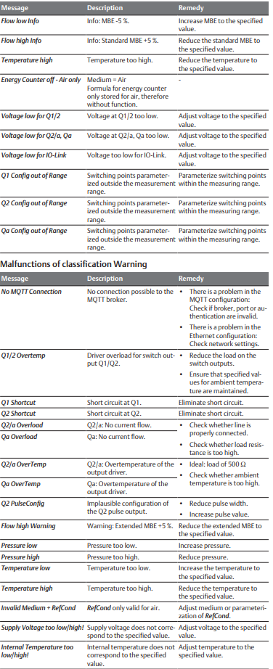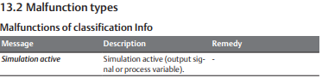

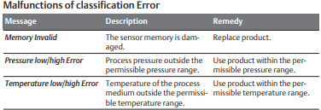

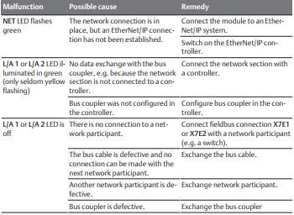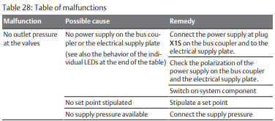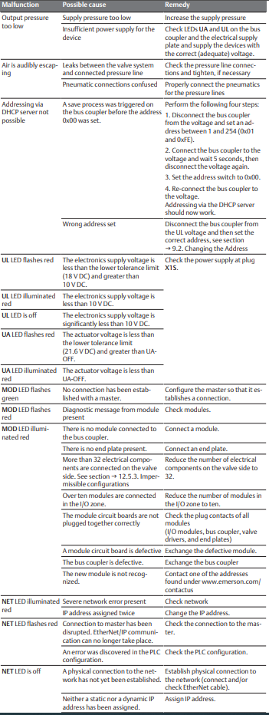Bus Coupler