**Introduction**

Baseline, a group of several CyGNSS satellites are flying in low orbit. CyGNSS constantly receives from the GPS/GLONASS satellites their positioning. GPS/GLONASS sends out a signal that CyGNSS receives with two kinds of antennas. CyGNSS receives the direct signal from GPS/GLONASS with its zenith antenna and receives the reflected signal from the land surface with its side antenna complex. In the case of waves on seas, the reflected signal has a Doppler shift, which increases with the increase of the roughness. By comparing the direct and reflected signals we can determine the Doppler shift value, and by this value, we can determine the height of the waves and the wind strength.

**Materials and Methods**

I assumed the following possible situation. Since the CyGNSS satellites fly in low orbit, they have a short lifetime, and they are prone to failure more often than other spacecraft. Let's consider a situation where one satellite is lost. The task is to use the data available from the remaining satellites to restore the velocities measured by the lost spacecraft. Alternatively: one of the satellites may have an instrumentation failure, and give incorrect data. Is it possible to use measurements from other satellites to diagnose the failure?

**Step 1**: *Prepare and process the data available*. The .ncl file proposed by DKRZ has data from 8 satellites numbered 1 through 8. Note that the signals received by all of the CyGNSS satellites from the GPS/GLONASS sensors do not match in time. Probably, it is caused by that in certain moments these signals for a part of satellites disappeared. Therefore, the first step is to synchronize the data for all satellites. To do so, we used the principle: if at a certain point in time at least one of the 8 satellites does not receive GPS/GLONASS signals, all data associated with this point in time are filtered out. The remaining data represents the array with which we will work.

**Step 2**: *Define the inputs for the neural network*. The CyGNSS satellites all fly in the same orbit. Let's fix a point on this orbit. Let the position of one of the eight satellites (for simplicity, let's label it id=0) coincides with this point. Note that when another satellite flying behind id=0 (say, id=1) comes to the fixed point, the Earth will turn by some distance (about 200 km). Since synoptic phenomena in the atmosphere are large enough, we can expect that the wind strength will not change much over 200 km. Thus, satellite id=1 at the location of id=0 will measure similar (but not the same) wind strength. Let us determine the location of the fixed point. At that point velocities from the id=0 measurements must have the most similarity to those of id=1. To find this most similarity we solve the following maximization problem:

|  |  |
| --- | --- |
| $$\max_{τ}\left\{corr(v_{id0}(t),v_{id1}(t+τ))\right\}$$ | (1) |

Where $v_{id0}(t)$ and $v_{id1}(t+τ)$, are the velocities from id=0 and id=1 respectively, and $τ$ is a time lag.

For simplicity, let us assume that satellite id=0 is lost. To determine how we can interpolate through data from other satellites the velocities obtained by id=0, we fix $v_{id0}(t)$ in (1) and solve (1) for all other id satellites. After calculating seven $τ$, we make appropriate shifts in velocities for each id. After that, we can use these velocities as inputs to the neural network.

**Step 3:** *Neural network construction*. Since our data has only a significant temporal dimension, (the spatial dimension is represented by only eight satellites), the neural network should be built primarily oriented to work with temporal series.

Note that in Step 2 we solved equation (1) for $τ$. But since the orbital objects fly at about 8 km/sec, the satellite will not move much relative to the scale of the synoptic phenomena in 1 second (which roughly corresponds to one interval to record). Thus, if we calculate in (1) the correlation for $τ±1$, it is not much smaller than for $τ$. Thus, instead of $v_{id1}(t+τ)$ we take as inputs from each satellite the sequence [$v_{id}\left(t+τ-s\right),….,v_{id}\left(t+τ+s\right)$].

**Results**

We tried 3 configurations of neural networks. The first test was with Recurrent Neural Network because neural networks of this type are good at detecting changes in time series and can interpolate these changes into missing data. The second test was with a one-dimensional convolutional neural network because this neural network detects patterns in time series during training. Then, using these patterns can recover lost speed measurements for id=0. The third test was for the vanilla neural network, which we did for reference. We also used the usual multivariate regression.

We used 75% of the satellite measurements for training and the remaining 25% for the test. We obtained that the recurrent and convolutional neural networks give almost the same result, the correlation of calculations and reference measurements are 0.7. The vanilla neural network correlates 0.65, and conventional linear regression gave a correlation of 0.57. The example of true and predicted wind speed for id=0 are shown in Fig.1.

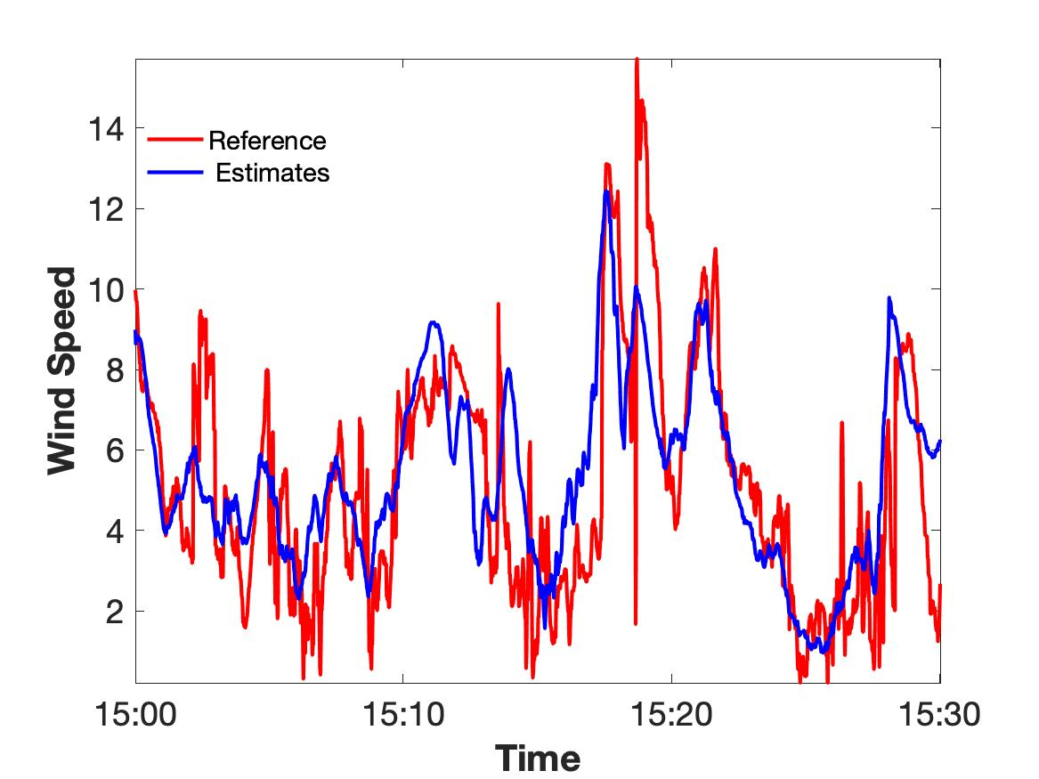

**Fig1.** True(red) and predicted wind velocities for the satellite s_id = 0.

**Conclusions**

We can restore or predict the missing data from satellite id=0. In case of predictions, the routine is the same as described above with the only difference, that $τ$ should be negative.

The code and the data available at <https://github.com/Vlasenko2006/dkrz>