Report on vehicle diagnostics with elements of information security analysis

Author: Vlassov vladislav

Car: LADA Priora 2171, 2012.

Date: 07/20/2025

# 1. Introduction

The purpose of the work: to diagnose the car using the ELM327 v1.5 adapter and the OBD Auto Doctor program, as well as to consider potential information security risks when working with diagnostic interfaces.

Software: OBD Auto Doctor Premium (Trial)

Adapter: ELM327 v1.5 Bluetooth

Protocol: ISO 14230-4 (KWP FAST)

# 2. Diagnostic progress

The connection was made via Bluetooth to the ELM327 adapter. The program established a connection using the KWP protocol (ISO 14230-4). The diagnosis was carried out in two stages: before and after troubleshooting. All parameters, fault codes, sensor readings and readiness monitors have been saved. Screenshots were taken to confirm this (see the appendix).

# 3. Diagnostic results BEFORE corrections

* Detected fault codes:
* •- P0504: Brake switch signal mismatch A/B
* •- P0441: Incorrect purging of the EVAP system
* Freeze Frame (the moment when errors are fixed):
* •- Coolant temperature: 81 °C
* •- Engine speed: 970 RPM
* •- Speed: 6 km/h
* •- Ignition timing angle: 21.5
* •- Throttle position: 12.9%

# 4. Results AFTER troubleshooting

After the intervention:

•- Errors were reset using the OBD Auto Doctor program

•- Repeated verification showed no active errors .

- All system monitors are ready or completed

. See screenshots of the status after diagnosis in the Application.

# 5. Information Security and OBD-II

* OBD-II adapters, especially Bluetooth versions, are a potential entry point for attacks. There is often no encryption or reliable authentication, which creates the following threats:
* •- Remote intervention in the operation of the ECU
* •- Cleaning and changing parameters without permission
* •- Interception and analysis of movement, car condition
* •- Using OBD devices as entry points to the CAN bus

# 6. Conclusions and recommendations

Errors P0504 and P0441 were identified and successfully resolved. The car has switched to a state without active errors, as evidenced by repeated screenshots. From the point of view of information security, it is necessary to use adapters with protection and minimize access to the OBD during operation.

# Screenshots of the work done:

Before:

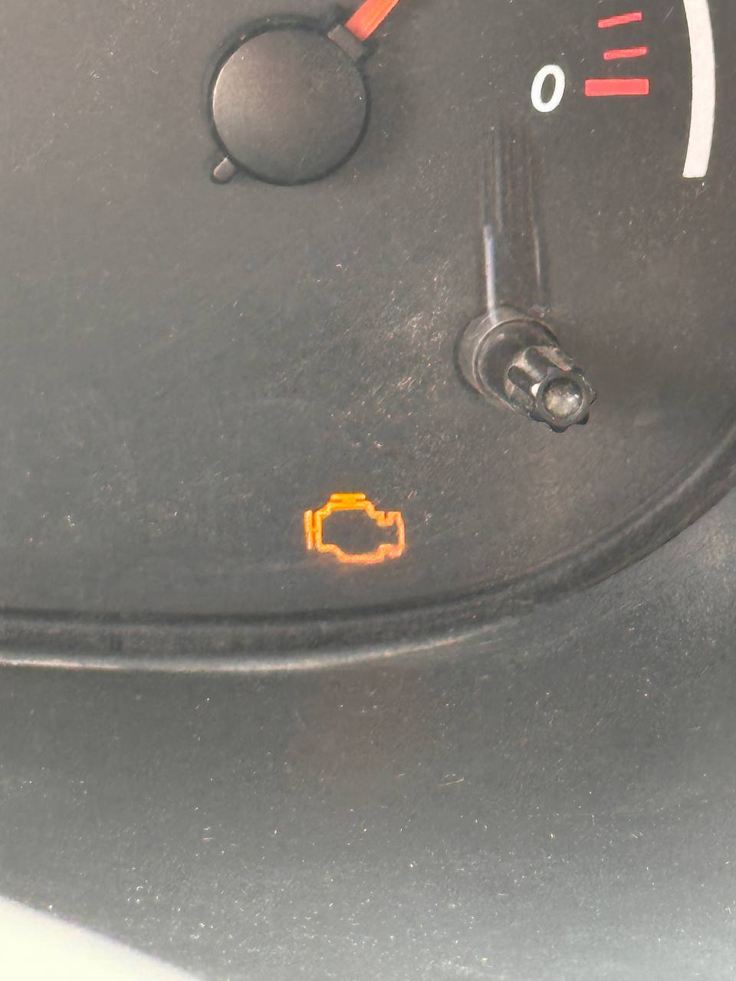

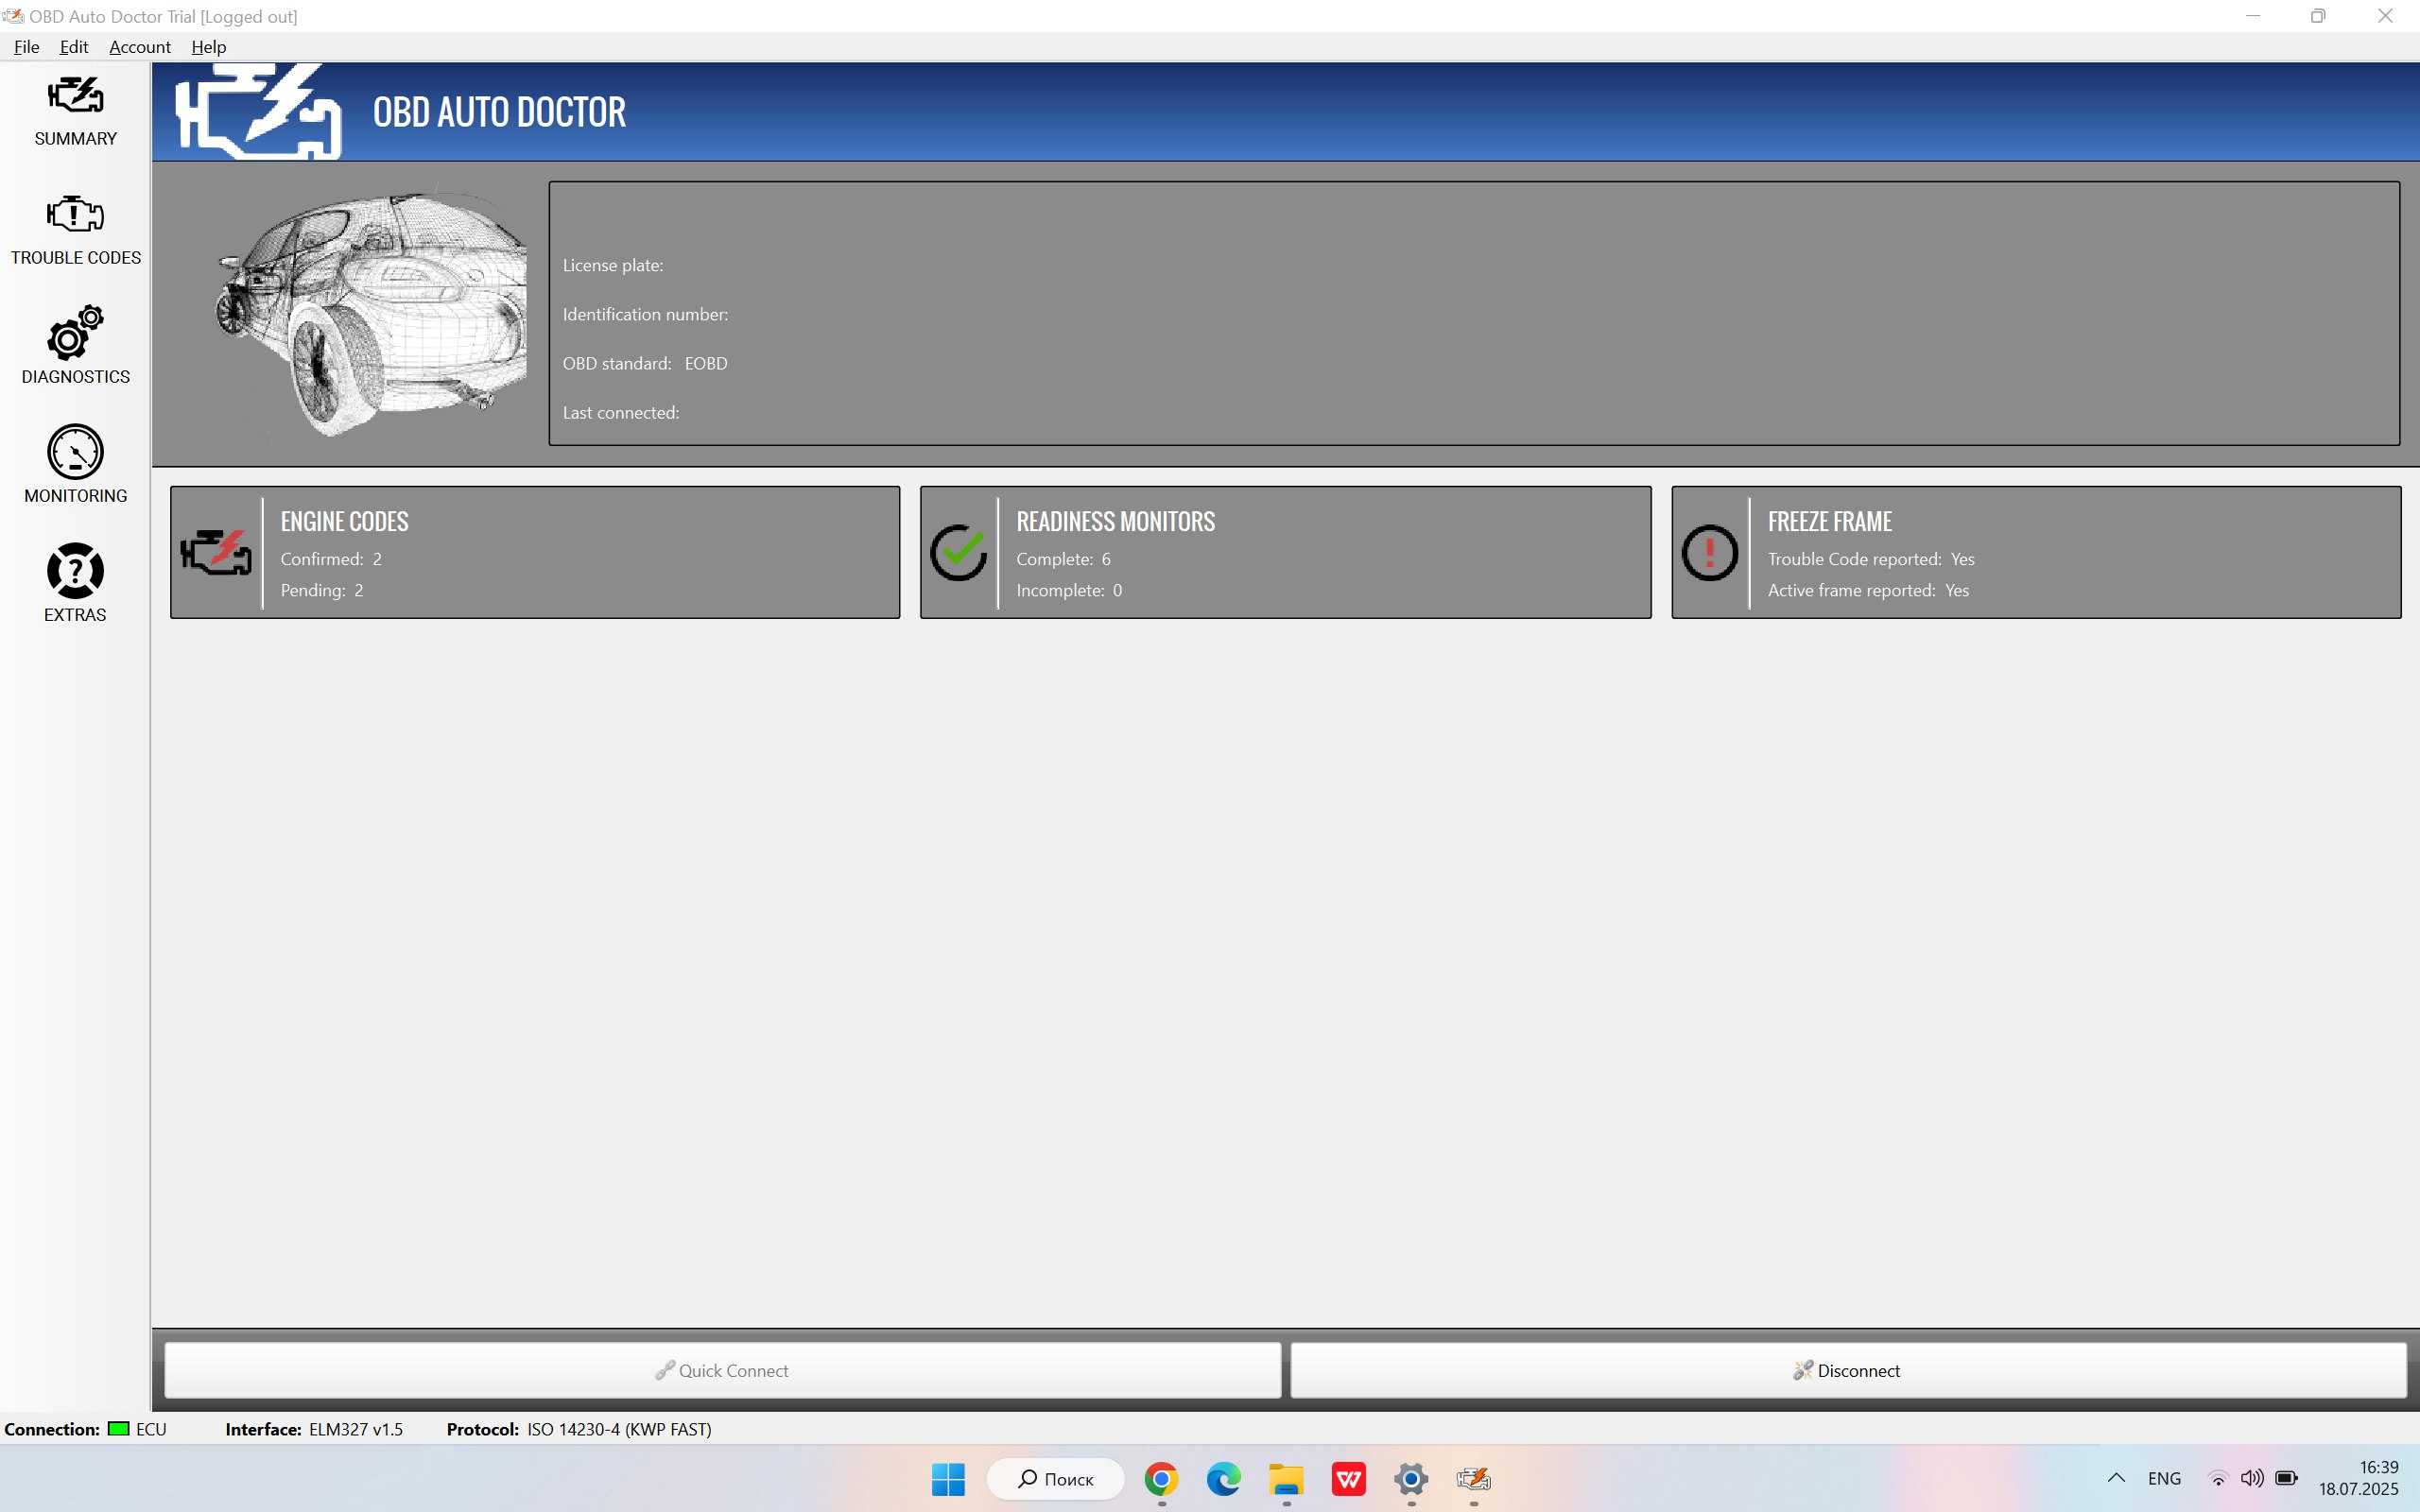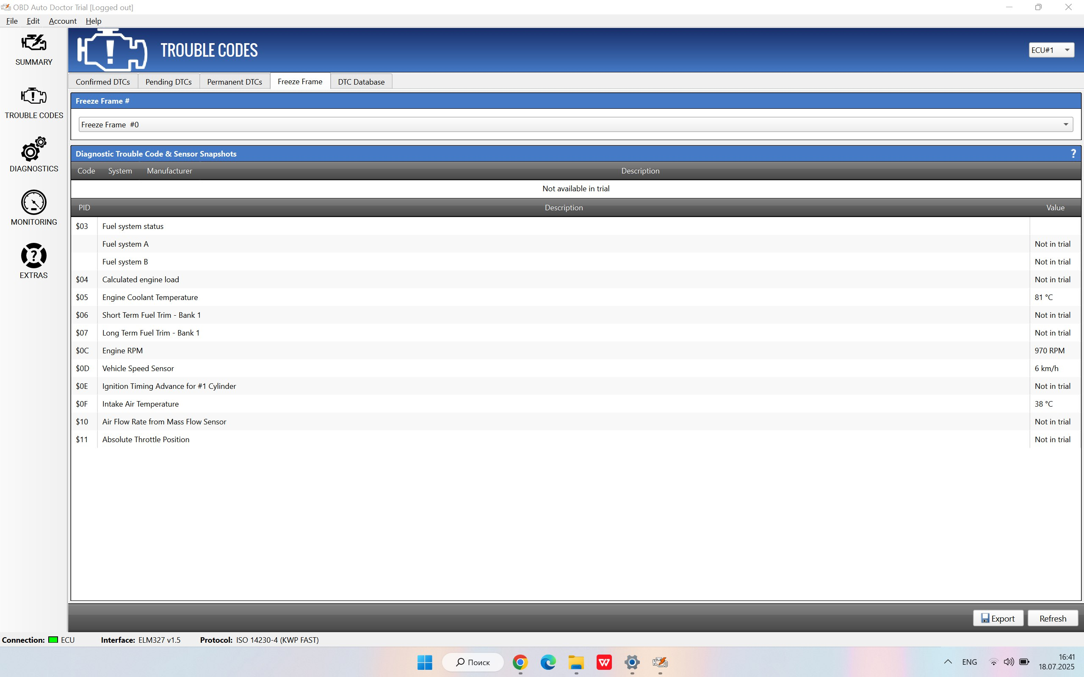

After:

