—

Thank you for contributing to RTIMDB!
Before going further, please fill out the forms below. Essentially, it will allow us the use your code and redistribute it by assigning ownership of your contribution to Vlinder Software, while allowing you to continue using your contributions as you see fit.
The reason why we need to do this is because employers (and schools) can often claim ownership of your work, even if you made your contributions by yourself, using your own computer in your own home.
I know it's a bit of a hassle, and I do apologize for that, but the way intellectual property law works, we really don't have much of a choice but to retain ownership of all the code we work with, including the open source software projects we sponsor. Remember, Vlinder Software is a really small business and we just don't have the resources to fight off infringement claims from big corporations with armies of lawyers – which just means we have to tread carefully.
I should also note that the form contains a disclaimer for your employer to sign. This protects you as well as us, as it allows you to have written proof that your employer has no stated interest in your contribution to this project. You need to have this disclaimer signed by your employer if you are employed to do programming (even at a university) or have a contract with anyone saying they own the intellectual property you product (it may be phrased differently).
If your employer has any questions about the disclaimer, or doesn't want to sign it, please give them my contact information so we can discuss it.
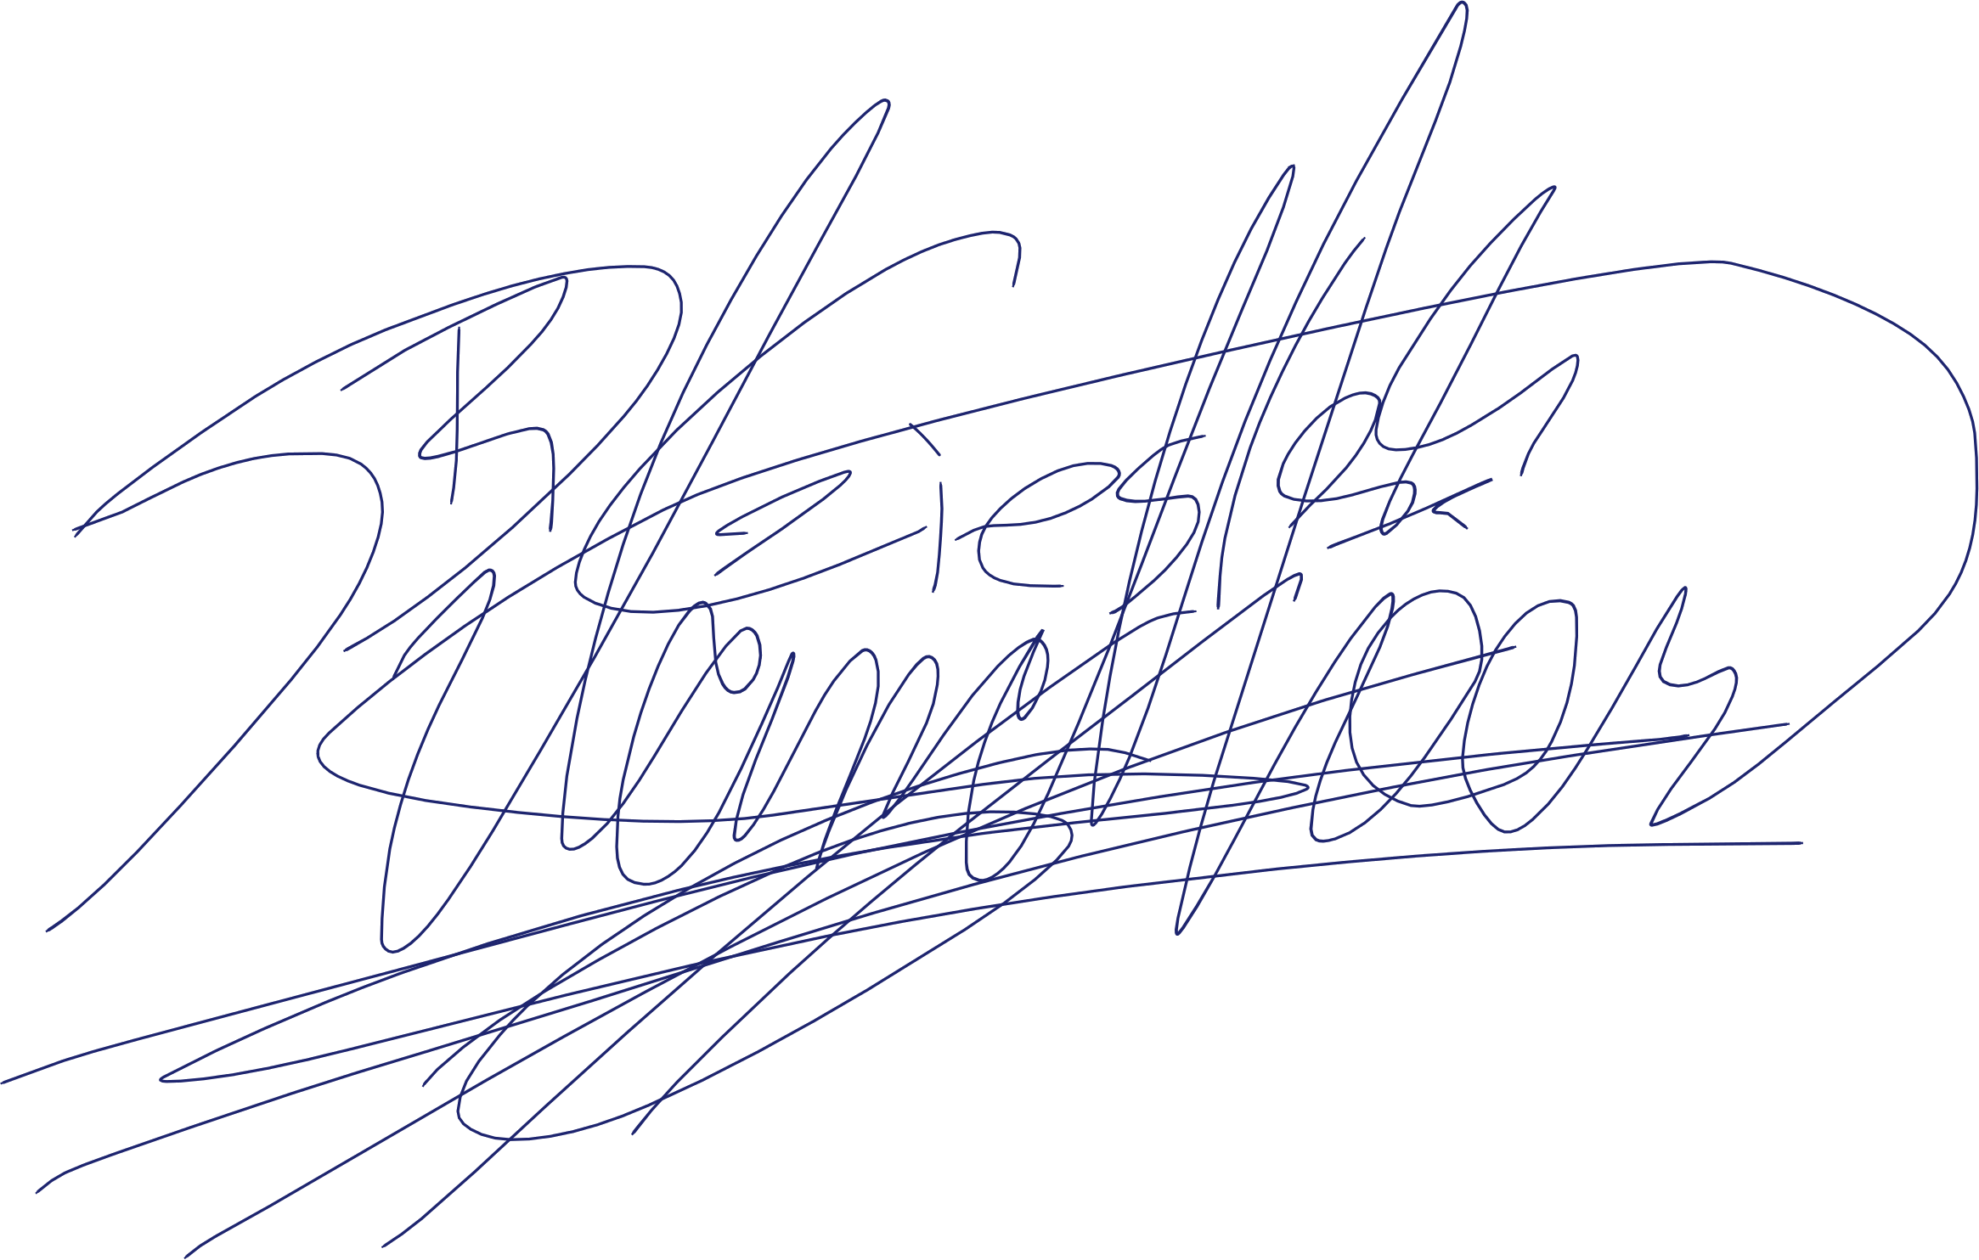
Thanks again for contributing to RTIMDB!
Sincerely,
Ronald Landheer-Cieslak

Contribution license agreement
This is a legal agreement between Vlinder Software, Quebec Business Registry number 2268177054, and You:
Full name:
Mailing address:
Country:
Telephone:
E-mail:
Birth-date:
You accept and agree to the following terms and conditions for your current and future contributions to the RTIMDB project.
- Upon thirty (30) days' prior notice in writing, or immediately if the following check-box is checked , Vlinder Software agrees to grant You non-exclusive rights to use the contributions (i.e. Your changes additions, enhancements, subtractions or modifications to the RTIMDB project – not the software, documentation or other intellectual property you may have added to, enhanced, subtracted from or modified) as You see fit. Vlinder Software's rights shall otherwise remain unchanged.
- You hereby agree that if You hereafter acquire any patent rights or other intellectual property right to parts of, or the whole of, the RTIMDB project, You will grant Vlinder Software unlimited, non-exclusive, global and perpetual license to use the intellectual property in any way Vlinder Software sees fit, including but not limited to re-licensing, selling, and/or transferring such license.
- You hereby agree that the terms and conditions contained herein shall be binding to Your heirs, assignees and/or successors as well as to You.
- You hereby warrant that You are the sole owner of intellectual property rights over Your contributions, and that You have the right and power to enter into this contract. You hereby indemnify and hold harmless Vlinder Software, its owners, officers, employees and agents, against any and all claims, actions and/or damages (including attorney's reasonable fees) asserted by or paid to any party on account of a breach or alleged breach of the foregoing warranty.
- You make no other express or implied warranty including without limitation warranties for merchantability or fitness for any particular purpose.

X signature

Copyright disclaimer
hereby disclaims any and all intellectual property interest in and ownership of any contributions to and/or modifications of the RTIMDB project and/or any derivative works, made by , including any future revisions or modifications and/or enhancements to said project.
affirms that it has no other intellectual property claims and/or interests that that would undermine its release, or the use of the RTIMDB software, and will do nothing to undermine its release or use in the future.

X signature

To fill out these forms:
- Use a computer program (such as Adobe Acrobat) to fill in the text boxes, etc.
- Print out two or three copies of the preceding two pages: one for your records, one for ours, and perhaps one for your employer.
- Sign the contribution license agreement yourself
- Have the copyright disclaimer signed by one of your employer's officers who is empowered to do so (usually a VP or a C-level executive).
- Scan the forms and send them to support@vlinder.ca.
If you want, you can ask us to send you a prepaid return envelope for the forms – we'll be happy to oblige.
- Send an original of each form to the following address:
Vlinder Software
1340 avenue de Gaudarville
Quebec, Quebec
Canada G2G 2K6

