**UBER BOOKING INFORMATION SYSTEM**

**Prepared By: VINCENT MWITI**

**ADM NO:41475**

**Supervisor Name: MR. Mburu**

# 

Table of Contents

CHAPTER ONE 3

1.0 Introduction 3

1.1Problem Statement 3

1.2 Objectives 3

1.3 Justification 3

CHAPTER TWO 4

2.0 System Overview 4

2.4 Existing Gaps 5

CHAPTER THREE 6

3.0 Logical Design 6

3.1.1 Entity Relationship Diagram (ERD) 6

3.1.2 Flowcharts 7

3.2 Physical Design 8

3.2.1 Normalized Tables 8

3.2.2 Wireframes 9

# CHAPTER ONE

## 1.0 Introduction

The Uber Booking Information System is designed to automate the process of booking rides, managing customers, and processing payments. It aims to improve efficiency, reduce manual errors, and enhance user experience by providing a reliable platform for drivers and customers.

## 1.1Problem Statement

The current ride booking process faces multiple challenges including delays, lack of accurate tracking, poor data management, and limited payment integration. These issues expose a significant gap in providing seamless, secure, and efficient booking services. Existing solutions often fail to adequately address customer experience, system reliability, and scalability.

## 1.2 Objectives

General Objective: To design and develop an Uber Booking Information System that streamlines ride booking and improves customer satisfaction.

Specific Objectives:  
- To generate reports on bookings, payments, and customers.  
- To provide customer ratings and reviews.  
- To provide secure and flexible payment options.  
- To improve driver and customer communication.

## 1.3 Justification

The Uber Booking Information System will reduce delays, improve efficiency, and offer customers a secure and reliable booking experience. It will benefit drivers by increasing transparency and enhancing service delivery. The system’s scope covers booking, customer management, payment processing, and reporting.

# CHAPTER TWO

## 2.0 System Overview

This chapter explores real-life digital systems to understand how they work, the challenges they face, and how technology can improve service delivery. The focus is on **Uber Eats**, **Bolt Ride System**, and **Uber Freight**, which are examples of modern platforms used in food delivery, transport, and logistics. These systems use mobile apps, GPS tracking, and online payments to make services faster and more convenient for users. However, they still face issues such as high costs, competition, and dependence on internet connectivity. Studying these systems helps show how digital technology can make services more efficient, reliable, and easier to manage across different industries.

**2.1 CASE STUDY 1: Bolt Ride System-**is a **mobility platform** that provides on-demand transportation services — mainly **ride-hailing**, but also **food delivery, micro mobility (scooters, bikes),** and **car rentals** in some regions.

Strengths;

1. Bolt generally offers **lower fares** for passengers and **lower commission rates** for drivers compared to competitors
2. Fast and Efficient Matching
3. Simple and **easy-to-use interface** for both passengers and drivers.

Weaknesses;

1. Limited Availability in Some Regions
2. High Competition
3. Fewer Drivers During Off-Peak Hours

**2.2 CASE STUDY 2:** **Uber Freight** -Logistics platform that matches trucking companies with shippers to move goods.

Strengths;

1. Transparent Pricing
2. User-Friendly Platform
3. Real-Time Tracking & Visibility

Weaknesses;

1. Limited Market Presence (Compared to Traditional Freight Companies).
2. Driver/Courier Dissatisfaction and Regulatory and Legal Challenges
3. Limited Human Support and High Competition

**2.3 CASE STUDY 3: Uber Eats System (Food Delivery)-** Connects **customers,** **restaurants,** and **delivery partners.**

Strengths;

1. Efficient & Reliable Technology
2. Wide User Base & Global Reach
3. Secure & Cashless Payment System

Weaknesses;

1. High Commission Fees and Courier Challenges
2. Dependence on Network Reliability
3. Competition Pressure and Customer Service Limitations

## 2.4 Existing Gaps

The reviewed studies show that Uber Eats, Bolt Ride, and Uber Freight improve efficiency through digital technology. However, gaps remain in high operational costs, limited coverage, and dependence on internet connectivity. Further research is needed to enhance affordability, reliability, and adaptability in different market environments.

# CHAPTER THREE

## 3.0 Logical Design

The logical design outlines the system’s structure including entities, attributes, and relationships. It consists of an Entity Relationship Diagram (ERD) and system flowcharts.

### 3.1.1 Entity Relationship Diagram (ERD)

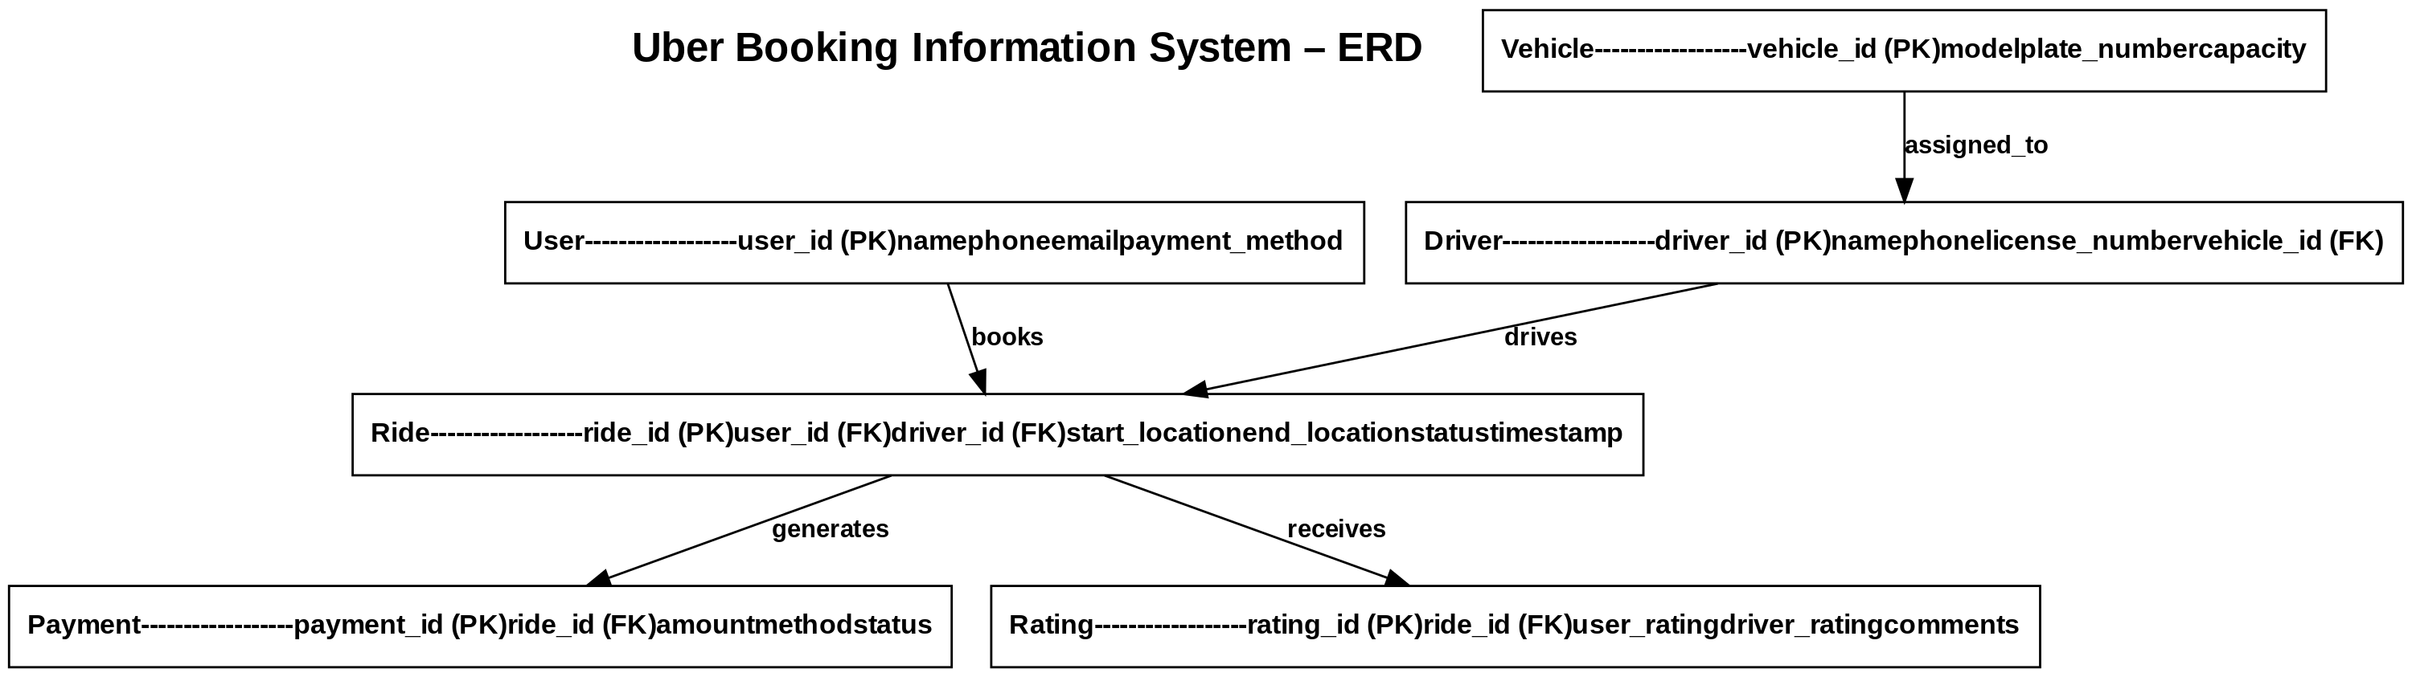

### 3.1.2 Flowcharts

Figure 2: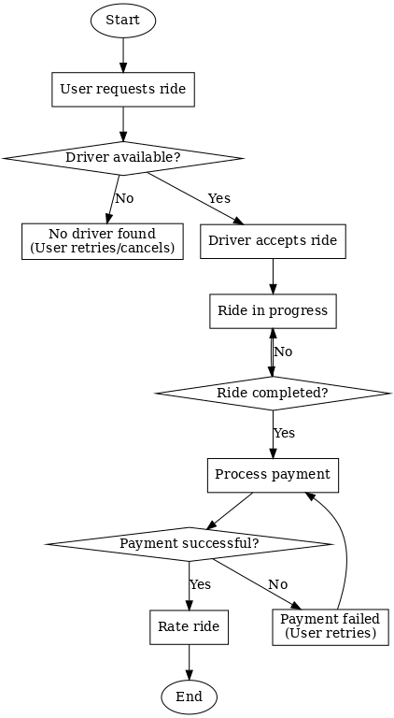

## 3.2 Physical Design

The physical design specifies the actual database implementation with normalized tables, datatypes, and relationships. Additionally, system wireframes illustrate the user interface layout.

### 3.2.1 Normalized Tables

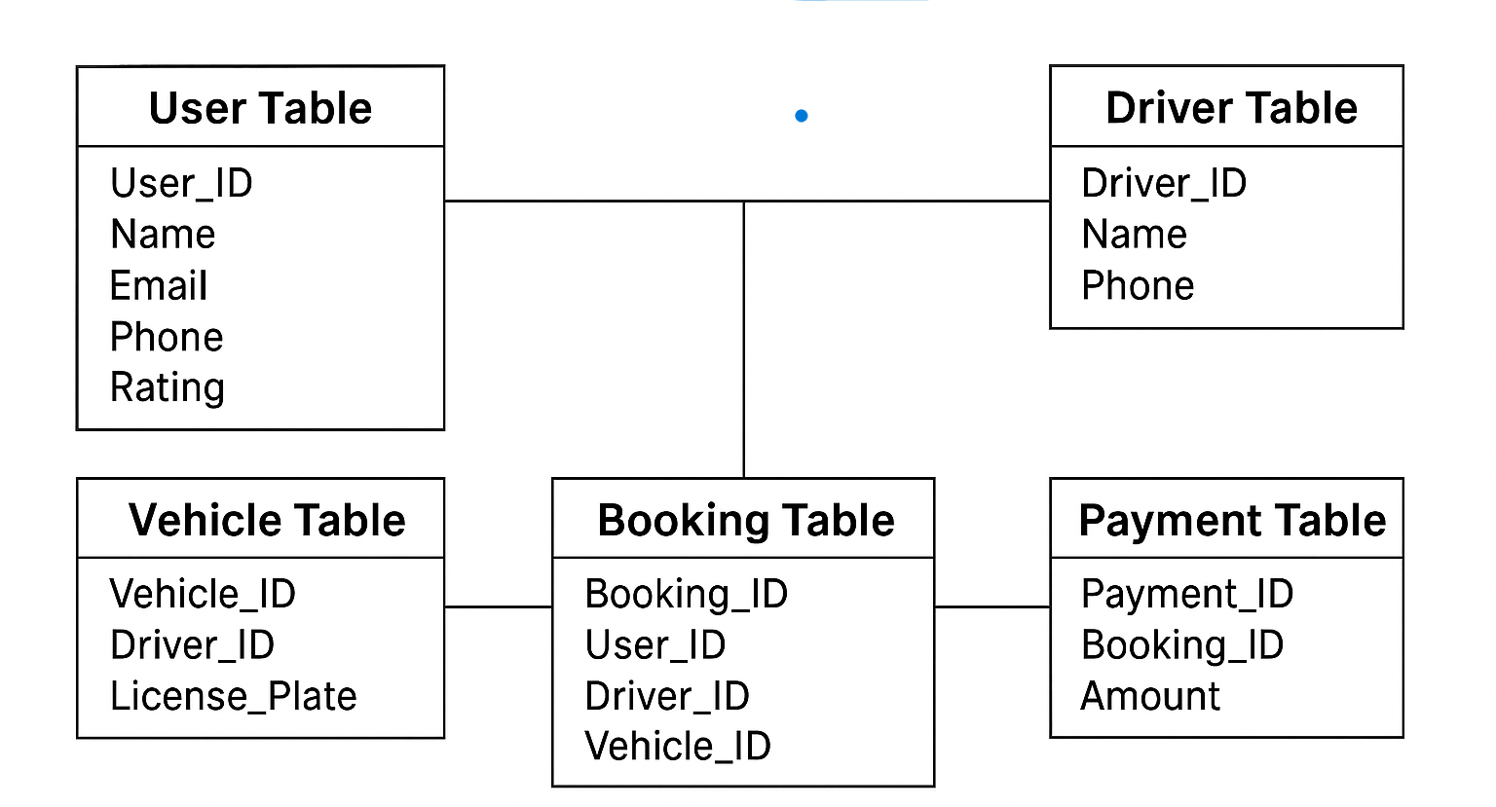

Figure 3:

### 3.2.2 Wireframes

[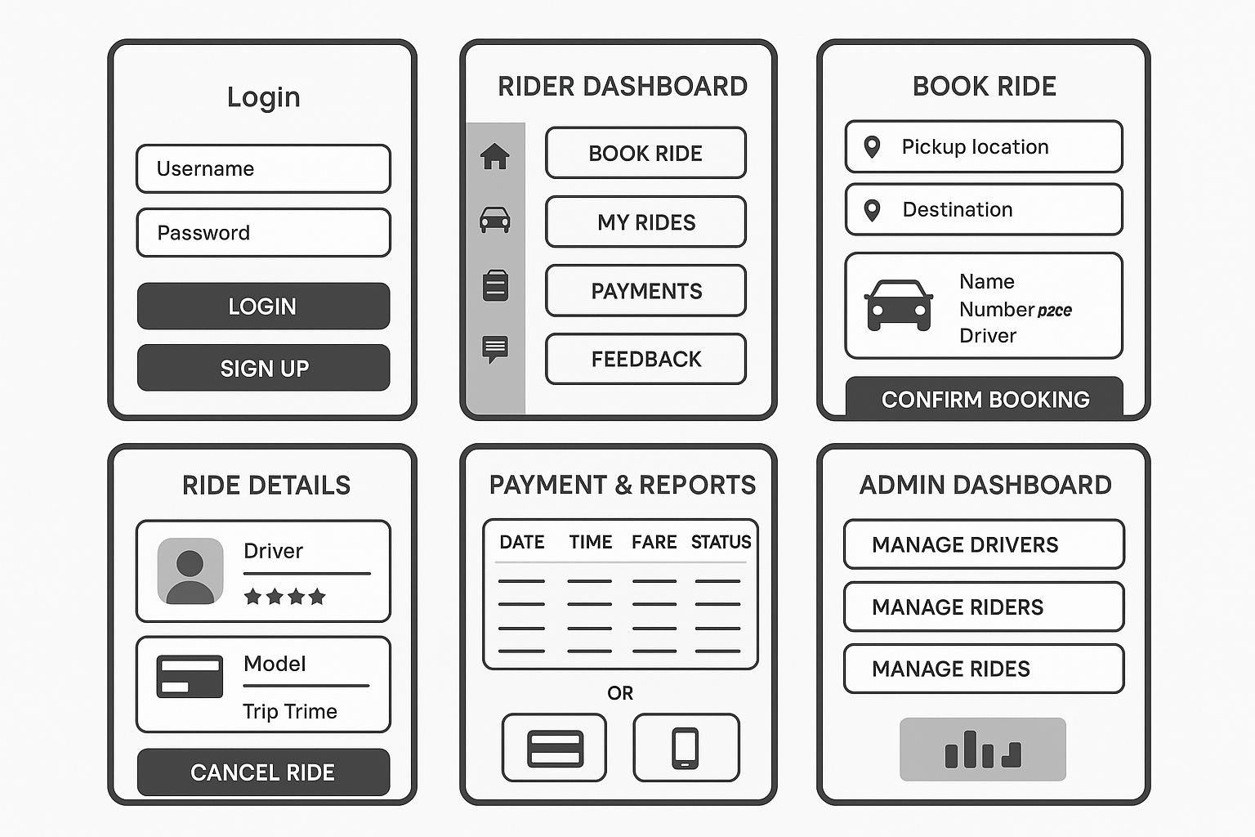]

Figure 4: