**Answer 1)**

1. Leaf Nodes Description:

* Leaf Node 1:
* Splitting Criterion: Entropy

Split Predictor: ‘EDUCATION’

Split Branches: ‘[0], [1, 2, 3, 4]’

* Number of Observation:

Total: 823

Commercial: 216

Private: 607

* Predicted Probabilities of CAR_USE:

Commercial: 216/823 = 0.26245443

Private: 607/823 = 0.73754557

* Predicted CAR_USE category: Private
* Split Entropy Value: 0.8304276080710689
* Leaf Node 2:
* Splitting Criterion: Entropy

Split Predictor: ‘EDUCATION’

Split Branches: ‘[0], [1, 2, 3, 4]’

* Number of Observation:

Total: 3029

Commercial: 2559

Private: 470

* Predicted Probabilities of CAR_USE:

Commercial: 2559/3029= 0.84483328

Private: 470/3029= 0.15516672

* Predicted CAR_USE category: Commercial
* Split Entropy Value: 0.6226204001098349
* Leaf Node 3:
* Splitting Criterion: Entropy

Split Predictor: ‘CAR_TYPE’

Split Branches: [['Minivan', 'Sports Car', 'SUV'], ['Van', 'Panel Truck', 'Pickup']]’

* Number of Observation:

Total: 4594

Commercial: 30

Private: 4564

* Predicted Probabilities of CAR_USE:

Commercial: 30/4594= 0.00653026

Private: 4564/4594= 0.99346974

* Predicted CAR_USE category: Private
* Split Entropy Value: 0.056791153992247115
* Leaf Node 4:
* Splitting Criterion: Entropy

Split Predictor: ‘CAR_TYPE’

Split Branches: [['Minivan', 'Sports Car', 'SUV'], ['Van', 'Panel Truck', 'Pickup']]’

* Number of Observation:

Total: 1856

Commercial: 984

Private: 872

* Predicted Probabilities of CAR_USE:

Commercial: 984/1856= 0.53017241

Private: 872/1856= 0.46982759

* Predicted CAR_USE category: Commercial
* Split Entropy Value: 0.9973716177249364

1. & C)

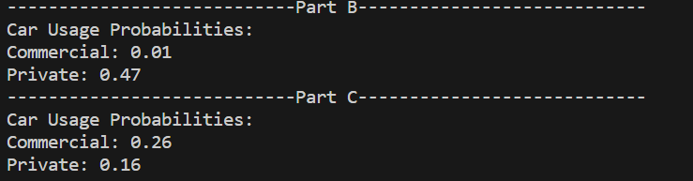

D) A histogram of predicted probabilities for

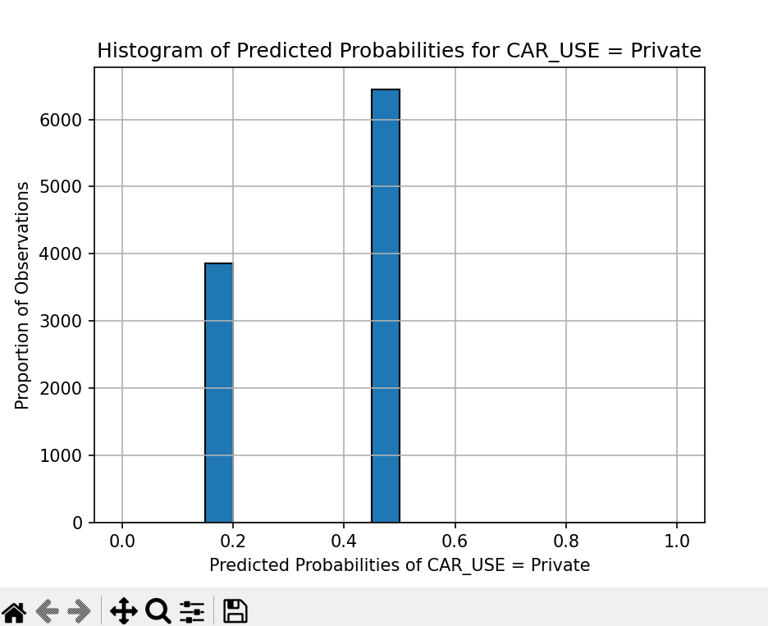

E) Misclassification Rate: 0.2030

**Answer 2)**

1. Selects relevant columns (‘CAR_USE’, ‘CAR_TYPE’, ‘OCCUPATION’, ‘EDUCATION’). Converts the ‘CAR_USE’ column to a categorical variable. Converts other categorical features to categorical data types. Prints the categories of each feature.

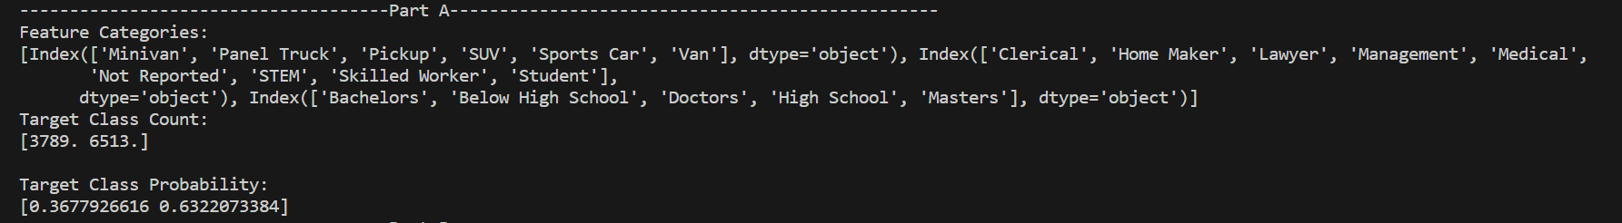

1. • Utilizes Ordinal Encoder to represent categorical features as ordinal values.

• Constructs a Categorical Naïve Bayes model with alpha smoothing during training.

• Displays both class counts and class probabilities.

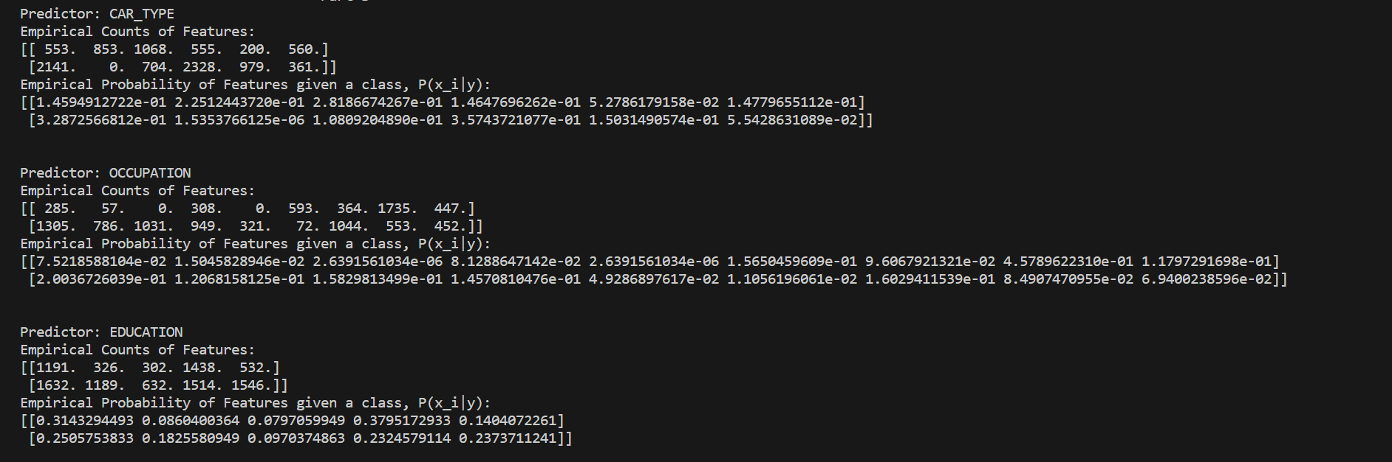

1. & D) In this context, it calculates probabilities for two fictional individuals and presents the outcome.

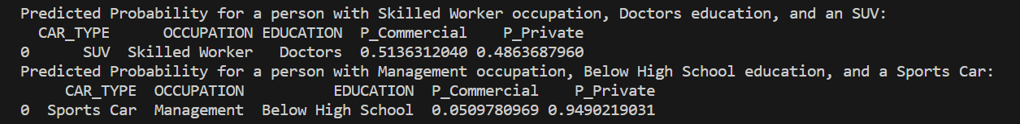

1. A histogram of predicted probabilities for

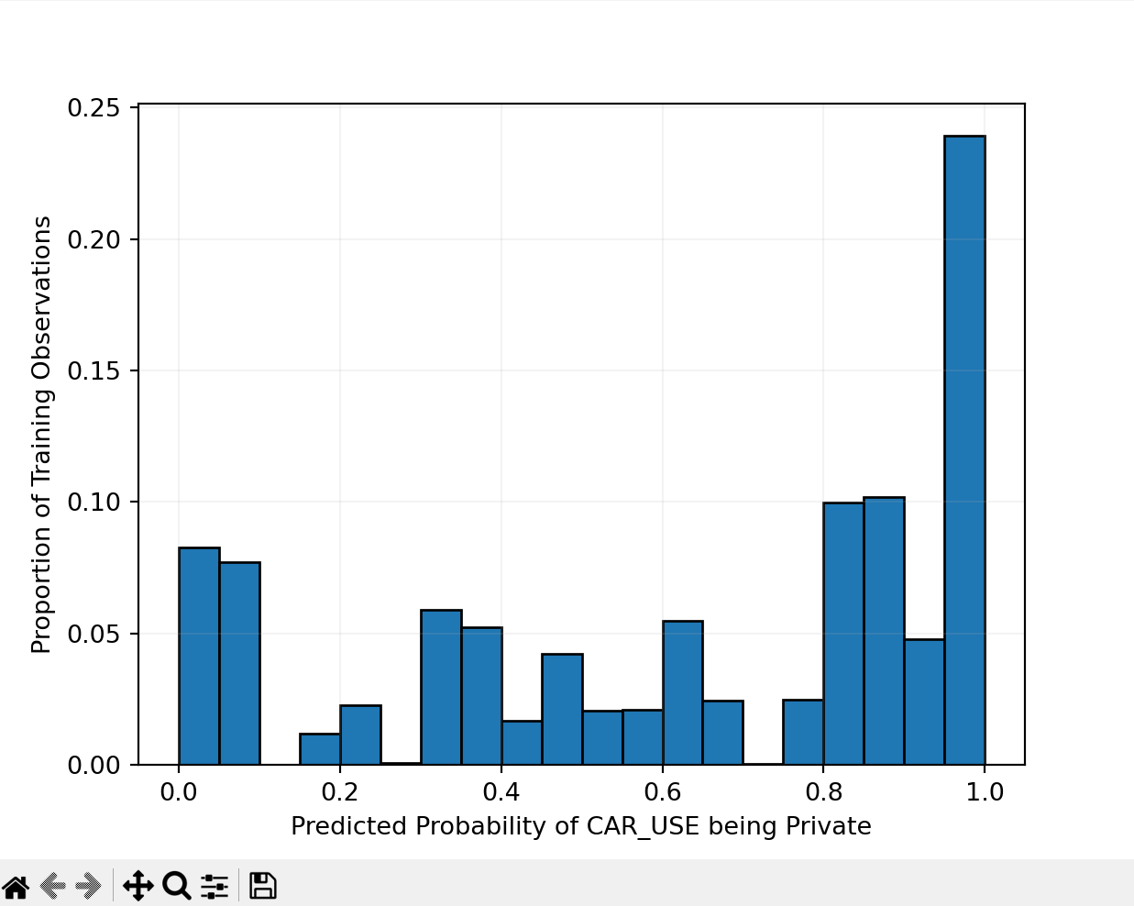

1. Computes the misclassification rate for the Naïve Bayes model: 12.803339157445158