**Question 1)**

1. Policies in each of four groups in the Training Data:

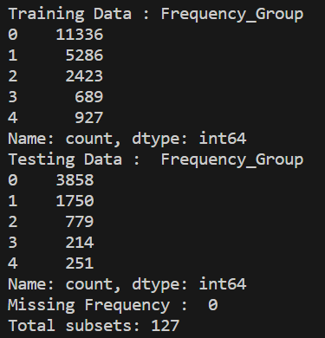

1. The Lowest AIC value on the Training partition along with its Model is:



1. The Lowest BIC value on the Training partition along with its model is:



1. The Highest Accuracy value on the Testing partition along with its model is:



1. The Lowest Root Average Squared Error value on the Testing partition along with the model which produces that RASE value:



**Question 2)**

**The Neural Network Version used is 1.3.0**

1. & B) Proportion of observations where quality_grp = 1 in the Training & Testing partition



1. The Grid Search Table is attached as a different CSV file(result_grid_search.csv) as the data is too large to show in screenshot.
2. Best Network by Misclassification:

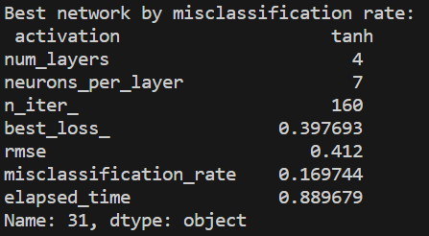

1. Best Network by root average squared error:

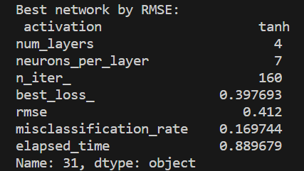

1. Grouped Boxplot for the Predicted Probability for quality_grp = 1 on the Testing data:

