Kod html:

<!DOCTYPE html>

<html lang="pl">

<head>

<title>Title</title>

<meta charset="utf-8">

<meta name="viewport" content="width=device-width, initial-scale=1, shrink-to-fit=no">

<link href="https://cdn.jsdelivr.net/npm/bootstrap@5.3.2/dist/css/bootstrap.min.css" rel="stylesheet"

integrity="sha384-T3c6CoIi6uLrA9TneNEoa7RxnatzjcDSCmG1MXxSR1GAsXEV/Dwwykc2MPK8M2HN" crossorigin="anonymous">

</head>

<body>

<div class="container">

<h2 class="m-3">Zad1</h2>

<div class="container p-4 my-3 bg-success">

<h1>Tytuł</h1>

<p>Tekst</p>

</div>

<div class="container p-4 my-3 bg-warning text-white">

<h1>Tytuł</h1>

<p>Tekst</p>

</div>

<div class="container p-4 my-3 bg-danger text-white">

<h1>Tytuł</h1>

<p>Tekst</p>

</div>

<hr>

<h2 class="m-3">Zad2</h2>

<div class="container p-5 my-5 bg-success">

<h1>Tytuł</h1>

<p>Tekst</p>

</div>

<div class="container p-1 my-1 bg-warning text-white">

<h1>Tytuł</h1>

<p>Tekst</p>

</div>

<div class="container p-5 bg-danger text-white">

<h1>Tytuł</h1>

<p>Tekst</p>

</div>

<hr>

<h2 class="m-3">Zad3</h2>

<div class="row border">

<div class="col-md-3">3</div>

<div class="col-md-3">3</div>

<div class="col-md-3">3</div>

<div class="col-md-3">3</div>

</div>

<div class="row border">

<div class="col-md-7">7</div>

<div class="col-md-5">5</div>

</div>

<div class="row border">

<div class="col-md-1">1</div>

<div class="col-md-1">1</div>

<div class="col-md-1">1</div>

<div class="col-md-1">1</div>

<div class="col-md-1">1</div>

<div class="col-md-1">1</div>

<div class="col-md-1">1</div>

<div class="col-md-1">1</div>

<div class="col-md-1">1</div>

<div class="col-md-1">1</div>

<div class="col-md-1">1</div>

<div class="col-md-1">1</div>

</div>

<div class="row border">

<div class="col-md-6">6</div>

<div class="col-md-6">6</div>

</div>

<hr>

<h2 class="m-3">Zad4</h2>

<div class="row border">

<div class="col-md-5">5</div>

<div class="col-md-7">7</div>

</div>

<div class="row border">

<div class="col-md-2">2</div>

<div class="col-md-2">2</div>

<div class="col-md-2">2</div>

<div class="col-md-2">2</div>

<div class="col-md-2">2</div>

<div class="col-md-2">2</div>

</div>

<div class="row border">

<div class="col-md-3">3</div>

<div class="col-md-3">3</div>

<div class="col-md-3">3</div>

<div class="col-md-3">3</div>

</div>

<div class="row border">

<div class="col-md-4">4</div>

<div class="col-md-4">4</div>

<div class="col-md-4">4</div>

</div>

<hr>

<h2 class="m-3">Zad5</h2>

<table class="table table-striped">

<thead class="table-dark">

<tr>

<th>#</th>

<th>First Name</th>

<th>Last Name</th>

<th>Username</th>

</tr>

</thead>

<tbody>

<tr>

<th scope="row">1</th>

<td>Mark</td>

<td>Otto</td>

<td>@mdo</td>

</tr>

<tr>

<th scope="row">2</th>

<td>Jacob</td>

<td>Thornton</td>

<td>@fat</td>

</tr>

<tr>

<th scope="row">3</th>

<td>Larry</td>

<td>the Bird</td>

<td>@twitter</td>

</tr>

<tr>

<th scope="row">4</th>

<td>Mark</td>

<td>Thornton</td>

<td>@x</td>

</tr>

</tbody>

</table>

<hr>

<h2 class="m-3">Zad6</h2>

<div class="btn btn-primary">Primary</div>

<div class="btn btn-secondary">Secondary</div>

<div class="btn btn-success">Success</div>

<div class="btn btn-danger">Danger</div>

<div class="btn btn-warning">Warning</div>

<div class="btn btn-info">Info</div>

<div class="btn btn-light">Light</div>

<div class="btn btn-dark">Dark</div>

<hr>

<h2 class="m-3">Zad7</h2>

<h1>Typography</h1>

<p>Use the mark element to <mark>highlight</mark> text.</p>

</div>

<script src="https://cdn.jsdelivr.net/npm/@popperjs/core@2.11.8/dist/umd/popper.min.js"

integrity="sha384-I7E8VVD/ismYTF4hNIPjVp/Zjvgyol6VFvRkX/vR+Vc4jQkC+hVqc2pM8ODewa9r" crossorigin="anonymous">

</script>

<script src="https://cdn.jsdelivr.net/npm/bootstrap@5.3.2/dist/js/bootstrap.min.js"

integrity="sha384-BBtl+eGJRgqQAUMxJ7pMwbEyER4l1g+O15P+16Ep7Q9Q+zqX6gSbd85u4mG4QzX+" crossorigin="anonymous">

</script>

</body>

</html>

Screeny:

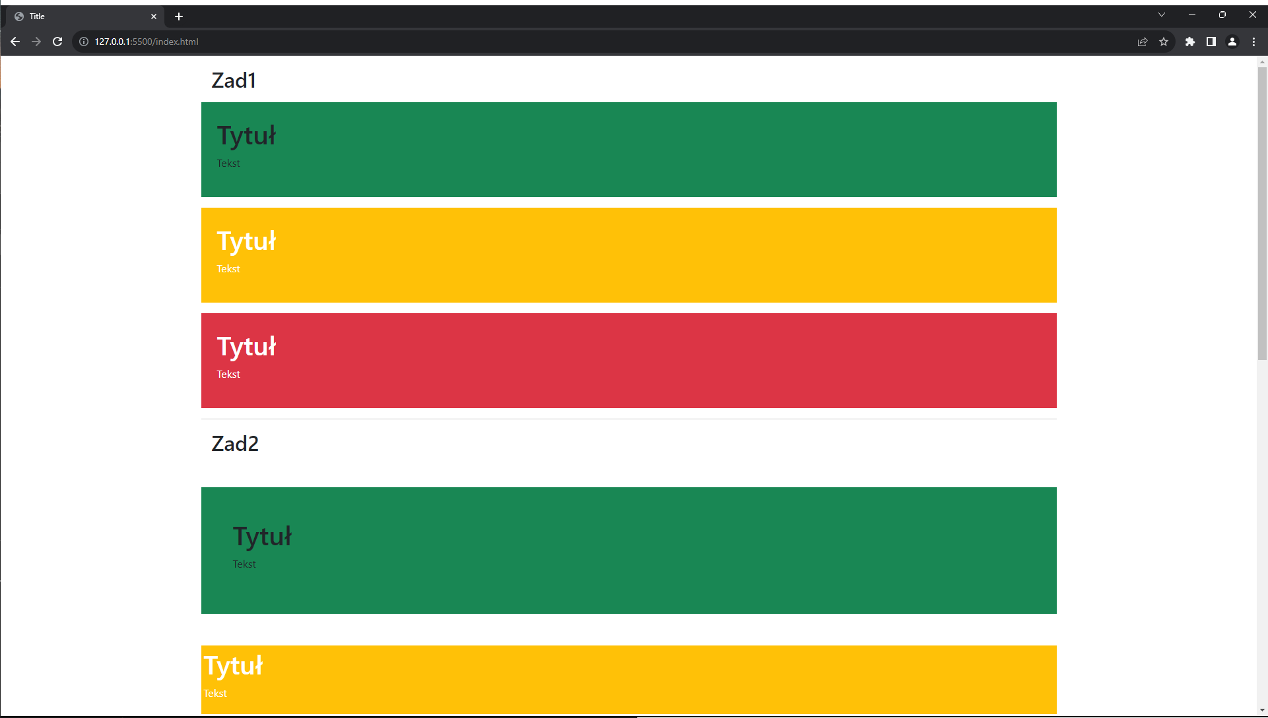

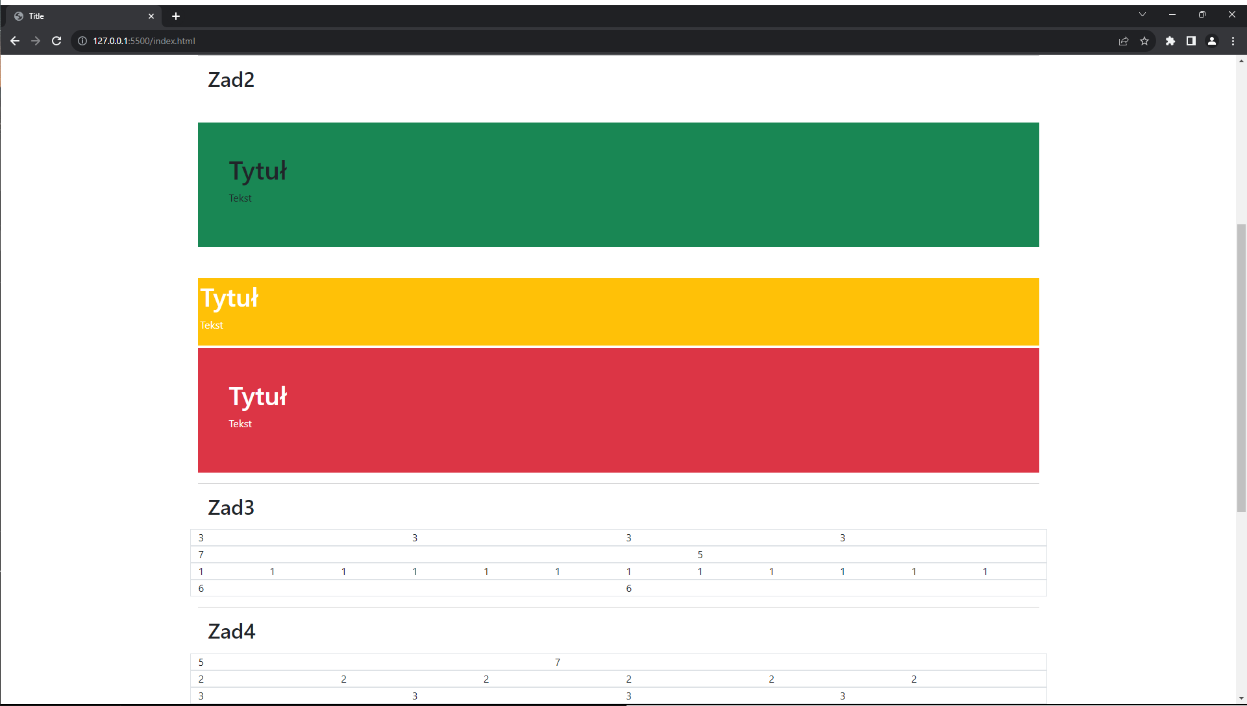

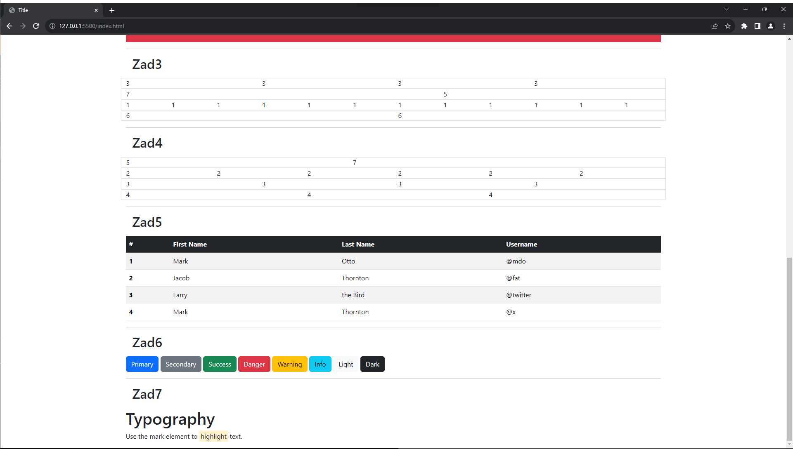

Link do repozytorium: <https://github.com/Vneder/Projektowanie-i-tworzenie-stron/tree/main/Bootstrap>

*Łukasz Woźniakowski 17501*