Kod html:

<!DOCTYPE html>

<html lang="pl">

<head>

<meta charset="UTF-8">

<meta name="viewport" content="width=device-width, initial-scale=1.0">

<title>Canvas</title>

<link rel="stylesheet" href="style.css">

</head>

<body>

<h2>Zad1 (1-3)</h2>

<canvas class="zad1" width="700" height="250"></canvas>

<h2>Zad2 (4)</h2>

<canvas class="zad2" width="200" height="180"></canvas>

<h2>Zad3 (5)</h2>

<canvas class="zad3" width="200" height="180"></canvas>

<h2>Zad4 (6)</h2>

<canvas class="zad4" width="400" height="250"></canvas>

<h2>Zad5 (7)</h2>

<canvas class="zad5" width="320" height="320"></canvas>

<script src="canvas.js"></script>

</body>

</html>

Kod CSS:

body {

text-align: center;

}

canvas {

border: 1px solid black;

}

Kod JS:

const zad1 = document.querySelector(".zad1");

const zad2 = document.querySelector(".zad2");

const zad3 = document.querySelector(".zad3");

const zad4 = document.querySelector(".zad4");

const zad5 = document.querySelector(".zad5");

const ctx = zad1.getContext("2d");

const ctx2 = zad2.getContext("2d");

const ctx3 = zad3.getContext("2d");

const ctx4 = zad4.getContext("2d");

const ctx5 = zad5.getContext("2d");

// zad1

ctx.fillStyle = "red";

ctx.strokeStyle = "black";

ctx.fillRect(10, 10, 200, 100);

ctx.fillStyle = "green";

ctx.strokeStyle = "black";

ctx.fillRect(220, 10, 200, 100);

ctx.fillStyle = "blue";

ctx.strokeStyle = "black";

ctx.fillRect(430, 10, 200, 100);

ctx.strokeStyle = "yellow";

ctx.strokeRect(10, 120, 200, 100);

ctx.strokeStyle = "purple";

ctx.strokeRect(220, 120, 200, 100);

ctx.strokeStyle = "orange";

ctx.strokeRect(430, 120, 200, 100);

// zad2

ctx2.beginPath();

ctx2.moveTo(50, 50);

ctx2.lineTo(50, 150);

ctx2.lineTo(150, 150);

ctx2.closePath();

ctx2.strokeStyle = 'black';

ctx2.stroke();

//zad3

ctx3.beginPath();

ctx3.moveTo(30, 30);

ctx3.lineTo(30, 130);

ctx3.lineTo(130, 130);

ctx3.lineTo(130, 30);

ctx3.closePath();

ctx3.strokeStyle = 'black';

ctx3.stroke();

//zad4

const linearGradient1 = ctx4.createLinearGradient(10, 10, 150, 50);

linearGradient1.addColorStop(0, 'red');

linearGradient1.addColorStop(0.33, 'yellow');

linearGradient1.addColorStop(0.66, 'green');

linearGradient1.addColorStop(1, 'blue');

ctx4.fillStyle = linearGradient1;

ctx4.fillRect(10, 10, 150, 50);

const linearGradient2 = ctx4.createLinearGradient(170, 10, 320, 50);

linearGradient2.addColorStop(0, 'red');

linearGradient2.addColorStop(0.5, 'green');

linearGradient2.addColorStop(1, 'blue');

ctx4.fillStyle = linearGradient2;

ctx4.fillRect(170, 10, 150, 50);

const radialGradient1 = ctx4.createRadialGradient(100, 180, 10, 125, 200, 80);

radialGradient1.addColorStop(0, 'red');

radialGradient1.addColorStop(0.5, 'green');

radialGradient1.addColorStop(1, 'blue');

ctx4.fillStyle = radialGradient1;

ctx4.beginPath();

ctx4.arc(100, 180, 60, 0, 2 \* Math.PI);

ctx4.fill();

const radialGradient2 = ctx4.createRadialGradient(300, 180, 10, 325, 200, 80);

radialGradient2.addColorStop(0, 'green');

radialGradient2.addColorStop(0.5, 'purple');

radialGradient2.addColorStop(1, 'red');

ctx4.fillStyle = radialGradient2;

ctx4.beginPath();

ctx4.arc(300, 180, 60, 0, 2 \* Math.PI);

ctx4.fill();

//zad5

const square = 40;

for (let row = 0; row < 8; row++) {

for (let col = 0; col < 8; col++) {

let color;

if ((row + col) % 2 == 0) {

color = '#777';

}

else {

color = '#fff'

}

ctx5.fillStyle = color;

ctx5.fillRect(col \* square, row \* square, square, square);

}

}

Screeny:

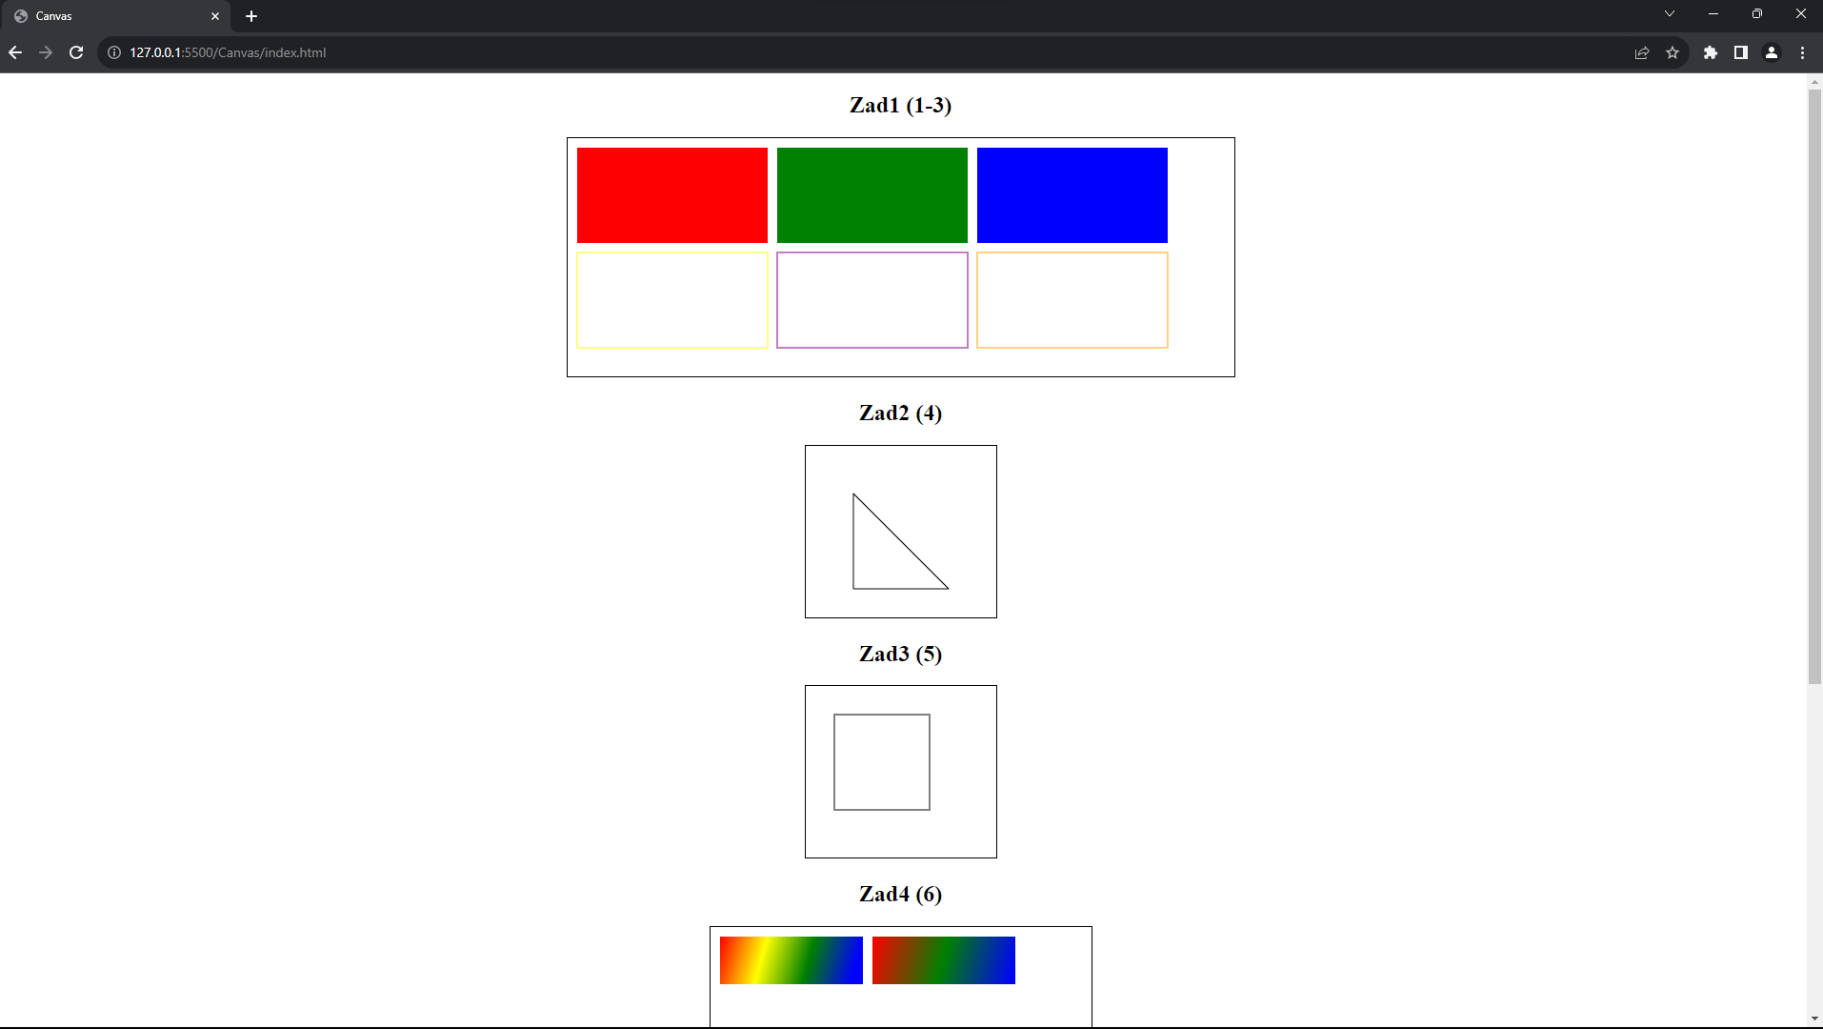

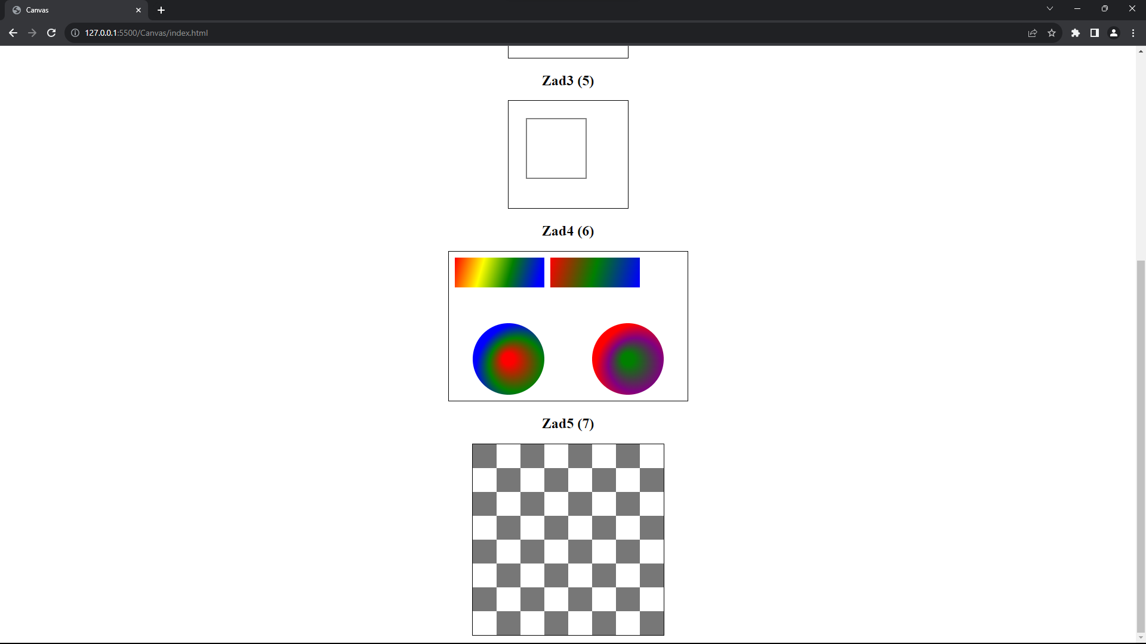

Link do repozytorium:

*Łukasz Woźniakowski 17501*