Kod html:

<!DOCTYPE html>

<html lang="pl">

<head>

<meta charset="UTF-8">

<meta name="viewport" content="width=device-width, initial-scale=1.0">

<link rel="stylesheet" href="style.css">

<title>Css v2</title>

</head>

<body>

<div class="zad9">

<h1>Zad9</h1>

</div>

<div class="zad10">

<h1>Zad10</h1>

<p class="dotted">

Lorem, ipsum dolor sit amet consectetur adipisicing elit. Cum fugiat dolore, voluptatibus deserunt

consequatur ipsum aut, est, natus dolor minus totam temporibus! Nostrum alias cupiditate error nobis magni,

commodi laborum itaque nesciunt omnis nisi suscipit maxime doloremque officiis a quae odio. In aperiam

corporis inventore necessitatibus porro quas dolore culpa.

</p>

</div>

</body>

</html>

Kod CSS:

div {

border: 1px solid black;

padding: 10px;

text-align: center;

width: 40vw;

min-height: 40vh;

margin: 30px auto;

}

.zad9 {

background: rgb(0, 59, 255);

background: linear-gradient(90deg, rgba(0, 59, 255, 1) 0%, rgba(20, 255, 0, 1) 100%);

}

.dotted {

border: 2px dotted blue;

}

Screen:

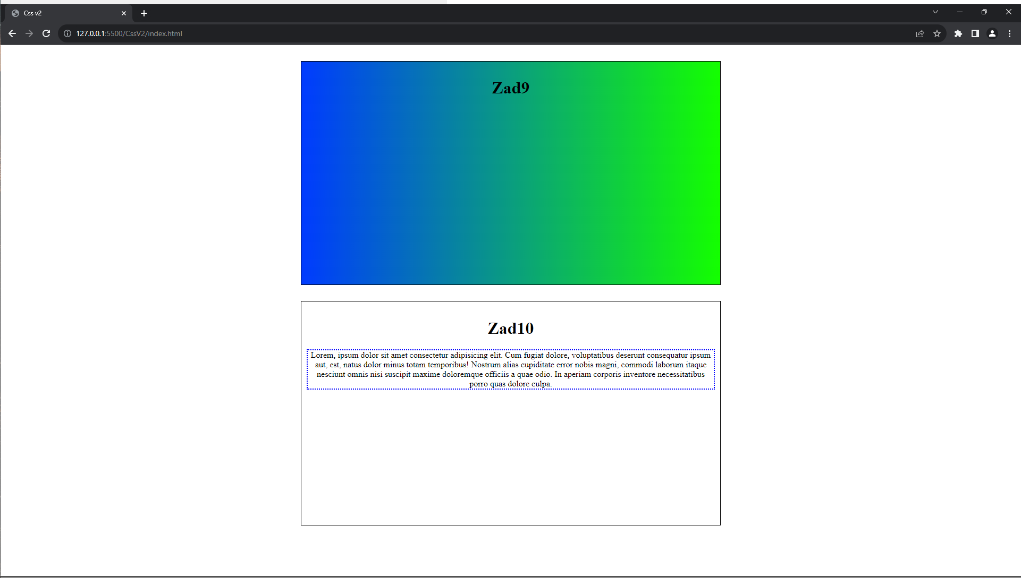

Link do repozytorium: <https://github.com/Vneder/Projektowanie-i-tworzenie-stron/tree/main/CSS%20jakis>

*Łukasz Woźniakowski 17501*