Kod html:

<!DOCTYPE html>

<html lang="en">

<head>

<meta charset="UTF-8">

<meta name="viewport" content="width=device-width, initial-scale=1.0">

<title>Zadania CSS</title>

<link rel="stylesheet" href="style.css">

</head>

<body>

<div>

<h2>Zad1</h2>

<a href="#1">Link do strony osobistej</a> <br>

<a href="#2">Link do strony uczelni</a> <br>

<a href="#3">Strona onetu</a>

</div>

<div>

<h2>Zad2</h2>

<p class="zad2">Paragrafy z tekstem</p>

<p class="zad2">Paragrafy z tekstem</p>

<p class="zad2">Paragrafy z tekstem</p>

</div>

<div>

<h2>Zad3</h2>

<p class="zad3">Paragrafy z tekstem</p>

<p class="zad3">Paragrafy z tekstem</p>

<p class="zad3">Paragrafy z tekstem</p>

</div>

<div>

<h2>Zad4</h2>

<p class="zad4">Lorem ipsum dolor, sit amet consectetur adipisicing elit. Esse placeat pariatur enim alias quos,

vel ullam odit facere cum eos ut explicabo labore sunt assumenda, repellendus natus saepe similique eveniet?

</p>

<br>

<p class="zad4">Lorem ipsum dolor sit amet consectetur adipisicing elit. Ratione et cupiditate molestiae odio

labore ex facere impedit iure mollitia soluta!</p>

<br>

<p class="zad4">Lorem ipsum dolor sit amet consectetur adipisicing elit. Commodi facilis dignissimos blanditiis

deserunt. Nesciunt consectetur est molestias omnis esse dicta nobis aperiam, nemo exercitationem incidunt

reiciendis obcaecati quas magni beatae ea repudiandae necessitatibus dolores ut, nihil laboriosam saepe

reprehenderit non.</p>

</div>

<div>

<h2>Zad5</h2>

<div class="bgBlack">

<p>Paragrafy z tekstem</p>

<p>Paragrafy z tekstem</p>

<p>Paragrafy z tekstem</p>

</div>

<div class="bgWhite">

<p>Paragrafy z tekstem</p>

<p>Paragrafy z tekstem</p>

<p>Paragrafy z tekstem</p>

</div>

</div>

<div>

<h2>zad6</h2>

<p class="zad6">Ala ma kota Bonifacego</p>

</div>

<div>

<h2>zad7</h2>

<p class="zad7">abcdefghijklmnoporstuwxyz</p>

</div>

<div>

<h2>zad8</h2>

<p class="piksel">Lorem ipsum dolor sit amet consectetur adipisicing elit. Voluptates, cupiditate.</p>

<hr>

<p class="milimetr">Lorem ipsum dolor sit amet consectetur adipisicing elit. Quaerat, assumenda!</p>

<hr>

<p class="responsywne">Lorem ipsum dolor sit amet consectetur adipisicing elit. Corporis, voluptates.</p>

</div>

</body>

</html>

Kod CSS:

\* {

box-sizing: border-box;

margin: 0;

padding: 0;

}

body {

width: 1400px;

margin: 0 auto;

}

div {

padding: 2rem;

border: 1px dashed #ccc;

}

/\* Zad1 \*/

a {

color: aqua;

}

a:visited {

color: lawngreen;

}

a:hover {

color: salmon;

}

/\* Zad2 \*/

.zad2 {

font-size: 20px;

font-family: Arial;

color: green;

font-weight: bold;

text-align: right;

text-transform: lowercase;

}

/\* Zad3 \*/

.zad3 {

font-size: 8mm;

font-family: Verdana;

color: blue;

font-style: italic;

text-align: center;

text-transform: capitalize;

}

/\* Zad4 \*/

.zad4 {

font-size: 20pt;

font-family: Helvetica;

color: red;

text-decoration: underline;

text-align: justify;

text-transform: uppercase;

text-indent: 30pt;

}

/\* Zad5 \*/

.bgWhite {

border: 1px solid black;

padding: 1rem;

text-shadow: 10px 10px 4px rgba(0, 0, 0, 1);

}

.bgBlack {

border: 1px solid black;

background-color: black;

color: white;

padding: 1rem;

text-shadow: 10px 10px 4px rgba(255, 255, 255, 1);

}

/\* Zad6 \*/

.zad6 {

letter-spacing: -4.5px;

font-size: 3rem;

}

/\* Zad7 \*/

.zad7 {

text-align: center;

letter-spacing: -50px;

font-size: 3rem;

}

/\* Zad8 \*/

.piksel {

font-size: 20px;

}

.milimetr {

font-size: 20mm;

}

.responsywne {

font-size: 3vw;

}

Screeny:

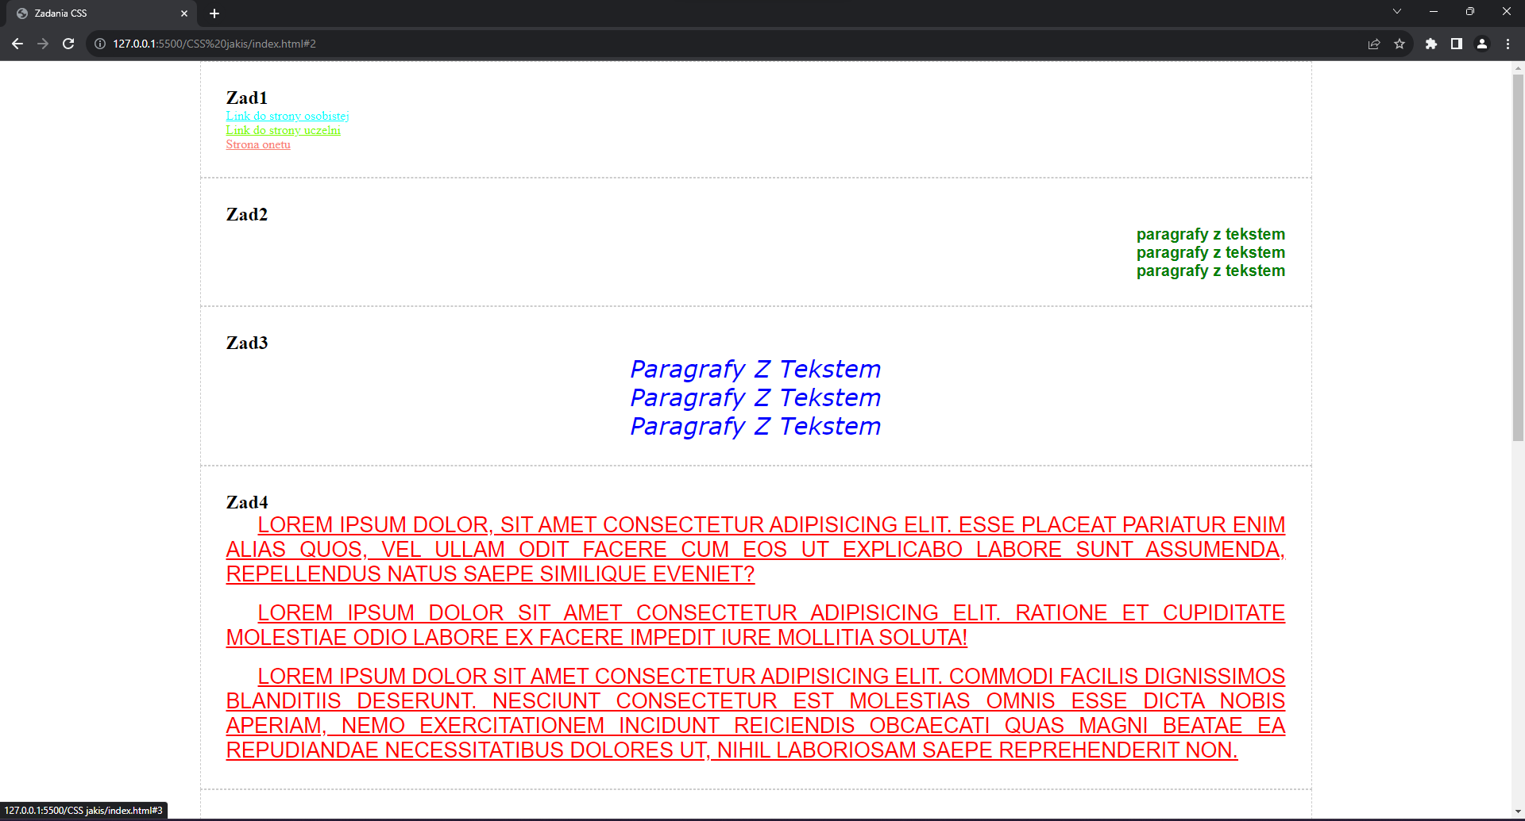

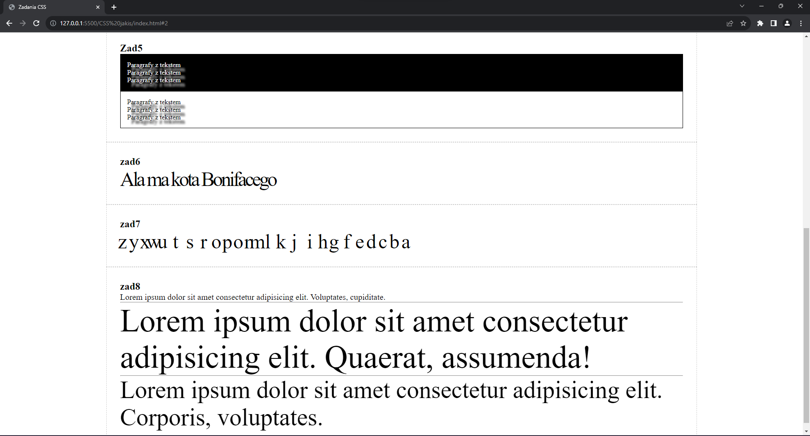

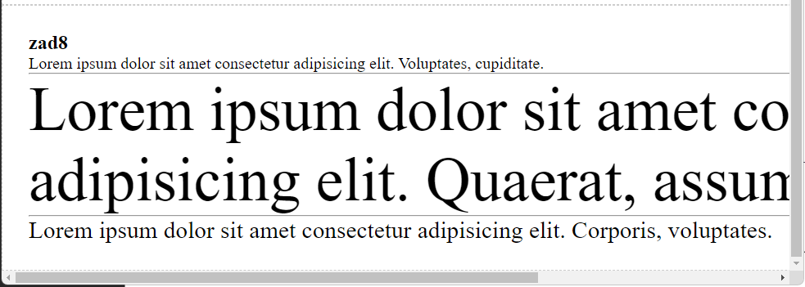

Link do repozytorium: <https://github.com/Vneder/Projektowanie-i-tworzenie-stron/tree/main/CSS%20jakis>

*Łukasz Woźniakowski 17501*