# PROPS

## **Exercise 4:**

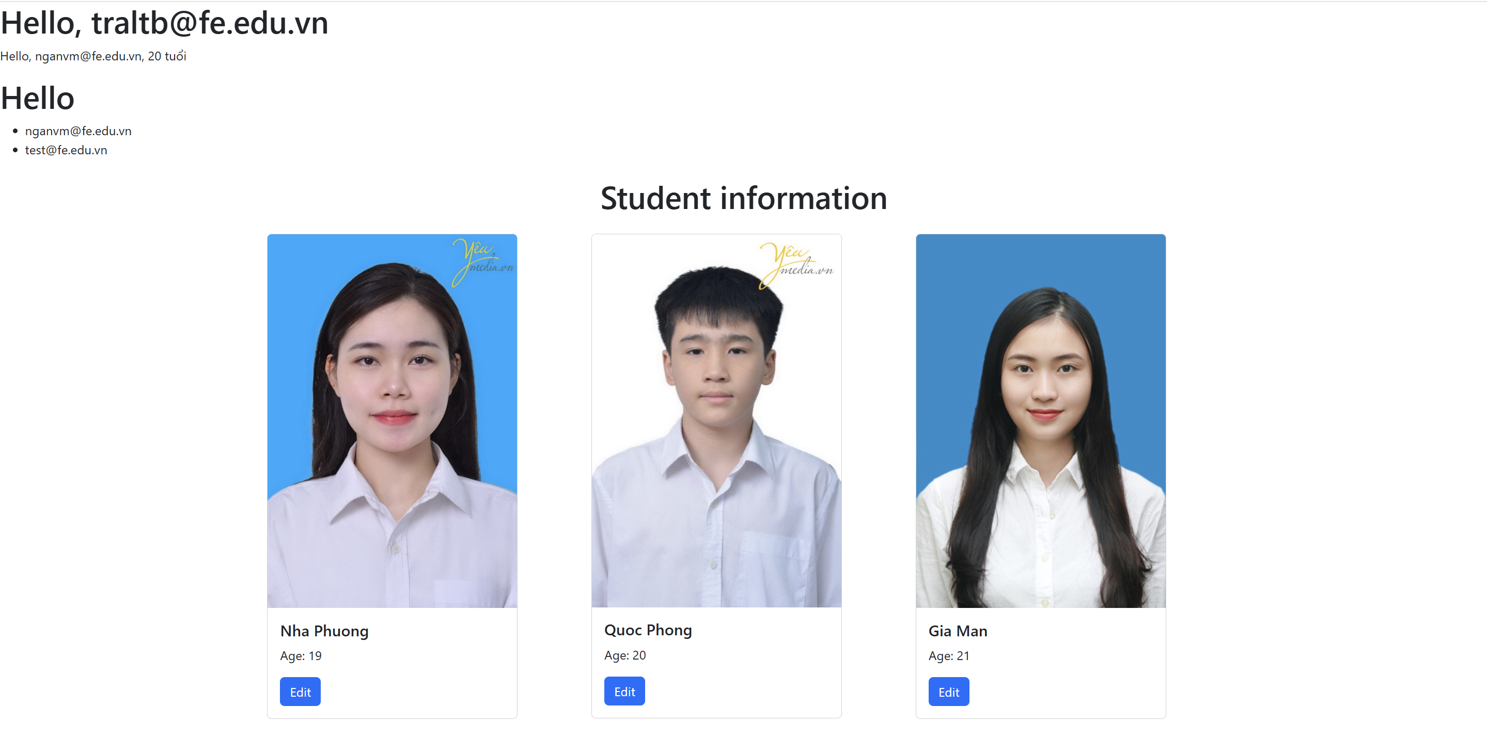

### StudentCard.js

import React from "react";

import { Card, Button } from "react-bootstrap";

const StudentCard = ({ student }) => {

  return (

    <Card style={{ width: "20rem" }} className="mb-4">

      <Card.Img

        variant="top"

        src={student.avatar}

        alt={`${student.name}'s avatar`}

      />

      <Card.Body>

        <Card.Title>{student.name}</Card.Title>

        <Card.Text>Age: {student.age}</Card.Text>

        <Button variant="primary">Edit</Button>

      </Card.Body>

    </Card>

  );

};

export default StudentCard;

### App.js

import 'bootstrap/dist/css/bootstrap.min.css';

import NameList from "./components/NameList";

import UserProfile from "./components/UserProfile";

import Welcome from "./components/Welcome";

import { Container, Row, Col } from "react-bootstrap";

import StudentCard from "./components/StudentCard";

function App() {

  const userData = { name: "nganvm@fe.edu.vn", age: 20 };

  const namesList = ["nganvm@fe.edu.vn", "test@fe.edu.vn"];

  const students = [

    { name: "Nha Phuong", age: 19, avatar: "https://bizweb.dktcdn.net/100/175/849/files/nhung-luu-y-khi-di-chup-anh-the-hoc-sinh-sinh-vien-7-0c8056ae-0cd9-4fe7-afba-6d568dbf322d.jpg?v=1720762638583" },

    { name: "Quoc Phong", age: 20, avatar: "https://bizweb.dktcdn.net/100/175/849/files/nhung-luu-y-khi-di-chup-anh-the-hoc-sinh-sinh-vien-1-016c9c22-e8bb-46fe-a6bb-69b81dcdd0c3.jpg?v=1720762597525" },

    { name: "Gia Man", age: 21, avatar: "https://anhvienpiano.com/wp-content/uploads/2016/10/anh-4.jpg" },

  ];

  return (

    <>

      <Welcome name="traltb@fe.edu.vn" />

      <UserProfile user={userData} />

      <NameList names={namesList} />

      <Container>

        <h1 className="my-4 text-center">Student information</h1>

        <Row>

          {students.map((student, index) => (

            <Col key={index} sm={12} md={4}>

              <StudentCard student={student} />

            </Col>

          ))}

        </Row>

      </Container>

    </>

  );

}

export default App;

### NameList.js

const NameList = ({ names }) => {

  return (

    <div>

        <h1>Hello</h1>

      <ul>

        {names.map((name, index) => (

          <li key={index}>{name}</li>

        ))}

      </ul>

    </div>

  );

};

export default NameList;

### UserProfile.js

const UserProfile = ({ user }) => (

  <div>

    <p>

      Hello, {user.name}, {user.age} tuổi

    </p>

  </div>

);

export default UserProfile;

### Welcome.js

const Welcome = ({ name }) => <h1>Hello, {name}</h1>;

export default Welcome;