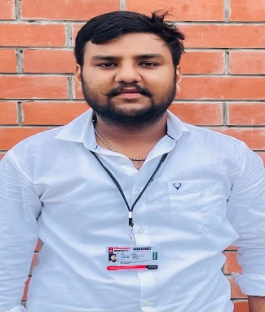

**Aarsh**



Address: Shop N0 42, Grain Market,

Raman(Bathinda)

E-mail: *aarshgarg0@gmail.com*

Phone: +91 7589393809

LinkedIn: linkedin.com/in/aarsh-garg-9a05b122a

**PROFESSIONAL SUMMARY**



1. well-organized, creative and goal-oriented graduate possessing excellent communication, problem-solving and leadership skills with a flair to explore suitable avenues in Computer Science Engineering while developing advanced projects with efficiency and quality.

**TECHNICAL COMPETENCIES**



C++ | PYTHON |Java Basic

WEB DEVELOPMENT|DSA|DBMS

**INTERPERSONAL SKILLS**



Team Leadership **|** Hard Working **|** Decision Making

**INTERESTS & HOBBIES**



Badminton**|** Traveling |Gardening

|Photography|Listening Music

**LANGUAGES KNOWN**



English **|** Hindi **|** Punjabi

**PERSONAL DETAILS**



Mother’ Name:Mamta

Father’ Name:Rajinder Kumar

D.O.B.:22/Nov/2002

**EDUCATION**

Bachelors in Computer Science Engineering | Chandigarh University,

*Session: 2020-2022 | Score: 8.09 CGPA*

Intermediate (CBSE) |RMM DAV SEN SEC SCHOOL

*Session: 2018-2019 | Percentage: 77%*

Matriculation (CBSE) | RMM DAV SEN SEC SCHOOL

SESSION*: 2017-2018 | Percentage: 74%*

**TRAINING & PROJECTS**



.

**Hospital Management Website**

Developed website for a hospital in order to manage daily logs & more.

Used HTML & CSS with PHP backend frameworks

**Pg life project**

Training on the Full stack by internshala

(june 2022-july 2022)

**ACADEMIC ACHIEVEMENTS**



Silver Medalist in the General Knowledge

**CERTIFICATIONS & AWARDS**



Completed Full stack certified course from intershala

Completed Java programming certified course from coursera

**EXTRA CURRICULAR & CO-CURRICULAR ACHIEVEMENTS**



District Badminton Player

NCC(Navy) A Grade Certified