**WORKSHEET 1**

**Student Name:** Vivek Kumar **UID:** 21BCS8129

**DOMAIN CAMP:** 16-01-2023 to 28-01-2023 **Section/Group:** DWWC-77

**Subject Name:** Database Management System

**Question 1. Consider the following schema**

|  |  |  |  |  |
| --- | --- | --- | --- | --- |
| **ord_no** | **purch_amt** | **ord_date** | **customer_id** | **salesman_id** |
| **70001** | **150.5** | **2012-10-05** | **3005** | **5002** |
| **70009** | **270.65** | **2012-09-10** | **3001** | **5005** |
| **70002** | **65.26** | **2012-10-05** | **3002** | **5001** |
| **70004** | **110.5** | **2012-08-17** | **3009** | **5003** |
| **70007** | **948.5** | **2012-09-10** | **3005** | **5002** |
| **70005** | **2400.6** | **2012-07-27** | **3007** | **5001** |
| **70008** | **5760** | **2012-09-10** | **3002** | **5001** |
| **70010** | **1983.43** | **2012-10-10** | **3004** | **5006** |
| **70003** | **2480.4** | **2012-10-10** | **3009** | **5003** |
| **70012** | **250.45** | **2012-06-27** | **3008** | **5002** |
| **70011** | **75.29** | **2012-08-17** | **3003** | **5007** |
| **70013** | **3045.6** | **2012-04-25** | **3002** | **5001** |

1. Create the table orders with columns order_no number type, purch_amt number(precision, scale), ord_date date, customer_id number and salesman_id number
2. Insert the values as given in the table
3. Add customer name, email address and contact_number columns in the given table
4. Add column gender in the table with single character value.
5. Update the values of newly added columns in the records.
6. Create another table orders_completed with ord_no, purch_amt, ord_date and customer name, email_address and contact number. Then copy the information of details from orders table where date is 10th October 2012.

**Solution:**

Create Table orders(order_no number, purch_amt number(6,2), order_date date, customer_id number, salesman_id number);

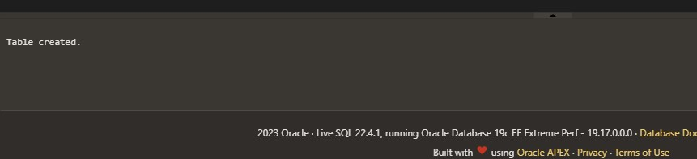

insert into orders values(70009, 270.65, to_date('10-09-2012', 'DD-MM-YYYY'),3001, 5005); insert into orders values(70002, 65.26, to_date('05-10-2012', 'DD-MM-YYYY'),3002, 5001); insert into orders values(70004, 110.5, to_date('17-08-2012', 'DD-MM-YYYY'),3009, 5003); insert into orders values(70007, 948.5, to_date('10-09-2012', 'DD-MM-YYYY'),3005, 5002); insert into orders values(70005, 2400.6, to_date('27-07-2012', 'DD-MM-YYYY'),3007, 5001); insert into orders values(70008, 5760, to_date('10-09-2012', 'DD-MM-YYYY'),3002, 5001); insert into orders values(70010, 1983.43, to_date('10-10-2012', 'DD-MM-YYYY'),3004, 5006); insert into orders values(70003, 2480.4, to_date('10-10-2012', 'DD-MM-YYYY'),3009, 5003); insert into orders values(70012, 250.45, to_date('27-06-2012', 'DD-MM-YYYY'),3008, 5002); insert into orders values(70011, 75.29, to_date('17-08-2012', 'DD-MM-YYYY'),3003, 5007); insert into orders values(70013, 3045.6, to_date('25-04-2012', 'DD-MM-YYYY'),3002, 5001); insert into orders values(70001, 150.5, to_date('05-10-2012', 'DD-MM-YYYY'),3005, 5002);

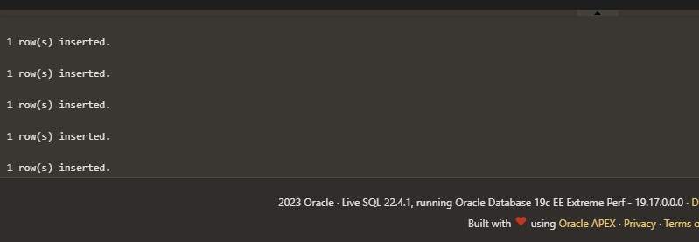

Alter Table orders add(customer_name Varchar(20), email_address varchar(50), contact_number number);

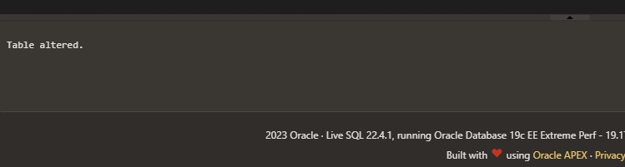

Alter Table orders add(gender character(1));

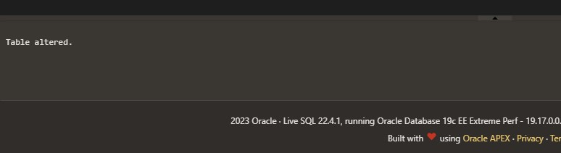

insert into orders values(70010, 1983.43, to_date('10-10-2012', 'DD-MM-YYYY'),3004, 5006, 'Sam', 'sam@cuchd.in',

87653, 'M');

insert into orders values(70003, 2480.4, to_date('10-10-2012', 'DD-MM-YYYY'),3009, 5003, 'Max', 'max@cuchd.in',

987521, 'M');

insert into orders values(70012, 250.45, to_date('27-06-2012', 'DD-MM-YYYY'),3008, 5002, 'Jannat Baweja',

'jannat.baweja@gmail.com', 98775, 'F');

insert into orders values(70011, 75.29, to_date('17-08-2012', 'DD-MM-YYYY'),3003, 5007, 'Ann', 'ann@cuchd.in',

134642, 'F');

insert into orders values(70013, 3045.6, to_date('25-04-2012', 'DD-MM-YYYY'),3002, 5001, 'Robin', 'robin@cuchd.in', 98436, 'M');

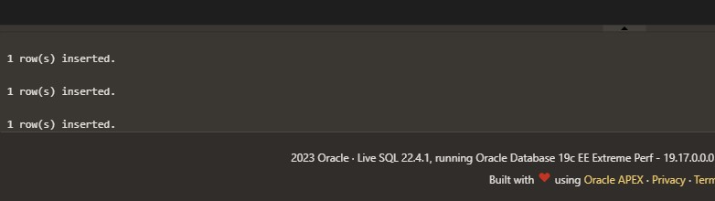

Create Table orders_completed(order_no number, purch_amt number(6,2), order_date date, customer_name Varchar(20), email_address varchar(50), contact_number number);

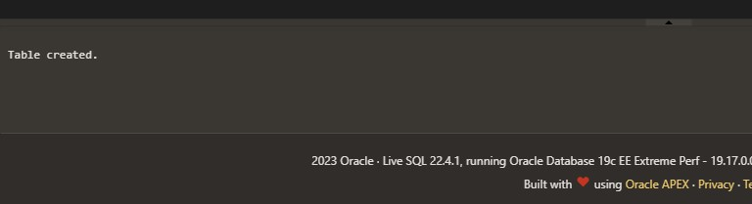

INSERT INTO orders_completed (order_no, purch_amt, order_date, customer_name, email_address, contact_number) SELECT order_no, purch_amt, order_date, customer_name, email_address, contact_number FROM orders WHERE order_date = date '2012-10-10';

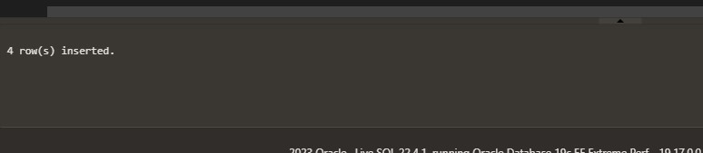

select * from orders_completed;

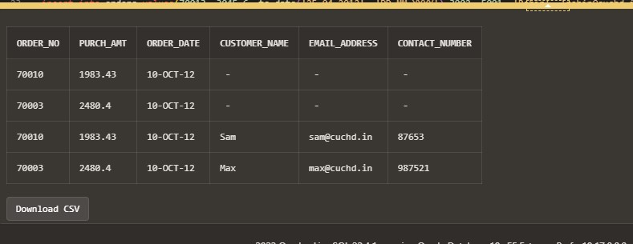

**Question2. Consider the following schema**

|  |  |  |  |  |  |
| --- | --- | --- | --- | --- | --- |
| ID | FNAME | LNAME | GENDER | SALARY | HIREDATE |
| 1 | Rajveer | Singh | M | 30000 | 2017/11/05 |
| 2 | Manveer | Singh | M | 50000 | 2017/11/05 |
| 3 | Ashutosh | Kumar | M | 40000 | 2017/12/12 |
| 4 | Ankita | Sharma | **F** | 45000 | 2017/12/15 |
| 5 | Vijay | Kumar | **M** | 50000 | 2018/01/12 |
| 6 | Dilip | Yadav | M | 25000 | 2018/02/26 |
| 7 | Jayvijay | Singh | M | 30000 | 2018/02/18 |
| 8 | Reenu | Kumari | F | 40000 | 2017/09/19 |
| 9 | Ankit | Verma | **M** | 25000 | 2018/04/04 |
| 10 | Harpreet | Singh | M | 50000 | 2017/10/10 |

1. Create table Employee.
2. Insert the values as mentioned.
3. Add column Employee ID as identity column.
4. Modify the column salary to store floating point values.
5. Rename the attribute FNAME to Emp_name.
6. Drop column LNAME from the employee table.
7. Add column Department with default value as ‘CSE’
8. Add an annual increment to the salary of employee whose joining date is 19th September 2017.
9. Modify the department value of DILIP and VIJAY to ME
10. Delete the employees belonging to ME department

**Solution:**

CREATE TABLE Employee ( ID INTEGER, FNAME VARCHAR(20), LNAME VARCHAR(20), GENDER CHAR(1), SALARY INTEGER, HIREDATE DATE);

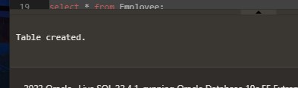

INSERT INTO Employee VALUES(1,'RAJVEER','SINGH','M',30000,DATE '2017-11- 05');

INSERT INTO Employee VALUES(2,'MANVEER','SINGH','M',50000,DATE '2017-11- 05');

INSERT INTO Employee VALUES(3,'ASHUTOSH','KUMAR','M',40000,DATE '2017-12- 12');

INSERT INTO Employee VALUES(4,'ANKITA','SHARMA','F',45000,DATE '2017-12- 15');

INSERT INTO Employee VALUES(5,'VIJAY','KUMAR','M',50000,DATE '2018-01-12');

INSERT INTO Employee VALUES(6,'DILIP','YADAV','M',25000,DATE '2018-02-26');

INSERT INTO Employee VALUES(7,'JAYVIJAY','SINGH','M',30000,DATE '2018-02- 18');

INSERT INTO Employee VALUES(8,'REENU','KUMARI','F',40000,DATE '2017-09-19');

INSERT INTO Employee VALUES(9,'ANKIT','VERMA','M',25000,DATE '2018-04-04'); INSERT INTO Employee VALUES(10,'HARPREET','SINGH','M',50000,DATE '2017-10- 10'); select * from Employee;

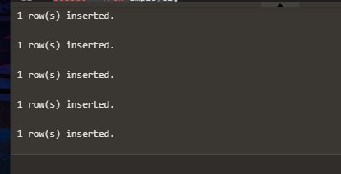

ALTER TABLE Employee ADD EMPLOYEE_ID INTEGER GENERATED BY DEFAULT ON NULL AS IDENTITY START WITH 1;

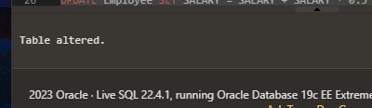

ALTER TABLE Employee MODIFY SALARY FLOAT;



ALTER TABLE Employee RENAME COLUMN FNAME TO EMP_NAME;

select * from Employee;



ALTER TABLE Employee DROP COLUMN LNAME;



ALTER TABLE Employee ADD DEPARTMENT VARCHAR(20) DEFAULT('CSE');

select * from Employee;



UPDATE Employee SET SALARY = SALARY + SALARY * 0.5 WHERE HIREDATE = DATE '2017-09-19';

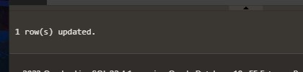

UPDATE Employee SET DEPARTMENT='ME' WHERE EMP_NAME='DILIP'; UPDATE Employee SET DEPARTMENT='ME' WHERE EMP_NAME='VIJAY';

select * from Employee;

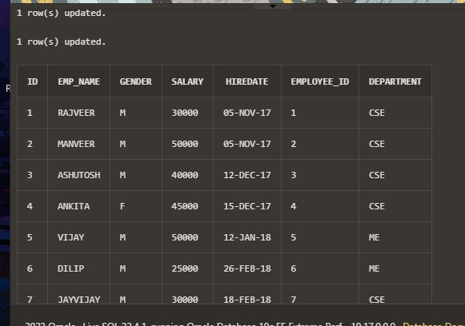

DELETE FROM EMPLOYEE WHERE DEPARTMENT='ME';

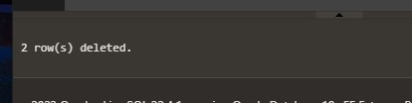

**Q3. Consider the table in question 2**

1. Apply Truncate command
2. Apply Drop command
3. Apply Delete command to delete all records at once.

Analyze the difference.

**Solution:**

Create Table Employee(id number, Fname Varchar(20), Lname Varchar(20), Gender Character(1), salary number, hiredate date); insert into Employee values(1, 'Rajveer', 'Singh', 'M', 30000, to_date('05-11-2017', 'DD-MM-YYYY')); insert into Employee values(2, 'Manveer','Singh', 'M', 50000, to_date('05-11-2017', 'DD-MM-YYYY')); insert into Employee values(3, 'Ashutosh', 'Kumar', 'M', 40000, to_date('12-12-2017', 'DD-MM-YYYY')); insert into Employee values(4, 'Ankita','Sharma', 'F', 45000, to_date('15-12-2017', 'DD-MM-YYYY'));

insert into Employee values(5, 'Vijay', 'Kumar', 'M', 50000, to_date('12-01-2018', 'DD-MM-YYYY')); insert into Employee values(6, 'Dilip', 'Yadav', 'M', 25000, to_date('26-02-2018', 'DD-MM-YYYY')); insert into Employee values(7, 'Jayvijay','Singh', 'M', 30000, to_date('18-02-2018', 'DD-MM-YYYY')); insert into Employee values(8, 'Reenu', 'Kumari', 'F', 40000, to_date('19-09-2017', 'DD-MM-YYYY')); insert into Employee values(9, 'Ankit', 'Verma', 'M', 25000, to_date('04-04-2018', 'DD-MM-YYYY')); insert into Employee values(10, 'Harpreet','Singh', 'M', 50000, to_date('10-10-2017', 'DD-MM-YYYY')); Select * from Employee;

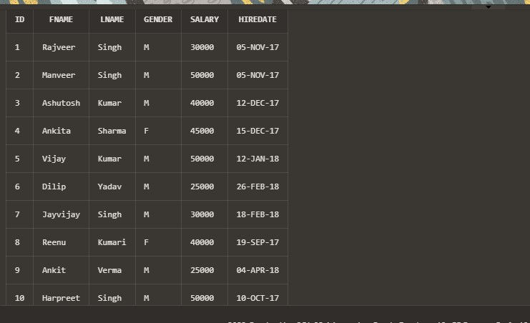

Truncate Table Employee;

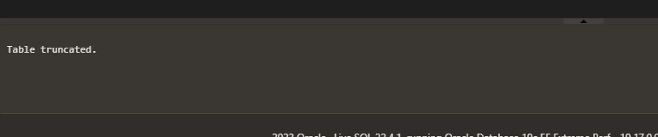

Drop Table Employee;

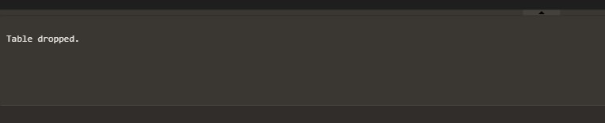

Delete from Employee;

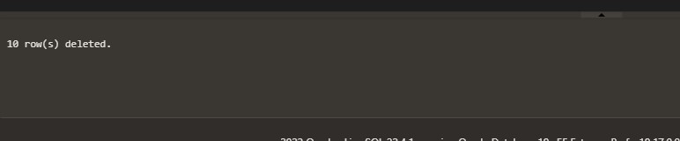

**Q4. Consider the following schema**

|CUST_CODE | CUST_NAME | CUST_CITY | WORKING_AREA | CUST_COUNTRY | GRADE |

OPENING_AMT | RECEIVE_AMT | PAYMENT_AMT |OUTSTANDING_AMT| PHONE_NO | AGENT_CODE |

+-----------+-------------+-------------+--------------+--------------+-------+-------------+-------------+-------------+---------------+--

------------+------------+

| C00013 | Holmes | London | London | UK | 2 | 6000.00 | 5000.00 | 7000.00 | 4000.00 | BBBBBBB | A003 |

| C00001 | Micheal | New York | New York | USA | 2 | 3000.00 | 5000.00 | 2000.00 | 6000.00 | CCCCCCC | A008 |

| C00020 | Albert | New York | New York | USA | 3 | 5000.00 | 7000.00 | 6000.00 | 6000.00 | BBBBSBB | A008 |

| C00025 | Ravindran | Bangalore | Bangalore | India | 2 | 5000.00 | 7000.00 | 4000.00 | 8000.00 | AVAVAVA | A011 |

| C00024 | Cook | London | London | UK | 2 | 4000.00 | 9000.00 | 7000.00 | 6000.00 | FSDDSDF | A006 |

| C00015 | Stuart | London | London | UK | 1 | 6000.00 | 8000.00 | 3000.00 | 11000.00 | GFSGERS | A003 |

| C00002 | Bolt | New York | New York | USA | 3 | 5000.00 | 7000.00 | 9000.00 | 3000.00 |

DDNRDRH | A008 |

| C00018 | Fleming | Brisban | Brisban | Australia | 2 | 7000.00 | 7000.00 | 9000.00 | 5000.00 | NHBGVFC | A005 |

| C00021 | Jacks | Brisban | Brisban | Australia | 1 | 7000.00 | 7000.00 | 7000.00 | 7000.00 | WERTGDF | A005 |

| C00019 | Yearannaidu | Chennai | Chennai | India | 1 | 8000.00 | 7000.00 | 7000.00 | 8000.00 | ZZZZBFV | A010 |

| C00005 | Sasikant | Mumbai | Mumbai | India | 1 | 7000.00 | 11000.00 | 70f00.00 | 11000.00 | 147-25896312 | A002 |

| C00007 | Ramanathan | Chennai | Chennai | India | 1 | 7000.00 | 11000.00 | 9000.00 | 9000.00 | GHRDWSD | A010 |

| C00022 | Avinash | Mumbai | Mumbai | India | 2 | 7000.00 | 11000.00 | 9000.00 | 9000.00 | 113-12345678 | A002 |

| C00004 | Winston | Brisban | Brisban | Australia | 1 | 5000.00 | 8000.00 | 7000.00 | 6000.00 | AAAAAAA | A005 |

| C00023 | Karl | London | London | UK | 0 | 4000.00 | 6000.00 | 7000.00 | 3000.00 | AAAABAA | A006 |

| C00006 | Shilton | Torento | Torento | Canada | 1 | 10000.00 | 7000.00 | 6000.00 | 11000.00 | DDDDDDD | A004 |

| C00010 | Charles | Hampshair | Hampshair | UK | 3 | 6000.00 | 4000.00 | 5000.00 | 5000.00 | MMMMMMM | A009 |

| C00017 | Srinivas | Bangalore | Bangalore | India | 2 | 8000.00 | 4000.00 | 3000.00 | 9000.00 | AAAAAAB | A007 |

| C00012 | Steven | San Jose | San Jose | USA | 1 | 5000.00 | 7000.00 | 9000.00 | 3000.00 | KRFYGJK | A012 |

| C00008 | Karolina | Torento | Torento | Canada | 1 | 7000.00 | 7000.00 | 9000.00 | 5000.00 | HJKORED | A004 |

| C00003 | Martin | Torento | Torento | Canada | 2 | 8000.00 | 7000.00 | 7000.00 | 8000.00 | MJYURFD | A004 |

| C00009 | Ramesh | Mumbai | Mumbai | India | 3 | 8000.00 | 7000.00 | 3000.00 | 12000.00 |

Phone No | A002 |

| C00014 | Rangarappa | Bangalore | Bangalore | India | 2 | 8000.00 | 11000.00 | 7000.00 | 12000.00 |

AAAATGF | A001 |

| C00016 | Venkatpati | Bangalore | Bangalore | India | 2 | 8000.00 | 11000.00 | 7000.00 | 12000.00 | JRTVFDD | A007 |

| C00011 | Sundariya | Chennai | Chennai | India | 3 | 7000.00 | 11000.00 | 7000.00 | 11000.00 | PPHGRTS | A010 |

+-----------+-------------+-------------+--------------+--------------+-------+-------------+-------------+-------------+---------------+--

------------+------------+

**Create the table Customer_details with following columns**

CUST_CODE

CUST_NAME

CUST_CITY

WORKING_AREA

CUST_COUNTRY

GRADE

OPENING_AMT

RECEIVE_AMT

PAYMENT_AMT

OUTSTANDING_AMT

PHONE_NO

AGENT_CODE

**Insert the values as shown in the table**

**Perform following operations on the above table**

1. Modify phone number column to number data type.
2. Update the values of all records corresponding to newly added columns.
3. Add Gender column in single char value.
4. Add order_time column of timestamp type.
5. Update the outstanding amount to 0 for all customers from India.
6. View all the Britishers whose outstanding amount is greater than 7000.
7. Add column feedback with clob data type.
8. Remove all customers with grade 2.

**Solution:**

Create TABLE customer_details ( CUST_CODE varchar(15), CUST_NAME varchar(50), CUST_CITY varchar(50),

WORKING_AREA varchar(50), CUST_COUNTRY varchar(50), GRADE NUMBER, OPENING_AMT float, RECEIVE_AMT float, PAYMENT_AMT float, OUTSTANDING_AMT float, PHONE_NO varchar(20), AGENT_CODE varchar(10));

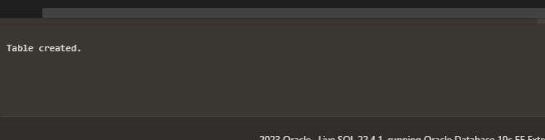 select * from customer_details;

INSERT ALL

INTO customer_details VALUES

('C00013','Holmes','London','London','UK',2,6000.00,5000.00,7000.00,4000.00,'BBBBBBB','A003')

INTO customer_details VALUES ('C00001','Micheal','New York','New

York','USA',2,3000.00,5000.00,2000.00,6000.00,'CCCCCCC','A008')

INTO customer_details VALUES ('C00020','Albert','New York','New

York','USA',3,5000.00,7000.00,6000.00,6000.00,'BBBBSBB','A008')

INTO customer_details VALUES

('C00025','Ravindran','Bangalore','Bangalore','India',2,5000.00,7000.00,4000.00,8000.00,'AVAVAVA','A011') INTO customer_details VALUES

('C00024','Cook','London','London','UK',2,4000.00,9000.00,7000.00,6000.00,'FSDDSDF','A006') INTO customer_details VALUES

('C00015','Stuart','London','London','UK',1,6000.00,8000.00,3000.00,11000.00,'GFSGERS','A003')

INTO customer_details VALUES ('C00002','Bolt','New York','New

York','USA',3,5000.00,7000.00,9000.00,3000.00,'DDNRDRH','A008')

INTO customer_details VALUES

('C00018','Fleming','Brisban','Brisban','Australia',2,7000.00,7000.00,9000.00,5000.00,'NHBGVFC','A005') INTO customer_details VALUES

('C00021','Jacks','Brisban','Brisban','Australia',1,7000.00,7000.00,7000.00,7000.00,'WERTGDF','A005')

INTO customer_details VALUES ('C00019

','Yearannaidu','Chennai','Chennai','India',1,8000.00,7000.00,7000.00,8000.00,'ZZZZBFV','A010') INTO customer_details VALUES

('C00005','Sasikant','Mumbai','Mumbai','India',1,7000.00,11000.00,7000.00,11000.00,'147-25896312','A002') INTO customer_details VALUES

('C00007','Ramanathan','Chennai','Chennai','India',1,7000.00,11000.00,9000.00,9000.00,'GHRDWSD','A010')

INTO customer_details VALUES ('C00022','Avinash','Mumbai','Mumbai','India',2,7000.00,11000.00,9000.00,9000.00,' 113-12345678','A002')

INTO customer_details VALUES

('C00004','Winston','Brisban','Brisban','Australia',1,5000.00,8000.00,7000.00,6000.00,'AAAAAAA','A005') INTO customer_details VALUES

('C00023','Karl','London','London','UK',0,4000.00,6000.00,7000.00,3000.00,'AAAABAA','A006') INTO customer_details VALUES

('C00006','Shilton','Torento','Torento','Canada',1,10000.00,7000.00,6000.00,11000.00,'DDDDDDD','A004') INTO customer_details VALUES

('C00010','Charles','Hampshair','Hampshair','UK',3,6000.00,4000.00,5000.00,5000.00,'MMMMMMM','A009') INTO customer_details VALUES

('C00017','Srinivas','Bangalore','Bangalore','India',2,8000.00,4000.00,3000.00,9000.00,'AAAAAAB','A007')

INTO customer_details VALUES ('C00012','Steven','San Jose','San

Jose','USA',1,5000.00,7000.00,9000.00,3000.00,'KRFYGJK','A012')

INTO customer_details VALUES

('C00008','Karolina','Torento','Torento','Canada',1,7000.00,7000.00,9000.00,5000.00,'HJKORED','A004') INTO customer_details VALUES

('C00003','Martin','Torento','Torento','Canada',2,8000.00,7000.00,7000.00,8000.00,'MJYURFD','A004')

INTO customer_details VALUES ('C00009','Ramesh','Mumbai','Mumbai','India',3,8000.00,7000.00,3000.00,12000.00,' 113-1263343','A002')

INTO customer_details VALUES

('C00014','Rangarappa','Bangalore','Bangalore','India',2,8000.00,11000.00,7000.00,12000.00,' AAAATGF','A001') INTO customer_details VALUES

('C00016','Venkatpati','Bangalore','Bangalore','India',2,8000.00,11000.00,7000.00,12000.00,' JRTVFDD','A007') INTO customer_details VALUES

('C00011','Sundariya','Chennai','Chennai','India',3,8000.00,11000.00,7000.00,11000.00,' PPHGRTS','A010') select * from dual;

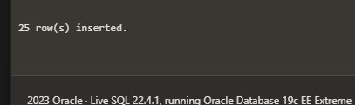

ALTER TABLE customer_details ADD cust_gender varchar(1);

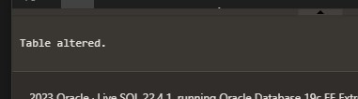

update customer_details SET cust_gender='M'; select * from customer_details order by cust_code;

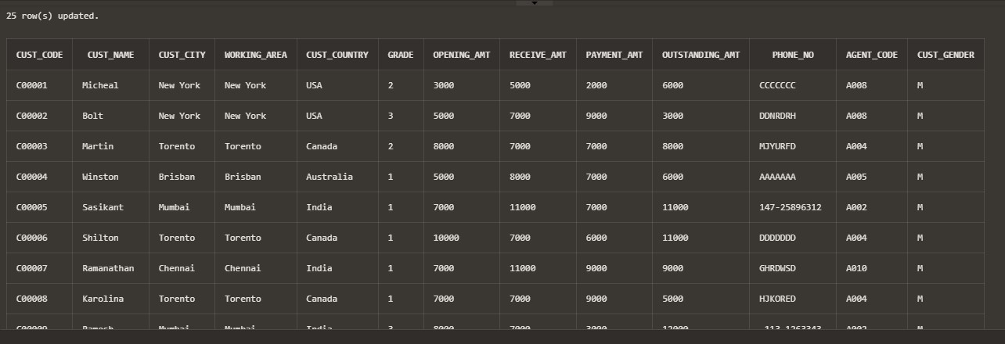

ALTER TABLE customer_details ADD order_time TIMESTAMP; select DBTIMEZONE from dual;

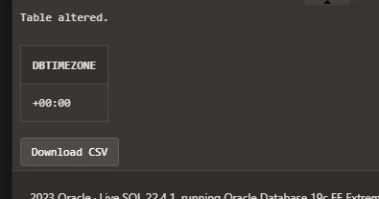

update customer_details SET outstanding_amt=0 where cust_country ='India';

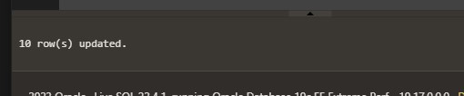

select * from customer_details where cust_country='UK' AND outstanding_amt>7000 order by cust_code;

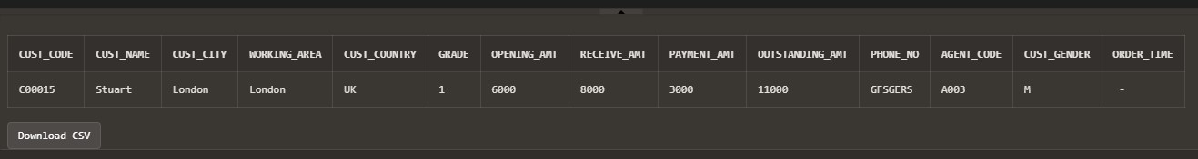

ALTER TABLE customer_details ADD feedback CLOB; update customer_details SET feedback='Large text space'; select * from customer_details order by cust_code

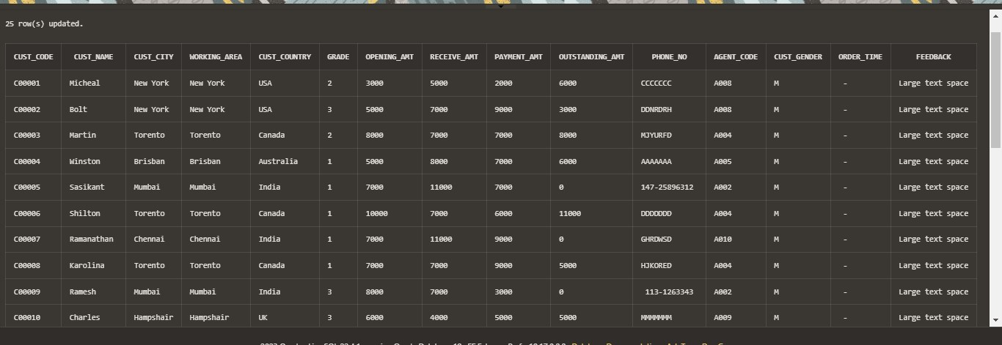

DELETE FROM customer_details WHERE grade =2;

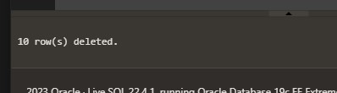

**Question5. Create table EMP with the following description :**

Name Type

EMPNO NOT NULL NUMBER(4)

ENAME VARCHAR2(10)

JOB VARCHAR2(9)

MGR NUMBER(4)

HIREDATE DATE

SAL NUMBER(7,2)

COMM NUMBER(7,2)

DEPTNO NUMBER(3)

AGE NUMBER(3)

1. Insert 5 records as shown in table below-

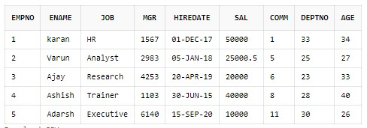

1. List all employee names , salary , 15% rise as ‘Raise’ and Rised amount after 15% as Raised_Amount in salary.

3.. Insert the following record in employee table-

(6,’ ‘, HR,2345,12-12-2020, 45000,40,20,32)

(7,George, Research,,2480,01-01-2018, 55000,’ ‘,25,42) 4. List ename, job where employee name is NULL 5.List ename whose manager is not NULL.

1. Find no.of dept in employee table.
2. List ename whose commission is NULL.
3. Display ename of the dept. with deptno 30.

**Solution:**

create table EMP (EMPNO number(4) NOT NULL, ENAME varchar2(10), JOB varchar2(9), MGR number(4), HIREDATE date, SAL number(7,2), COMM number(7,2), DEPTNO number(3), AGE number(3));



insert into EMP values (1,'karan','HR',1567,date '2017-12-1', 50000, 1,33,34); insert into EMP values (2,'Varun','Analyst',2983,date '2018-1-5', 25000.5,5,25,27); insert into EMP values (3,'Ajay','Research',4253,date '2019-4-20', 20000, 6,23,33); insert into EMP values (4,'Ashish','Trainer',1103,date '2015-06-30', 40000, 8,28,40); insert into EMP values (5,'Adarsh','Executive',6140,date '2020-09-15', 10000, 11,30,26);

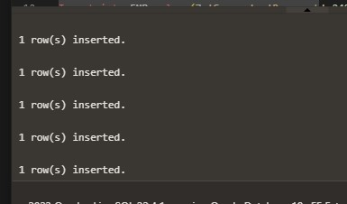

select ENAME, SAL, (SAL*.15) as Raise from EMP;

select ENAME, SAL,SAL*.15 as Raise, SAL+(SAL*.15) as Raised_Amount from EMP;

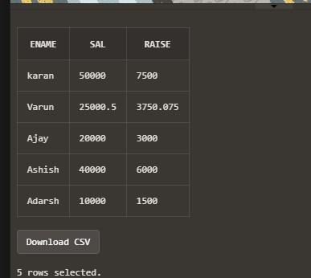 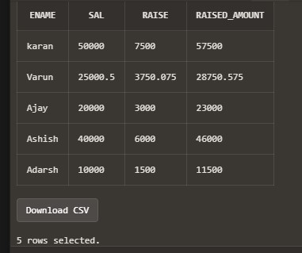

Insert into EMP values(6,NULL,'HR',2345,date '2020-12-12', 45000,40,20,32);

Insert into EMP values(7,'George', 'Research',2480,date '2018-01-01',55000,NULL,25,42);

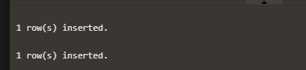

select ENAME,JOB from EMP where ENAME is NULL;

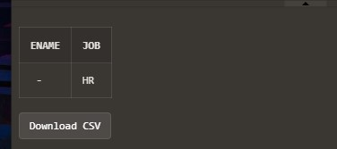

select ENAME from EMP where MGR is NOT NULL;

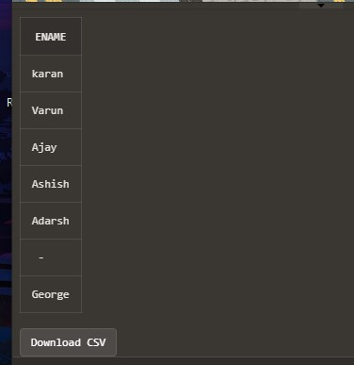

select count(DEPTNO) from EMP;

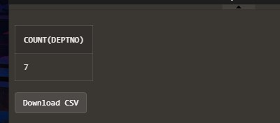

select ENAME from EMP where COMM is NULL;

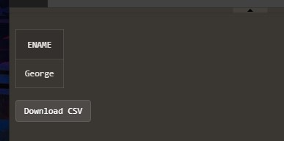

select ENAME from EMP where DEPTNO = 30;

